Advanced LEarning Night
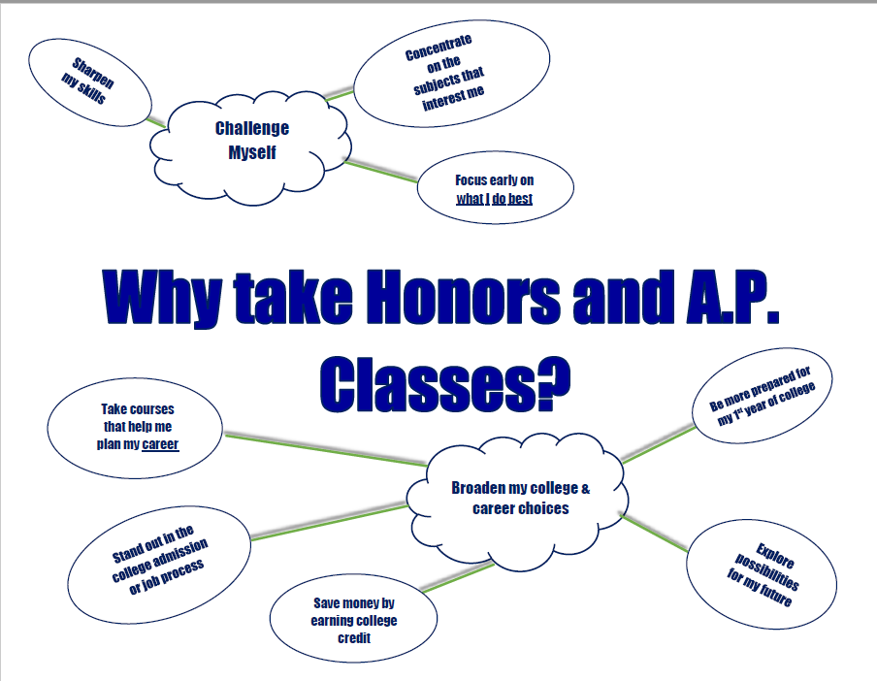

Thursday, September 9, 2021. 6:00 – 7:30pm
Join Zoom Meeting
https://bit.ly/3iySkUN

  - Questions? Contact Kara Harris: kara.harris@cobbk12.org

