-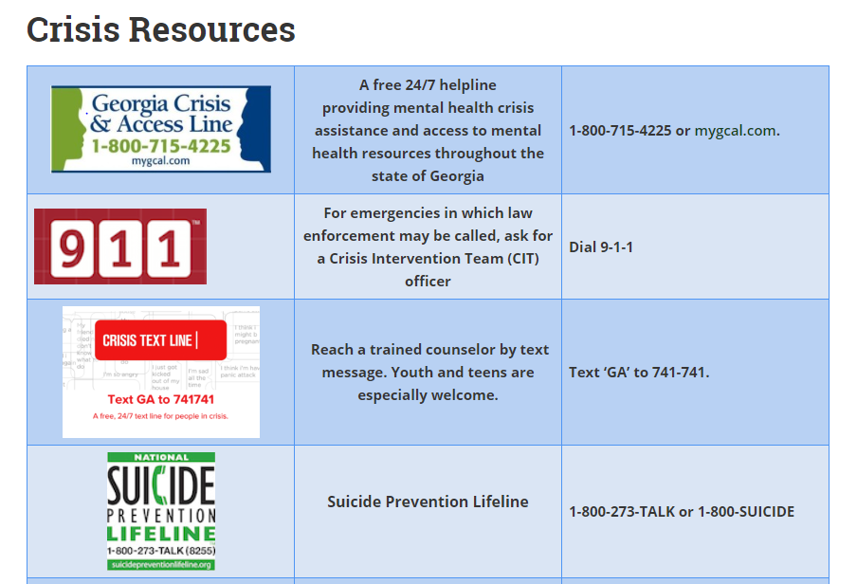

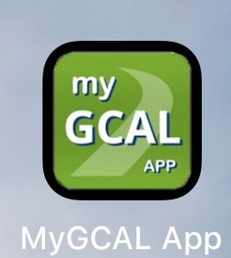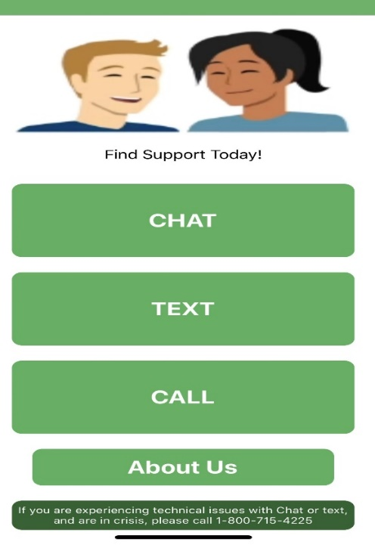

***\*\*\*New easy number to call or text #988. When people call or text 988, they will be connected to trained counselors within the existing lifeline network.***