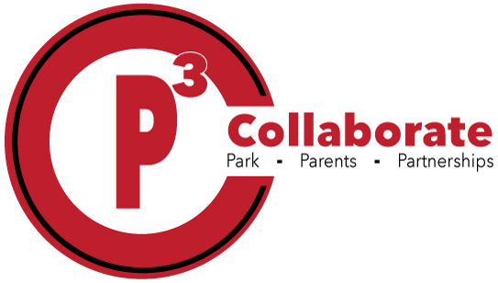

|  |
| --- |
| Three hold punch pouch |
| Ear buds |
| 1-2 packages of #2 pencils |
| Crayola Crayons 24 count |
| 1 package of erasers |
| 2-4 large glue sticks |
| Colored pencils |
| 1 package of Expo markers |
| 1-2 Primary Composition notebooks (with space for illustration at the top) |
| Blunt-end scissors (1) |
| Kleenex |
| Disinfectant wipes |
| Hand sanitizer |
| Ziploc bags: Gallon size and Quart size |
|  |
|  |
|  |

**2nd grade Supply List**