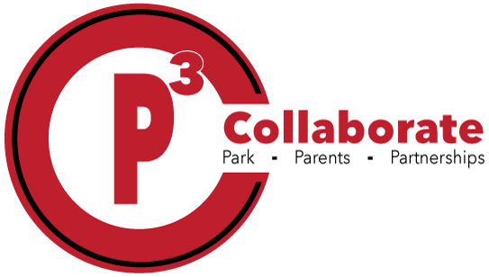

|  |
| --- |
| Color Pencils (12 count) |
| Markers (10 count) |
| Crayons (24 count) |
| Pencil Packs (2 packs) |
| Personal pencil sharpener |
| Big pink erasers (2 pack) |
| 5 composition notebooks wide-ruled |
| Dry erase markers (4 pack) |
| 3x5 index cards |
| 3x3 sticky note pack (1) |
| Kleenex |
| Lysol wipes |
|  |
|  |
|  |
|  |
|  |

**3rd Grade Supply List**