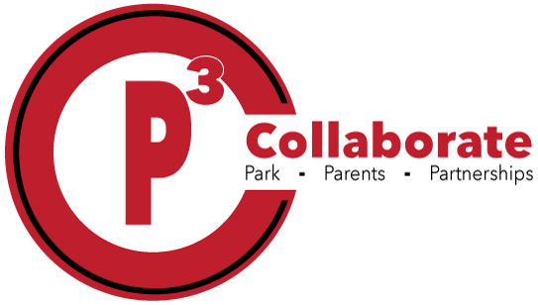

|  |
| --- |
| Wide-ruled Notebook Paper |
| Crayola Crayons |
| Colored Pencils |
| 1 pair of scissors |
| 2 packages of #2 pencils |
| Large glue sticks (6) |
| Disinfectant Spray |
| Hand sanitizer |
| 1 pack of dry erase Expo markers- BLACK ONLY |
| 5 Composition Notebooks |
| Pencil p2ouch or pencil box |
| 1 box of tissues |
| 1 roll of paper towels |
| 1 box of Ziploc bags (gallon or sandwich) |
| Highlighters |
| HEADPHONES OR EAR BUDS |
|  |

**Fifth Grade Supply List**