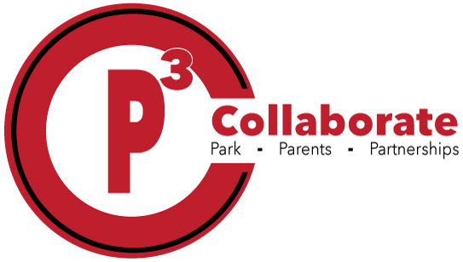

|  |
| --- |
| Clorox/Lysol wipes |
| Crayola Crayons 24 count (2) |
| Dry erase markers- 1 pack |
| Glue sticks (5 large) |
| Student scissors |
| Pencil bag with zipper |
| Hand sanitizer |
| Kleenex |
| Disinfectant spray |
| Girls: Ziploc bags quart or sandwich size |
| Boys: Ziploc bags gallon or snack size |
| Wide rule notebook |
| Folders |
| Headphones |
|  |
|  |
|  |

**Kindergarten Supply List**