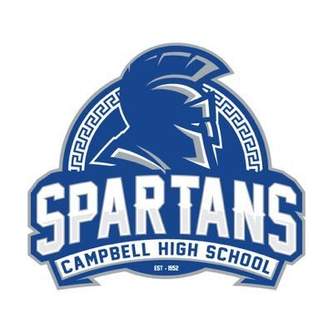
Campbell High School
Principal’s Advisory Council Meeting
Wednesday, October 30, 2024
One School, One Team, One Goal: Student Success

- Welcome and Introductions

- Selection of the Secretary for the Principal’s Advisory Council

- Academic updates:
    - Graduation rate- 88.57 – increase of 2.09 from 2023
    - School’s Strategic Plan
    - End of second six-week grading period

- Operational updates:
- Upcoming Hybrid parent meetings- Career Pathways and work-based learning- November 6 and 8

- School highlights:
    - International Festival- November 22

- Meeting dates for the year
    - November
    - January
    - February

- Questions and Comments

