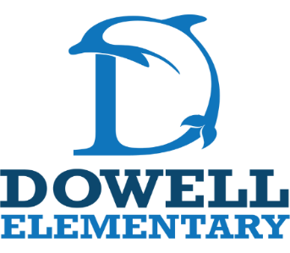
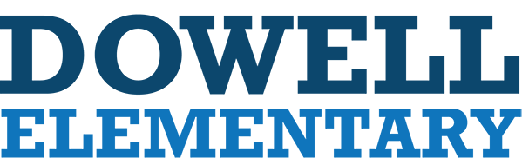

1st Grade Supply List
2026-2027

- Plug in Headphones
- 12 #2 pencils (Ticonderoga preferred)
- 3 large pink pearl erasers (no pencil cap erasers)
- 2 boxes of 24 Crayola crayons
- 12 glue sticks
- 1 pair of scissors
- 1 Primary writing journal
- 2 plastic folders – 2 pocket with prongs (1 blue and 1 red)
- 3 packs of Black Expo Dry Erase Markers, Chisel Tip
- 3 family size boxes of tissues
- 1 bottle of hand sanitizer
- 1 box of Band-Aids
- 2 container of disinfecting wipes
- 1 box Ziplock style bags (Boys- Gallon Size 20 ct.; Girls- Sandwich 50 ct.)
- 1 pencil box
***Please note: Individual teachers may ask for special items. Look for a more info. at Meet and Greet.
Specials Teachers:
- Disinfectant wipes
- tissues
- baby wipes

