McEachern Counseling 2026 summer Office hours


Our office will be open the following dates this summer:

Thursday, May 28, 9am to 4pm (All) Thursday, June 18, 9am to 4pm (BF)

Thursday, June 4, 9am to 4pm (KR) Thursday, June 25, 9am to 4pm (ML)

Thursday, June 11, 9am to 4pm (CW) Thursday, July 9, 9am to 4pm (CW)

Thursday, July 16, 9am to 4pm (RH)

Office is closed for lunch from 12pm to 1:00pm

Office will be closed the week of June 29th to July ^{3rd}

New Student Enrollments:

All new student enrollments will take place on Tuesdays, by appointment only.

All enrollment appointments will be conducted virtually this summer.

To begin: Go to CCSD website: Student Enrollment (cobbk12.org). Review all required documents.

Please note, missing required documents will delay & prevent a student from being registered for school.

Once all required documents are uploaded into your OLR (online registration), you will receive a call and/or email to complete the registration and select courses for your student.
- Class of 2026 Final Transcript Request: Link active until July 10th, 2026
  - Transcripts requested and paid for after May 31st will be processed once a week.
  - 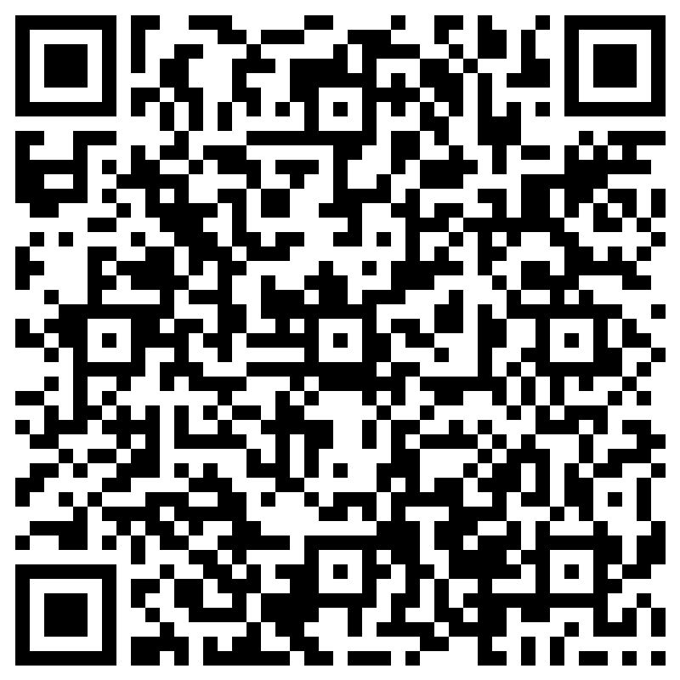 or https://forms.office.com/r/vFZHeVWJaz

