McEachern Counseling 2026 summer Office hours


Our office will be open the following dates this summer:

Thursday, May 28, 9am to 4pm (All) Thursday, June 18, 9am to 4pm (BF)

Thursday, June 4, 9am to 4pm (KR) Thursday, June 25, 9am to 4pm (ML)

Thursday, June 11, 9am to 4pm (CW) Thursday, July 9, 9am to 4pm (CW)

Thursday, July 16, 9am to 4pm (RH)

Office is closed for lunch from 12pm to 1:00pm

Office will be closed the week of June 29th to July 3rd

New Student Enrollments:

All new student enrollments will take place on Thursdays, by appointment only.

All enrollment appointments will be conducted virtually and by phone.

To begin: Go to CCSD website: Student Enrollment (cobbk12.org). Review all required documents.

Please note, missing required documents will delay & prevent a student from being registered for school.

Once all required documents are uploaded into your OLR (online registration), you will receive a call and/or email to complete the registration and select courses for your student.
- Class of 2026 FREE Final Transcript Request: Link active until July 10th, 2026
  - Final transcript requests made after 5/29/26 will be processed once a week.
- MPP will be inactive for the summer on 5/29/2026. Transcripts may be requested and paid for in person (cash only) during our counselling summer hours or during Russell Hall’s summer operating hours.

  - 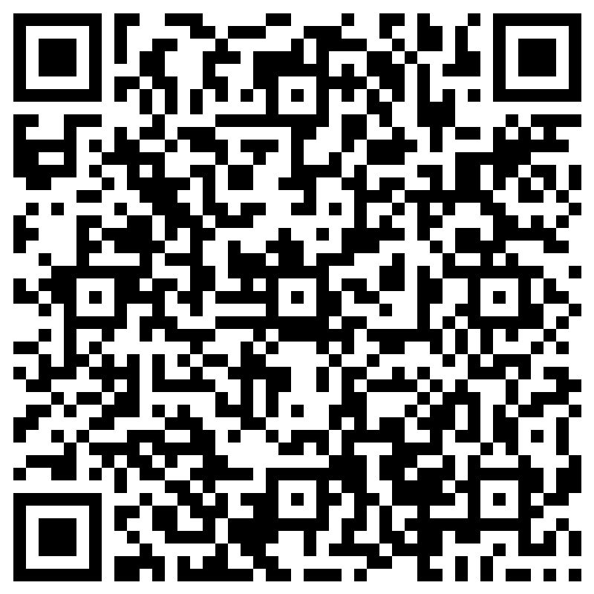 or https://forms.office.com/r/vFZHeVWJaz

