2026-2027
Floyd Middle School
School-Parent Compact for Achievement

Grade 6th, 7th, 8th
July 23, 2026

Floyd Middle School Activities to Build Partnerships
Please consider joining us through some of the events listed below. Volunteer opportunities may be virtual or face to face.

Volunteer Opportunities:
- Family Game Night
- 8th Grade Dance
- Title I Planning Committee
- Field Day

Partnership Meetings:
- Annual Title I Parent Informational Meeting
- Open House
- Meet and greet
- Title I Parent Input Meetings
- Parent Teacher Conference Week

Family Engagement Opportunities:
- Stem Night
- Curriculum in Action night
Parent Resource Room
What is a School-Parent Compact?

Congue nihil imperdiet doming id quod mazim placerat facer minim veni am ut wisi enim ad minimeniam, quis erat nostr uexe
rci tation ullamcorper nostru exerci tation ullam corper et iusto odio dig nissim qui blandit praesent lupta. Tummer delenit
augue duis dolore te feugait nulla facilisi. Con erattis sectetuer adip iscing elit, sed erat diam nonummy nibh magna erat.
If you would like more information, please contact:

Parent Facilitator
Rose Chavous
(770) 819-2453 ex.059 or
Rose.chavous@cobbk12.org
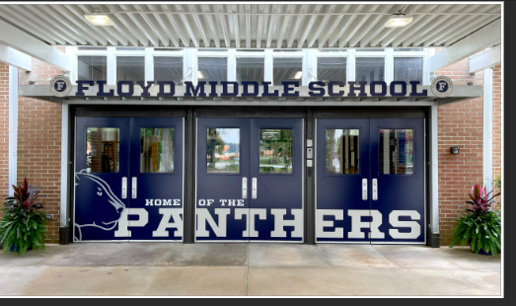

I
picture, photo, etc.
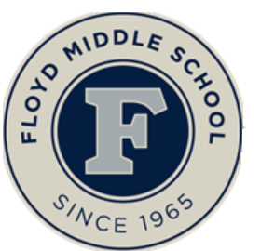

Dr. Ashley Hosey Principal

Ashley.Hosey@cobbk12.org

4803 Floyd Road
Mableton, Georgia 30126
(770) 819-2453
www.cobbk12.org/floyd

Jointly Developed

The parents, students, and staff of Floyd Middle School worked together and shared ideas to develop the school-parent compact for achievement. Teachers suggested home learning strategies, parents added ideas to make them more specific, and students told us what would help them learn. Parents are encouraged to participate in the annual review process of the compact and make changes based on students’ needs. Parents are welcome to contribute comments at any time. Please contact Parent Facilitator Rose Chavous at (770) 819-2453 ex.059 or Rose.chavous@cobbk12.org to provide feedback.

- CTLS Parent
- ParentVUE
- Weekly Folders
- Student Agendas
- School Website
- Monthly Newsletters
- Email

- Parent/Teacher Conferences
- Facebook &Twitter
- Flyers
- District Website
- School Marquee

Some communications may be provided virtually

A School-Parent Compact is an agreement that parents, students, and teachers, develop together. It explains how parents and teachers will work together to make sure all of our students succeed. This compact includes strategies to help connect learning at school to learning at home.

Floyd Middle School
Activities to Build Communication


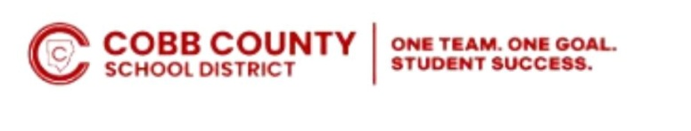
ONE TEAM.ONE GOAL.STUDENT SUCCESS.

District Goals for Student Achievement

- By SY28, increase growth by 2 percentage points, for students scoring at the proficient and distinguished levels, as evidenced by state assessments.

- By SY28, increase graduation rate from 87% to 88% as measured by GaDOE adjusted cohort graduation rate.

Visit Our Website:
www.cobbk12.org/floyd

Floyd Middle School Goal(s) for Student Achievement

Goal 1: Students at each grade level scoring level 2-4 on the Math EOG Assessment will increase 3-5% from the 2026 EOG Math Assessment to the 2027 EOG Math Assessment. 6th Grade students scoring Level 2-4 will increase from 67% the 2026 Math EOG Assessment to 70% on the Math 2027 EOG Assessment. 7th Grade students scoring Level 2-4 will increase from 67% on May 2026 Math EOG Assessment to 70% on the Math 2027 EOG Assessment. 8th Grade students scoring Level 2-4 will increase from 72% on the 2026 Math EOG Assessment to 75% on Math EOG Assessment.
Goal 2: LA Assessment to the 2027 EOG ELA Assessment. 6th Grade students scoring Level 2-4 will increase from 58% the 2025 ELA EOG Assessment to 63% on the ELA 2027 EOG Assessment. 7th Grade students scoring Level 2-4 will increase from 60% on May 2025 ELA EOG Assessment to 65% on the ELA 2027 EOG Assessment. 8th Grade students scoring Level 2-4 will increase from 76% on the 2025 ELA EOG Assessment to 80% on ELA EOG Assessment.

- Insert grade level will focus insert the skill or concept everyone will work toward (ask academic coach for assistance)

Floyd Middle Students

Attend school daily and actively participate in learning, be on time for class, complete all classwork assignments, especially homework.

Take ownership of learning and performance by implementing effective research - based strategies to master prioritized and supporting learning.

Maintain positive communication with teachers and school staff. Attend tutorials, read as often as possible and discuss performance with families.

Floyd Middle Families

Ensure students are aware of the opportunities that are available.
Provide a quiet study place at home and discuss their school day.

Keep up with your student performance in class.
Communcate with your child teacher, and utilize the Title 1 resources.

Access CTLS Parent, Parent VUE, and teacher contact , to stay informed and involved in your student progress. Review tutorial with your student. Talk to your child concerning future goals.
Floyd MiddleTeachers

Create opportunities to use research – based strategies to increase Lexile score in social Studies, Science , Fine Arts, Mathematics and Language Arts.

Provide additional academic support within the school day to students who are performing below grade level in reading or math by utilizing Title 1 resources.

Offer targeted instruction through tutorial and addition academic instructional to support for all core content areas to promote college and career readiness.

Teachers, Parents, and Students-Together for Success

