**2024-2025**

Simpson MS Intramurals: 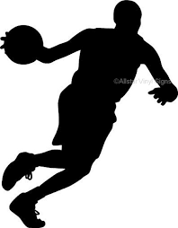

**Schedule** **8:15am-8:45am**

Wednesday: Soccer

Thursday: Tchoukball

Friday: Touchdown

**Expectations**

1. Students report to the gym doors when they arrive to school.
2. Students who do not arrive by 8:25am cannot be included in that day’s IM activities. If the doors are closed, you are too late. **YOU will have to report to study hall. NO EXCEPTIONS!**
3. Students can place their personal belongings in the locker room. You may change in the locker room as well.
4. Students will actively participate in the daily activity.
5. All IM students must stay in the gymnasium area until the 8:50 am bell.

**Behavior Management**

1st Strike: 1 Day IM Suspension

2nd Strike: 1 Week IM Suspension

3rd Strike: 1 Semester IM Suspension

**Behavior issues include, but are not limited to: Profanity, Cheating, Fighting, Excessive Horseplay, and Disrespect.**

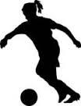

**Questions? Contact Us**

**Coach Aumann:**

[Alan.aumann@cobbk12.org](mailto:Alan.aumann@cobbk12.org)

[Whitney.robinson@cobbk12.org](mailto:Whitney.robinson@cobbk12.org)

**Remember: You must arrive to the gym doors at 8:15, by 8:25 at the latest.**

**Parents should drop off AT the gym doors and EXIT parking lot as if a car rider. SEE ATTACHED MAP FOR DIRECTIONS.**

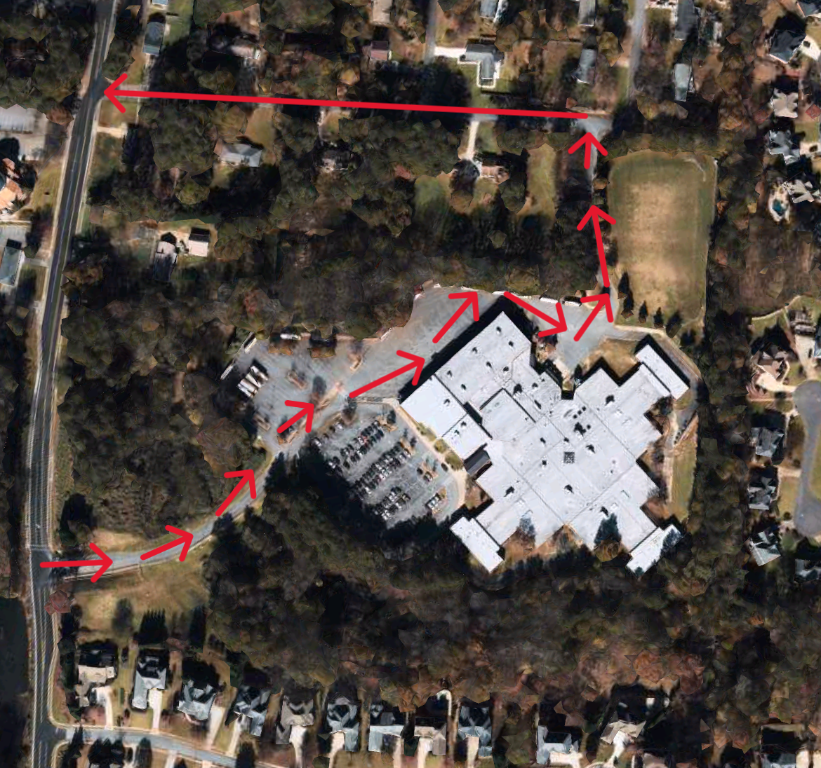

Parents and students,

Drop-off for students participating in intramurals will take place at the bus port side of the building through the gym doors. Parents should go STRAIGHT instead of turning to the right to drop off at the front of the building.

Drop-off times are 8:15-8:25. Please know that any time AFTER 8:25, students will not be allowed to attend intramurals that day. The gym doors WILL BE closed. If students arrive after 8:25, parents should follow the normal carpool procedures and pull through the carpool line, dropping off at the front of the school.

**Rules of Intramural Games:**

**Tuesday: Soccer**

Students will be placed onto teams and given colored jerseys (pinnies) to indicate their teams.

Games are played to 1 score; after this score, the winning team stays on the court and the losing team rotates off while the next team rotates on. The new team begins the next game.

**SHAPE America Standards Addressed:**

**Standard 1:** The physically literate individual demonstrates competency in a variety of motor skills and movement patterns.

**Standard 2:** The physically literate individual applies knowledge of concepts, principles, strategies and tactics related to movement and performance.

**Standard 4:** The physically literate individual exhibits responsible personal and social behavior that respects self and others.

**Standard 5:** The physically literate individual recognizes the value of physical activity for health, enjoyment, challenge, self-expression and/or social interaction.

**Thursday: Tchoukball**

Students will be placed onto teams. The students will try to throw the ball of a rebounder and have it land in the field of play.

Offense will try to knock the ball to the ground while the defense tries to catch the ball to ensure it does not hit the ground.

First team to score, wins. They stay to play another game against the next team in line.

**SHAPE America Standards Addressed:**

**Standard 1:** The physically literate individual demonstrates competency in a variety of motor skills and movement patterns.

**Standard 2:** The physically literate individual applies knowledge of concepts, principles, strategies and tactics related to movement and performance.

**Standard 4:** The physically literate individual exhibits responsible personal and social behavior that respects self and others.

**Standard 5:** The physically literate individual recognizes the value of physical activity for health, enjoyment, challenge, self-expression and/or social interaction.

**Friday: Touchdown**

Students will be placed on teams. The goal of the game is to move the ball from one end zone to the other without moving with the ball.   
First team to score, wins. They stay to play another game against the next team in line.

**SHAPE America Standards Addressed:**

**Standard 1:** The physically literate individual demonstrates competency in a variety of motor skills and movement patterns.

**Standard 2:** The physically literate individual applies knowledge of concepts, principles, strategies and tactics related to movement and performance.

**Standard 4:** The physically literate individual exhibits responsible personal and social behavior that respects self and others.

**Standard 5:** The physically literate individual recognizes the value of physical activity for health, enjoyment, challenge, self-expression and/or social interaction.