Dismissal Procedures
Prior to students leaving for the day, please ensure all students communicate their mode of afternoon transportation. Remind them to have students listen to the announcements for bus lanes called.
Using a roster or Excel spreadsheet, select the following information for each student: Band/Orch student, walker, car rider, bus rider, bus number, and group number. Once you fill out your spreadsheet, filter and sort, so all students are grouped appropriately by lane number.
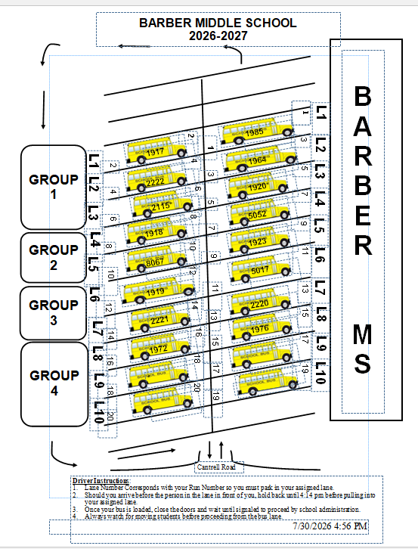
Student Name | Band/Orch Sticker | Walker | Car Rider | Bus Rider | Bus # | Lane #
Student 1 | X |  |  | X | 1974 | 4
Student 2 | X |  | X
Student 3 | X |  |  | X | 1964 | 1
Student 4 | X |  |  | X | 1617 | 3
*Band/Orchestra students who need to retrieve instruments from their band/orchestra lockers should be released at 4:10 (with a fine arts sticker affixed to the front of their agendas). Students without fine arts stickers should not be released to go to the band/orchestra rooms. If the student is a car rider or walker, he/she should take his bookbag and other belongings with him/her to retrieve instrument. Once students collect their instruments (car riders and walkers only), they should exit out of the main entrance of the building. They should not return to 7th period.

