What is the Warrior Way at Barber?
The Warrior Way is Barber Middle School’s PBIS (Positive Behavior Interventions and Supports) framework. It is a tiered system that we use to improve our school culture. We use data to inform decisions about instructional practices and systems to influence student behaviors positively. Students can earn rewards throughout the day by meeting behavior expectations and redeem them for tangible items or activities. Students can manage their own behaviors through the PBIS Rewards App and track any infractions for misbehavior. Parents can also see rewards and infractions by using the PBIS Rewards Parent App. We expect to see overall behavior improve throughout the school and the number of referrals will decrease.

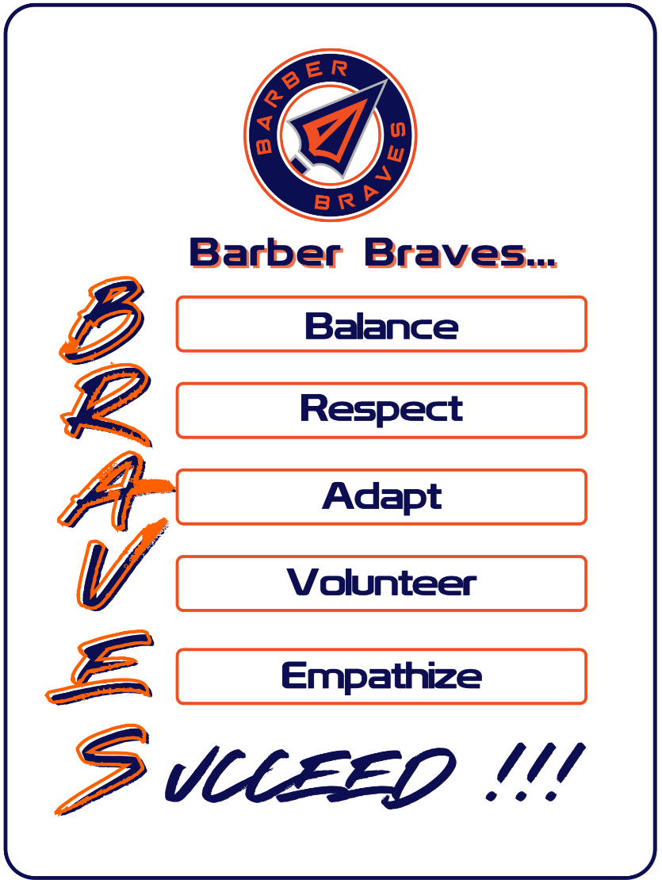

Mission statement:
Our Warrior Way team is committed to fostering a safe, inclusive, and positive learning environment where every school community member feels valued, respected, and empowered.

Vision statement:
Through proactive strategies, consistent reinforcement of positive behaviors, and targeted interventions, we aim to cultivate a culture of success through balance, respect, adaptability, volunteerism, and empathy.

Barber Braves Incentives and Rewards
Students can earn Barber Bucks for demonstrating the positive attributes of Braves (as listed above). Barber Bucks can be used to make no-cash purchases in classrooms or within the school such as sitting with a friend at lunch, charging devices, getting snacks, or attending Rewards events (there are several other opportunities for using reward points). Parents can see reward points earned by checking the PBIS app.
Braves Days:
August 29 September 18 October 30 November 20 December 11
January 29 February 26 March 26 April 30 May 14
In order to participate in BRAVES DAY, students must meet the requirements below:
- 20 Barber Bucks
- The student CANNOT have 3 minor referrals during the monthly cycle.
- The student CANNOT have an office referral during the monthly cycle.

Barber Bi-Annual Blowout Criteria
- The Blowouts occur once per semester.
- To participate, you must meet BRAVE criteria each semester:
  - Behavior
    - Students CANNOT have 2 instances of ISS assigned during the semester
    - Students CANNOT have 1 instance of OSS assigned during the semester
    - Students CANNOT have advisement assigned two or more times during the semester.
  - Attendance
    - Students MUST NOT have 5 or more unexcused absences.
  - Financial
    - A fee may be charged, if necessary, to offset blowout expenses.

Barber Warrior Way Minor Referral Steps
Parents can see if students earn minor referrals in the PBIS app. Minor referrals can be given when students are not following directions, not adhering to the cell phone or dress code policy, etc. Students earn major referrals when they violate the Student Code of Conduct for incidents such as fighting, having weapons or drugs, habitually being insubordinate, bullying, having a verbal altercation, etc. (Note: These are examples, not an exhaustive list, of ways students can earn minor and major referrals.)
Barber Warrior Way Minor Referral Steps
If a student receives a minor referral, we will follow the steps below:
1st infraction - Parent Email/App Notification
2nd Infraction – Parent Phone Call
3rd Infraction - In team isolation (ITI)
4th infraction - Office Referral
* Consequences are cumulative during each BRAVES Day cycle.

Barber Middle School Warrior Way Common Areas Matrix
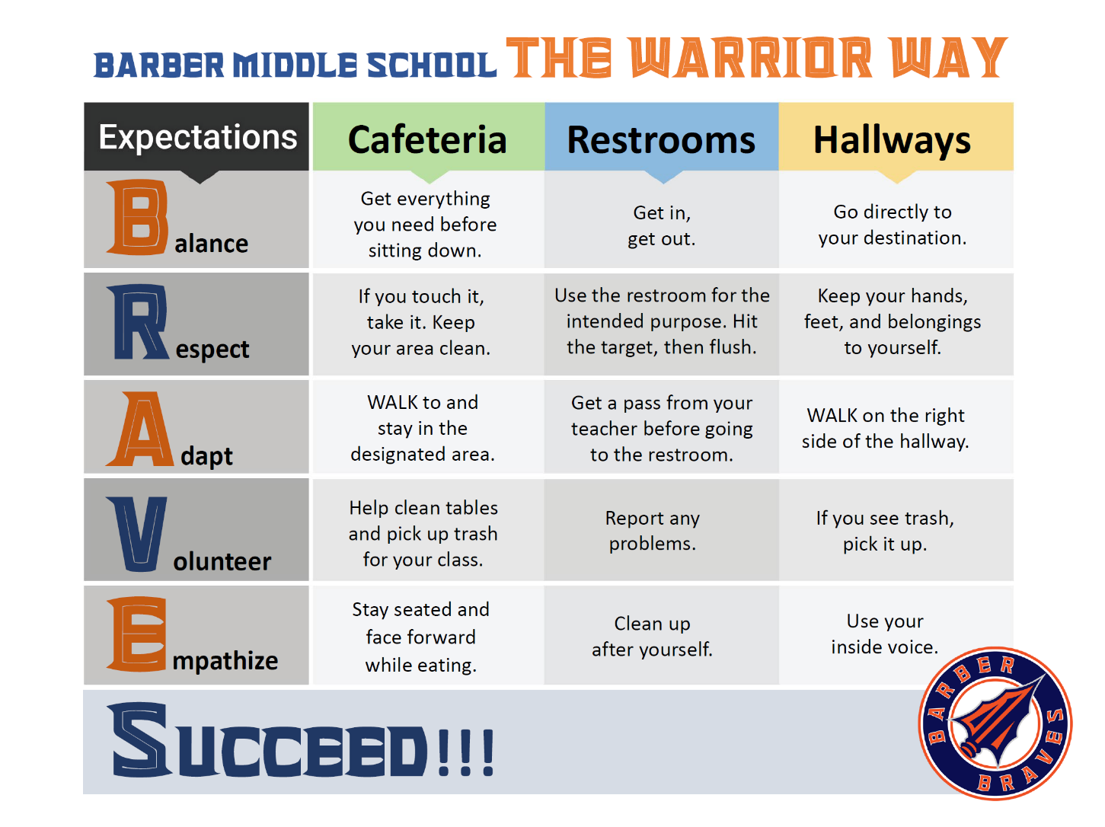
Each day, we expect our students to exhibit BRAVES behavior in our classrooms, cafeteria, restrooms, and hallways.

