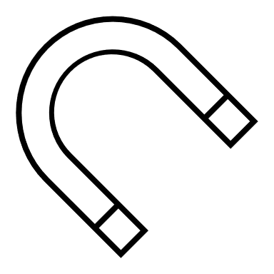 Science Fair

You are invited to explore the wonderful world of science by participating in the Science Fair! Your project does not have to be complicated for it to be an amazing one. It can be both fun AND educational!
- Your parents may assist you, but YOU must be the main scientist.
- If you choose to work with a partner, s/he must be in the same grade as you.
- Everyone who participates will receive a certificate.
- The top 5 projects will have the chance to move on to the Cobb Science Fair. For more information you can go to Cobb County Science blog: http://www.ccsdscience.com/1-5.html
Important Dates:
- March 18th Drop off projects in Media Center
- March 19th-22nd Keheley Science Fair
- April 20th Cobb County Science Fair

Be creative and HAVE FUN!!!

--------------------------------------------------------
Science Fair Intent to Participate Form
Please return this form to Mrs. Medlin for more information
Student name ____________________________ Teacher ________________________ Grade ____
(Optional) Partner name/ Homeroom Teacher ____________________________________________
*Please note: Only groups of 2 are allowed AND partners must be in the same grade.

Student Signature: __________________________________________________
Parent Signature: __________________________________________________

