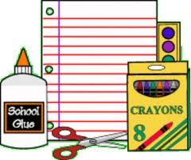

4th Grade Supply List
2026-2027

1 Pack of multi-colored highlighters
48 Ticonderoga pre-sharpened pencils
1 Nylon zippered pencil pouch
- Crayola 7” Colored pencils pre-sharpened 12 ct.
- Crayola crayons 24 ct.
- Crayola thick markers 8 ct.
1 Sharpie black fine marker
10 Elmer’s purple glue sticks (giant sticks)
1 Pair of sharp 6” scissors
4 Expo low odor black chisel dry erase markers
- 3X3 lined sticky note 100 sheet pad
1 Red plastic pocket folder
1 Blue plastic pocket folder
1 Yellow plastic pocket folder
8 Subject wide-ruled spiral Notebooks--assorted colors (single subject)
1 Pair of headphones
- Paper Mate Pink Pearl eraser (large)
- Lined Paper (Wide Ruled)
1 Kleenex tissues 160 ct.
- Individually wrapped paper towels
- Clorox or Lysol wipes
"If you choose to purchase a school supply box via the PTA, any general classroom cleaning supplies (tissues, clorox wipes, paper towels, hand sanitizer, hand soap, or ziploc bags) will not be included in the box that is shipped to your home, but will be provided to teachers directly by the PTA. This allows us to buy these supplies in bulk and save our families money! If you opt out of a PTA-sponsored school supply box, please have your student bring in these supplies to contribute to the classroom."

