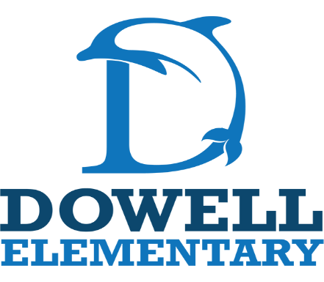
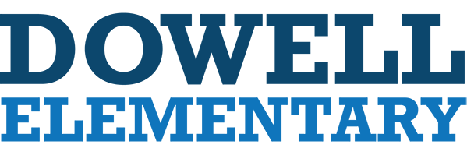

4th Grade Supply List
2026-2027
-1 packs of notebook paper
-2-3 boxes of pencils
-1 pencil bag (no boxes please)
-5-6 big eraser and/or 1 pack of cap erasers
-6 Composition notebooks
-1 packs of highlighters
Specials Teachers:
- Disinfectant wipes
- tissues
- baby wipes

-3 packs of glue sticks
-3 pocket folders with prongs
-8 dry erase Expo markers
-24 pack of crayons
-24 pack of colored pencils
-1 pair of scissors
-2 bottles of hand sanitizer w/pump
-4 boxes of Kleenex
-Girls – 1 box of gallon size Ziploc bags
-Boys – 1 box sandwich size of Ziploc bags
-1 set of earbuds headphones
- 3 pack of disenfectant wipes
-1 box of Band-Aids

