Daniel Middle School
6th grade Supply List – 2024-2025
General Supplies needed for all classes  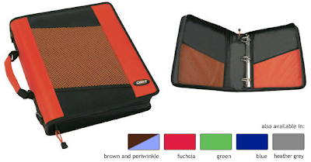  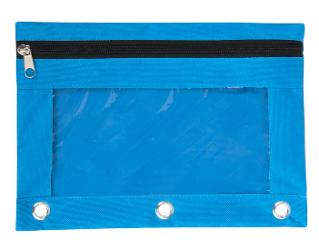 | 1 binder with pencil pouch and *dividers with pockets- this will be carried around to each class and will hold supplies needed for all classes. ****You only need to purchase one binder (See picture to the left for an example). Teachers will assist students with labeling and organizing binders during the first week of school.  Keep in Pencil Pouch (refresh AS NEEDED throughout the year)  - Pencils  - Pens  - Handheld pencil sharpener  - Highlighters (4 colors)  - Expo markers  - Glue sticks  - Scissors  - *Colored pencils (used frequently so please make sure you have)  Laptop and charger (label both after distribution)  USB Headphones/Earbuds (5 Below has USB headphones for $10) (AirPods and other wireless headphones are not allowed)  3 packs of wide ruled lined notebook paper (keep one pack in binder, refresh throughout the year)
Homeroom Donations | Ream of copy paper  Tissues (3 boxes)  Paper towels (3 pack)  Lysol/Clorox Wipes  Hand Sanitizer  Band-Aids
Language Arts supplies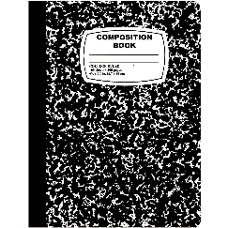 | 1 composition book: Wide-ruled any color or design (no spiral notebooks)  *Section in their binder designated for ELA to keep handouts and assignments organized.
Social Studies supplies | Section in a binder designated for SS – *dividers with pockets needed to keep papers in  *Colored pencils/markers- we have multiple projects throughout the year
Math  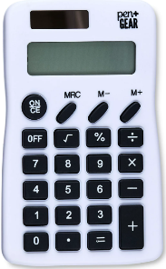 | Section in a binder designated for Math OR 3-prong folder just for Math  Basic 4-function calculator (not-scientific)  MUST have notebook paper, a pencil, and calculator EVERY day!
Science: 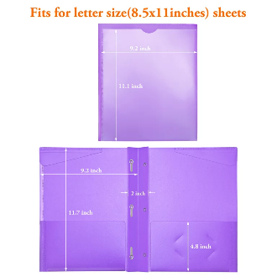 | Plastic three prong folder with front pocket (see picture)  *Colored pencils/markers- we have multiple projects throughout the year
Miscellaneous | Extra Kleenex is always appreciated!  Pastel color copy paper is also appreciated!  Expo markers for teachers  A wireless or wired mouse, for the school computer, makes navigating much easier for the students. (optional)  Label all materials with a permanent marker

Walmart Supply List - Everything on the list is required, however you can buy any brand that you like. Walmart does not have 3 prong folders with a clear front pocket, if you cannot find one, a heavy-duty plastic 3 prong folder is fine.

