7th Grade Supply List
2024-2025
Binders/Folders/Paper:
- Notebook paper
- (1) 1-inch 3-ring binder for Social Studies
- (5) plastic 2-pocket folders: Science (green), Math (blue), ELA (red), Homeroom (yellow), Connections (color of choice)
- Sato only - (1) spiral notebook for Math (color of choice)

Zippered pencil pouch, labeled with first and last name, with the following inside:
- Pencils/erasers
- Colored pencils or crayons
- Markers
- Pens
- Expo markers for math whiteboards
- Calculator (4-function or Scientific)
- Handheld pencil sharpener
- Glue stick
- Highlighters
- Wired earbuds/headphones for laptop (3.5 mm plug)
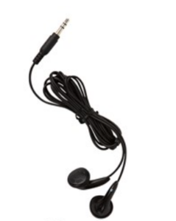
3.5 mm

Suggested donations for homeroom teacher:
- Tissues (high priority)
- Ream of copy paper
- Hand sanitizer
- Band-Aids
- Baby wipes, not cleaning/sanitizing wipes
- Paper towels (for science)
- Rubber gloves (for science)
- Black Sharpies (for science)
- Gallon Ziplock bags (for science)
- Pencil donations
- Expo markers

Individual teachers may request additional supplies when school starts.

