**8th Grade Supply List**

**2024-2025**

**Math 8 Supplies**

* 3-prong folder
* A single subject spiral notebook
* At least 2 packs of loose leaf notebook paper per semester

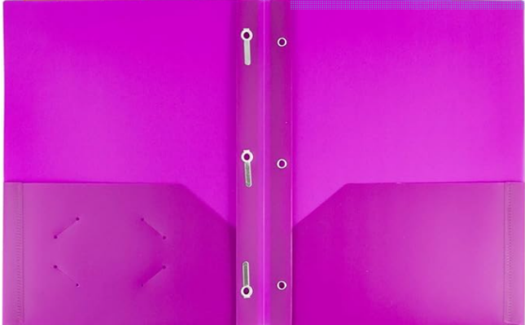

**Algebra 1 Supplies**

* One inch binder
* 5 tab dividers
* At least 2 packs of loose leaf notebook paper per semester

**For Georgia Studies:**

* Notebook or a section in a larger notebook or a two-pocket folder
* Pens
* Pencils
* Paper
* Highlighter

**Science:**

* Hand sanitizer
* Tissue
* Folder or Binder
* Paper
* Pencils
* Optional but encouraged: scissors, coloring items, and glue