AP Art & Design
Scan the QR code to fill out the AP Art application.
Serious inquiries only!

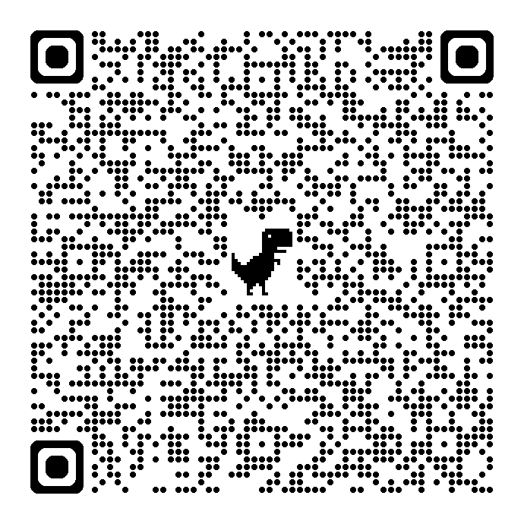

AP Art is a course designed for any artistic students who want to learn how to become inquisitive, thoughtful artists that are able to communicate well about their work.
Be ready to make 15 pieces over the course of a semester!
*This is a spring semester only class.

It is highly encouraged that you take
VA Comp, Draw Paint 1, & Draw Paint 2
before taking AP Art & Design.

*To be accepted into AP Art & Design, you must fill out the application fully & email Mrs. Beard images of your artwork that you’ve created on your own or in a past art class.
Dory.beard@cobbk12.org

