
What is a School-Parent Compact?
2026-2027
Betty Gray Middle School
School-Parent Compact for Achievement
Grade 6th, 7th, 8th
Revised July 17, 2026

Dr. Vanessa Watkins, Principal
Vanessa.Watkins@cobbk12.org

1550 Pebblebrook Circle
Mableton, GA 30126
(770) 819 - 2414
Cobbk12.org/bettygray
Betty Gray Middle School Activities to Build Partnerships
Please consider joining us through some of the events listed below. Volunteer opportunities may be virtual or face to face.
Volunteer Opportunities:
- School Events (Fundraisers, Parties, Performances)
- Media Center
- Title I Planning Committee

Partnership Meetings:
Annual Title I Parent Informational Meeting Open House
Meet and greet
Title I Parent Input Meetings Parent Teacher Conference Week
Family Engagement Opportunities:
Curriculum Night Expo
Strategy Training to Assist Students at Home Parent Resource Room
A School-Parent Compact is an agreement that parents, students, and teachers, develop together. It explains how parents and teachers will work together to make sure all our students succeed. This compact includes strategies to help connect learning at school to learning at home.

Jointly Developed
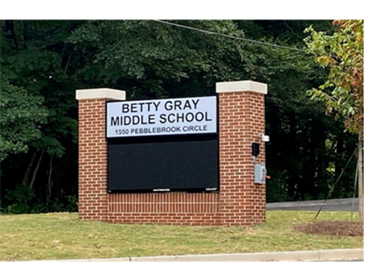
The parents, students, and staff of Betty Gray Middle School worked together and shared ideas to develop the school-parent compact for achievement. Teachers suggested home learning strategies, parents added ideas to make them more specific, and students told us what would help them learn. Parents are encouraged to participate in the annual review process of the compact and make changes based on students’ needs. Parents are welcome to contribute comments at any time. Please contact Elaine Hill at (770) 819 – 2414 ext. 064 or Email elaine.hill@cobbk12.org to provide feedback.
 | Betty Gray School Activities to Build Communication
Some communications may be provided virtually
- CTLS Parent  - ParentVUE  - Weekly Newsletters  - Student Agendas  - School Website  - Monthly Newsletters  - Email |  | - Parent/  Teacher Conferences  - Facebook &Twitter  - Flyers  - District Website  - School Marquee

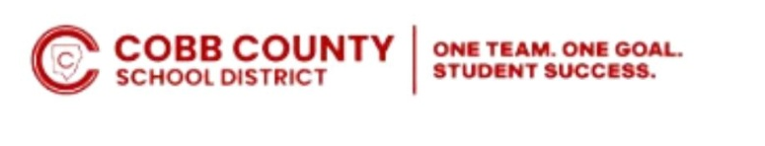
If you would like more information, please contact:
Elaine Hill – Parent facilitator
(770) 819 – 2414 ext. 064 or
elaine.hill@cobbk12.org
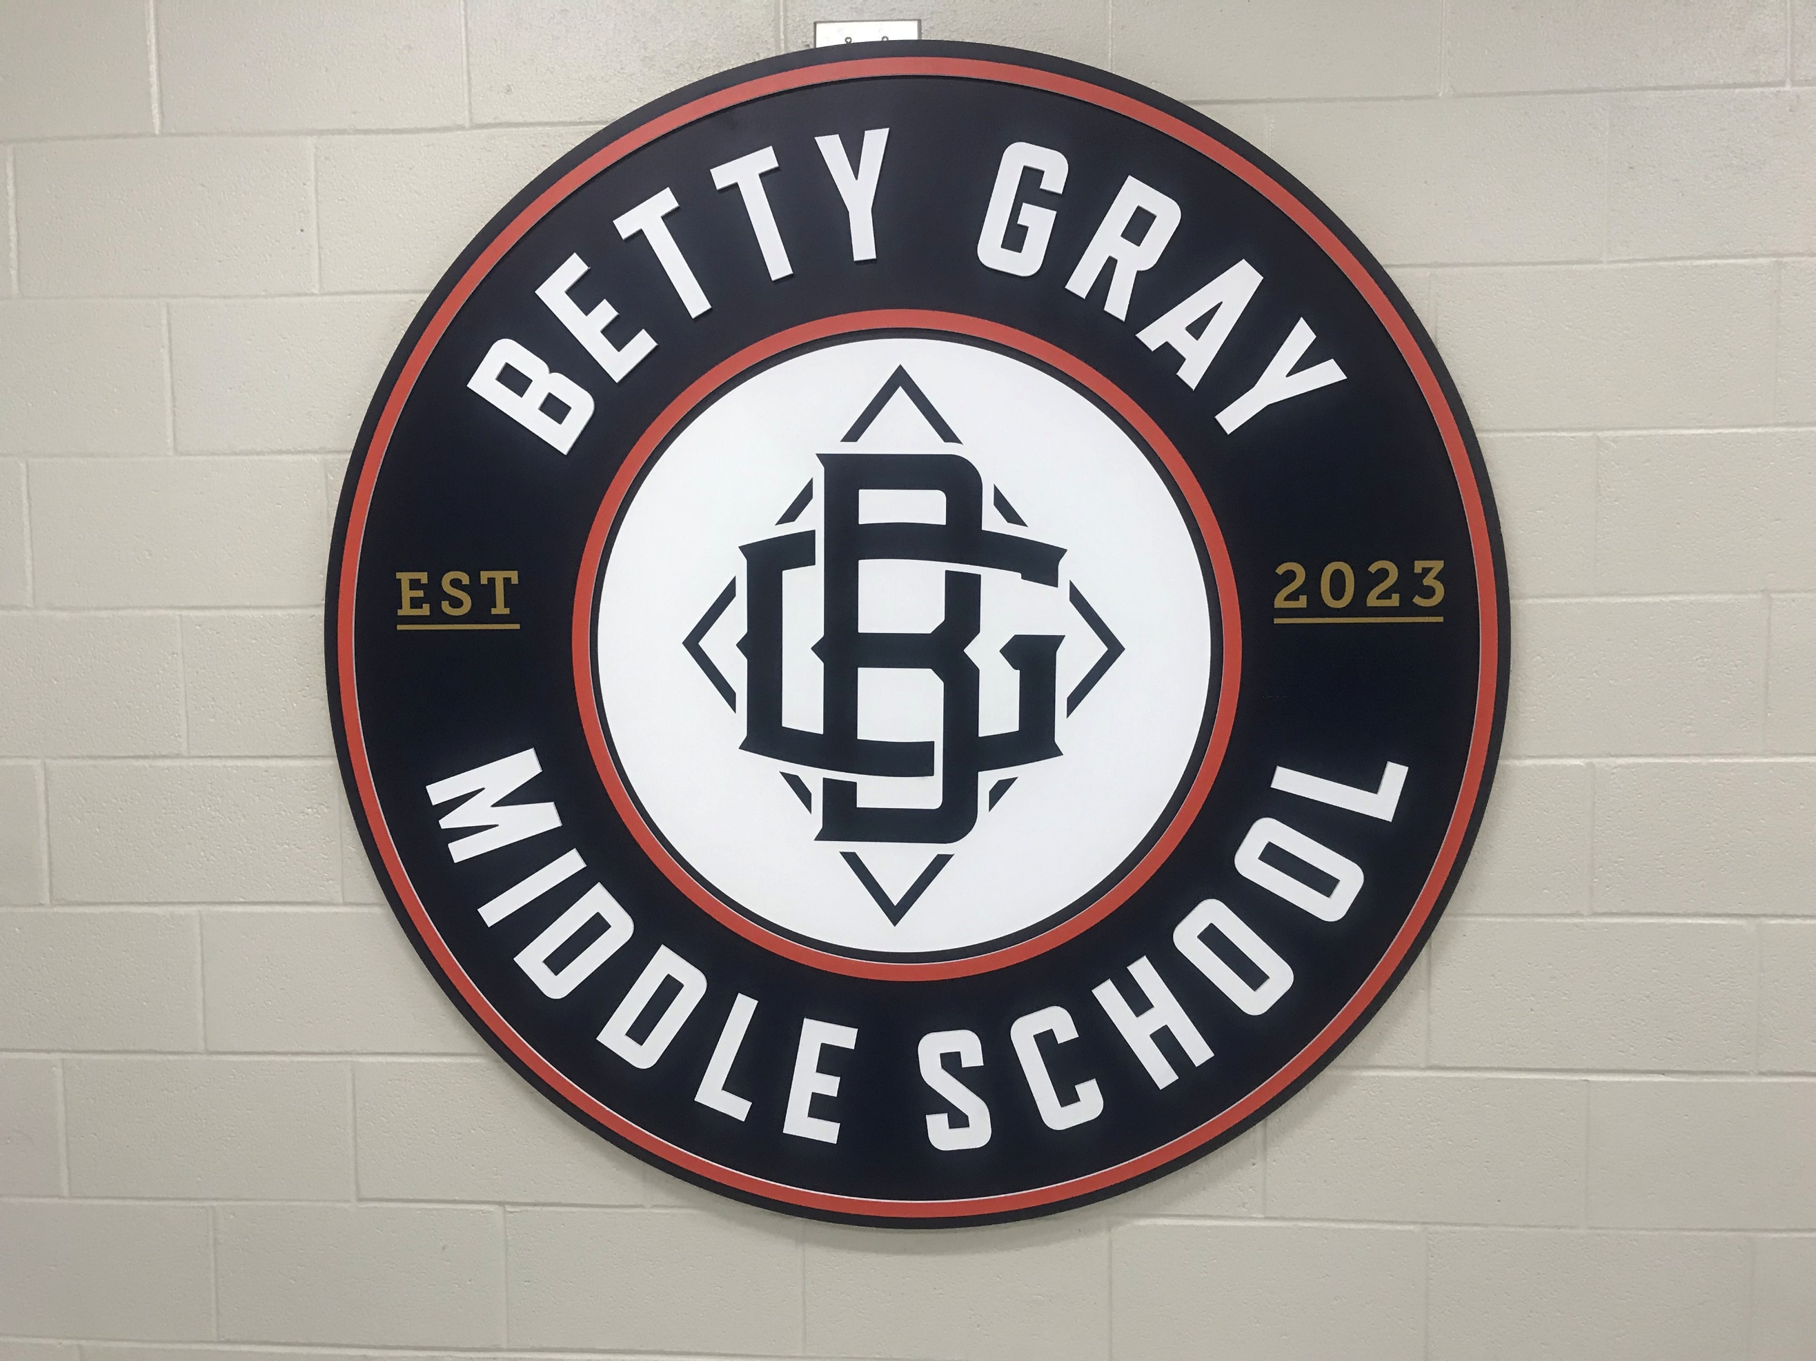

INSERT School related picture, photo, etc.

5

Teachers, Parents, and Students-Together for Success
District Goals for Student Achievement
• By SY29, increase growth by 2 percentage points, for students scoring at the proficient and distinguished levels, as evidenced by state assessments.

• By SY29, increase graduation rate from 89% to 91% as measured by GaDOE adjusted cohort graduation rate.
Betty Gray Middle School Goal(s) for Student Achievement
- By May 2027, 15.9% of students to 20% of students will increase the level of achievement by 100 points on the ELA BEACON from fall to spring.
- By May 2027, 26.7% of students to 30% of students will increase the level of achievement by 100 points on the Math BEACON from fall to spring.
- By May 2027, Betty Gray Middle School will strengthen interdisciplinary STEM instruction through increased implementation of real-world application, problem solving, and mathematical modeling across core content areas as measured by successful attainment of Cognia STEM Certification

Visit Our Website:
https://www.cobbk12.org/BettyGray
 | Insert strategy/activity #3 Insert how parents will utilize  strategies/activities #3. | Insert how students will utilize strategies/activities with family members #3.

Betty Gray MS Teachers
Betty Gray MS Families
Betty Gray MS Students

Teachers will maintain updated CTLS Class Tiles and landing pages aligned with current units of study as a form of communication

Families will check teachers’ class tiles on CTLS and ParentVue weekly to monitor daily/weekly progress and communicate any concerns to teachers to ensure success.
Students will be actives participants in the learning process by checking CTLS and StudentVue daily/weekly to monitor their individual progress and to take ownership of their learning.


Students will ensure their parents are well-informed by taking home all correspondences about opportunities for engagement and academic support.
Families will Participate in the Parent Engagement Boot Camp to gain the necessary skills and knowledge to support their students at home.
The STEM night will be offered to empower parents with necessary skills and knowledge to provide support at home.

Https//Bettygray@cobbk12.or

Visit Our Website:
https:/www.cobbk12.org/BettyGray

