**Betty Gray Middle School Activities to Build Partnerships**

Please consider joining us through some of the events listed below. Volunteer opportunities may be virtual or face to face.

**Volunteer Opportunities:**

* School Activities
* Media Center
* Title I Planning Committee
* Principal Advisory – PTSA

**Partnership Meetings:**

Annual Title I Parent Informational Meeting

Open House

Summer Meet and Greet

Title I Parent Input Meetings

Parent Teacher Conference Week

**Family Engagement Opportunities:**

Parent Workshop – Spring Curriculum Exhibit

Parent Resource Room

**What is a School-Parent Compact?**

Congue nihil imperdiet doming id quod mazim placerat facer minim veni am ut wisi enim ad minimeniam, quis erat nostr uexe

rci tation ullamcorper nostru exerci tation ullam corper et iusto odio dig nissim qui blandit praesent lupta. Tummer delenit

augue duis dolore te feugait nulla facilisi. Con erattis sectetuer adip iscing elit, sed erat diam nonummy nibh magna erat.

If you would like more information, please contact:

**Ms. Elaine Hill, Parent Facilitator**

770.819.2414 ext. 064 or

Elaine.Hill@cobbk12.org

**Jointly Developed**

The parents, students, and staff of Betty Gray Middle School worked together and shared ideas to develop the school-parent compact for achievement. Teachers suggested home learning strategies, parents added ideas to make them more specific, and students told us what would help them learn. Parents are encouraged to participate in the annual review process of the compact and make changes based on students’ needs. Parents are welcome to contribute comments at any time. Please contact Parent Facilitator, Ms. Elaine Hill at 770.819.2414 or elaine.hill@cobbk12.org to provide feedback.

*2024-2025*

*Betty Gray Middle School*

*School-Parent Compact for Achievement*

Grade 6th , 7th , 8th

*Revised July 12, 2024*



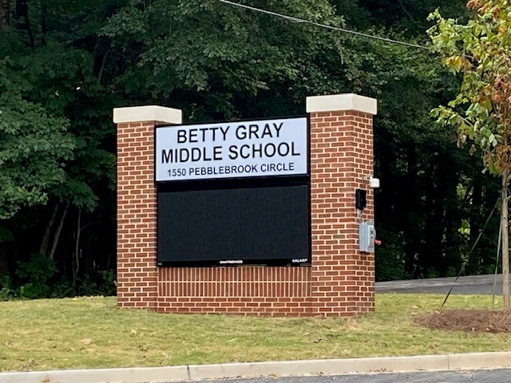

* CTLS Parent
* ParentVUE
* Weekly Emails/Calls from the Principal & Professors
* Student Agendas
* School Website
* Monthly Newsletters
* Email Blasts
* Parent/Teacher Conferences
* Facebook &Twitter
* Flyers
* District Website
* School Marquee

**Some communications may be provided virtually**

**Dr. I. Denise Magee, Principal**

**Denise.Magee@cobbk12.org**

**1550 Pebblebrook Circle**

**Mableton, GA 30126**

**770.819.2414**

**https://www.cobbk12.org/BettyGray**

*A School-Parent Compact is an agreement that parents, students, and teachers, develop together. It explains how parents and teachers will work together to make sure all of our students succeed. This compact includes strategies to help connect learning at school to learning at home.*

**Betty Gray Middle School Activities to Build Communication**

**Betty Gray Middle School Goal(s) for Student Achievement**

* Betty Gray Middle School will increase the percent of ELL and SWD student groups scoring at levels 2 or above in the vocabulary acquisition domain from 25% to 35% as measured by the 2024-2025 ELA End-Of-Grade Georgia Milestone assessment.
* Betty Gray Middle School will increase the percent of ELL and SWD student groups scoring at level 2 or above in the number systems domain from 23% to 33% as measured by the 2024-2025 Math End-Of-Grade Georgia Milestone assessment.

**District Goals for Student Achievement**

* By SY26, increase growth by 2 percentage points for students scoring at proficient and distinguished levels, as evidenced by state assessments.
* By SY28, increase graduation rate from 87% to 88% as measured by GaDOE adjusted cohort graduation rate.

**Visit Our Website:**

**https://www.cobbk12.org/BettyGray**

**BGMS Students**

Students will be active participants in the learning process by checking CTLS and StudentVue daily/weekly to monitor their individual progress and to take ownership of their learning.

Students will be activie participants in the tutoring sessions and learn to be self-advocates.



Students will ensure their parents are well-informed by taking home all correspondences about opportunities for engagement and academic support.

**BGMS Families**

Families will check teachers’ class tiles on CTLS and ParentVue weekly to monitor daily/weekly progress and communicate any concerns to teachers to ensure success.

Families will ensure students are taking advantage of tutoring services as needed.



Families will participate in the Parent University to gain the necessary skills and knowledge to support their students at home.

*One Team, One Goal, Student Success!*

**BGMS Teachers**

Teachers will maintain updated CTLS Class Tiles and landing page aligned with current units of study as a form of communication for families and students.

Teachers will provide face-to-face tutoring for identified students as needed and on-going in class interventions.



A Parent University will be offered to empower parents with necessary skills and knowledge to provide support at home.

*Teachers, Parents, and Students-Together for Success*