Birney Elementary School Spirit Wear Order Form
Show your Birney pride with our official spirit wear! Order your Birney Elementary T Shirt and Birney Car Magnet today.
WHILE SUPPLIES LAST

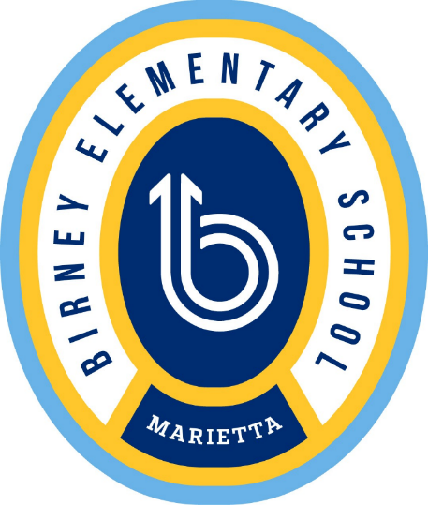

Car Magnet — $5.00 each
Quantity: ______ × $5.00 = $________

Birney T‑Shirt — $10.00 each
Size | Youth Quantity | Adult Quantity
Small | ______ | ______
Medium | ______ | ______
Large | ______ | ______
X‑Large | ______ | ______
Total Shirts Cost: ______ × $10.00 = $________

Order Total
Magnet Total: $________
T‑Shirt Total: $________
TOTAL AMOUNT DUE: $________

Student Information
Student Name: ________________________________
Teacher: __________________ Grade: ______
Phone/Email: ________________________________
Cash, Check or My Payments Plus. Make checks payable to Birney Elementary School. Orders will be sent home with students. Thank you for supporting Birney Elementary School!

