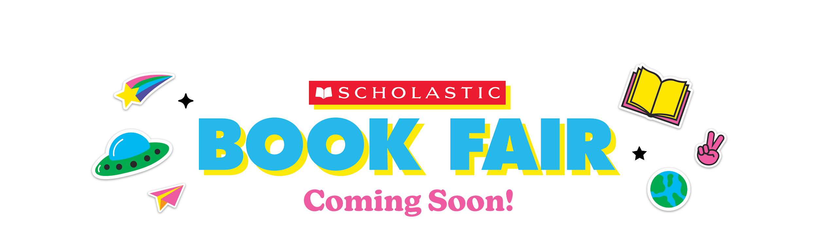Dear Parents and Families:

The Scholastic Book Fair is coming our way (YAY!). Choosing their books empowers kids and inspires them to become Bolder, Prouder, and Stronger Readers, AND—as always—every book they buy earns rewards for our library program.  Book fair earnings support 100% of the library’s trivia prizes given throughout the year including for October’s “Spooky Books Trivia” winners, for example. Books for Lunch Bunch Book Club and materials for Crochet Circle are also purchased using book fair funds as well as extensive instructional resources used during collaborative lessons between the library staff and classroom teachers including Breakout kits, manipulatives, and materials that make learning engaging and fun for Durham students.

This year’s Fair will take place from **Monday, March 18th – Friday, March 22nd, 2024** in the Durham Library.

You can say goodbye to cash and hello to **eWallet**—your child’s digital payment account. Before the Fair, set up eWallet for worry-free, cash-free purchases. Anyone can contribute! Share each child’s eWallet so friends and family can add funds and give your kids more books to enjoy.

If you can’t make it to the Fair, then **shop at our school’s Online Book Fair**. All online orders ship directly to your home, and shipping is free for book orders over $25. Your online orders will also benefit our school.

Visit our Book Fair homepage to learn more and get started with eWallet and online shopping:

<https://www.scholastic.com/bf/durhammiddleschool1>

The countdown to more Bookjoy is on! Catch you at the Fair!

Happy reading, and many thanks for your support,

Mrs. Erin Baker

Library Media Specialist

Durham Middle School

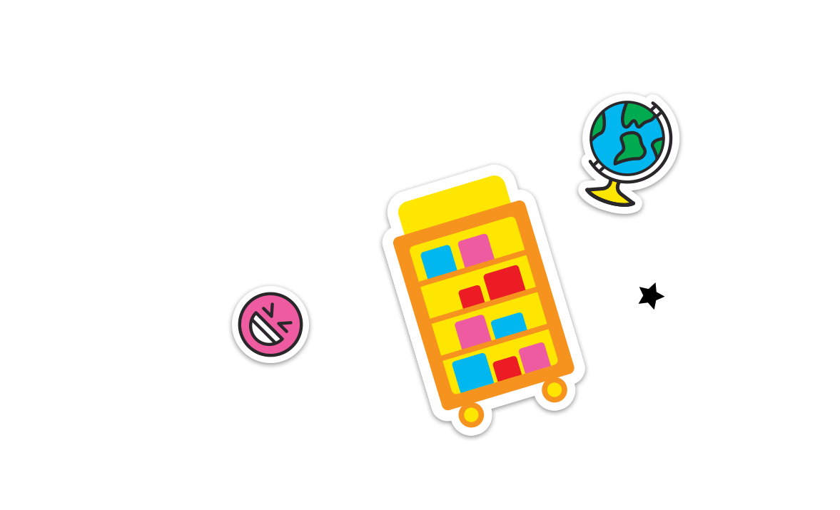

Permission to reproduce this item is granted by Scholastic Book Fairs®.©2022 Scholastic Inc. All rights reserved. 2580250 F22 • 2579757