School Is Almost Here: Is Your Bus Rider Registered?

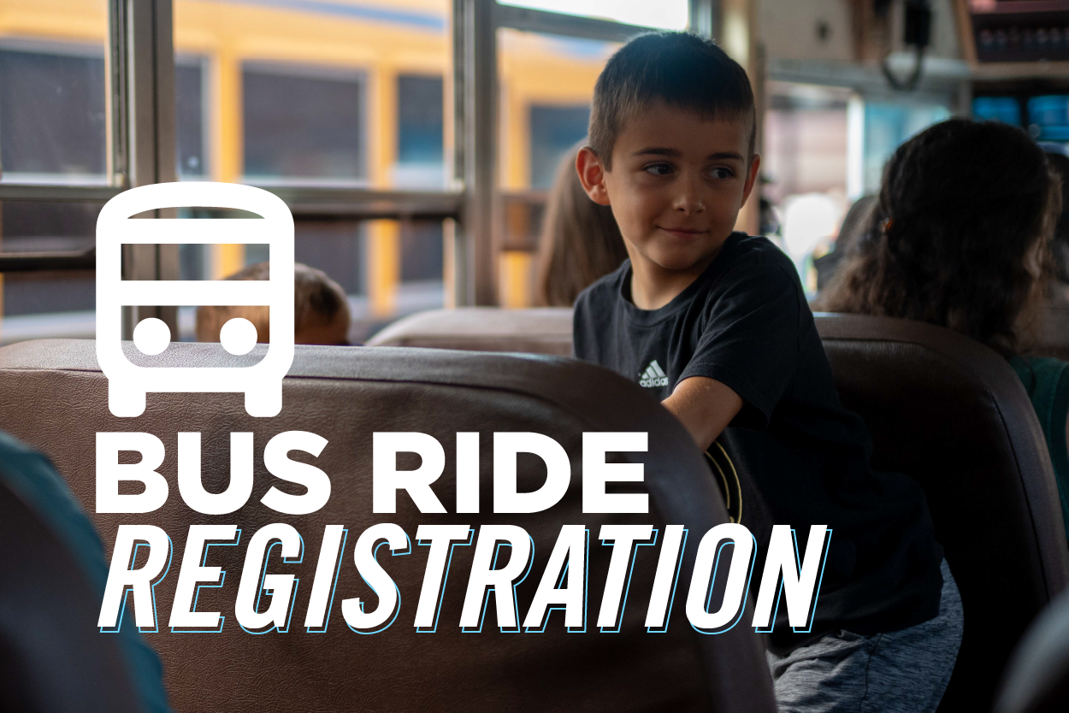
★ HOW DO I REGISTER MY BUS RIDER?
Step 1: Download Edulog and create your account:
DOWNLOAD FOR IPHONE →

DOWNLOAD FOR ANDROID →
- Open the app and create an account (or sign in if you already have one)
- Verify your email/phone number if prompted
- In the menu/settings area, select Transportation (or Bus Information)
- Choose Add Student (or Link Student)
- Enter your student's information exactly as it appears in school records (ex: student ID and/or date of birth, depending on which is expected)
- Confirm the student profile, then allow notifications so you can receive important transportation updates
- Repeat these steps for each student you'd like to add
Step 2: Fill out the Safe Rider Form:
SAFE RIDER FORM →
- Use this link above to enter the SRP page
- Sign in using your Edulog Parent Portal credentials
- Enter your student's district ID and select “Look up student”
- Confirm your selected student's name, school, and district ID are accurate and select “Continue”
- Read and understand the Safe Rider Program, check the confirmation box, and select “Continue”
- If your student is 8 or under, complete the Release Consent and then select “Review & Submit”
- Review the details and select “Submit Consent”

514 Glover Street · Marietta, GA 30060

