NOTE: Parents MUST provide transportation to and from School.
Camp Cooper 2026
Rising 6th Grade Summer Camp
COST: FREE!

 Tuesday, May 26 - Friday, May 29 8:30 a.m. – 11:30 a.m.
__________________________________________
Plan to attend our Rising 6th Grade Summer Camp.
This will be an opportunity for students to:
Participate in fun activities
Meet some of our teachers and staff

Get a jump start on Middle School schedule

Meet fellow students

Practice opening your Locker

Parents interested in registering their child/children should go to the Cooper Middle School website: www.cobbk12.org.cooper the link will be available on March 25th, 2026

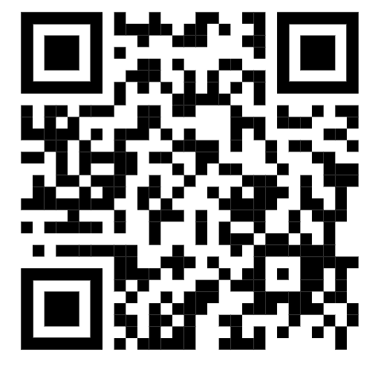

The deadline to sign-up is Wednesday, April 30, 2025
Space is limited.
For more information please e-mail: Rosana.machado@cobbk12.org
Parent Night is Wednesday, March 25th at 6:30 – 8:00 p.m. at Cooper MS

