Cap and Gown Ordering

Every student participating in graduation must have a cap and gown that corresponds with their high school.
Graduation caps and gowns must be ordered at:
www.atlgrad.com

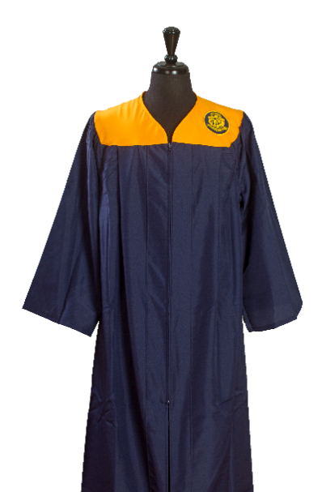

Graduates are expected to wear academic regalia available from the school’s graduation vendor. Commencement is a formal ceremony of prestige and honor. To ensure the decorum of the ceremony and to provide consistency among schools, alterations to the mortarboard and gown will not be permitted. Graduates may only wear stoles, cords, and other insignia authorized by the school. Men are expected to wear a collared shirt, dark dress slacks, dress shoes, and socks. Women are expected to wear dark dress slacks, a dress, or a skirt and a blouse. Flat shoes are recommended due to the distance graduates will walk from graduate parking to the line-up room and to the ceremony venue.

