**Bells Ferry’s Celebration of Nations 2022!**

Calling all Bells Ferry families to join us **OUTDOORS** this Spring to celebrate all the little seeds of different cultures and nations that have sprouted and are cherished in Bells Ferry Elementary’s 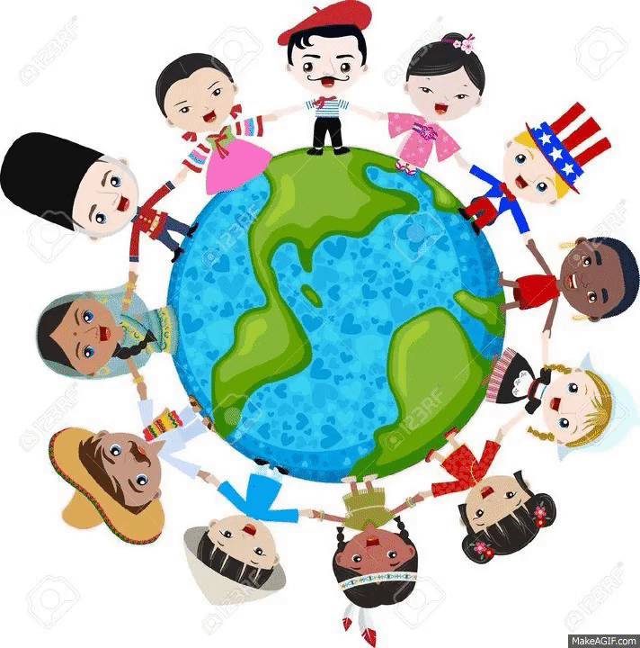soil!

**Date: Friday, March 25th, 2022**

**Time: 6:00-7:30 pm**

**Place:** School Playground/Track area

**Wear:** Any special traditional clothing or colors that represent your cultural background/flag

**Bring:** A picnic blanket to sit on & enjoy the performances after your “travels” around the world!

**Would you like to showcase your culture with a Table Display? Sign up by 3/15**

Please sign up here if you would like to display your nation’s art, clothing, music, crafts, pictures, flag, and/or cultural artifacts at a display table. No food at your display, please.

[**Click this link**](https://www.signupgenius.com/go/508094CAEAB22A6F85-celebration) or Scan the QR code below



**Are you a performer? Here is your chance! Sign up by 3/15**

Sign up here and wow us with your cultural music, dance, sport, drama, or story!

We would be happy to have all members of the family join in the performance. If any parents, older siblings would like to perform, we would love to see you, too!

[**Click this link**](https://www.signupgenius.com/go/508094CAEAB22A6F85-celebration1)  or Scan the QR code below



**We will have a concession stand selling pizza slices and water bottles for $1 each! Come hungry!**

**We look forward to seeing you there! Please wear your traditional cultural attire, if you would like, for this outdoor event with dance, music, culture, art, and lots of fun!**