  - Cobb County School District
  - •
  - 4605 Ewing Road Austell, GA 30106
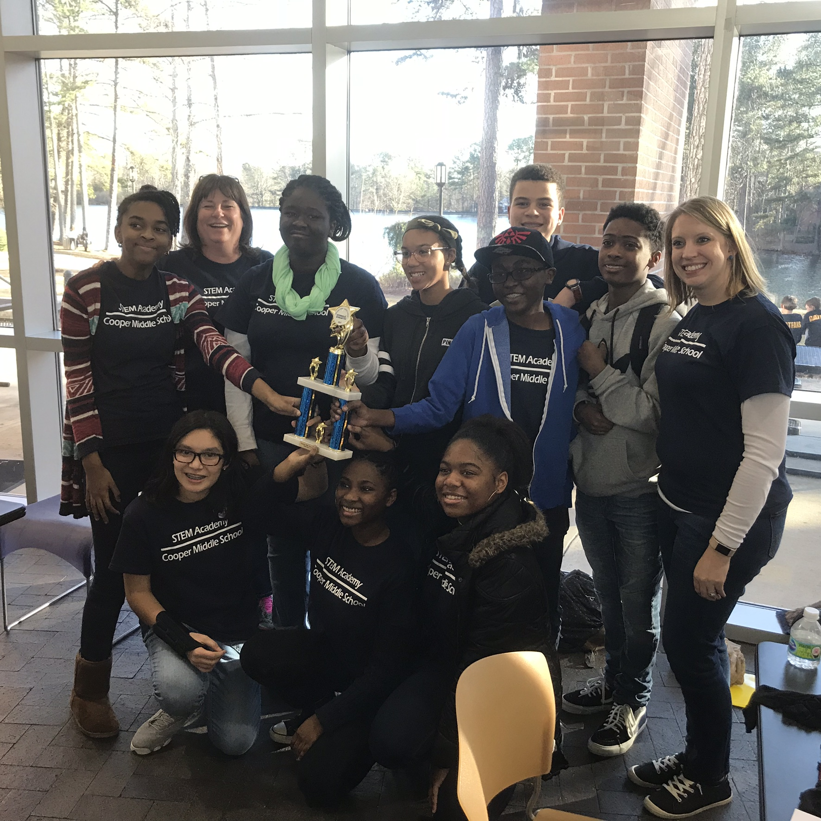  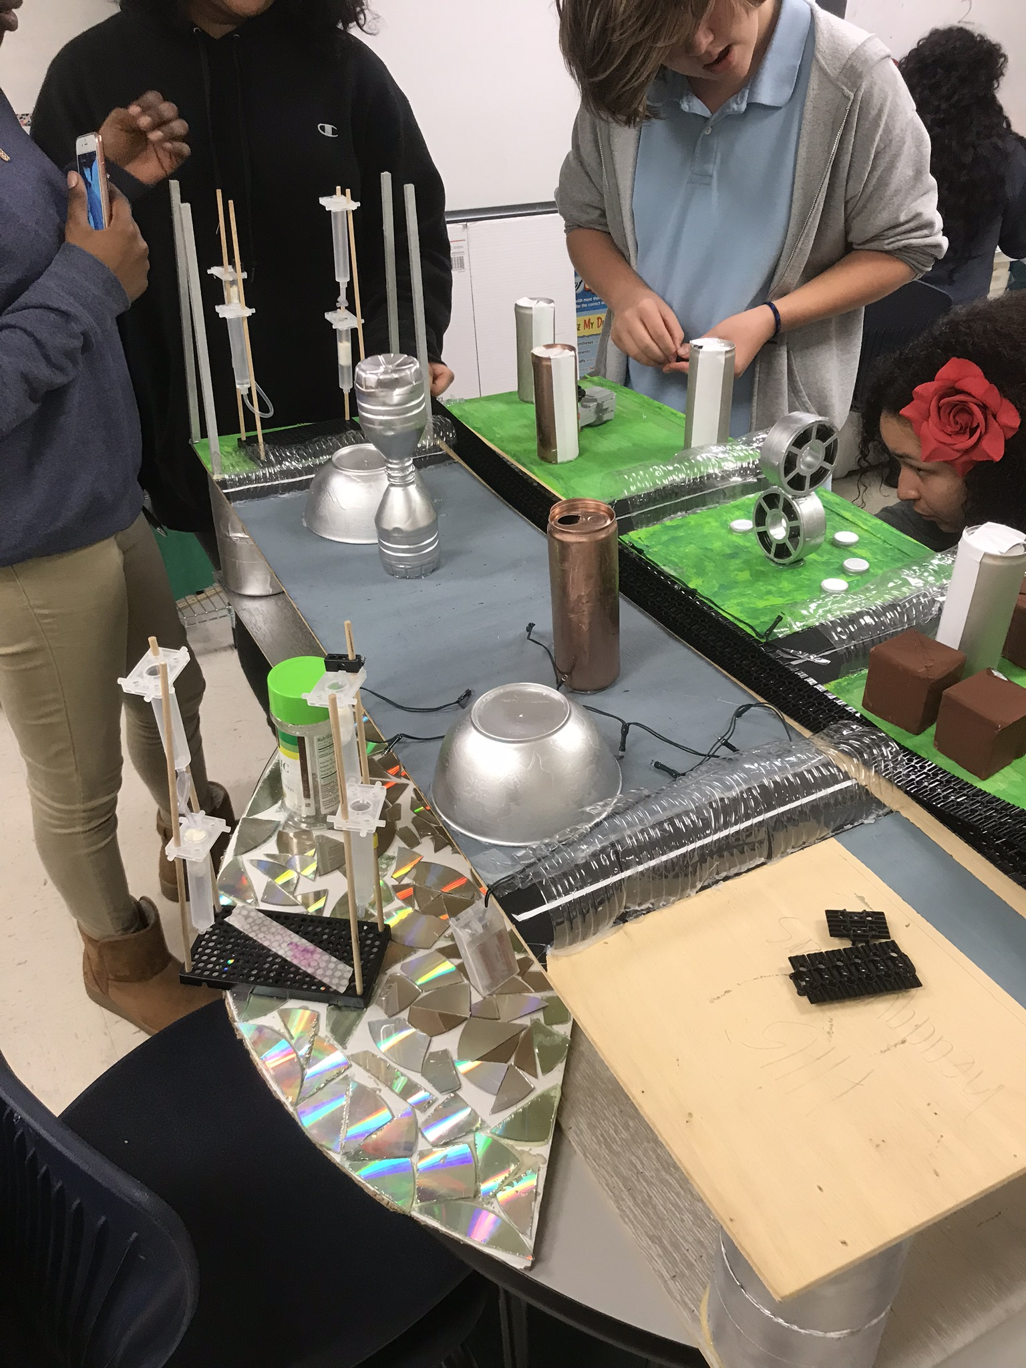  About Us  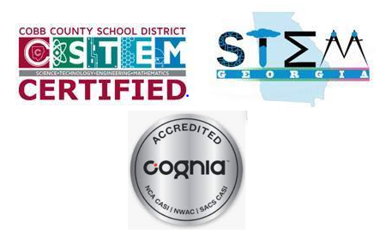  The Cooper STEM Academy was established in 2013 to inspire, support and engage students in engineering through enhanced math and science experiences. In 2016 Cooper STEM Academy received Cobb County STEM certification. In 2017 the STEM Academy was awarded state STEM and Cognia certification. The STEM Academy provided rigorous cross-disciplinary curriculum among all content areas. The Academy exposes students to various engineering design projects and challenges during a specialized STEM enrichment block. All Cooper students have access to STEM enrichment within multiple connections classes such as career development, art, audio and visual programming, health sciences and performing arts. The Cooper STEM academy works with multiple community partnerships to provide relevant local Problem Based Learning experiences throughout the year. | 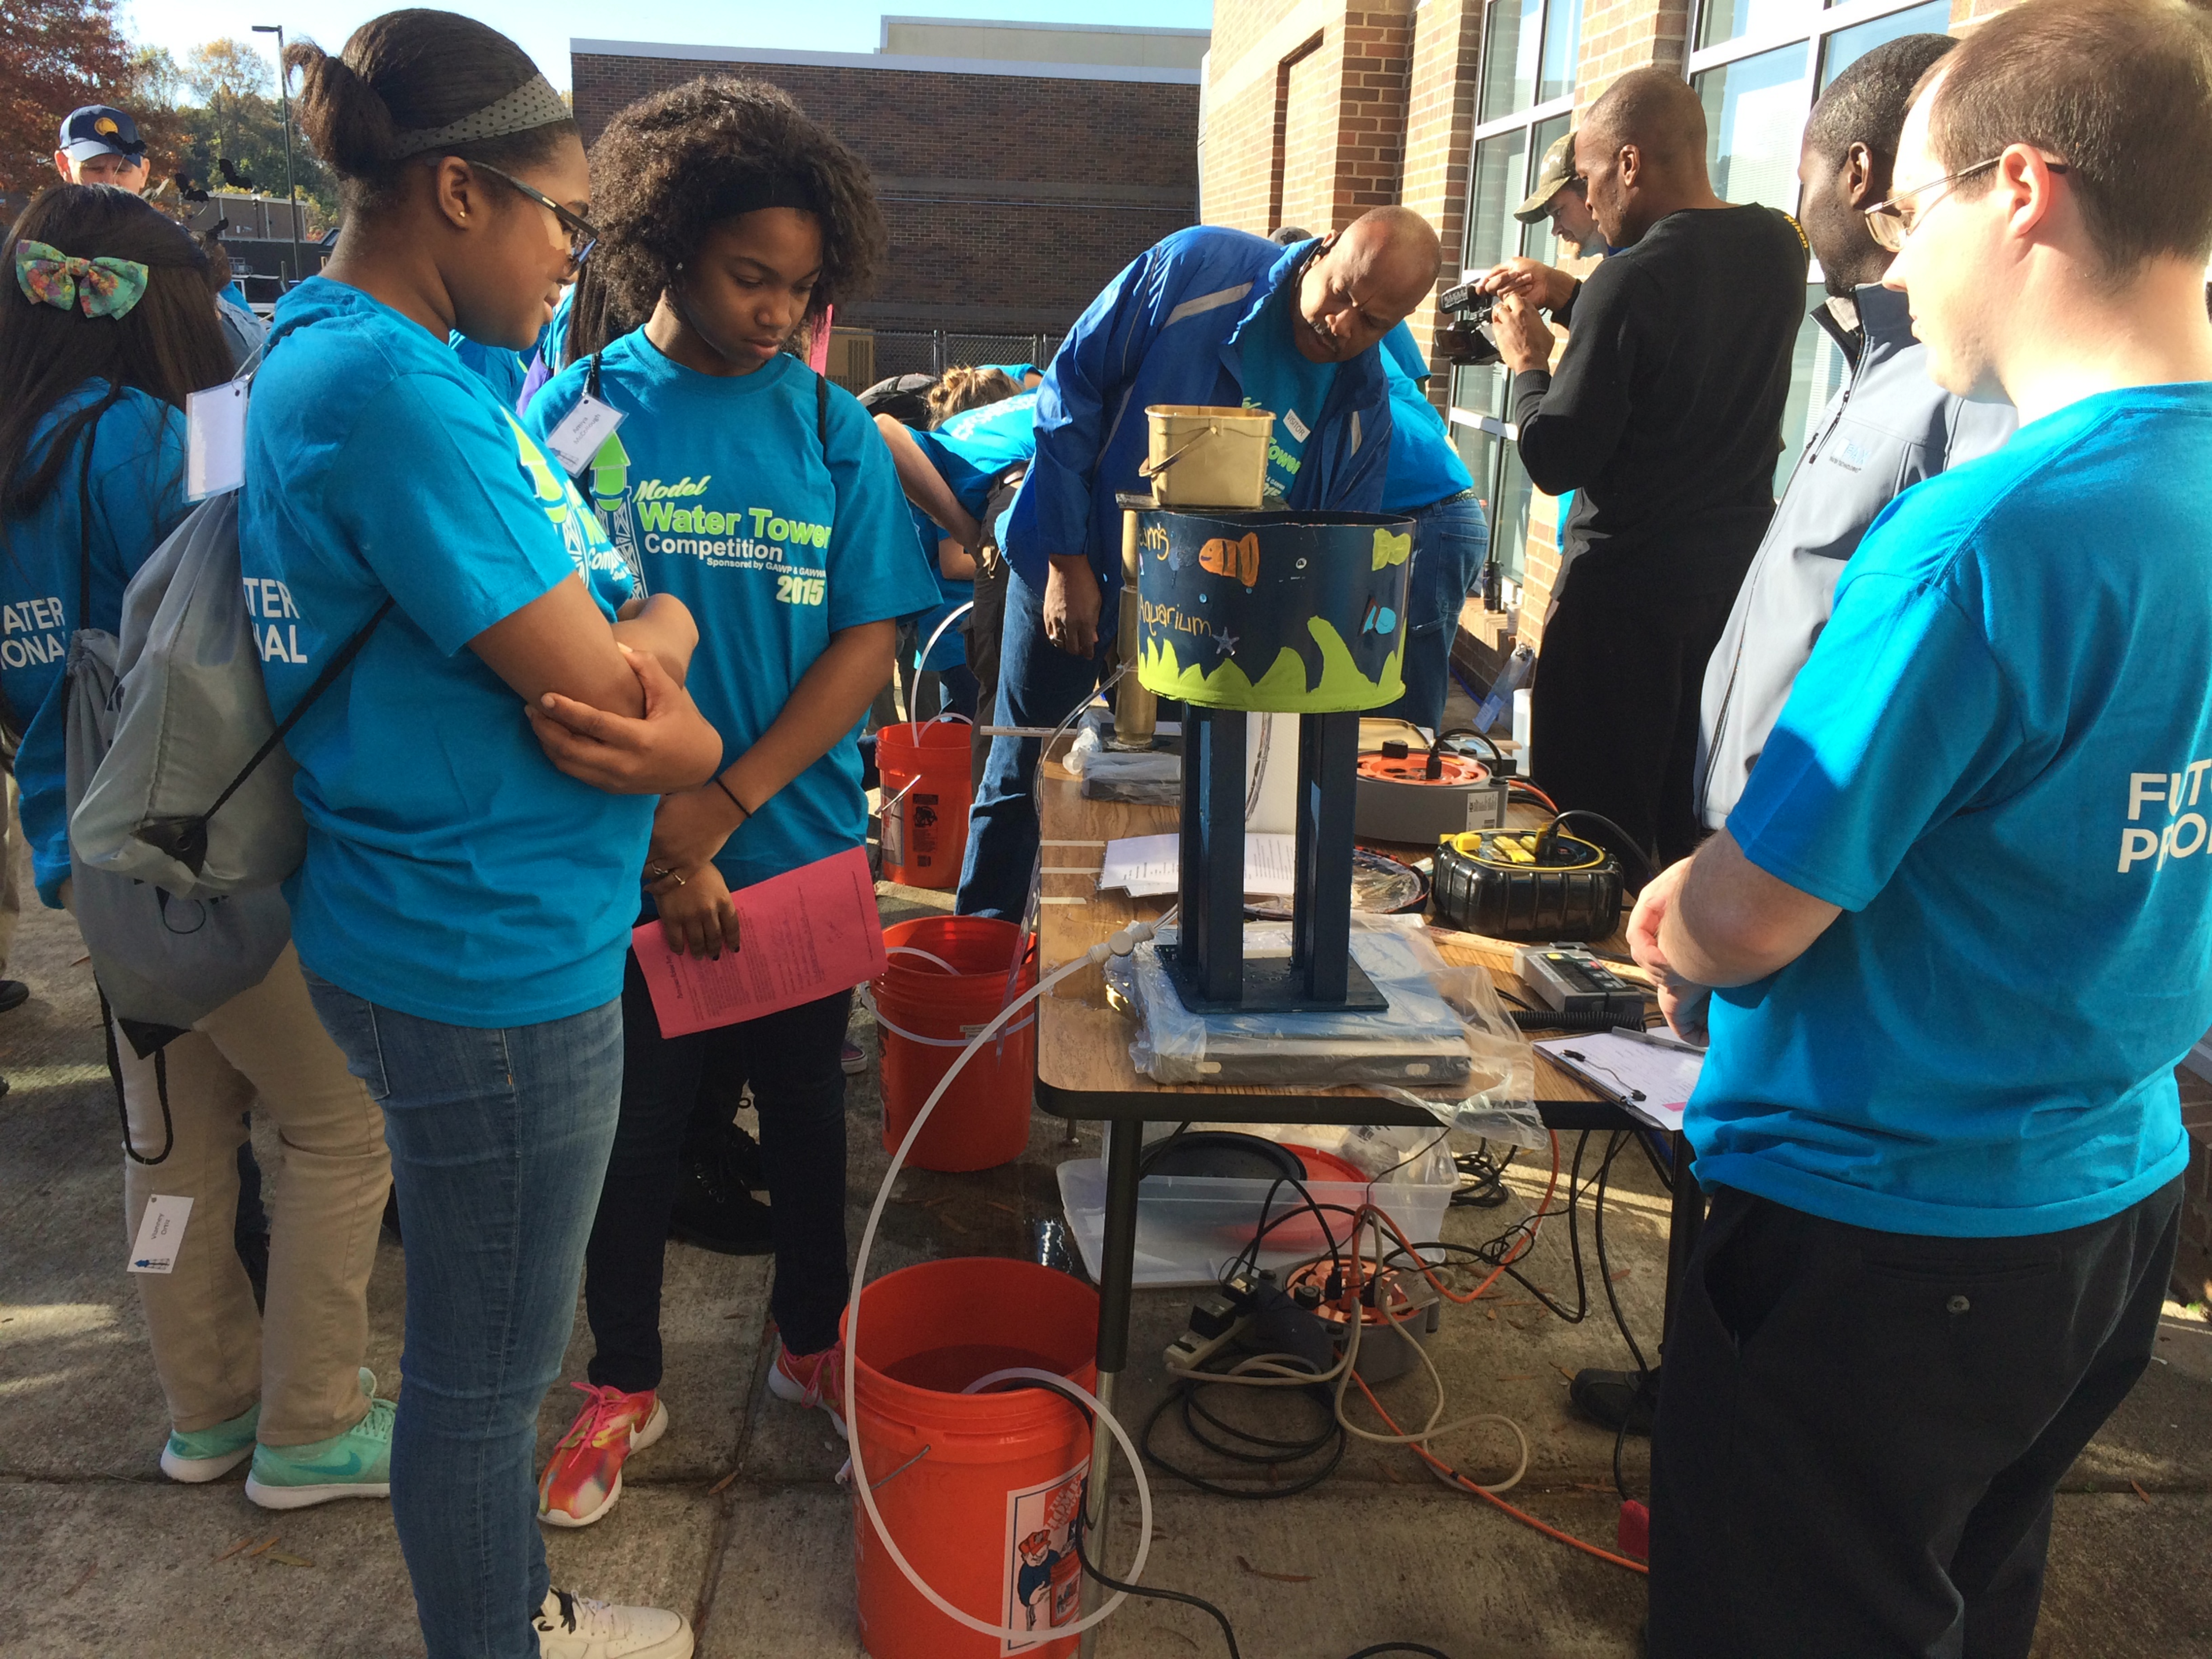  Partnerships  Cobb Water  Colonial Pipeline  GATech  CERM  StarBase  Follow Us  cooperstemacademy.weebly.com  Twitter: @CooperSTEMAcad  STEM Director  Stephanie Ruffner  770.819.2438  Stephanie.ruffner@cobbk12.org

Academy Set Up
Sample Schedule  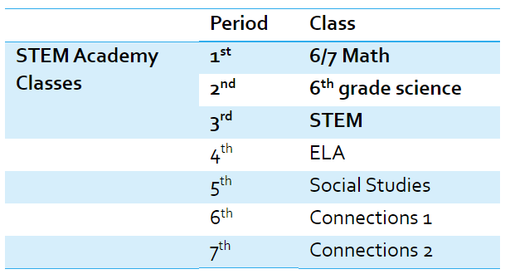 |  | Course Progression
Sample Curriculum
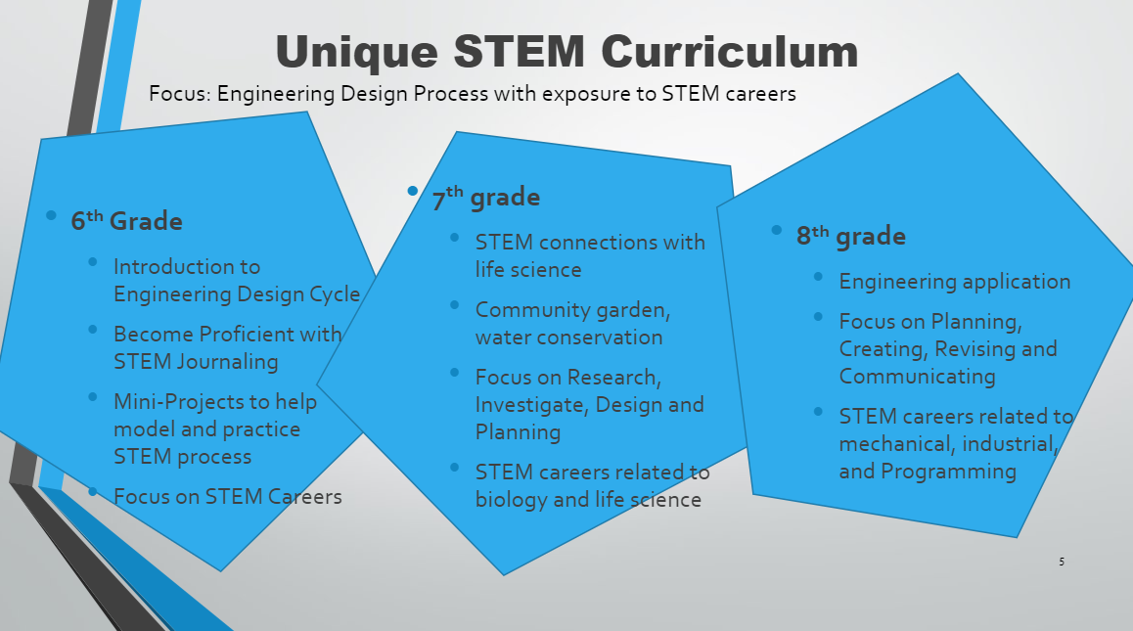
Requirements
6th grade | 7th grade |  | 8th Grade
- Math Inventory Score- 710 minimum  - Math Milestone Score- 525 minimum  - Science Milestone Score- 475 minimum  at end of 5th grade  and  maintain 80% or higher in Math and Science | - Math Inventory Score- 820 minimum  - Math Milestone Score- 525 minimum  at end of 6th grade  and  maintain 80% or higher in Math and Science |  | - Math Inventory Score- 980 minimum  - Math Milestone Score- 525 minimum  at end of 7th grade  and  maintain 80% or higher in Math and Science
Complete Interest Survey by April 18, 2024
https://forms.office.com/r/Mr4BEg7v4k

