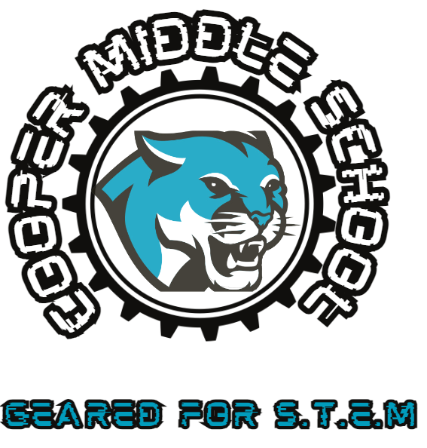 | - Cobb County School District  - •  - 4605 Ewing Road Austell, GA 30106
    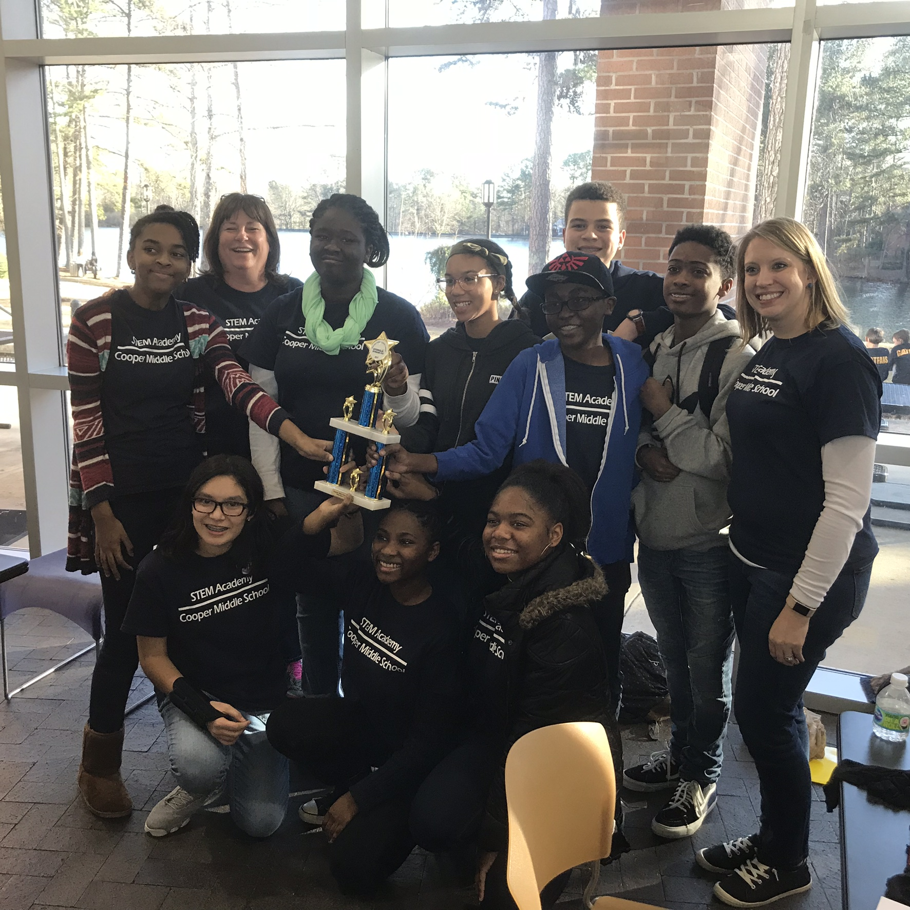  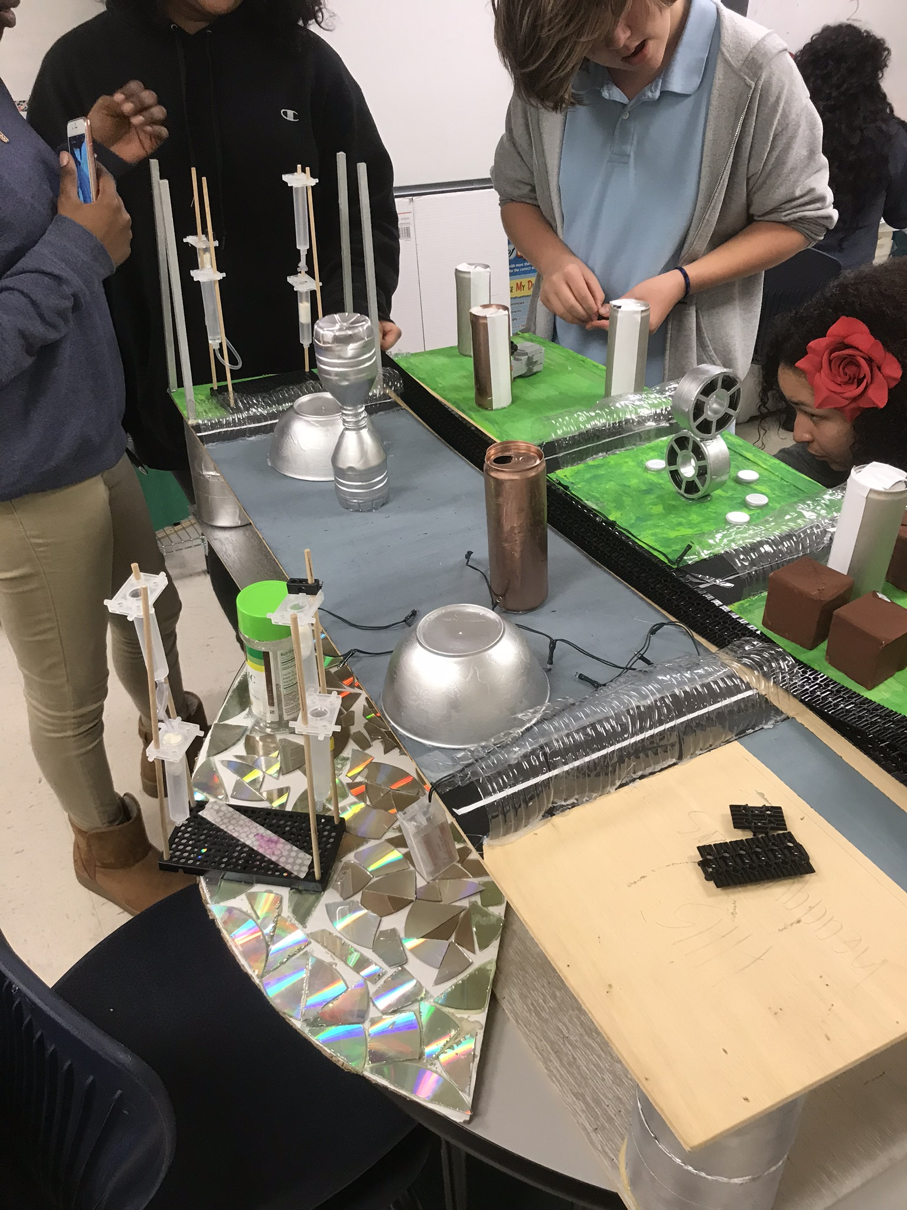  About Us  The Cooper STEM Academy was established in 2013 to inspire, support and engage students in engineering through enhanced math and science experiences. In 2016 Cooper STEM Academy received Cobb County STEM certification. In 2017 the STEM Academy was awarded state STEM and Cognia certification. The STEM Academy provided rigorous cross-disciplinary curriculum among all content areas. The Academy exposes students to various engineering design projects and challenges during a specialized STEM enrichment block. All Cooper students have access to STEM enrichment within multiple connections classes such as career development, art, audio and visual programming, health sciences and performing arts. The Cooper STEM academy works with multiple community partnerships to provide relevant local Problem Based Learning experiences throughout the year. | 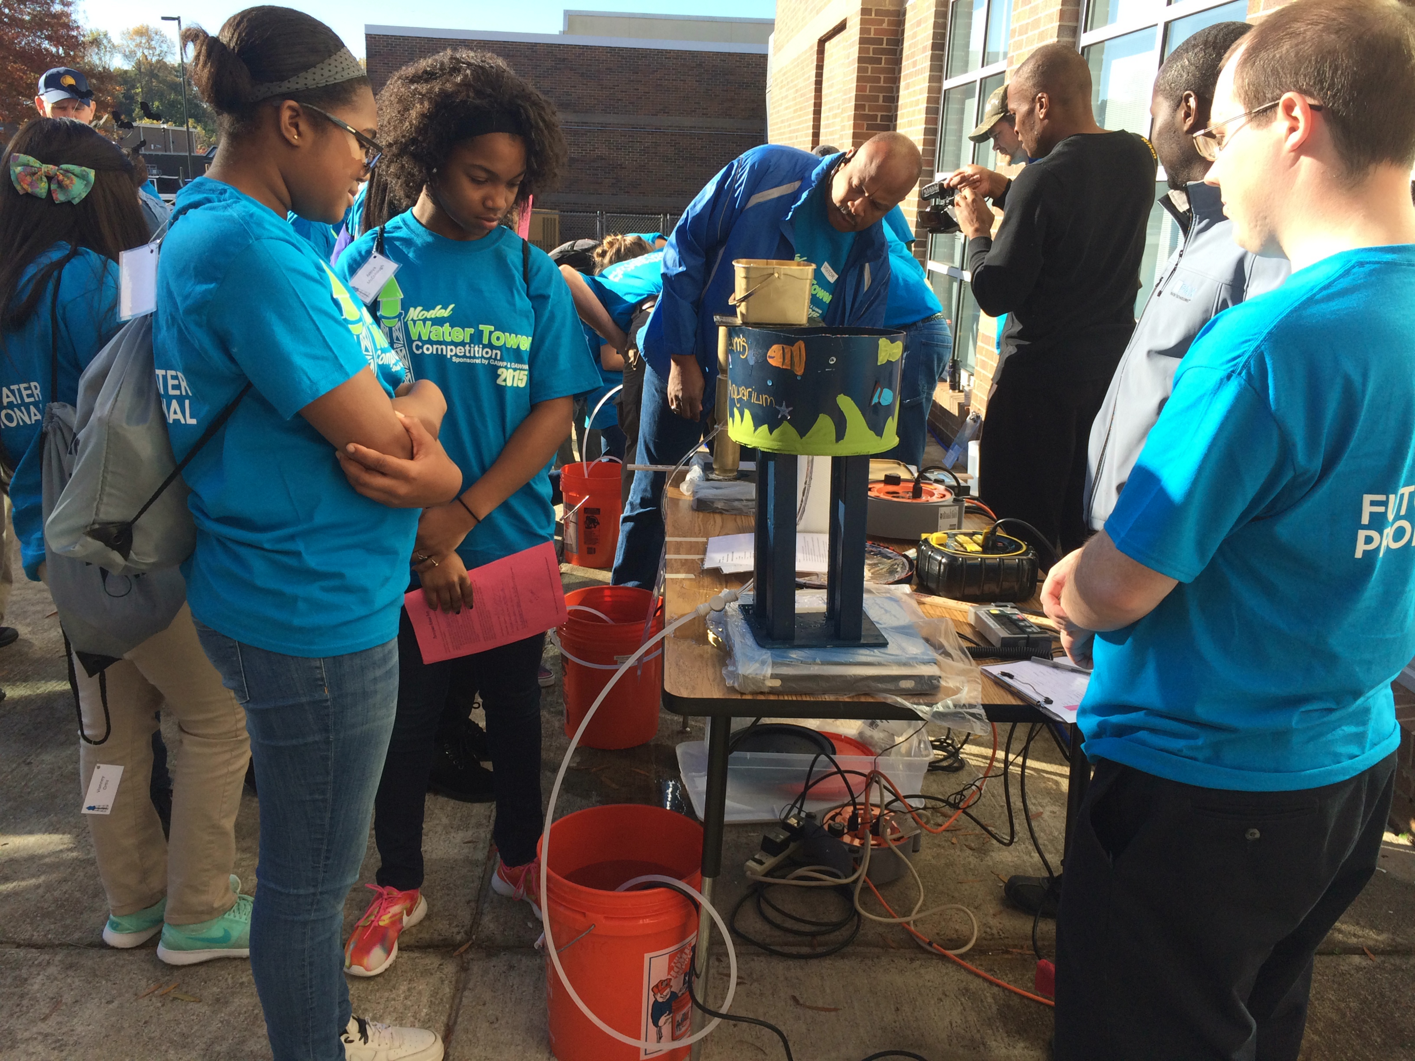  Partnerships  Cobb Water  Colonial Pipeline  GATech  Follow Us  cooperstemacademy.weebly.com  Twitter: @CooperSTEMAcad  STEM Director  Stephanie Ruffner  770.819.2438  Stephanie.ruffner@cobbk12.org

Academy Set Up
Sample Schedule  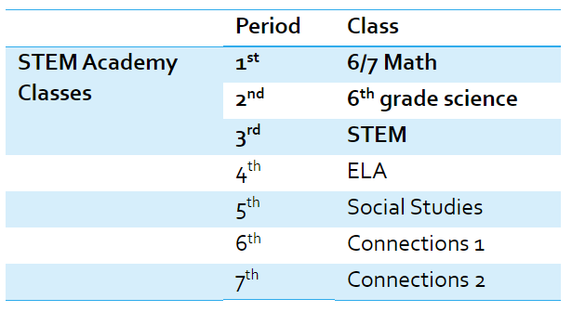 |  | Course Progression
Sample Curriculum
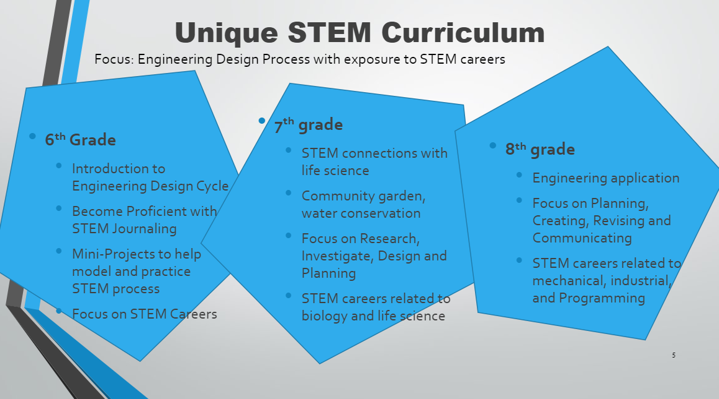
Requirements
Rising 6th grade | Rising 7th grade |  | Rising 8th Grade
- 5th grade Math Milestone Score must be in the top 20% of entering 6th graders  - 5th grade Science Milestone Score must be in the top 20% of entering 6th graders  - maintain 80% or higher in Math and Science  - Must complete the STEM interest survey | - 6th grade Math Milestone Score must be in the top 20% of entering 7th graders  - Completion of 6/7 math and 6th grade science (and STEM, if in the Academy in 6th grade) with 80% or higher  - Must complete the STEM Interest survey |  | - 7th grade Math Milestone Score must be in the top 20% of entering 8th graders  - Completion of 7/8 math and 7th grade science (and STEM, if in the Academy in 7th grade) with 80% or higher  - Must complete the STEM Interest survey
STEM Interest Survey by Grade Level -complete by April 14, 2025
Rising 6th graders- https://forms.office.com/r/XXVKcgLau8
Rising 7th graders- https://forms.office.com/r/Z906pDy89U
Rising 8th graders- https://forms.office.com/r/xRmPXXzedG

