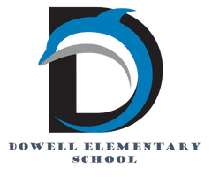
Dolphin Weekly
Sunday, January 11, 2026


Save the Date!

Wednesday 1/14
- 4th Grade Fairytales Performance
Monday, 1/19
- MLK Jr. Day/No School
Wednesday, 1/21
- Safety Village visits Kindergarten classes
Thursday, 1/22 *100th Day of School*
- Cosmic Bowling, Science Fair & Math Night
- 2nd Grade Safety Village
Thursday, 1/29
- 3rd Grade - Tellus Museum
- 7:50 AM PTA General Meeting



From the Principal's Desk
💙 A Great Start to 2026 at Dowell! 💙

Dowell Families,
We have had a wonderful first week back, and it has been such a joy welcoming our students into the building as we kicked off 2026 together! Smiles, routines, and learning returned quickly, and our classrooms are once again buzzing with thinking, collaborating, questioning, and discovering.

Thank you for your continued partnership and support. We are grateful to work alongside such a caring and involved community of families. We can’t wait to see many of you at Cosmic Bowling Night and throughout the exciting months ahead. Let’s make the rest of 2026 a successful and joyful journey for all of our Dowell Dolphins! 💙🐬

With appreciation,
Dr. Pam Cain
Principal


----------------------------------------------------------------

Reminders:
- ID Requirement: A picture ID is required every time you visit the school. Please show it to the camera at the right front door and press the button (door bell). A staff member will confirm your reason for visiting and verify your child’s information before buzzing you in. Upon entry, always go straight to the front office.
- Visiting for Lunch? You’re welcome to sit with your child in the cafeteria during their lunch time. We kindly ask that you not bring fast food or restaurant meals, as it’s not fair to other students. Please check out at the front office after your visit.
- Do NOT Enter: For student and staff safety, please do not use the DO NOT ENTER/Buses Only entrance during AM or PM carpool.

Family Survey Announcement
Dear Parent or Guardian,
Dowell Elementary School will take the new Georgia School Climate Survey this year. Each parent or guardian is invited to take the family version to answer questions about the current school or schools you have a child or children attending. If two or more children attend the same school, please only complete one survey for that school.
The survey measures what you think about how the school engages with families. Answers are not linked to names in any way. When typing answers, please do not give names or information that you don’t want to share with this school. Data will be shared with school leaders to help improve the school and will be published on the GaDOE website.
Please help by sharing your honest opinion on this 22-question survey. T
If you have any questions about the survey, please contact Dr. Clark at Tina.Clark@cobbk12.org.

Take Survey Here

Dowell Steppers: Sign Up Now!
We’re putting together a student step team for Black History Night, and we want kids who are ready to try something fun and high-energy. No experience is needed. Just enthusiasm and a willingness to jump in.

Students will learn the basics of stepping, work as a team, build confidence, and pick up some seriously cool moves along the way.

Sign-Up Deadline: Monday, January 12 at 8:30 pm.

Practice Dates:
January 13, 20, 27
February 3, 10, 24

Time: 2:45 to 3:45 pm

If your child wants to be part of something exciting and full of school spirit, this is the perfect chance. We can’t wait to see who signs up.

Sign up here

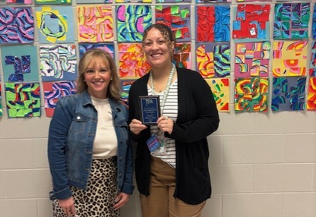
Congratulations
Congratulations to Ms. Ward for earning Teacher of the month and Mr. Sanford (not pictured) for earning Staff member of the month. We appreciate you and everything you do!

Classroom Celebrations Request Form
Dear Teachers/Parents/Staff,
Do you want to celebrate with your students but don’t have the time for all the planning and details? Return this request form to the Cafeteria Manager and leave the party to us! Upon receipt of the request form, we will provide you with a price quote for your party within 48 hours. On the celebration day, we take care of everything for you!

Please see attached form for pricing items and pricing.

Also if you plan on bringing in a treat for your child's birthday please fill out the attached cupcake form at least 24 hours in advance for the teacher and front office staff to be aware. This helps with planning and any allergies in the classroom.

Cosmic Bowling Night

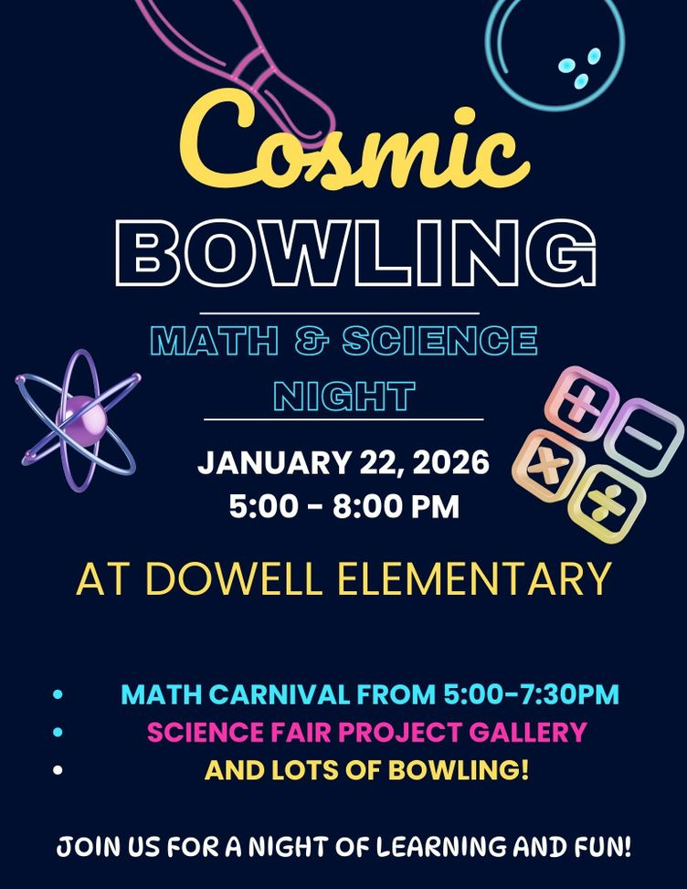
.
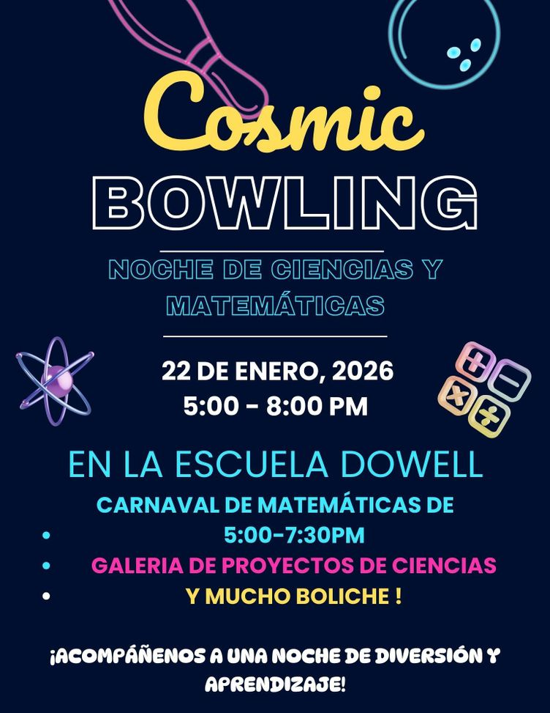
.

Dowell's Science Fair

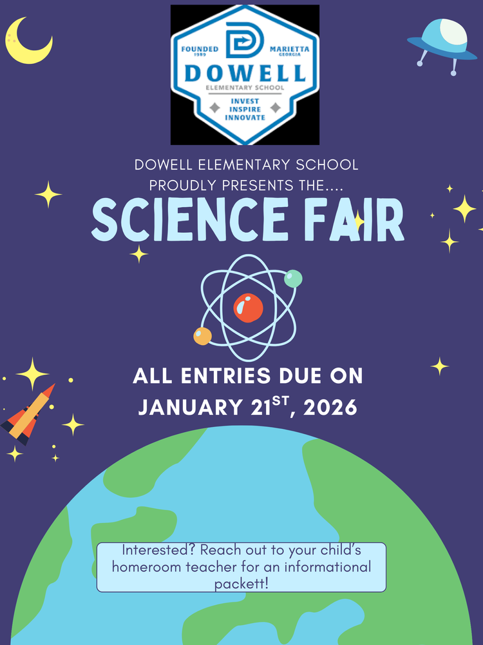

Girls on the run

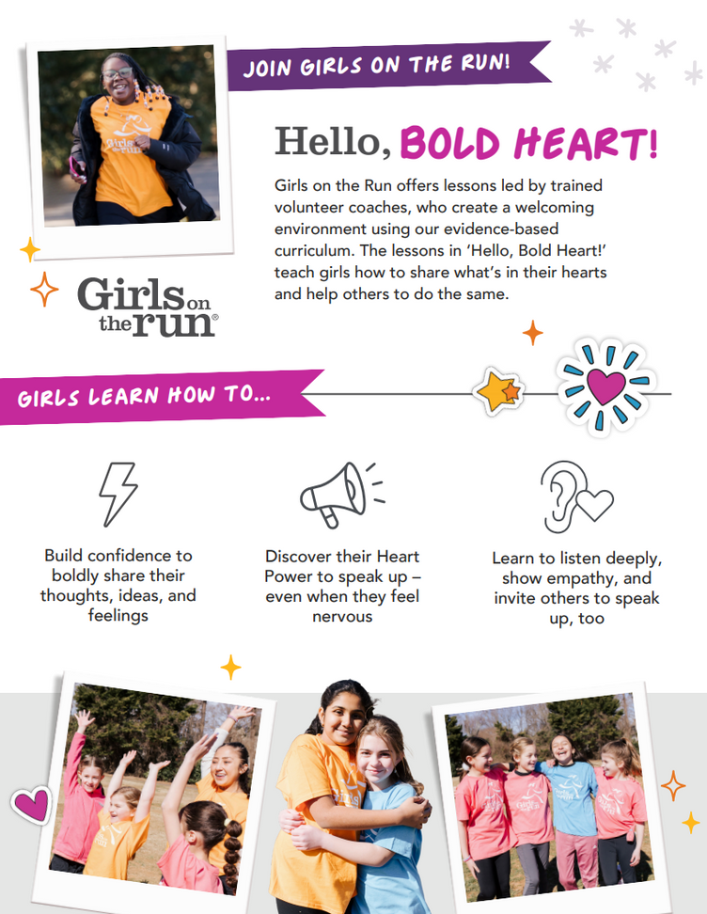
.
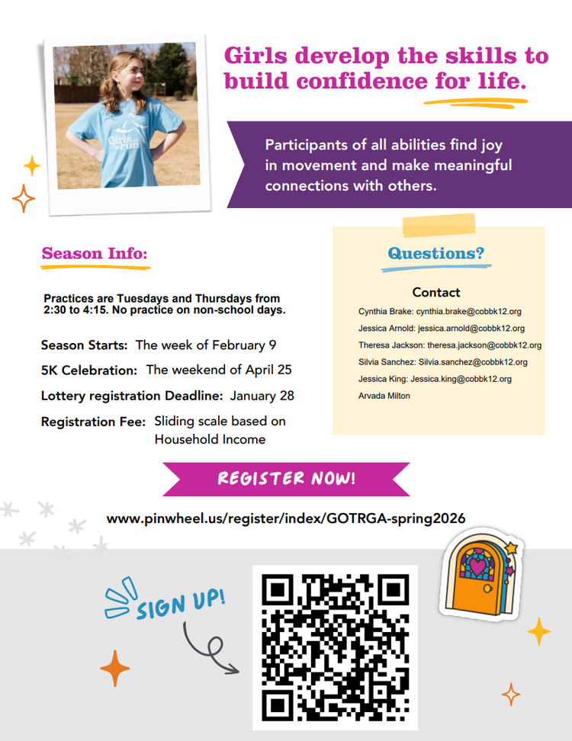
.

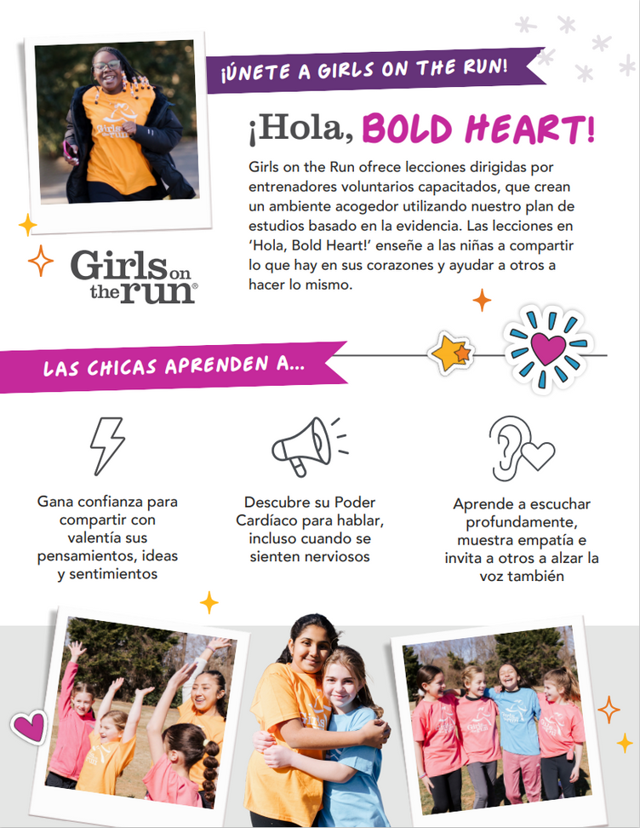
.
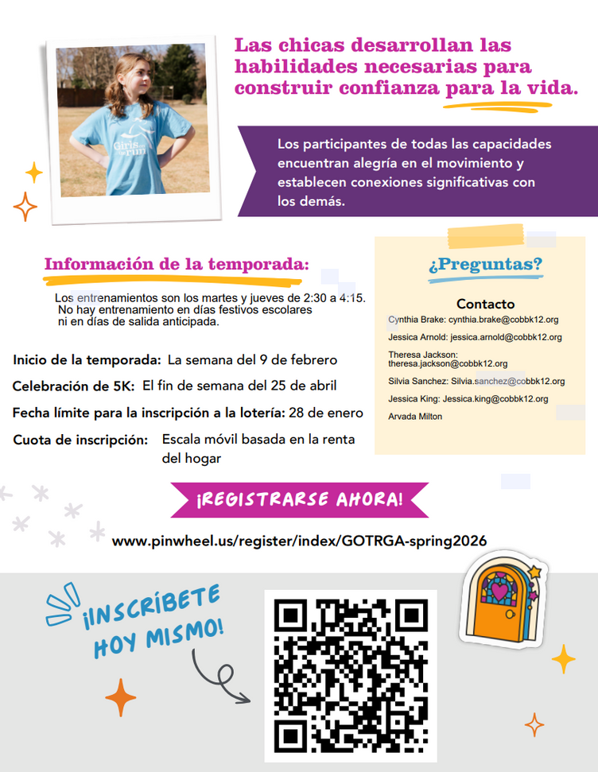
.

Community Events



Fun Club Registration is now OPEN!
Spring 2026 Registration Opens Soon! Please Visit https://www.funclubs.com/schools and Choose Dowell Elementary School to Preview Clubs that will be offered this coming semester!

📅 Mark Your Calendars! Sign-Ups are now Open!

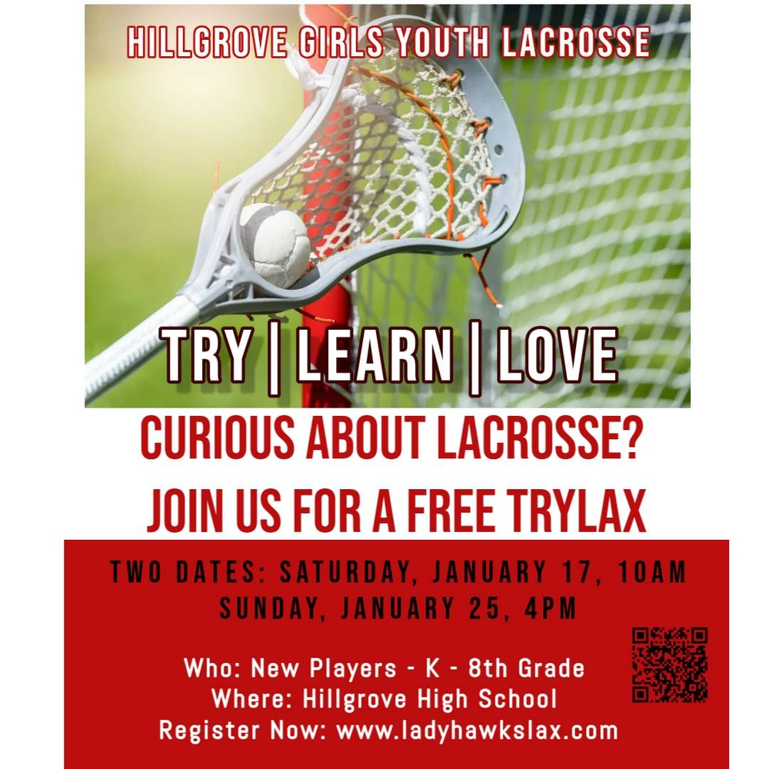

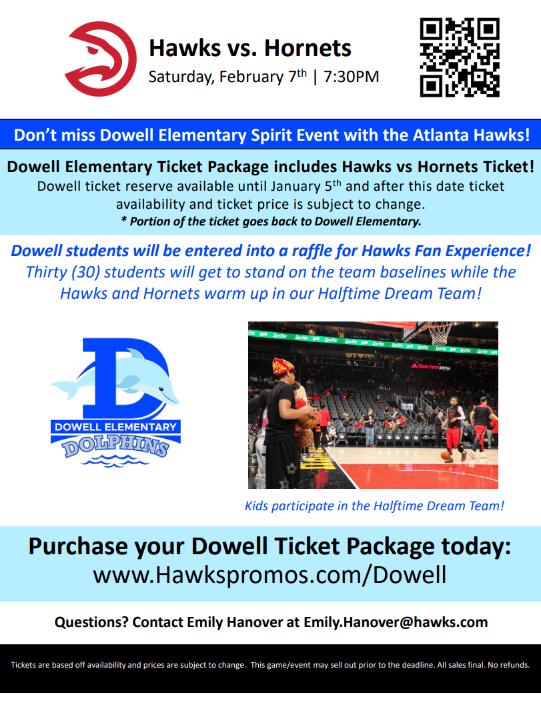

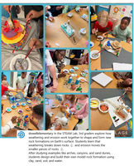
Follow us on social media.
https://www.instagram.com/dowellelementary

