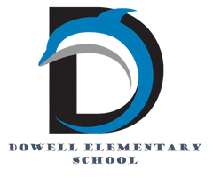
Dolphin Weekly
Sunday, January 4, 2026


Save the Date!
Tuesday, 1/6
- Students return to school
Friday, 1/9
- Terrific Kids: Compassion
Wednesday 1/14
- 4th Grade Fairytales Performance
Monday, 1/19
- MLK Jr. Day/No School
Thursday, 1/22
- Cosmic Bowling, Science Fair & Math Night
- 2nd Grade Safety Village

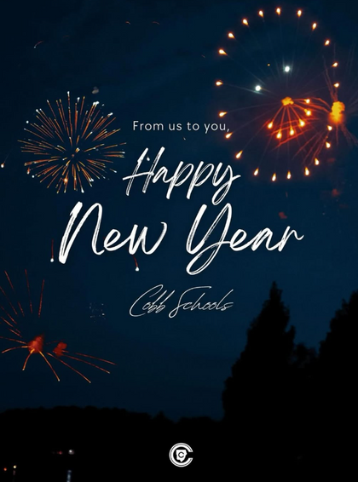

From the Principal's Desk
💙 Welcome Back & Happy New Year, Dowell Families! 💙

We hope you enjoyed a restful winter break filled with joy, connection, and special moments with family and friends. As we welcome our students back to Dowell, we are excited to begin a brand-new year of learning, growth, and possibility together. Happy New Year and welcome to 2026!

There is so much to look forward to in the months ahead. Our students will be participating in the American Heart Challenge during PE, promoting healthy hearts and healthy habits. We’re also excited about fun and engaging events like Cosmic Bowling and our upcoming Science Fair, where students will showcase their curiosity, creativity, and problem-solving skills.

Most importantly, classrooms are buzzing once again with new learning—filled with thinking, collaborating, questioning, and discovering. Our teachers are ready to challenge and support every student as they continue to grow academically, socially, and emotionally.

Thank you, as always, for your continued partnership and support. We are grateful to work alongside such an amazing community of families as we begin this new year together. Let’s make 2026 a year of learning, kindness, and success for all of our Dowell Dolphins! 💙

With appreciation,
Dr. Pam Cain
Principal


----------------------------------------------------------------

Reminders:
- ID Requirement: A picture ID is required every time you visit the school. Please show it to the camera at the right front door and press the button (door bell). A staff member will confirm your reason for visiting and verify your child’s information before buzzing you in. Upon entry, always go straight to the front office.
- Visiting for Lunch? You’re welcome to sit with your child in the cafeteria during their lunch time. We kindly ask that you not bring fast food or restaurant meals, as it’s not fair to other students. Please check out at the front office after your visit.
- Do NOT Enter: For student and staff safety, please do not use the DO NOT ENTER/Buses Only entrance during AM or PM carpool.

Classroom Celebrations Request Form
Dear Teachers/Parents/Staff,
Do you want to celebrate with your students but don’t have the time for all the planning and details? Return this request form to the Cafeteria Manager and leave the party to us! Upon receipt of the request form, we will provide you with a price quote for your party within 48 hours. On the celebration day, we take care of everything for you!

Please see attached form for pricing items and pricing.

Also if you plan on bringing in a treat for your child's birthday please fill out the attached cupcake form at least 24 hours in advance for the teacher and front office staff to be aware. This helps with planning and any allergies in the classroom.

Community Events



Fun Club Registration is now OPEN!
Spring 2026 Registration Opens Soon! Please Visit https://www.funclubs.com/schools and Choose Dowell Elementary School to Preview Clubs that will be offered this coming semester!

📅 Mark Your Calendars! Sign-Ups are now Open!

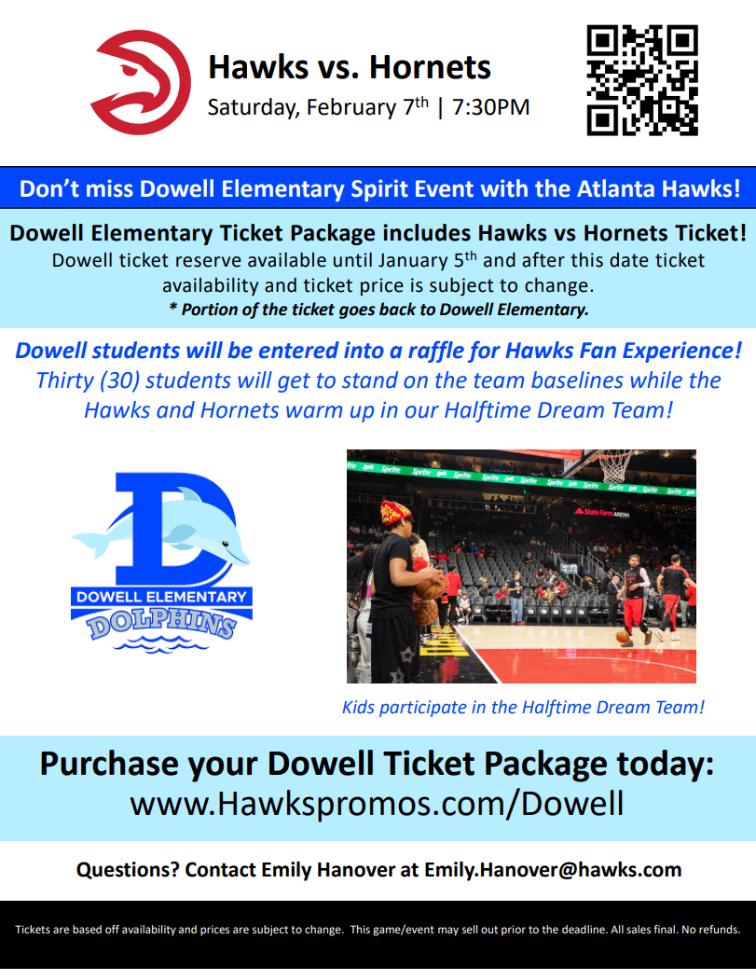

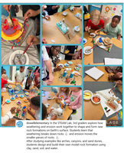
Follow us on social media.
https://www.instagram.com/dowellelementary

