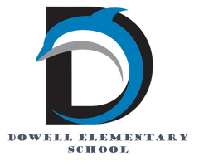
Dolphin Weekly
Sunday, October 19, 2025


Save the Date!

October 20
- 50th Day of School
October 21
- Small Cakes - Dowell Spirit Day
October 21-24
- IOWA Assessment for 3rd & 5th grade students
- Bus Safety Appreciation Week- Thank your bus driver!
October 28
- Author, Rosemary Wells, visits Dowell
October 31
- Book Character Dress Up and Parade

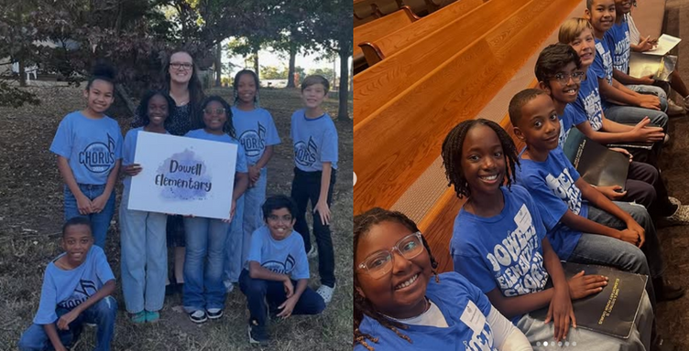

From the Principal's Desk

Dear Dowell Families,

We’ve had another wonderful week at Dowell, and I continue to be so proud of our students and staff! 🌟

A special shout-out to Ms. Somers and our talented 5th-grade chorus students who represented Dowell beautifully in the District XII Honor Chorus! Eight students (one student not pictured due to illness) worked diligently to prepare their repertoire during rehearsals with Ms. Somers. They joined 398 other 5th graders from across Cobb County to perform under the direction of Dr. Craig Hurley at Turner Chapel AME Church, and they were outstanding! Their performance reflected the dedication, teamwork, and musical excellence that make our Dolphins shine! 🎶

Thank you to all our families for making Conference Week such a success. We value your partnership and appreciate the time you took to meet with teachers, celebrate progress, and plan ahead for continued growth.

This week, we return to regular dismissal times, including after-school Fun Clubs, Dowell Clubs, and ASP. Please make sure your child's dismissal is up to date each day in ParentVUE.

Our 3rd and 5th grade students will take the IOWA assessment this week (Tuesday–Friday). Please help your child be on time each morning—prompt attendance sets the tone for a focused and confident start to testing.
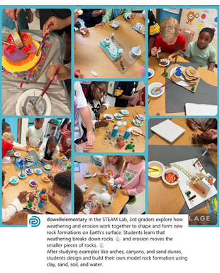

Finally, a quick reminder about carpool safety: students should remain inside their vehicle until reaching the curb in front of the school where staff are available to supervise. For everyone’s safety, please do not let students exit cars in the parking lot or along the curved drive. Your cooperation helps ensure every Dolphin arrives safely and smoothly each morning.

Thank you for your ongoing support and commitment to making Dowell the best place to learn and grow.

Together, we’re creating tomorrow—today!

Dr. Cain
principal
----------------------------------------------------------------

Reminders:
- ID Requirement: A picture ID is required every time you visit the school. Please show it to the camera at the right front door and press the button (door bell). A staff member will confirm your reason for visiting and verify your child’s information before buzzing you in. Upon entry, always go straight to the front office.
- Visiting for Lunch? You’re welcome to sit with your child in the cafeteria during their lunch time. We kindly ask that you not bring fast food or restaurant meals, as it’s not fair to other students. Please check out at the front office after your visit.
- Do NOT Enter: For student and staff safety, please do not use the DO NOT ENTER/Buses Only entrance during AM or PM carpool.

Conference Week

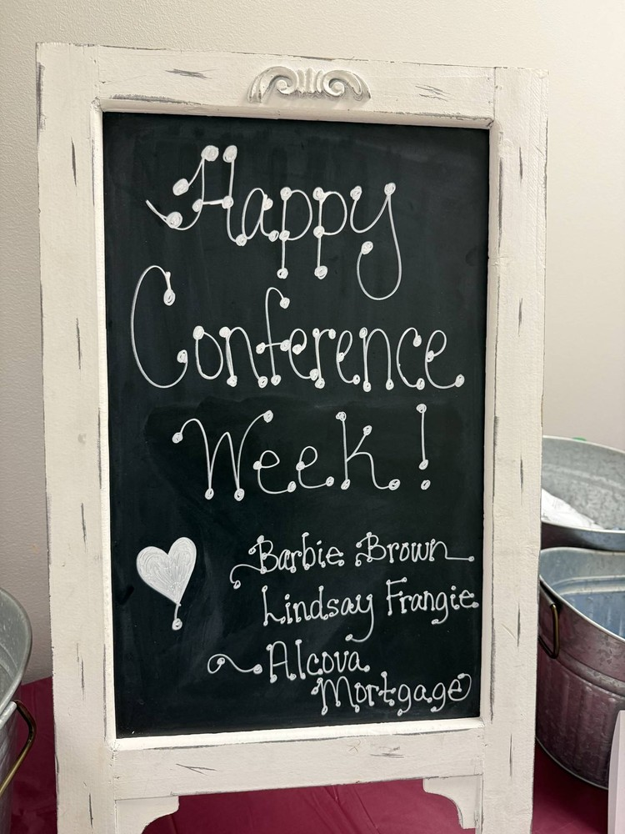
.
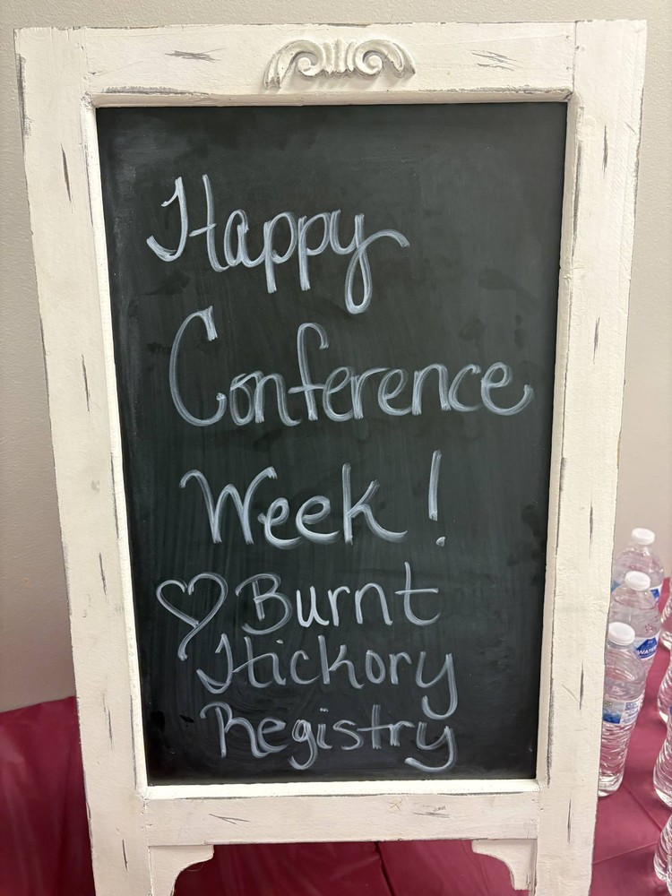
.

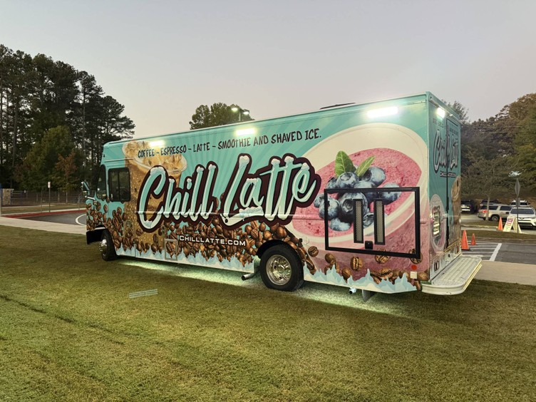
.
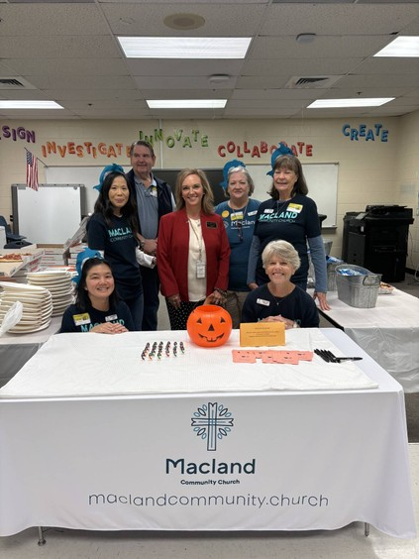
.

A special Thank You goes out to our amazing PTA, Macland Community Church, Burnt Hickory Registry and Alcova Mortgage for an amazing week of coffee, snacks and lunch.


Safety & Security Reminder
Thank you, parents, for always showing your Drivers License when visiting the school. Please remember we can only accept the actual ID (not a photo on your phone). This applies during the school day and for ASP. We appreciate your support in keeping our students safe!

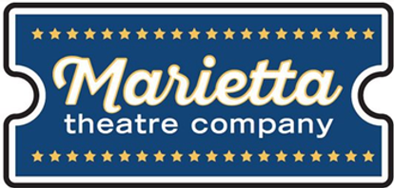
Marietta Theatre Company
Thank you to Marietta Theatre Company for donating 2 sets of tickets for prizes for our amazing staff on Teacher Appreciation Day. Congratulations to Mrs. Jones and Mrs. Mitchell on winning the tickets to enjoy the production of Dirty Rotten Scoundrels.

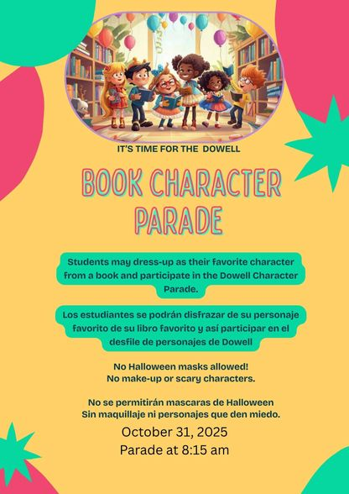
Book Character Parade
Join us for our Book Character Parade on October 31st. Please no mask, makeup or scary characters.

Annual Book Character Pumpkin Contest
Decorate a pumpkin to represent your favorite book character. Open to students and staff.
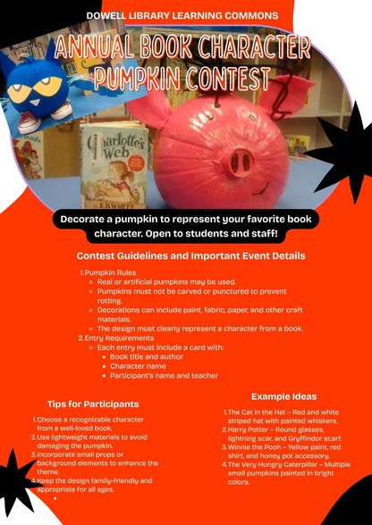

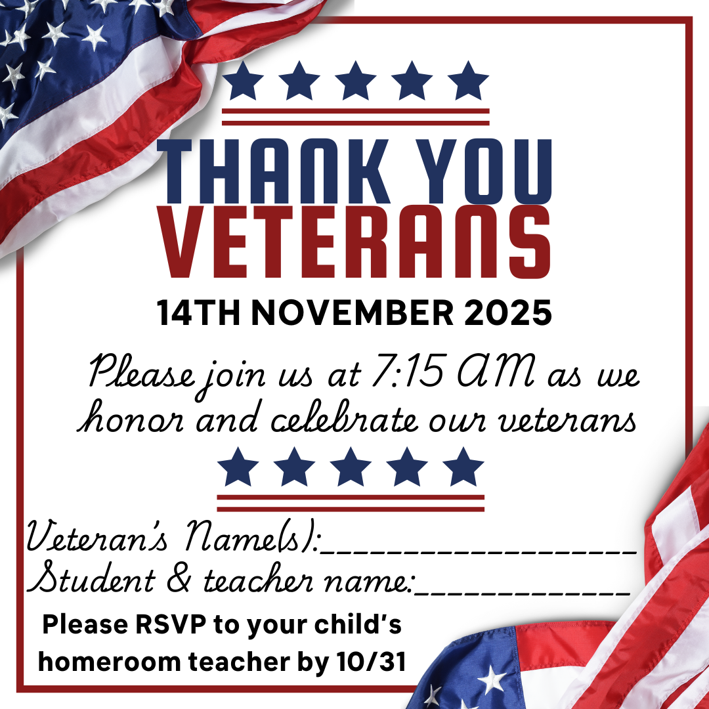

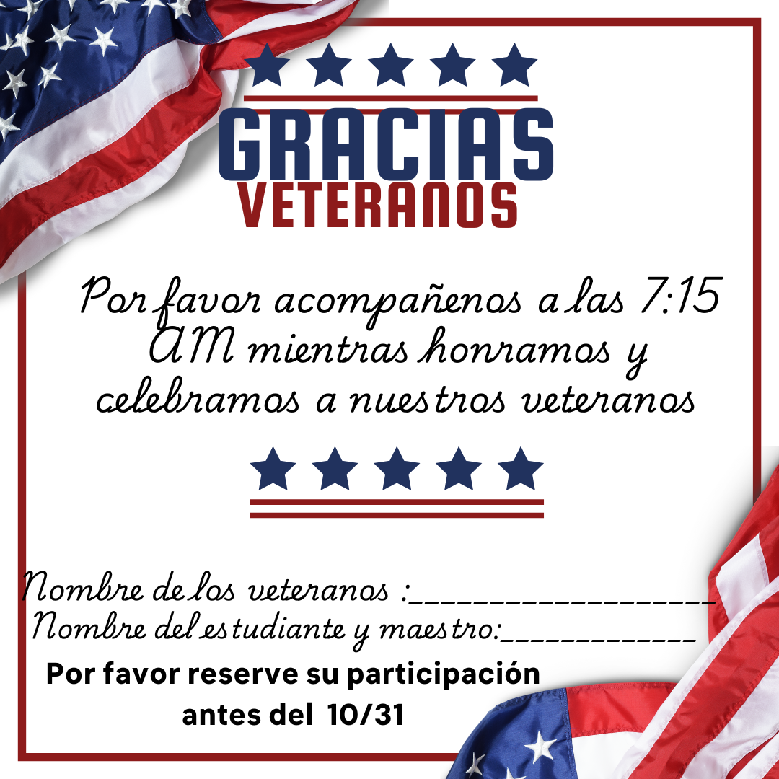

Classroom Celebrations Request Form
Dear Teachers/Parents/Staff,
Do you want to celebrate with your students but don’t have the time for all the planning and details? Return this request form to the Cafeteria Manager and leave the party to us! Upon receipt of the request form, we will provide you with a price quote for your party within 48 hours. On the celebration day, we take care of everything for you!

Please see attached form for pricing items and pricing.

Thanksgiving Lunches
Mark your calendars

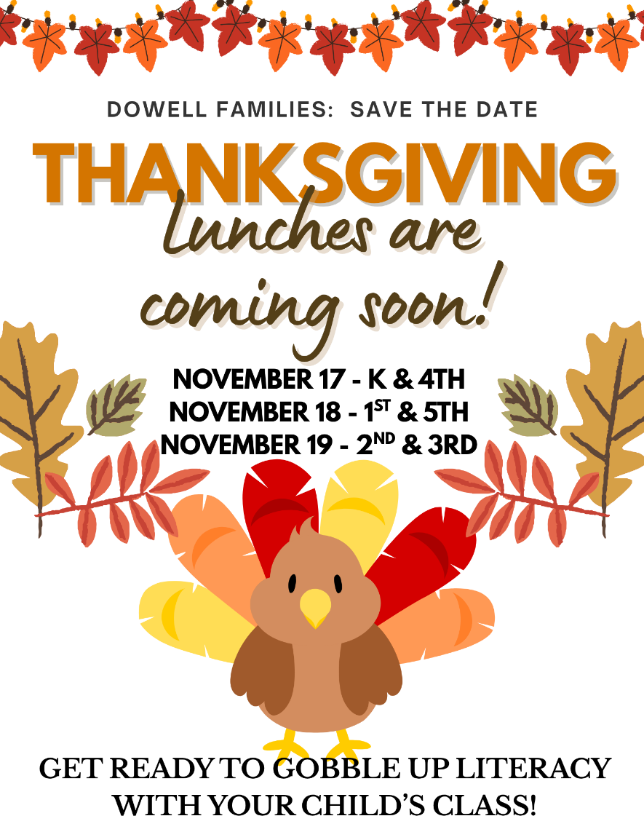

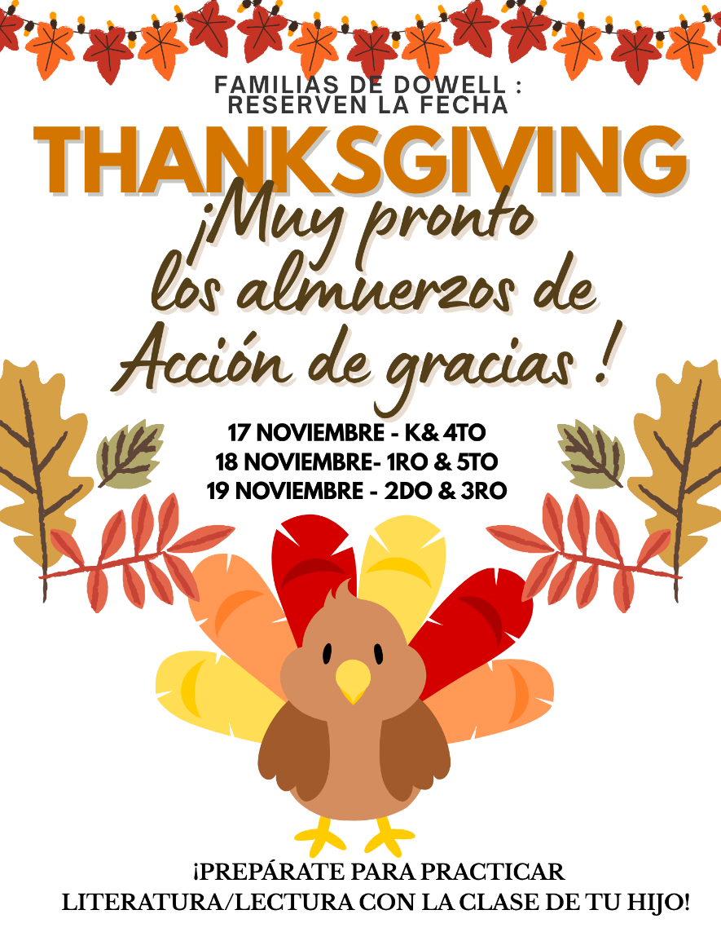

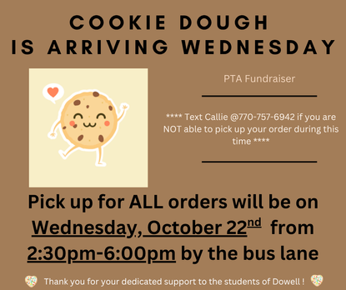
PTA News
Cookie Dough Orders will be delivered Wednesday October 22nd from 2:30-6 PM


Thank you, Dowell PTA
Our teachers were treated to a delicious cup of coffee from Chill Latte this week! A huge thank you to Dowell PTA, Chill Latte, Marietta Theater and Industrial Tape and Supply Co., for making this thoughtful gesture possible. Your support and kindness mean so much to our school community!

Volunteer Opportunities
The school is looking for parents to join the Foundation Board (5) and the Principal Advisory Committee (6-8 parents or business partners). If you are interested, please reach out to dowellpta@gmail.com.

Black History Month – if you or anyone you know is/was in a Divine Nine sorority or fraternity and interested in helping the school please reach out to Dr. Clark or dowellpta@gmail.com. The school is also interested in parents to help decorate the school.


Bus Safety Appreciation Week
Don’t’ forget to thank your bus driver. Appreciation week October 21st – 25th.

Reflections
Deadline is EXTENDED to October 20th
All paperwork needed is online on the PTA Reflections website https://www.pta.org/home/programs/reflections
Email Dowell PTA @dowellpta@gmail.com if you have any questions
Due Date to submit entries to Mr. Itnyre - October 20th- PTSA Reflections submissions
All paperwork needed is online on the PTA Reflections website https://www.pta.org/home/programs/reflections


Community Events

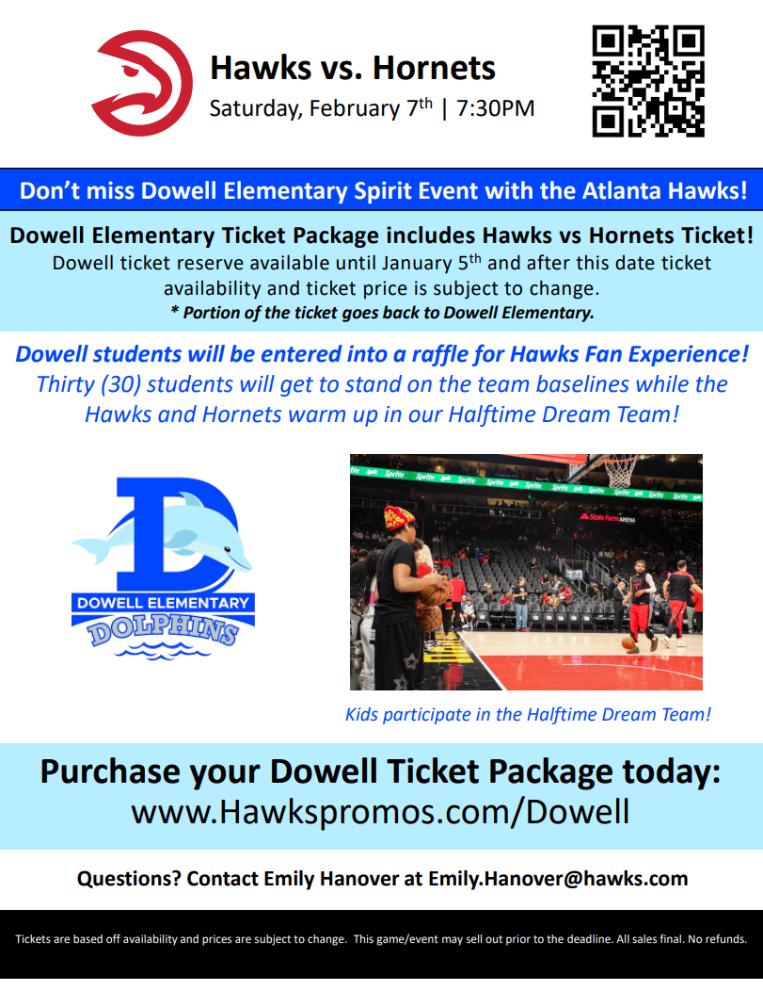

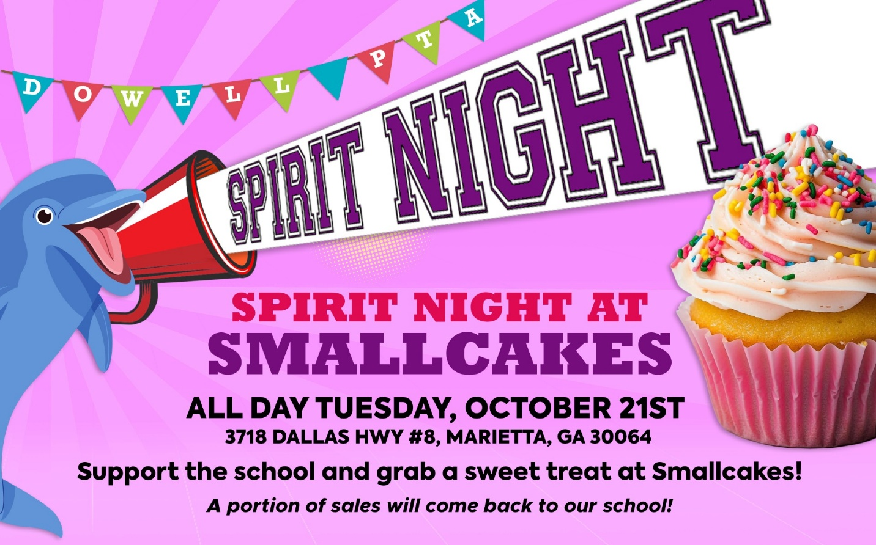

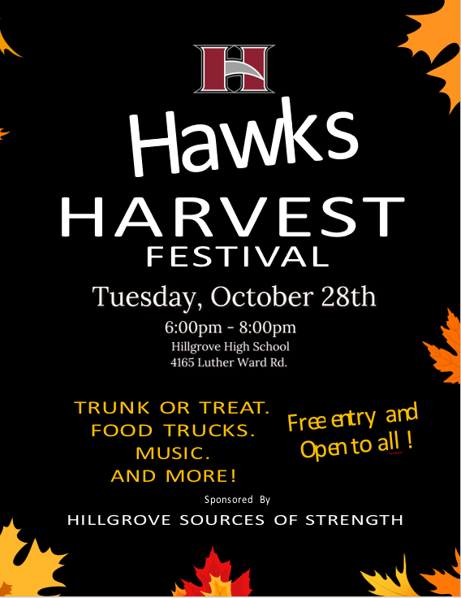



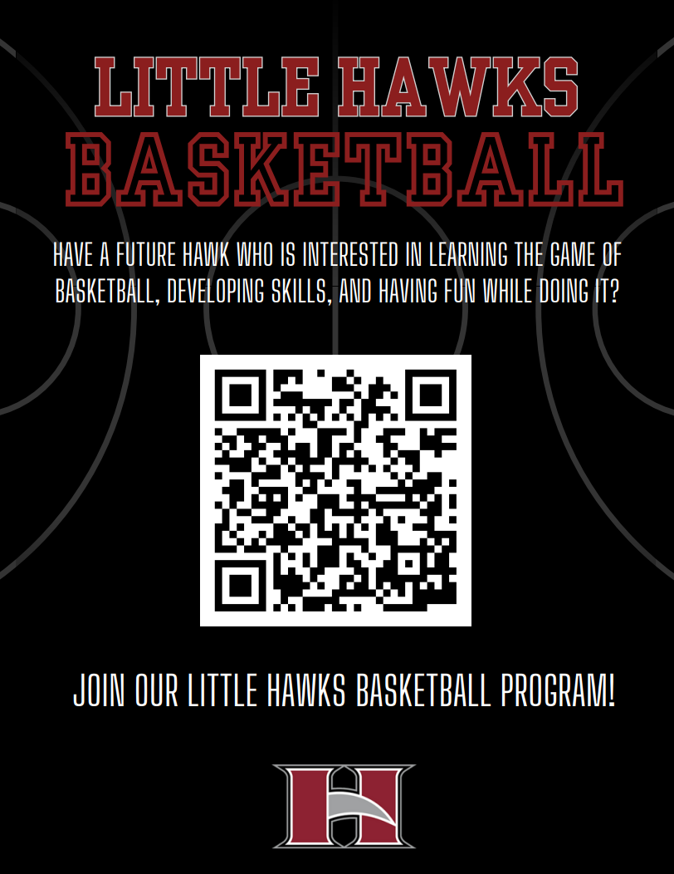

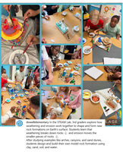
Follow us on social media.
https://www.instagram.com/dowellelementary

