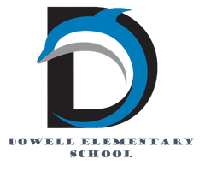
Dolphin Weekly
Sunday, October 26, 2025


Save the Date!
October 27 - 31
- Healthy Choices Dress Up Days
October 28, Tuesday
- Author, Rosemary Wells, visits Dowell
October 30, Thursday
- Young ladies with High Expectations, 8:00-9:00 AM
October 31, Friday
- Book Character Dress Up and Parade
November 4, Tuesday
- Election Day - No School for Students
November 5 - 7, Wednesday - Friday
- IOWA Tests for 3rd & 5th Grades
November 11, Tuesday
- Spelling Bee, 9:00
November 14, Friday
- Veteran's Day program
November 17, Monday
- Thanksgiving Lunches, K & 4th
November 18, Tuesday
- Thanksgiving Lunches 1st & 5th
November 19, Wednesday
- Thanksgiving Lunches 2nd & 3rd
November 20, Thursday
- 4th & 5th Grade chorus field trip
- 5th Grade Dance, 6:00-7:30
November 21, Friday
- Terrific Kids (Responsibility), 8:00 AM
November 24 - 28, M-F
- Thanksgiving Holiday break

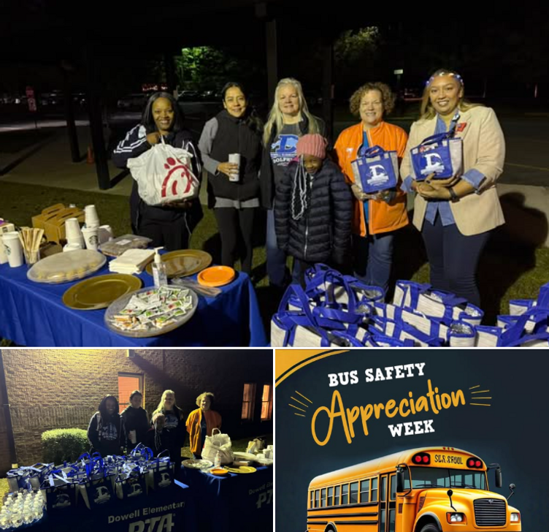

From the Principal's Desk

Dear Dowell Families,

It’s been another great week at Dowell, and I’m so thankful for the continued partnership and positivity within our school community. 💙

A special thank-you to our amazing PTA for recognizing our Dowell bus drivers last week! Their daily commitment to safely transporting our students deserves to be celebrated, and we appreciate the PTA for taking the time to honor them in such a meaningful way. 🚌💛

This week is Healthy Choices Dress-Up Week! Tomorrow kicks off the fun with “Wear Your Favorite Hat Day.” We can’t wait to see the creative ways our students show their spirit while learning about making healthy choices for their minds and bodies!

Per the previous county correspondence, IOWA testing was postponed due to technical issues with the Riverside Insight testing platform (the vendor for the Iowa assessment). Updated testing dates for 3rd and 5th grade are Wednesday–Friday, November 5, 6, and 7. Thank you for your patience and understanding as we ensure a smooth testing experience for all students.

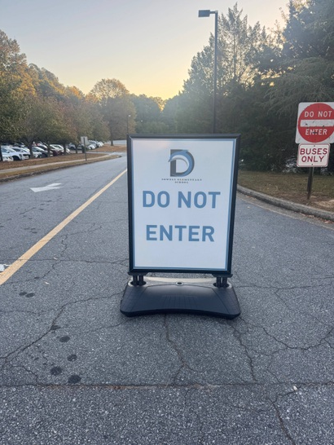

Finally, a friendly reminder about morning arrival procedures: please do not enter through the “Bus Only/Do Not Enter” entrance. This area must remain clear to allow our staff to safely direct buses and carpool traffic. Entering there creates safety concerns and makes it difficult for staff to monitor students and cars in the main carpool line. Thank you to the many families who consistently follow our procedures—your cooperation truly helps keep everyone safe!

As always, I’m proud of our students, grateful for our dedicated staff, and appreciative of our supportive families. Together, we’re creating tomorrow—today! 🌟

Dr. Cain
principal
----------------------------------------------------------------

Reminders:
- ID Requirement: A picture ID is required every time you visit the school. Please show it to the camera at the right front door and press the button (door bell). A staff member will confirm your reason for visiting and verify your child’s information before buzzing you in. Upon entry, always go straight to the front office.
- Visiting for Lunch? You’re welcome to sit with your child in the cafeteria during their lunch time. We kindly ask that you not bring fast food or restaurant meals, as it’s not fair to other students. Please check out at the front office after your visit.
- Do NOT Enter: For student and staff safety, please do not use the DO NOT ENTER/Buses Only entrance during AM or PM carpool.

Healthy Choices Dress Up Week

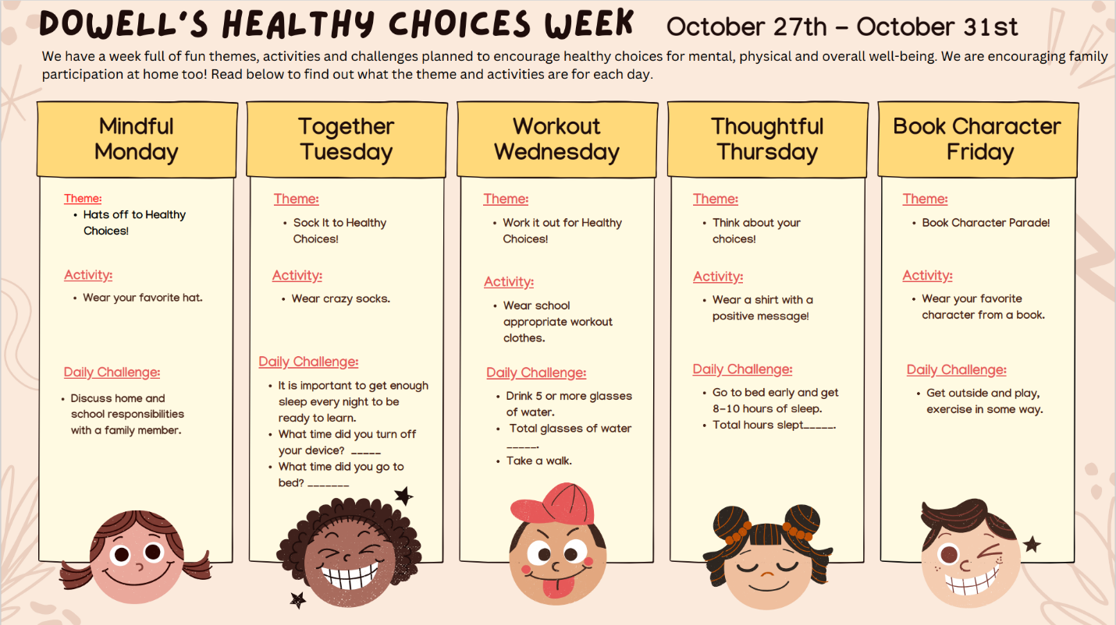

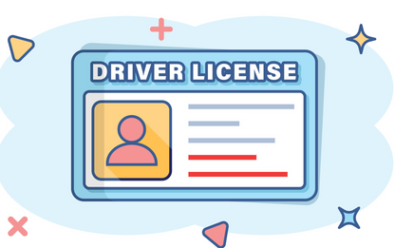
Safety & Security Reminder
Thank you, parents, for always showing your Drivers License when visiting the school. Please remember we can only accept the actual ID (not a photo on your phone). This applies during the school day and for ASP. We appreciate your support in keeping our students safe!

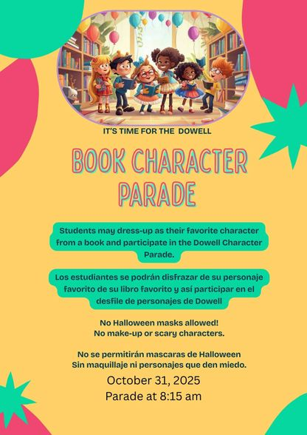
Book Character Parade
Join us for our Book Character Parade on October 31st. Please no mask, makeup or scary characters.

Annual Book Character Pumpkin Contest
Decorate a pumpkin to represent your favorite book character. Open to students and staff.
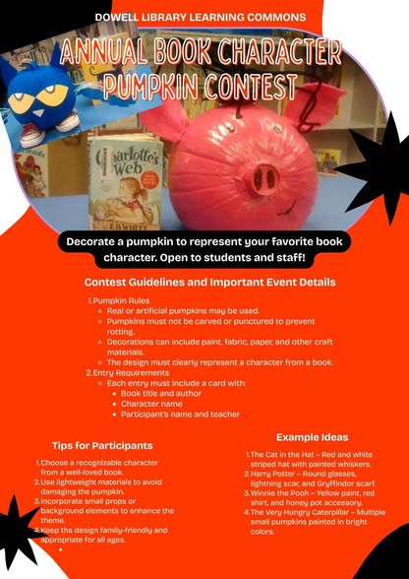

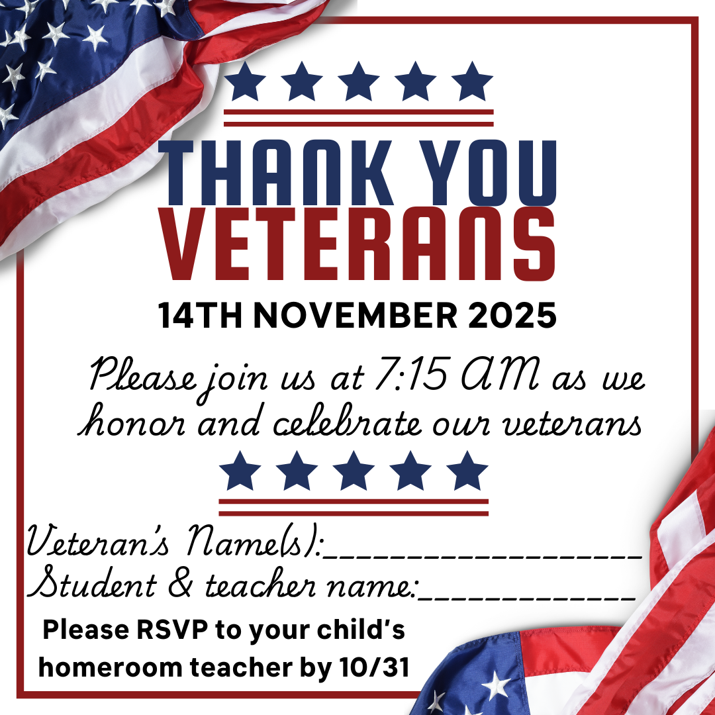

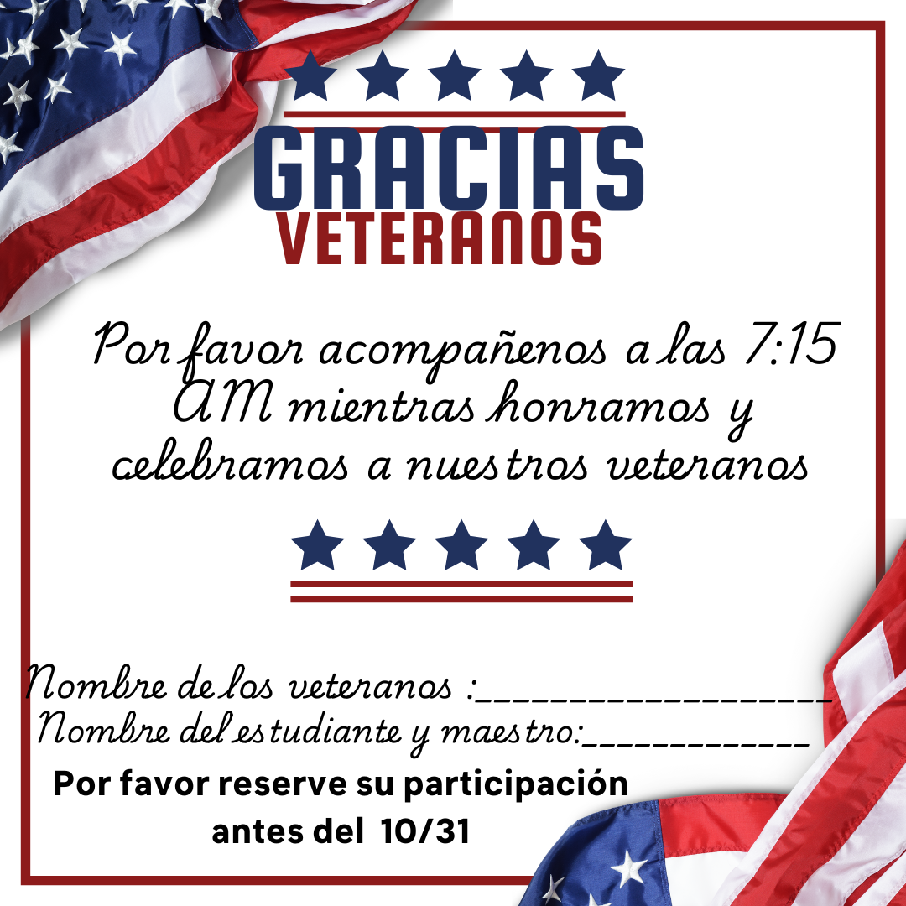

Classroom Celebrations Request Form
Dear Teachers/Parents/Staff,
Do you want to celebrate with your students but don’t have the time for all the planning and details? Return this request form to the Cafeteria Manager and leave the party to us! Upon receipt of the request form, we will provide you with a price quote for your party within 48 hours. On the celebration day, we take care of everything for you!

Please see attached form for pricing items and pricing.

Thanksgiving Lunches
Mark your calendars

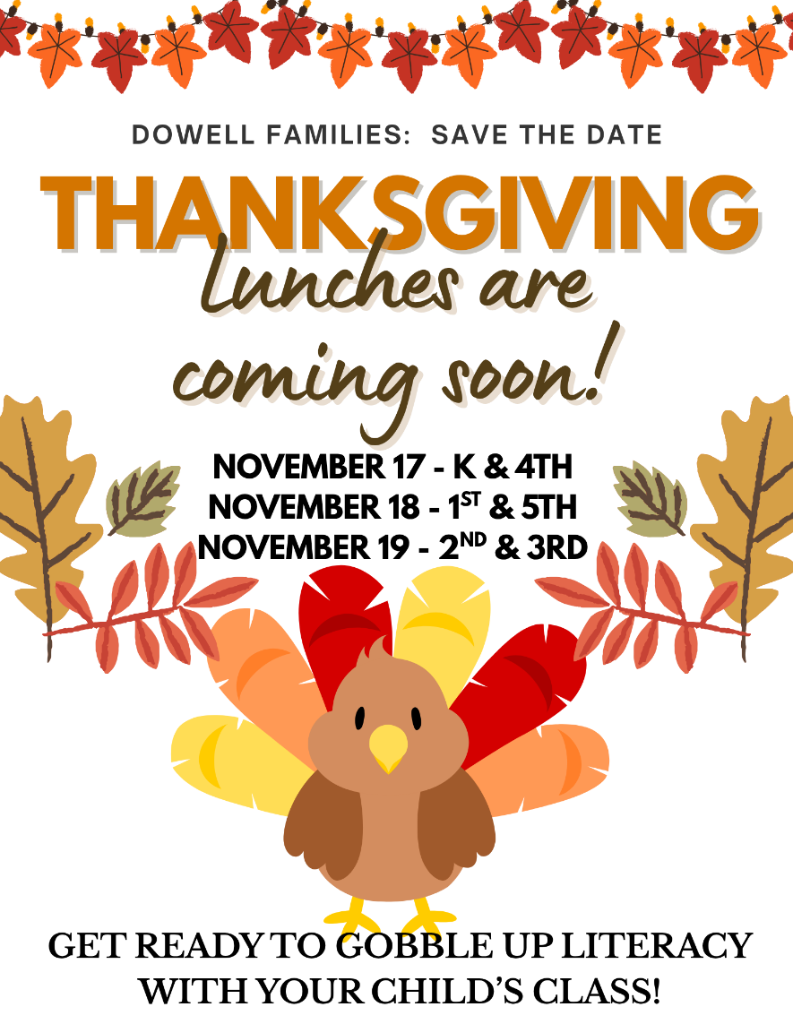

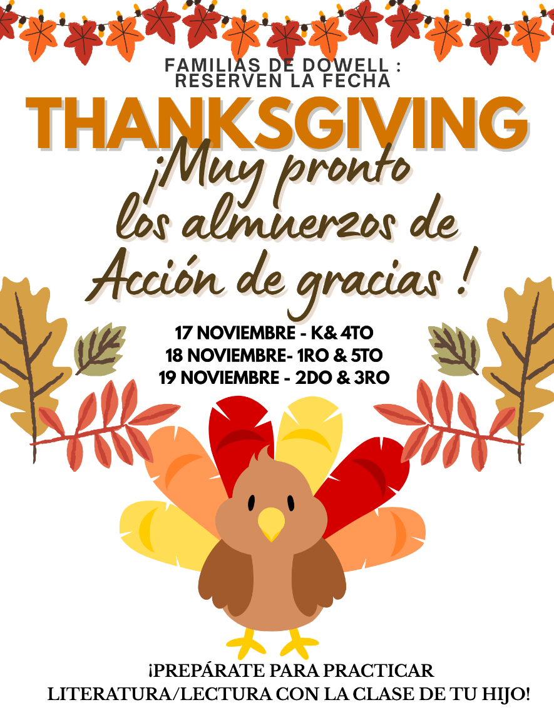

Volunteer Opportunities
The school is looking for parents to join the Foundation Board (5) and the Principal Advisory Committee (6-8 parents or business partners). If you are interested, please reach out to dowellpta@gmail.com.

Black History Month – if you or anyone you know is/was in a Divine Nine sorority or fraternity and interested in helping the school please reach out to Dr. Clark or dowellpta@gmail.com. The school is also interested in parents to help decorate the school.

Reflection Winners
We have our results for Dowell Elementary's Reflections Contest Winners! Please share the news in the dolphin weekly and PTA announcements today. Thanks!

2nd Grade Winners
- Olivia Evans - Visual Arts (1st Place)
- Indigo D'Elia - Visual Arts (1st Place)
- Olivia Evans - Photography (1st Place)
3rd Grade Winners
- Heaven Pratt - Visual Arts (1st Place)
- Norah Joof - Dance Choreography (1st Place)
4th Grade Winner
- Soham Patil - Visual Arts (1st Place)
5th Grade Winner
- Andrew Jones - Visual Arts (1st Place)


Community Events

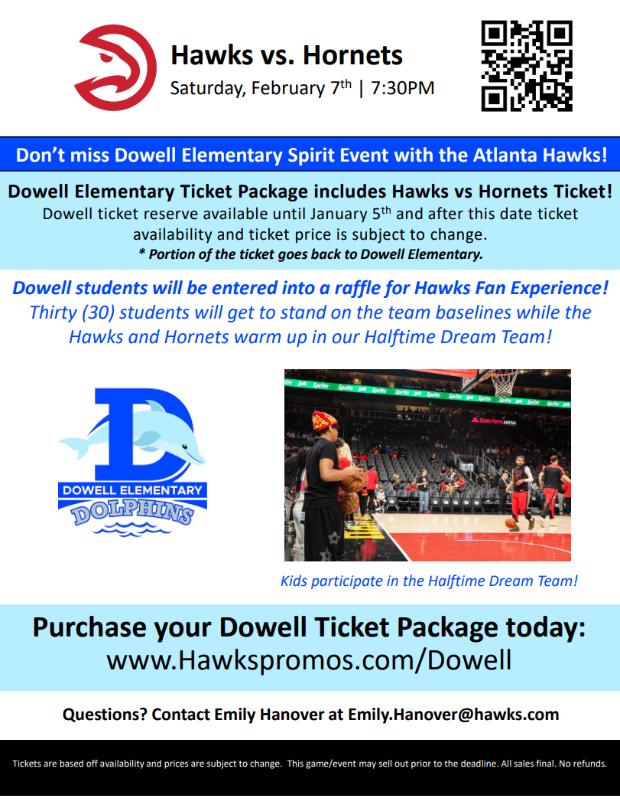

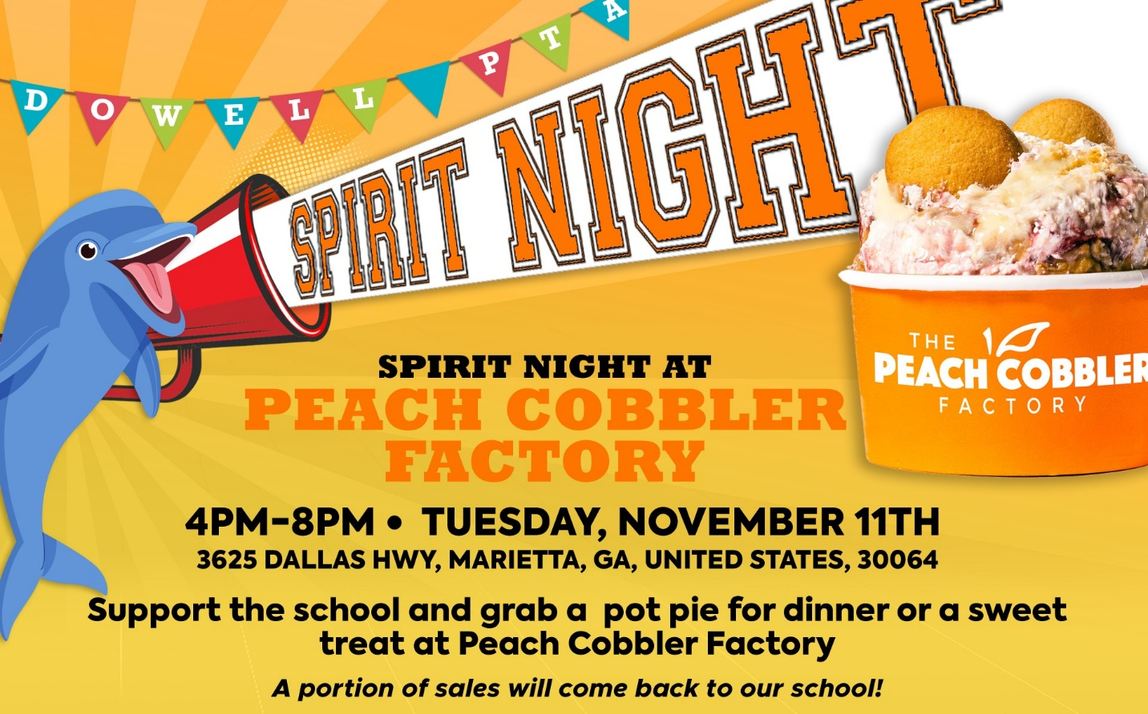

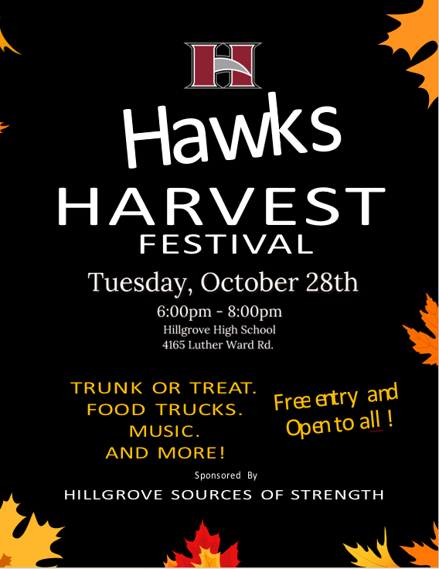

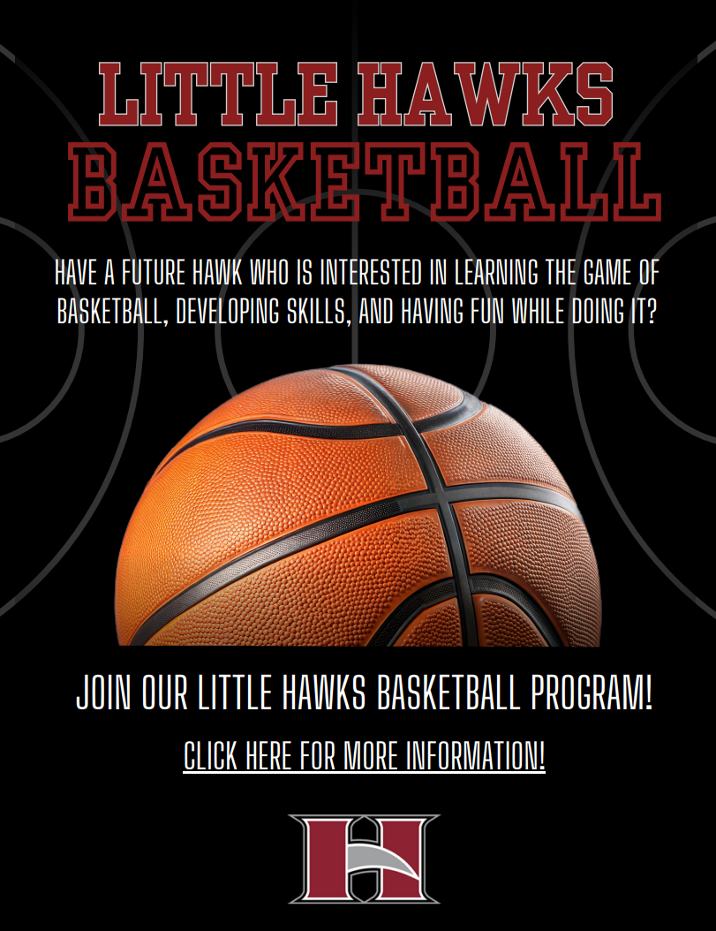

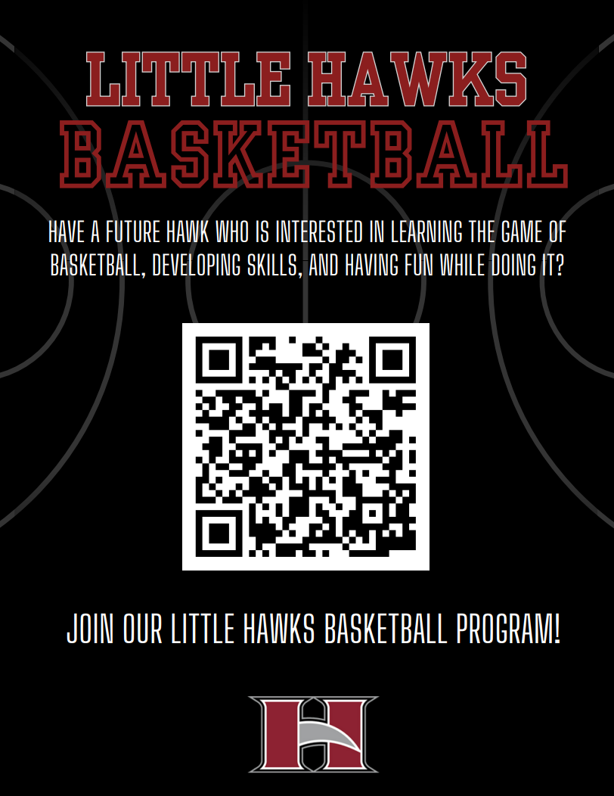

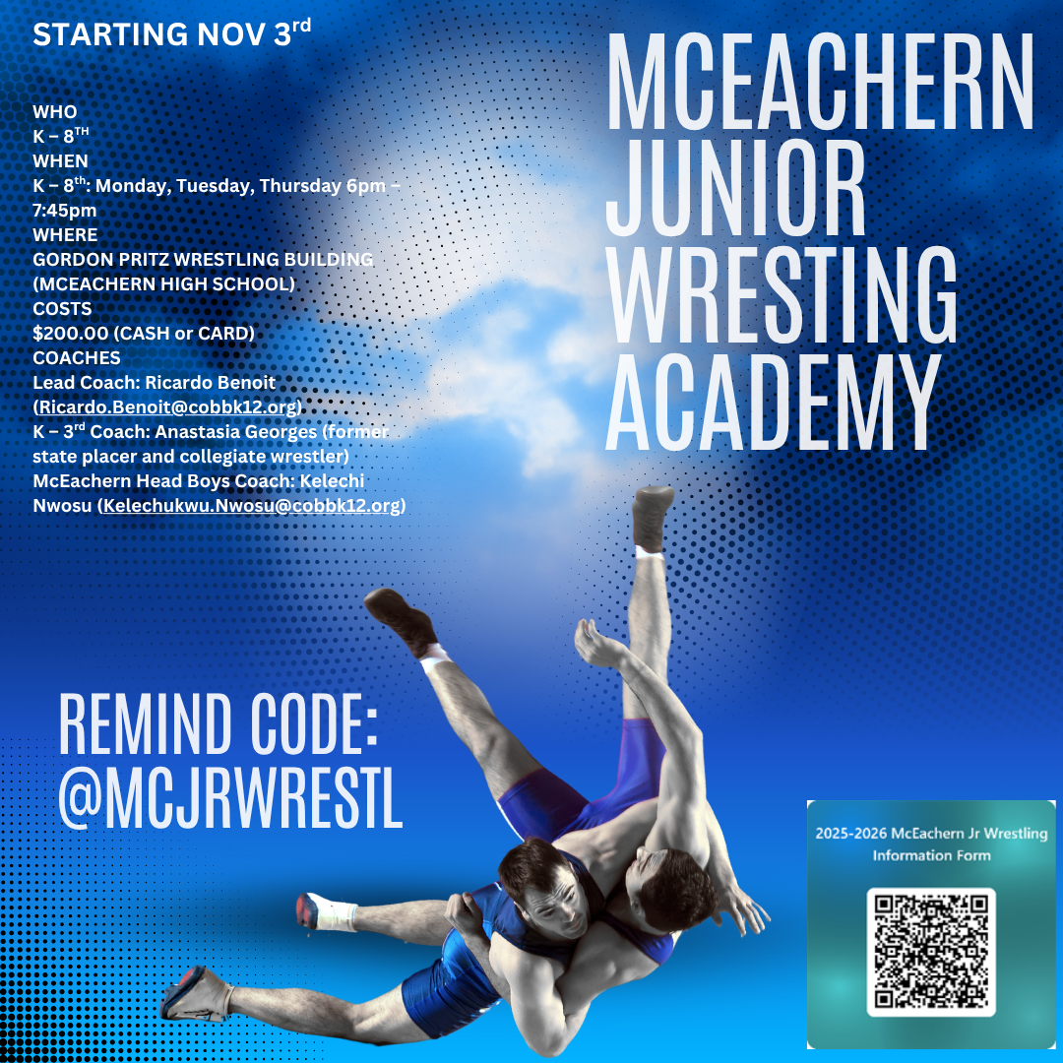

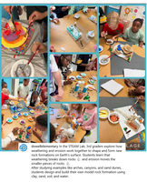
Follow us on social media.
https://www.instagram.com/dowellelementary

