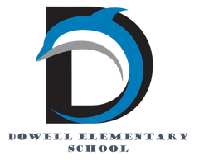
Dolphin Weekly
Sunday, November 16, 2025


Save the Date!

November 17, Monday
- Thanksgiving Lunches, SNPK, K & 4th & CORE
November 18, Tuesday
- Thanksgiving Lunches 1st & 5th & Bridge
- Fourth grade Field Trip to Cobb Museum of Art
November 19, Wednesday
- Thanksgiving Lunches 2nd & 3rd
- Fourth grade Field Trip to Cobb Museum of Art
November 20, Thursday
- Picture Retakes
- 4th & 5th Grade chorus field trip
- 5th Grade Dance, 6:00-7:30
November 21, Friday
- Terrific Kids (Responsibility), 8:00 AM
November 24 - 28, M-F
- Thanksgiving Holiday break
December 2/Tuesday
- Digital Learning Day
December 5/Friday
- Terrific Kids, Citizenship
December 11/Thursday
- Chorus Concert & PTA Holiday Event
December 18 & 19/Thursday & Friday
- Early Release Days

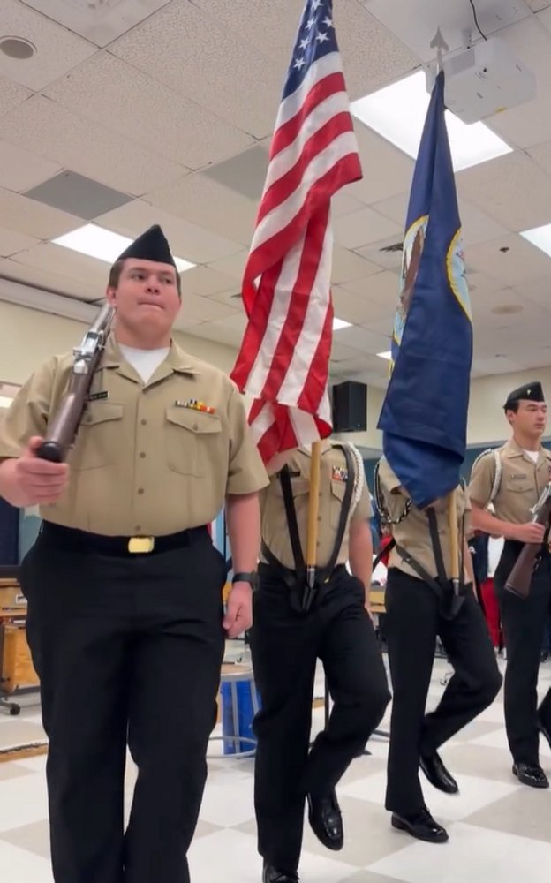

From the Principal's Desk
Dear Dowell Families,

What a wonderful week we’ve had at Dowell! 💙 We are incredibly grateful to the many veterans and family members who joined us for our annual Veterans Day Celebration. Your presence made the day truly special, and our students were honored to recognize and celebrate your service. A very special thank you to Ms. Somers, our music teacher, and our amazing 4th graders for their exceptional performance. Their voices, preparation, and heartfelt presentation made the ceremony even more meaningful.

📚 Spelling Bee Celebration
Congratulations to our 2025 Spelling Bee Champion, Kylie (4th grade), and our Runner-Up, Ameer (5th grade)! We are so proud of every student who courageously stepped into the spotlight and gave their very best. Their confidence, preparation, and sportsmanship were inspiring!

🦃 Family Thanksgiving Meals – This Week!
We are excited to welcome families for our Thanksgiving Meals this week. Thank you in advance for helping us make these special days run smoothly. Please remember to bring cash, as our cafeteria cannot accept card payments.
As a reminder:
- Please arrive early for check-in.
- A physical photo ID is required for every adult visitor.
- Parking is available in the main lot, the bus lot, and at Macland Church of Christ.
- Families may enter through the front doors or the bus port doors.
We look forward to sharing this tradition with you and your children!

Thank you for your continued partnership and for all you do to support our school community.

With appreciation,

Dr. Cain
principal

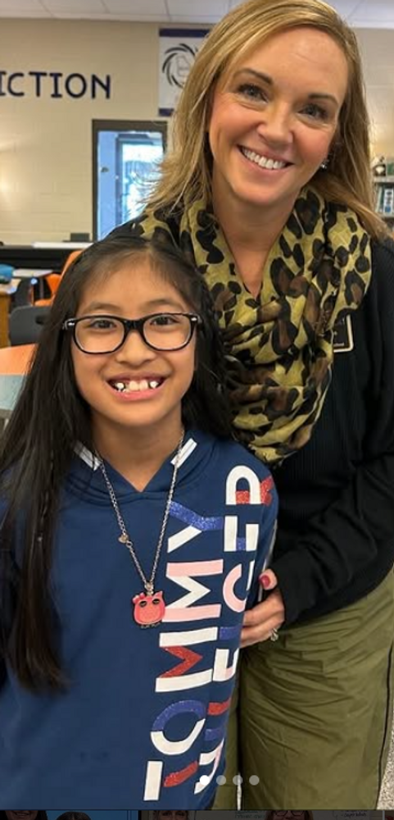

----------------------------------------------------------------

Reminders:
- ID Requirement: A picture ID is required every time you visit the school. Please show it to the camera at the right front door and press the button (door bell). A staff member will confirm your reason for visiting and verify your child’s information before buzzing you in. Upon entry, always go straight to the front office.
- Visiting for Lunch? You’re welcome to sit with your child in the cafeteria during their lunch time. We kindly ask that you not bring fast food or restaurant meals, as it’s not fair to other students. Please check out at the front office after your visit.
- Do NOT Enter: For student and staff safety, please do not use the DO NOT ENTER/Buses Only entrance during AM or PM carpool.

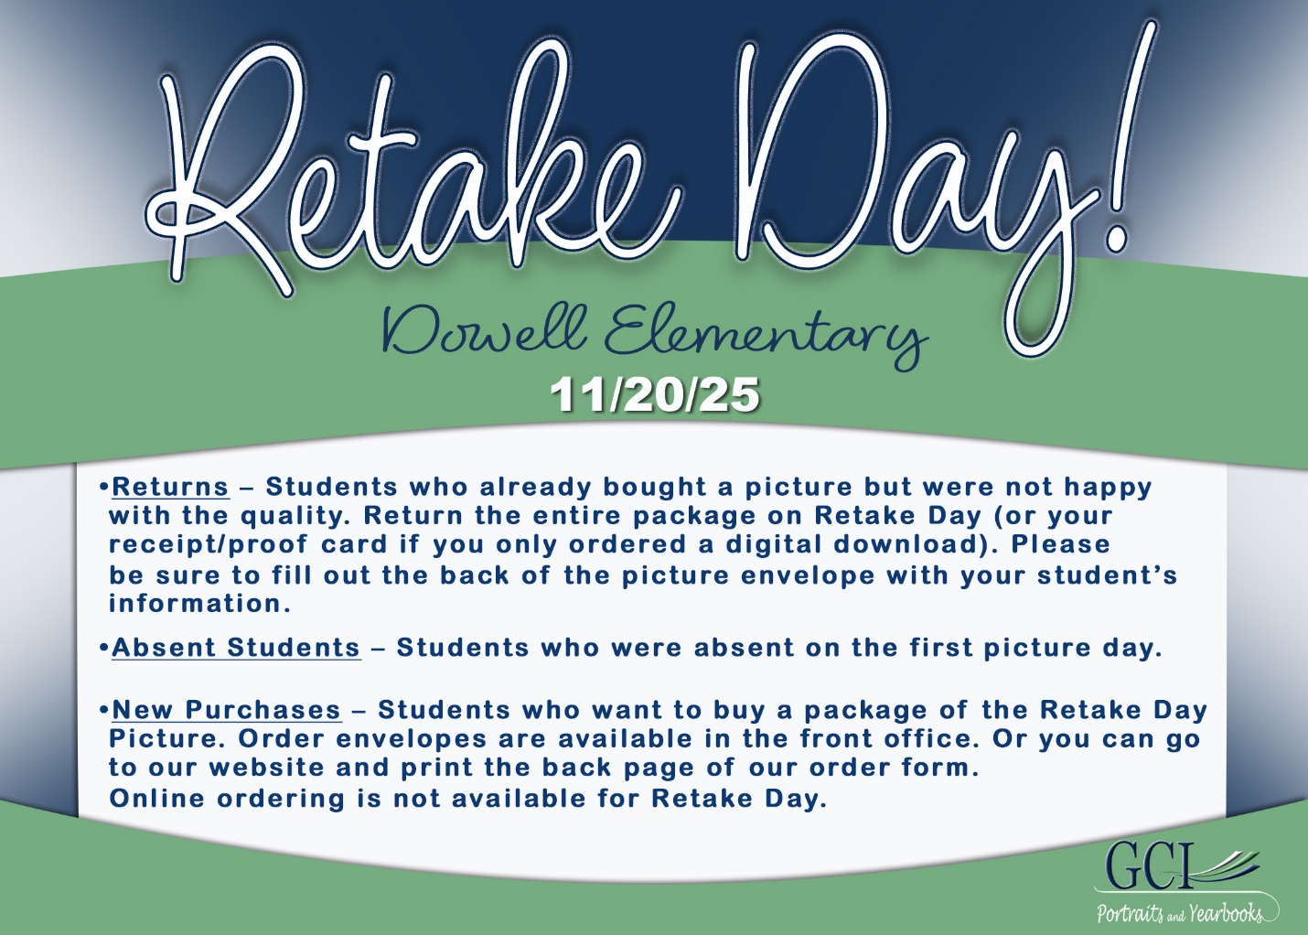

Black History Month
We’re beginning to plan our Black History Month celebration and would love for our families to be part of it! If you’d like to volunteer, share a tradition, or help make this event special, please fill out our short interest form.

Sign up here

Classroom Celebrations Request Form
Dear Teachers/Parents/Staff,
Do you want to celebrate with your students but don’t have the time for all the planning and details? Return this request form to the Cafeteria Manager and leave the party to us! Upon receipt of the request form, we will provide you with a price quote for your party within 48 hours. On the celebration day, we take care of everything for you!

Please see attached form for pricing items and pricing.

Also if you plan on bringing in a treat for your child's birthday please fill out the attached cupcake form at least 24 hours in advance for the teacher and front office staff to be aware. This helps with planning and any allergies in the classroom.

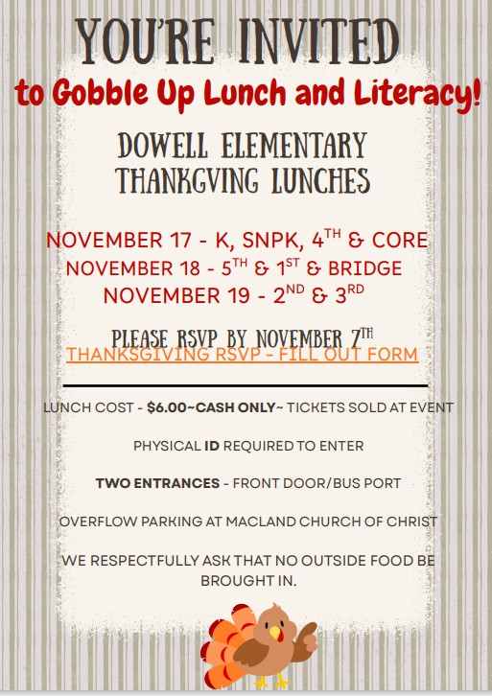

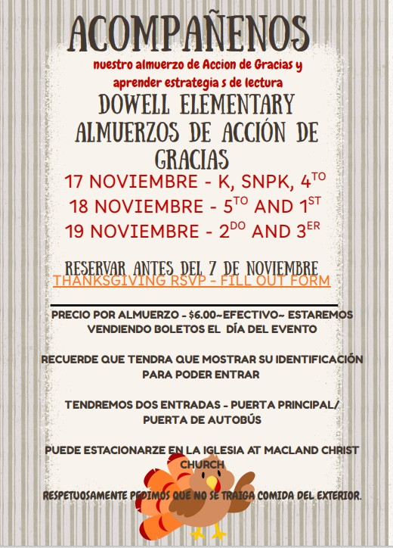

Community Events



Holiday Shop coming soon!
Its that time of year…the time for giving. Please consider volunteering for the Dowell Holiday Shop.

https://www.signupgenius.com/go/20F0F4DAFA82B0-60318955-2025#/

https://www.signupgenius.com/go/20F0F4DAFA82B0-60375873-santa#/



Fun Club Registration is now OPEN!
Spring 2026 Registration Opens Soon! Please Visit https://www.funclubs.com/schools and Choose Dowell Elementary School to Preview Clubs that will be offered this coming semester!

📅 Mark Your Calendars! Sign-Ups are now Open!

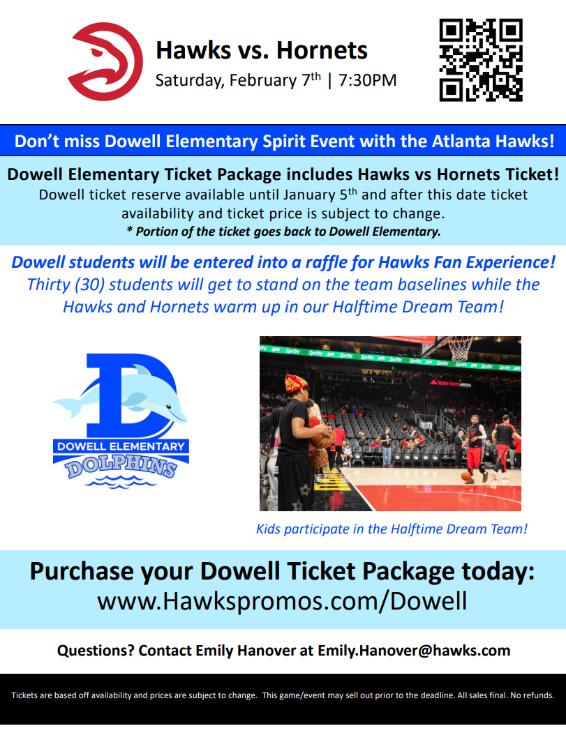

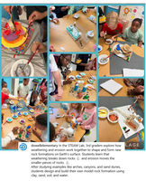
Follow us on social media.
https://www.instagram.com/dowellelementary

