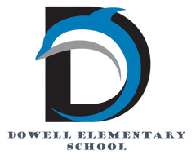
Dolphin Weekly
Sunday, November 2, 2025


Save the Date!

November 2, Sunday
- Daylight Savings Time- Adjust your clocks/Fall Back
November 4, Tuesday
- Election Day - No School for Students
November 5 - 7, Wednesday - Friday
- IOWA Tests for 3rd & 5th Grades
November 6, Thursday
- DOWELL DAY AT the Barrett Pkwy & Powder Springs Road location **Free Entre when you show your ParentVue account**
November 10, Monday
- 2nd Graders go to the Etowah Indian Mounds
November 11, Tuesday
- Spelling Bee, 9:00
November 14, Friday
- Veteran's Day program
November 17, Monday
- Thanksgiving Lunches, SNPK, K & 4th & CORE
November 18, Tuesday
- Thanksgiving Lunches 1st & 5th & Bridge
- Fourth grade Field Trip to Cobb Museum of Art
November 19, Wednesday
- Thanksgiving Lunches 2nd & 3rd
- Fourth grade Field Trip to Cobb Museum of Art
November 20, Thursday
- 4th & 5th Grade chorus field trip
- 5th Grade Dance, 6:00-7:30
November 21, Friday
- Terrific Kids (Responsibility), 8:00 AM
November 24 - 28, M-F
- Thanksgiving Holiday break


Dowell Day at Chick-fil-A
Thursday, November 6th: Every Dowell student and staff member can receive a FREE entree. Parents, just show your ParentVue account on your phone as your child's Dowell ID to receive the FREE entree.

It is the brand-new Chick-fil-A located in front of the Walmart at the corner of EW Connector.

Barrett Pkwy & Powder Springs Rd
6652 Ernest W Barrett Pkwy SW
Marietta, GA 30064

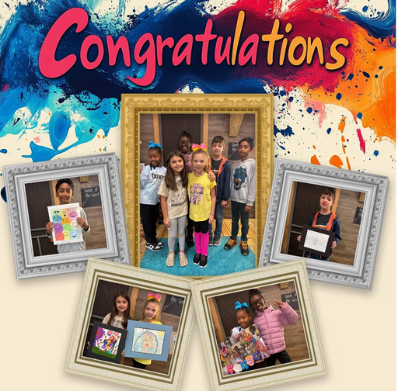

From the Principal's Desk

Dear Dowell Families,

What an exciting week it’s been at Dowell! 🌟 From an unexpected false fire alarm in the rain to our spirited Healthy Choices dress-up days, our students and staff showed flexibility, teamwork, and plenty of smiles through it all. We wrapped up the week with one of our favorite traditions—the Book Character Parade! 📚✨ It was wonderful seeing our students’ creativity shine as they brought their favorite literary characters to life.

🧠 IOWA Testing Reminder
Our 3rd and 5th grade students will be taking the rescheduled IOWA assessments on Wednesday, Thursday, and Friday of this week. Thank you for ensuring your child arrives on time each day, well-rested and ready to do their best!

🎨 PTA Reflections Update
Congratulations to all of our talented student artists who participated in this year’s PTA Reflections Program! The school-level awards ceremony date will be announced soon. All school-level winners have advanced to the County level, where winners will be announced in December. We’re so proud of our creative and expressive students!

School-Level Winners

2nd Grade
• Olivia – Visual Arts (1st Place)
• Indigo– Visual Arts (1st Place)
• Olivia – Photography (1st Place)
3rd Grade
• Heaven – Visual Arts (1st Place)
• Norah – Dance Choreography (1st Place)
4th Grade
• Soham – Visual Arts (1st Place)
5th Grade
• Andrew – Visual Arts (1st Place)

Family Support: SNAP Updates

We understand that recent changes to SNAP (Supplemental Nutrition Assistance Program) benefits may affect some of our families. Please know that you are not alone, and support is available.

If your household experiences a reduction or loss of benefits, our school can help connect you with local food resources, community partners, and emergency assistance programs. Your family’s well-being matters deeply to us.
For confidential support or resource information, please contact our school parent facilitator, Esther Islam @ Esther.Islam@cobbk12.org.
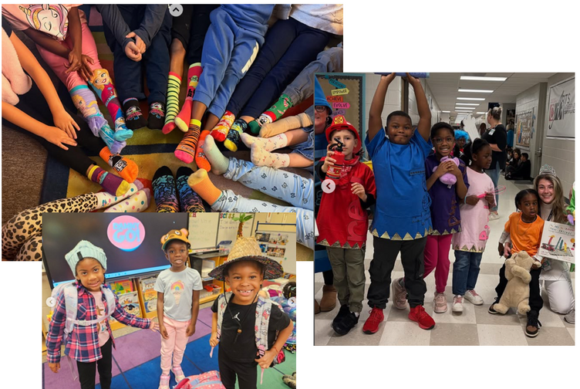

.
🚗 Morning Arrival Safety Reminder
For everyone’s safety, please do not enter through the “Bus Only/Do Not Enter” entrance during morning arrival. This area must remain clear so our staff can safely direct buses and carpool traffic. Entering there creates safety concerns and makes it difficult for staff to monitor students and cars in the main carpool line.
Thank you to the many families who consistently follow our procedures—your cooperation truly helps keep everyone safe!
As always, I’m so proud of our students, grateful for our dedicated staff, and appreciative of our supportive families. Together, we’re Building the Future and Creating Tomorrow—Today! 💫

Dr. Cain
principal
----------------------------------------------------------------

Reminders:
- ID Requirement: A picture ID is required every time you visit the school. Please show it to the camera at the right front door and press the button (door bell). A staff member will confirm your reason for visiting and verify your child’s information before buzzing you in. Upon entry, always go straight to the front office.
- Visiting for Lunch? You’re welcome to sit with your child in the cafeteria during their lunch time. We kindly ask that you not bring fast food or restaurant meals, as it’s not fair to other students. Please check out at the front office after your visit.
- Do NOT Enter: For student and staff safety, please do not use the DO NOT ENTER/Buses Only entrance during AM or PM carpool.

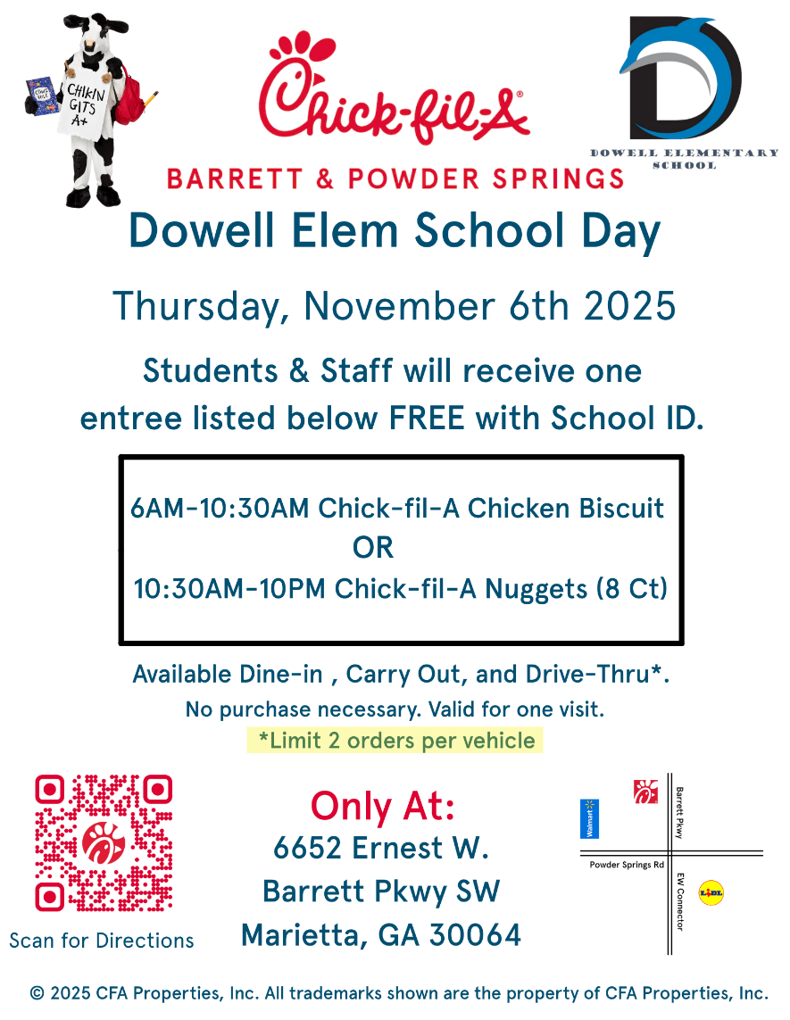

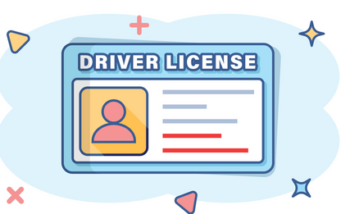
Safety & Security Reminder
Thank you, parents, for always showing your Drivers License when visiting the school. Please remember we can only accept the actual ID (not a photo on your phone). This applies during the school day and for ASP. We appreciate your support in keeping our students safe!

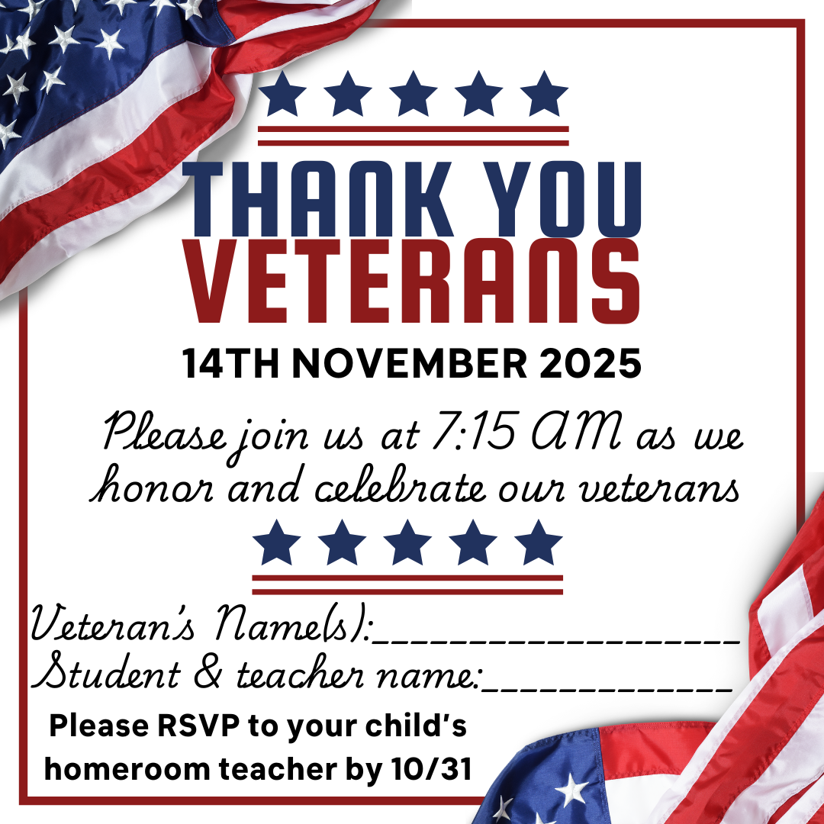

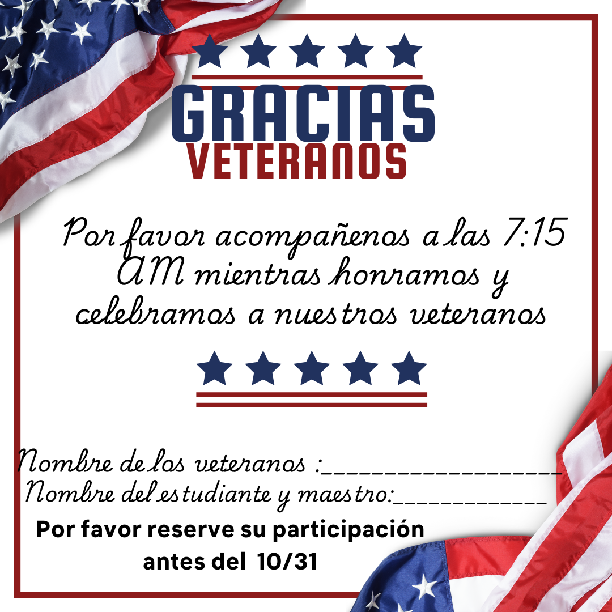

Sign up here!

Thanksgiving Lunches
Mark your calendars

Classroom Celebrations Request Form
Dear Teachers/Parents/Staff,
Do you want to celebrate with your students but don’t have the time for all the planning and details? Return this request form to the Cafeteria Manager and leave the party to us! Upon receipt of the request form, we will provide you with a price quote for your party within 48 hours. On the celebration day, we take care of everything for you!

Please see attached form for pricing items and pricing.

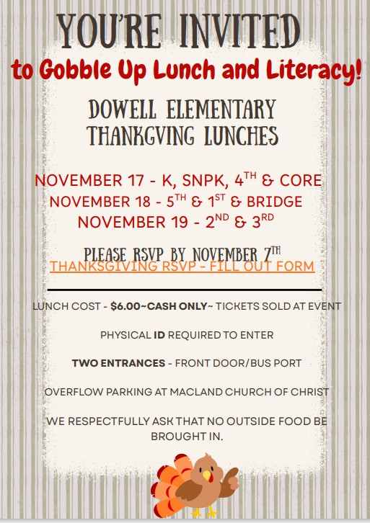

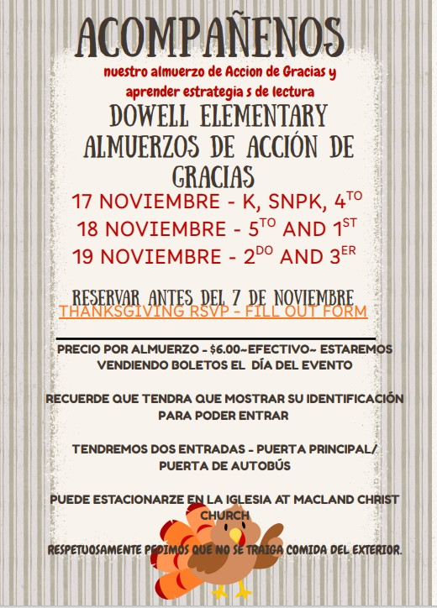

Your RSVP is requested
Please let us know by November 7th if you are able to join your student for Thanksgiving Lunch.

Click here to RSVP

Celebrate Black History Month with Us!
We’re beginning to plan our Black History Month celebration and would love for our families to be part of it! If you’d like to volunteer, share a tradition, or help make this event special, please fill out our short interest form.

Community Events

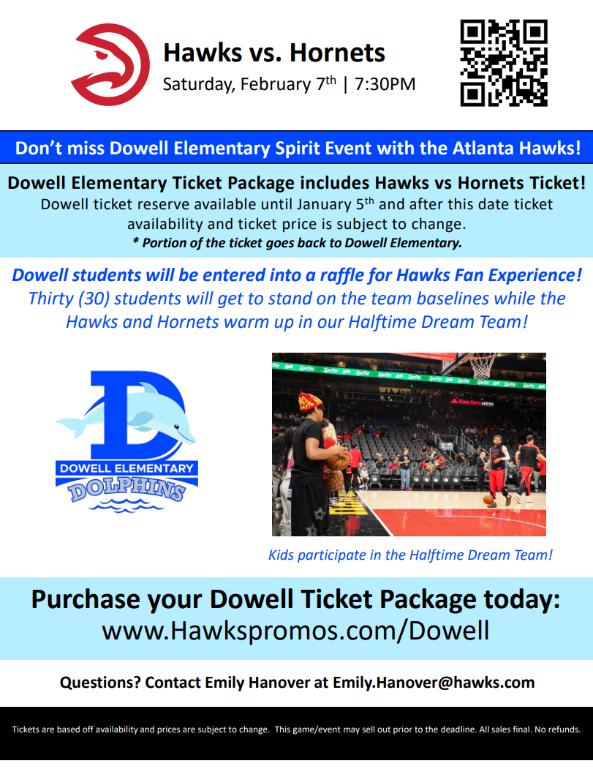

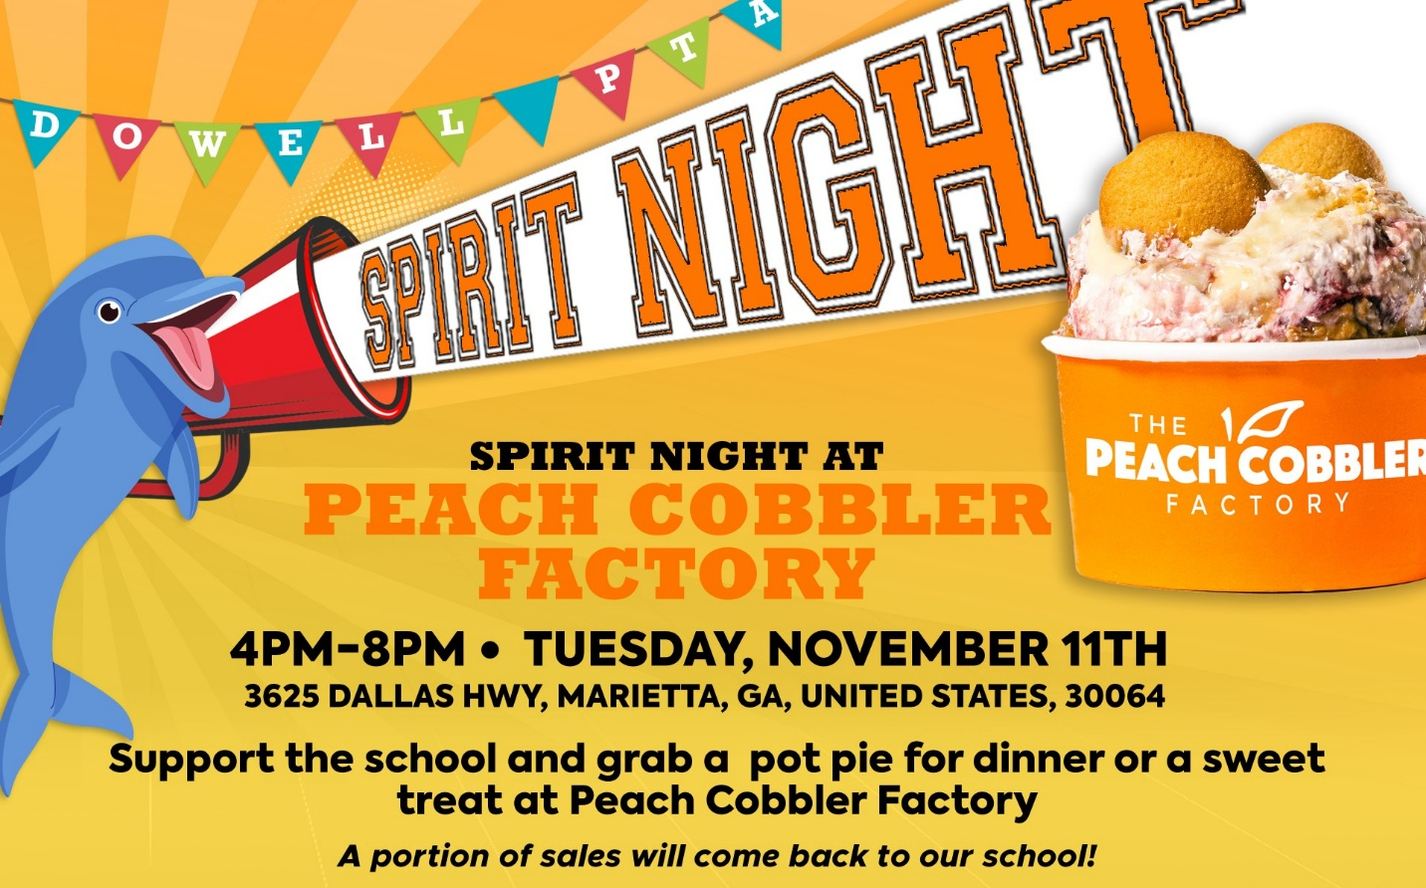

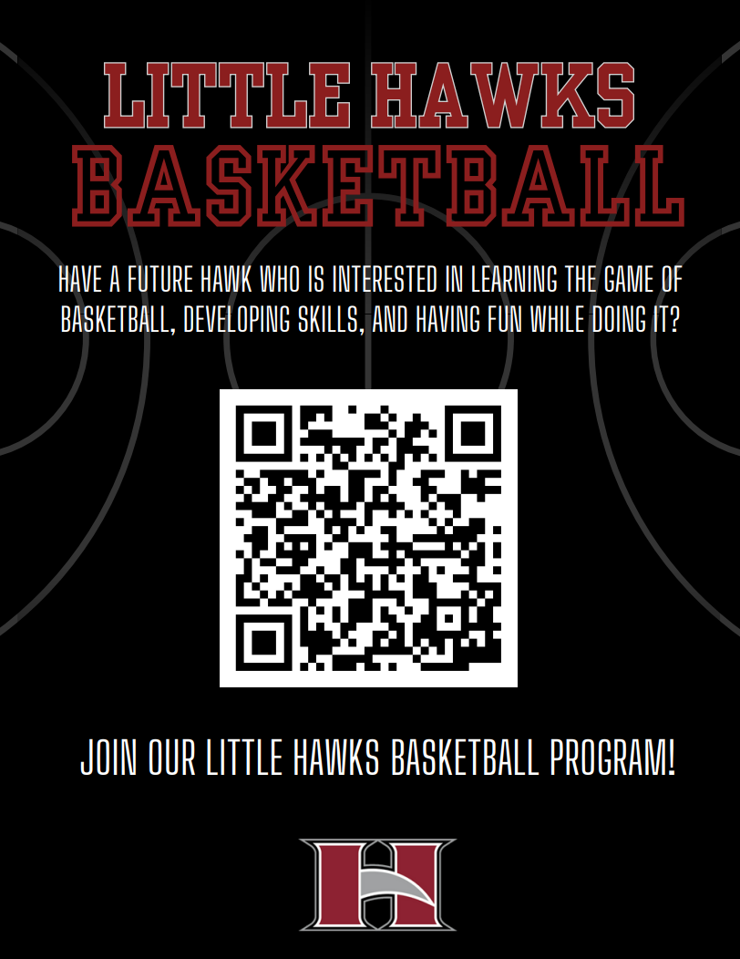

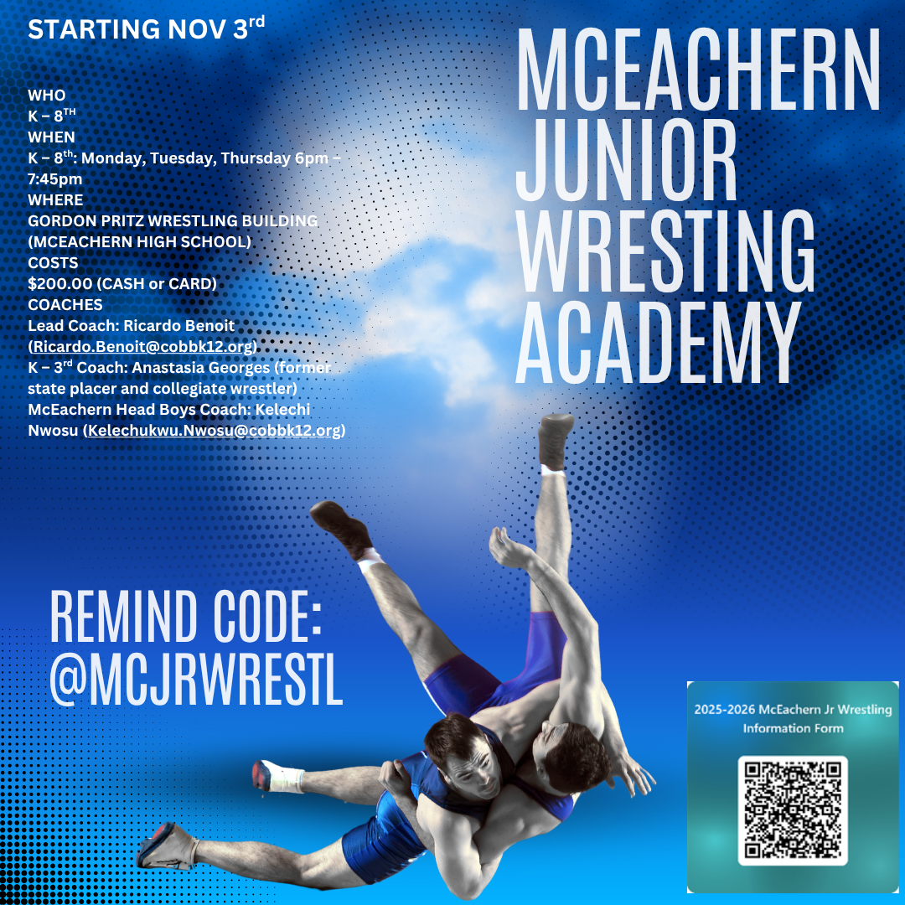

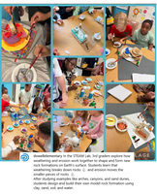
Follow us on social media.
https://www.instagram.com/dowellelementary

