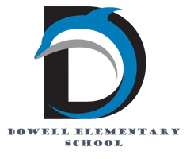
Dolphin Weekly
Sunday, November 30, 2025


Save the Date!
December 1/Monday - Back to School
December 2/Tuesday
- Digital Learning Day
December 5/Friday
- Terrific Kids, Citizenship
December 11/Thursday
- Chorus Concert & PTA Holiday Event, 6:00 pm
December 12/Friday
- Chorus at Piedmont, 5:30-6:30
December 18 & 19/Thursday & Friday
- Early Release Days

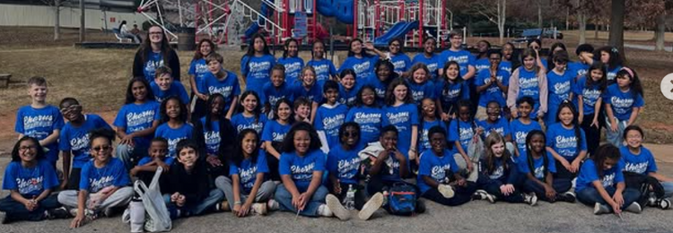

From the Principal's Desk
Dear Dowell Families,

I hope your Thanksgiving break was wonderful! 💙 As we continue into this busy and festive season, our students and staff are shining in so many ways—and we’re grateful to share the highlights with you.

🎼 Dowell Chorus Shines in the Community
We are incredibly proud of our committed Dowell Chorus members who recently brightened the day at the Kiwanis Club with their beautiful performance. Their voices, enthusiasm, and professionalism represented our school with excellence. Thank you to these dedicated students (and to Ms. Somers!) for sharing their talents with our community.

🍽️ Cafeteria Golden Tray Winners – October & November
We expect great manners, kindness, and positive behavior from our Dolphins in the cafeteria, and these classes went above and beyond!

✨ Golden Tray Winners ✨Congratulations to the following classes for demonstrating outstanding lunchroom behavior—we are so proud of you! 🥇
- Mrs. Zahrndt & Mr. Durham
- Ms. Haynes & Ms. Sanchez
- Dr. Scott
- Mrs. Wint
- Ms. Larkin & Ms. Shaw
- Mrs. Sargent
- Mrs. Baltes
- Mr. Ricks
- Mr. Thomas
- Mrs. Haklik
- Mrs. Wilson
Keep up the great work, Dolphins!

Thank You for Your Partnership
Thank you to those who were able to join us for Thanksgiving lunch and Gobble Up Literacy! We are so grateful for the ongoing support and encouragement you give our staff and school community. Your involvement truly helps make Dowell a special place to learn and grow.

Wishing all of our families a warm and wonderful week ahead!

With appreciation,

Dr. Cain
principal
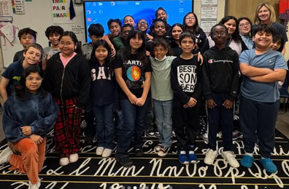

----------------------------------------------------------------

Reminders:
- ID Requirement: A picture ID is required every time you visit the school. Please show it to the camera at the right front door and press the button (door bell). A staff member will confirm your reason for visiting and verify your child’s information before buzzing you in. Upon entry, always go straight to the front office.
- Visiting for Lunch? You’re welcome to sit with your child in the cafeteria during their lunch time. We kindly ask that you not bring fast food or restaurant meals, as it’s not fair to other students. Please check out at the front office after your visit.
- Do NOT Enter: For student and staff safety, please do not use the DO NOT ENTER/Buses Only entrance during AM or PM carpool.

Join us for our December Dress Up Days!

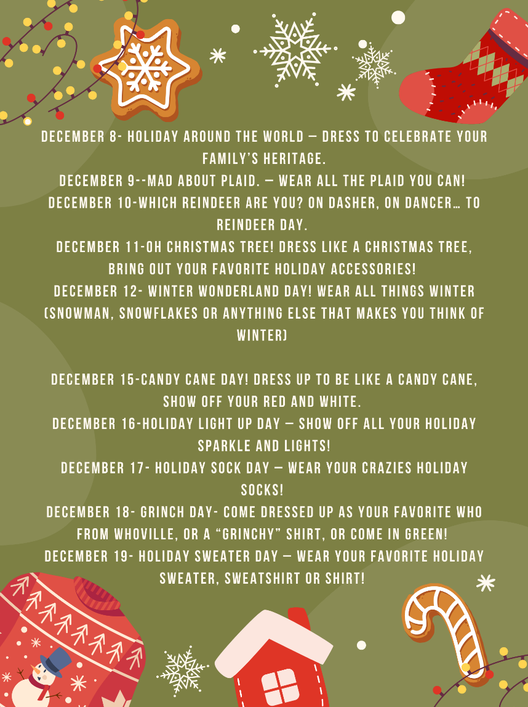

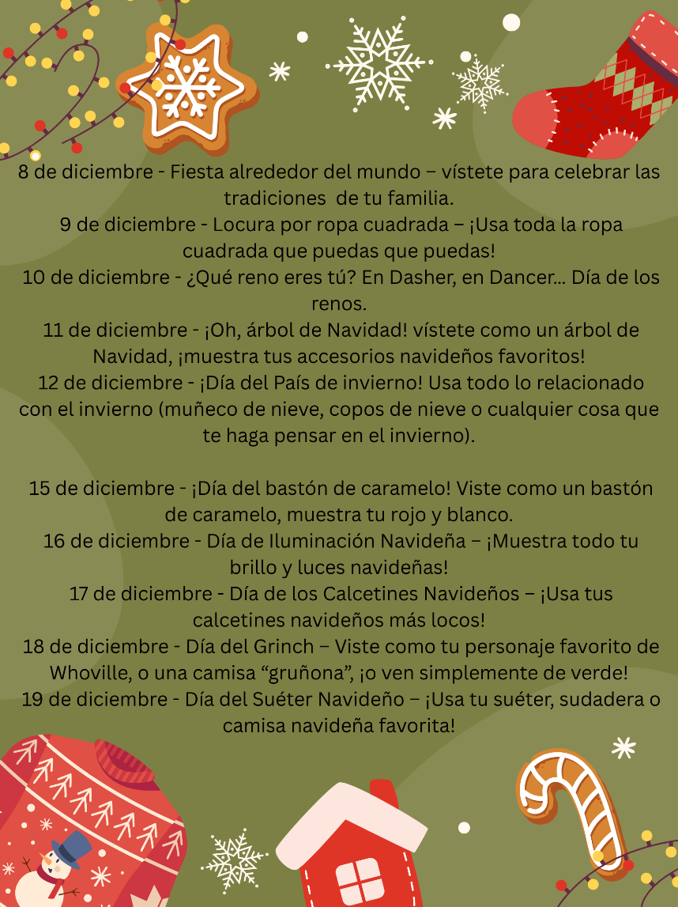

Black History Month
We’re beginning to plan our Black History Month celebration and would love for our families to be part of it! If you’d like to volunteer, share a tradition, or help make this event special, please fill out our short interest form.

Save the Date: Thursday, February 26th

Sign up here

Classroom Celebrations Request Form
Dear Teachers/Parents/Staff,
Do you want to celebrate with your students but don’t have the time for all the planning and details? Return this request form to the Cafeteria Manager and leave the party to us! Upon receipt of the request form, we will provide you with a price quote for your party within 48 hours. On the celebration day, we take care of everything for you!

Please see attached form for pricing items and pricing.

Also if you plan on bringing in a treat for your child's birthday please fill out the attached cupcake form at least 24 hours in advance for the teacher and front office staff to be aware. This helps with planning and any allergies in the classroom.

Community Events



Holiday Shop coming soon!

Preview items at Dowell Elementary School | Marietta, GA | MySchool Holiday Shop

Chorus Concert/Holiday Shop/FREE PHOTO With Santa – December 11th 6PM-730PM

Volunteers Needed

Its that time of year…the time for giving. Please consider volunteering for the Dowell Holiday Shop.

https://www.signupgenius.com/go/20F0F4DAFA82B0-60318955-2025#/

https://www.signupgenius.com/go/20F0F4DAFA82B0-60375873-santa#/

