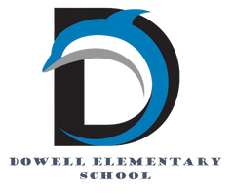
Dolphin Weekly
Sunday, November 9, 2025


Save the Date!

November 10, Monday
- 2nd Graders go to the Etowah Indian Mounds *CANCELLED due to cold temps***
November 11, Tuesday
- Spelling Bee, 9:00
November 14, Friday
- Veteran's Day program, 8:00
November 17, Monday
- Thanksgiving Lunches, SNPK, K & 4th & CORE
November 18, Tuesday
- Thanksgiving Lunches 1st & 5th & Bridge
- Fourth grade Field Trip to Cobb Museum of Art
November 19, Wednesday
- Thanksgiving Lunches 2nd & 3rd
- Fourth grade Field Trip to Cobb Museum of Art
November 20, Thursday
- Picture Retakes
- 4th & 5th Grade chorus field trip
- 5th Grade Dance, 6:00-7:30
November 21, Friday
- Terrific Kids (Responsibility), 8:00 AM
November 24 - 28, M-F
- Thanksgiving Holiday break
December 2/Tuesday
- Digital Learning Day
December 11/Thursday
- Chorus Concert & PTA Holiday Event
December 18 & 19/Thursday & Friday
- Early Release Days

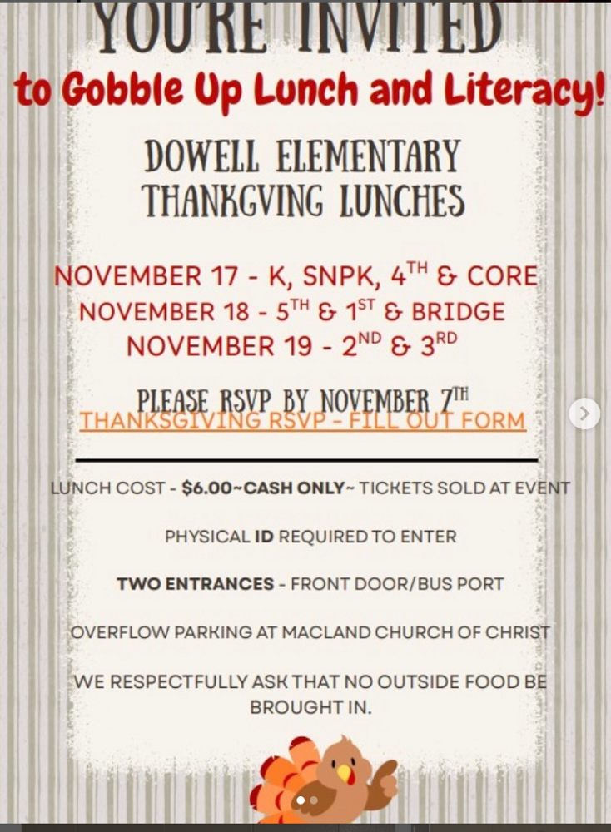

From the Principal's Desk
Dear Dowell Families,

We have so much to look forward to over the next two weeks at Dowell! 💙 Thank you again for your support during IOWA testing and all of our recent events—you truly help make our school a special place.

Veterans Day Celebration – Friday, November 14th
We are excited to honor those who have served our country at our Veterans Day Celebration on Friday, November 14th. We look forward to welcoming our students, families, and their special veterans to our school for this meaningful event.

🦃 Thanksgiving Lunches – November 17th, 18th, and 19th
The following week, we are excited to host our Thanksgiving Lunches. We love welcoming families to share this tradition with their children. To ensure a safe and smooth experience for everyone, the following procedures will apply:
- Please arrive early for check-in.
- Every adult must present a physical photo ID before entering the building.
- Parking is available in the main lot, the bus lot, and at Macland Church of Christ.
- Families may enter through the front doors or the bus port doors.
We appreciate your cooperation and look forward to seeing many of you on campus during these special days.

🌟 Staff Members of the Month

Please help us celebrate our Dowell Staff Members of the Month:
- Ms. Clare, Kindergarten Paraprofessional
- Mrs. Duran, Kindergarten Teacher

Both of these outstanding educators go above and beyond each day to support our youngest learners. They show patience, kindness, and a true commitment to helping students grow—academically, socially, and emotionally. We are so thankful to have them as part of our Dowell family!
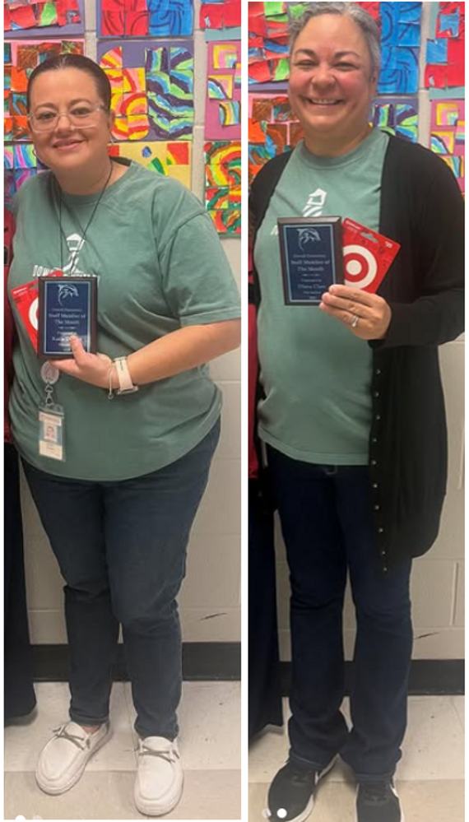

Ongoing Family Support

As a reminder, if your family is experiencing challenges, including those related to SNAP benefit changes, we are here to help connect you with resources. For confidential support, please reach out to our parent facilitator, Ms. Esther Islam, at Esther.Islam@cobbk12.org
.
Thank you for your continued partnership, support, and trust. I am grateful for each of you and the way you show up for our students and staff every day. 💙

With appreciation,

Dr. Cain
principal
----------------------------------------------------------------

Reminders:
- ID Requirement: A picture ID is required every time you visit the school. Please show it to the camera at the right front door and press the button (door bell). A staff member will confirm your reason for visiting and verify your child’s information before buzzing you in. Upon entry, always go straight to the front office.
- Visiting for Lunch? You’re welcome to sit with your child in the cafeteria during their lunch time. We kindly ask that you not bring fast food or restaurant meals, as it’s not fair to other students. Please check out at the front office after your visit.
- Do NOT Enter: For student and staff safety, please do not use the DO NOT ENTER/Buses Only entrance during AM or PM carpool.

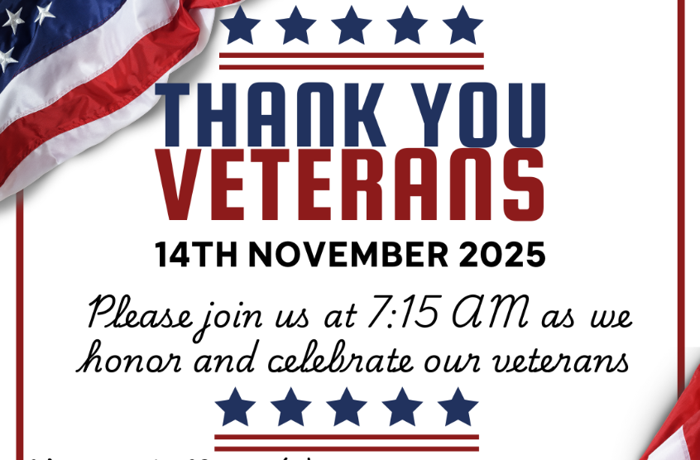

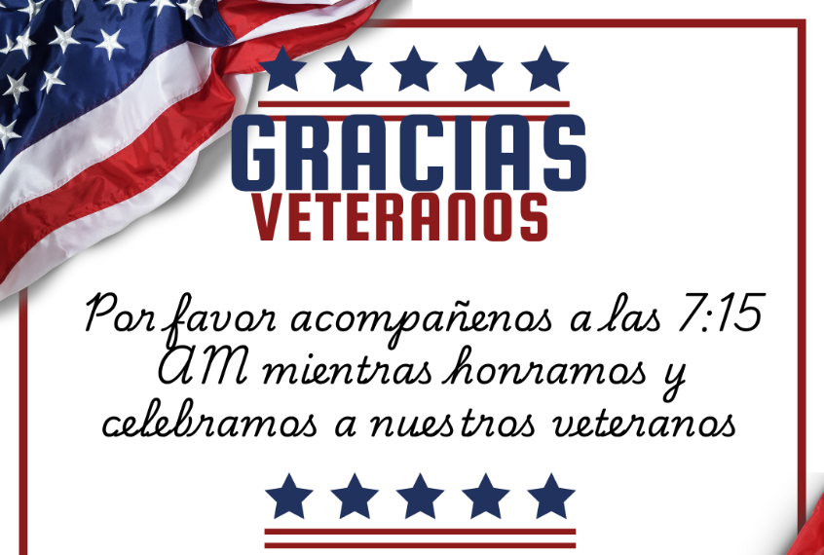

Black History Month
We’re beginning to plan our Black History Month celebration and would love for our families to be part of it! If you’d like to volunteer, share a tradition, or help make this event special, please fill out our short interest form.

Sign up here

Classroom Celebrations Request Form
Dear Teachers/Parents/Staff,
Do you want to celebrate with your students but don’t have the time for all the planning and details? Return this request form to the Cafeteria Manager and leave the party to us! Upon receipt of the request form, we will provide you with a price quote for your party within 48 hours. On the celebration day, we take care of everything for you!

Please see attached form for pricing items and pricing.

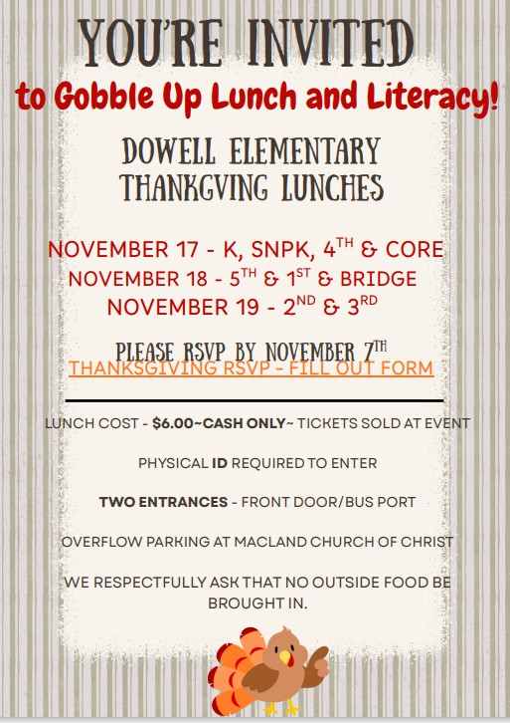

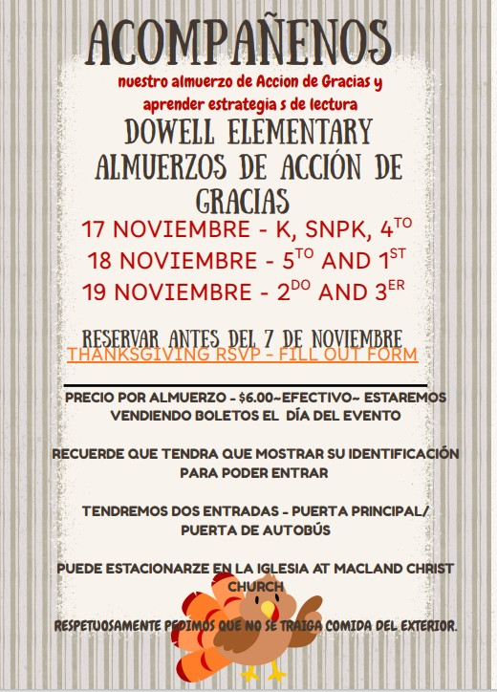

Community Events

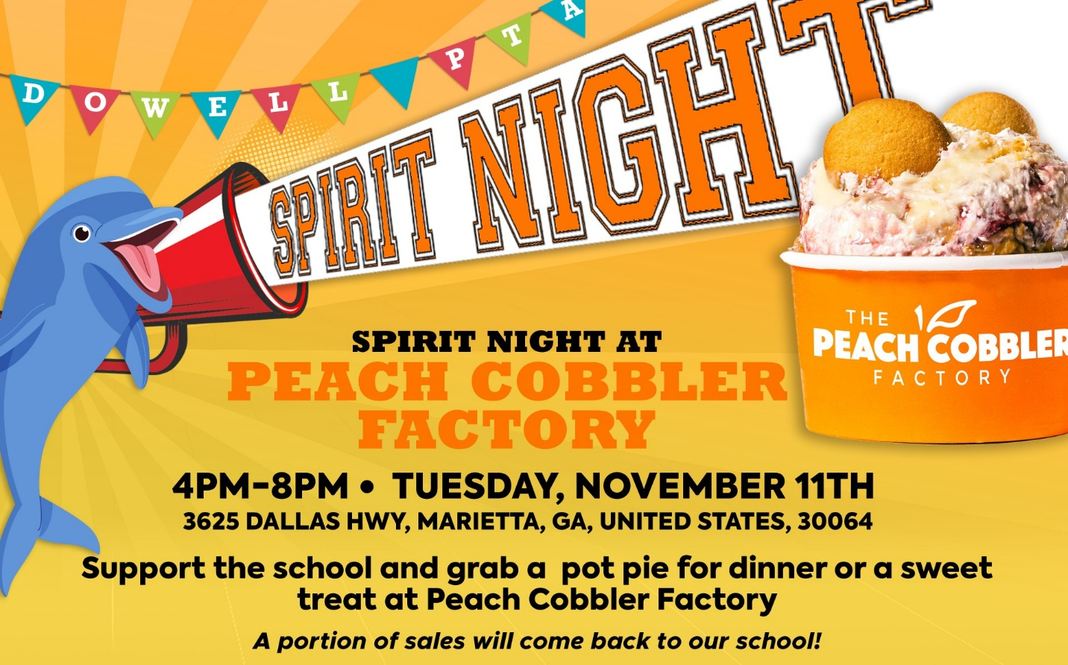



Fun Club Registration is now OPEN!
Spring 2026 Registration Opens Soon! Please Visit https://www.funclubs.com/schools and Choose Dowell Elementary School to Preview Clubs that will be offered this coming semester!

📅 Mark Your Calendars! Sign-Ups Open Nov 10th at 8 PM!

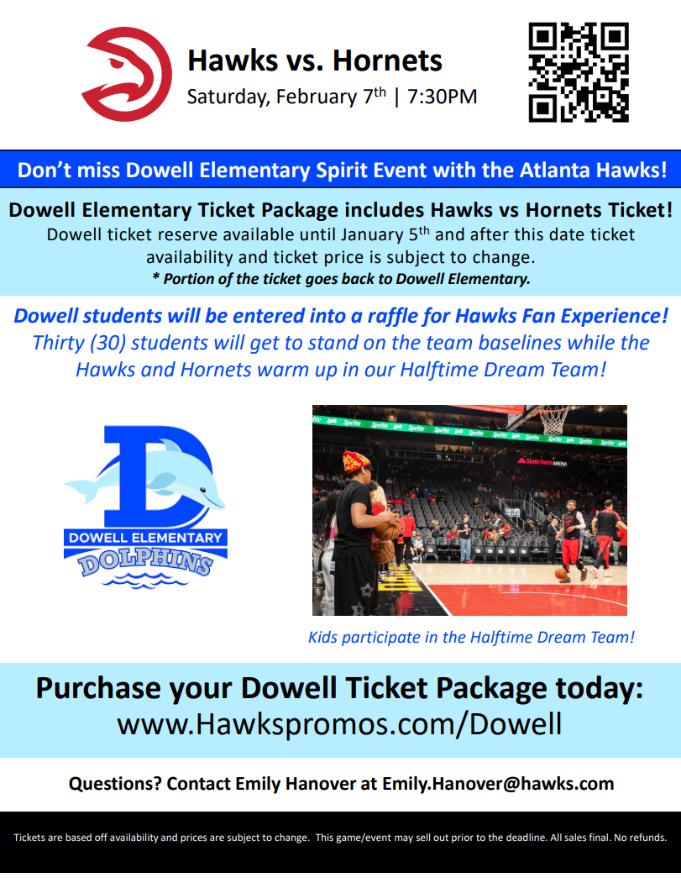

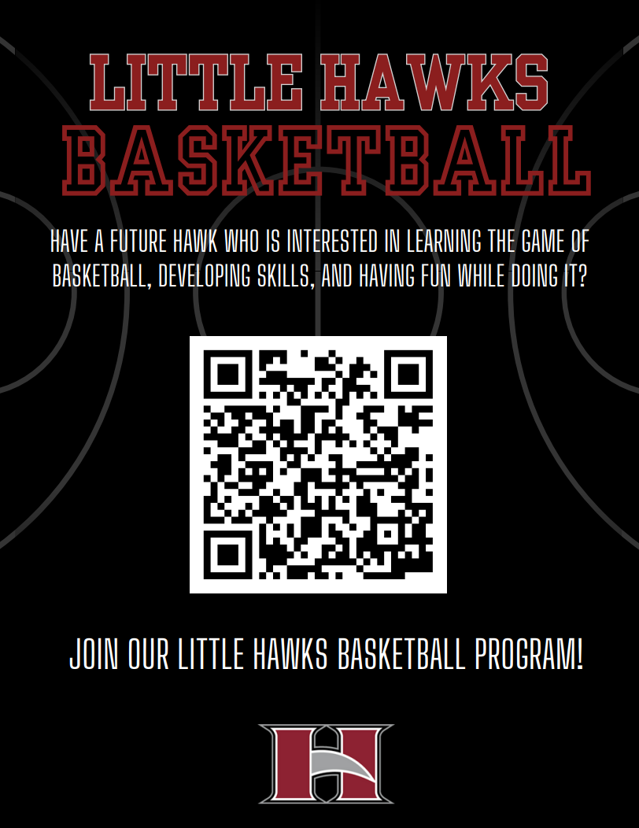

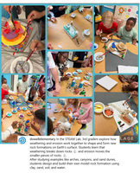
Follow us on social media.
https://www.instagram.com/dowellelementary

