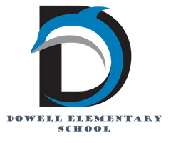
Dolphin Weekly
Sunday, December 14, 2025


Save the Date!
December 16th, Tuesday
- 5:00-8:00 PM Chick-fil-A Night at Barrett & Powder Springs
December 18 & 19/Thursday & Friday
- Early Release Days (students dismissed 2 hours early)
December 22- January 5th
- Holiday Break

Tuesday, 1/6
- Student return to school
Friday, 1/9
- Terrific Kids: Compassion
Monday, 1/19
- MLK Jr. Day/No School
Thursday, 1/22
- Cosmic Bowling, Science Fair & Math Night

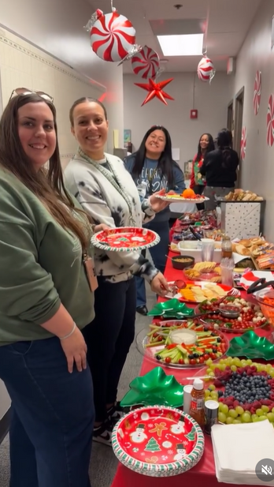

From the Principal's Desk
Dear Dowell Families,

We continue to be so proud of the amazing things happening at Dowell! 💙 Thank you for your continued support and partnership as we move through this busy and joyful season.

💙 Thank You, PTA!
A huge thank you to our incredible Dowell PTA for spoiling our staff with amazing treats and fun gift giveaways this week. We truly have the best PTA and the most dedicated team of parents who give their time, energy, and hearts to support our students and staff. We are so grateful for you!

🎨 ArtsNOW Demonstration of Learning Day – Phenomenal!
Our ArtsNOW Demonstration of Learning Day was an absolute success! Guests from around the Southeast—including Cobb County schools and district office staff—had the opportunity to see outstanding arts integration in action throughout our building. Our students confidently shared their learning, and our teachers beautifully facilitated meaningful, engaging instruction. We could not be prouder of our Dowell Dolphins and staff for showcasing the incredible work happening here every day.
best each day.

⏰ Early Release Reminder
Please remember that Thursday and Friday of this week are Early Release Days, and students will be dismissed two hours early on both days. Thank you for planning accordingly.

🎄 Thank You for a Wonderful Thursday Night!
Thank you to everyone who joined us for the Chorus Concert, PTA Holiday Shop, and Pictures with Santa. It was a festive and joyful evening, and we loved celebrating the season together with our Dowell families.

As always, thank you for being such an important part of our Dowell community. We are proud of our students, staff, and families—and grateful to share these special moments with you! 💙

With appreciation,

Dr. Cain
principal
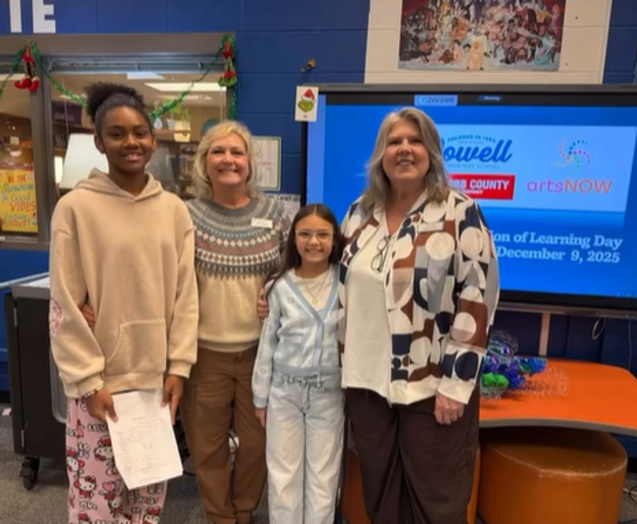

----------------------------------------------------------------

Reminders:
- ID Requirement: A picture ID is required every time you visit the school. Please show it to the camera at the right front door and press the button (door bell). A staff member will confirm your reason for visiting and verify your child’s information before buzzing you in. Upon entry, always go straight to the front office.
- Visiting for Lunch? You’re welcome to sit with your child in the cafeteria during their lunch time. We kindly ask that you not bring fast food or restaurant meals, as it’s not fair to other students. Please check out at the front office after your visit.
- Do NOT Enter: For student and staff safety, please do not use the DO NOT ENTER/Buses Only entrance during AM or PM carpool.

Holiday Shop!!!!
Great news! The School Holiday Shop will be extended for this coming Monday Dec 15th and Tuesday 16th only and will be open to all students and teachers.
🛍️ Cash-only purchases will be available to shop.
🎁 Please feel free to send your children and students by to continue shopping and find special items for the holiday season.
Thank you for your support, and happy holiday shopping!

Dowell Steppers: Sign Up Now!
We’re putting together a student step team for Black History Night, and we want kids who are ready to try something fun and high-energy. No experience is needed. Just enthusiasm and a willingness to jump in.

Students will learn the basics of stepping, work as a team, build confidence, and pick up some seriously cool moves along the way.

Sign-Up Deadline: Wednesday, December 17, 2025

Practice Dates:
January 13, 20, 27
February 3, 10, 24

Time: 2:45 to 3:45 pm

If your child wants to be part of something exciting and full of school spirit, this is the perfect chance. We can’t wait to see who signs up.

Sign up here!

Join us for our December Dress Up Days!

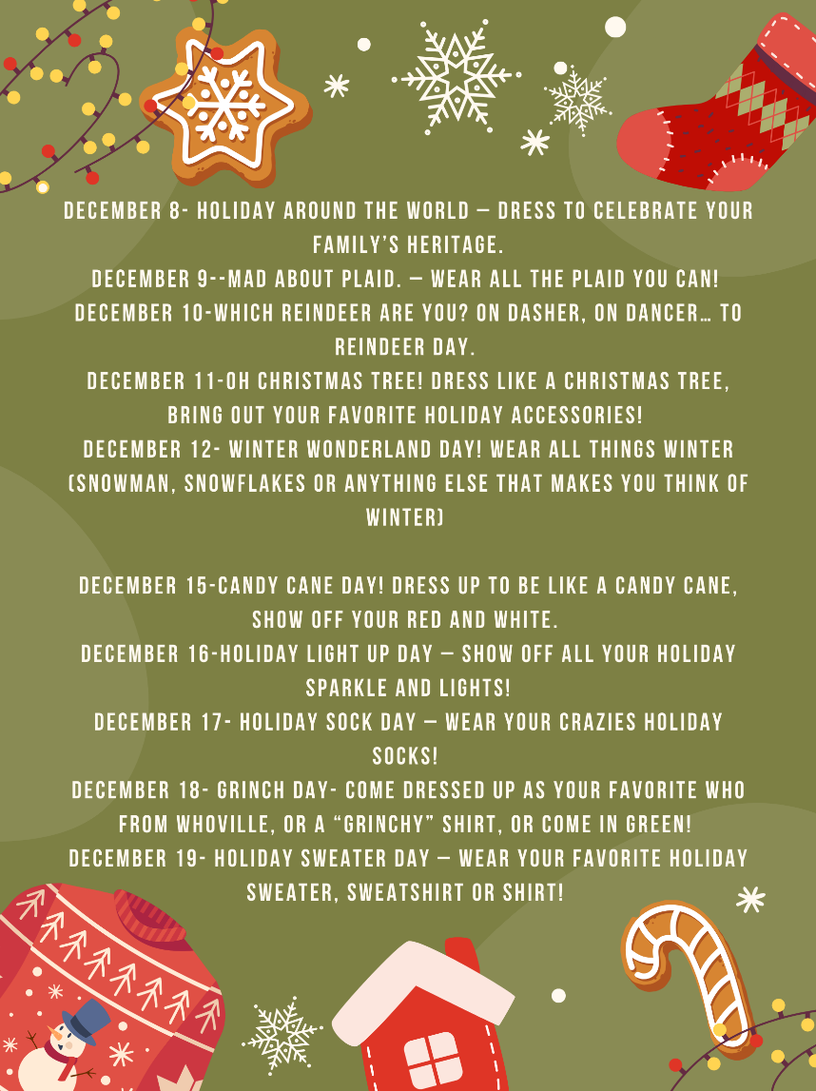

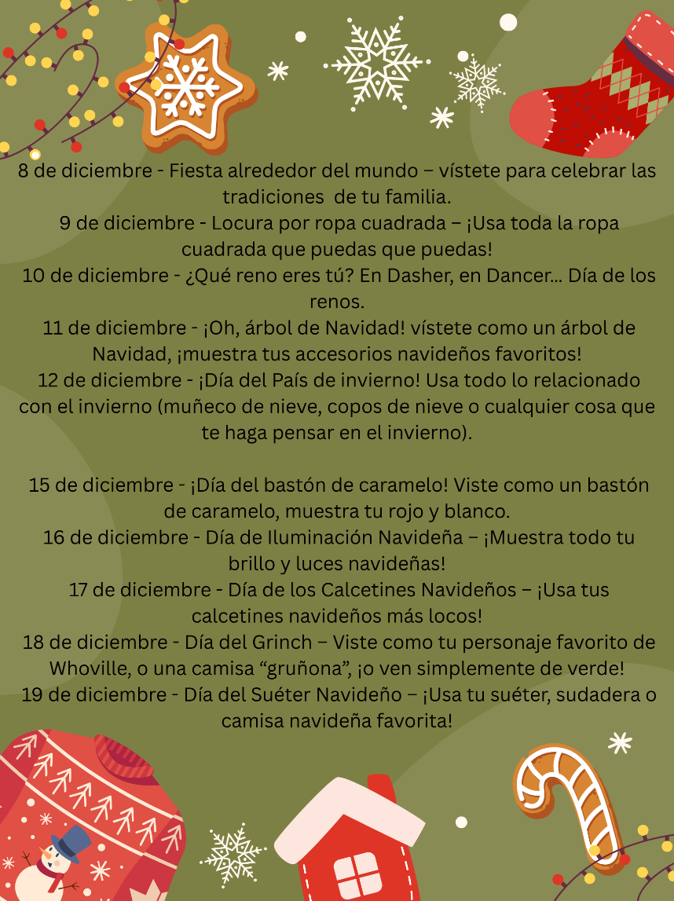

Classroom Celebrations Request Form
Dear Teachers/Parents/Staff,
Do you want to celebrate with your students but don’t have the time for all the planning and details? Return this request form to the Cafeteria Manager and leave the party to us! Upon receipt of the request form, we will provide you with a price quote for your party within 48 hours. On the celebration day, we take care of everything for you!

Please see attached form for pricing items and pricing.

Also if you plan on bringing in a treat for your child's birthday please fill out the attached cupcake form at least 24 hours in advance for the teacher and front office staff to be aware. This helps with planning and any allergies in the classroom.

Community Events

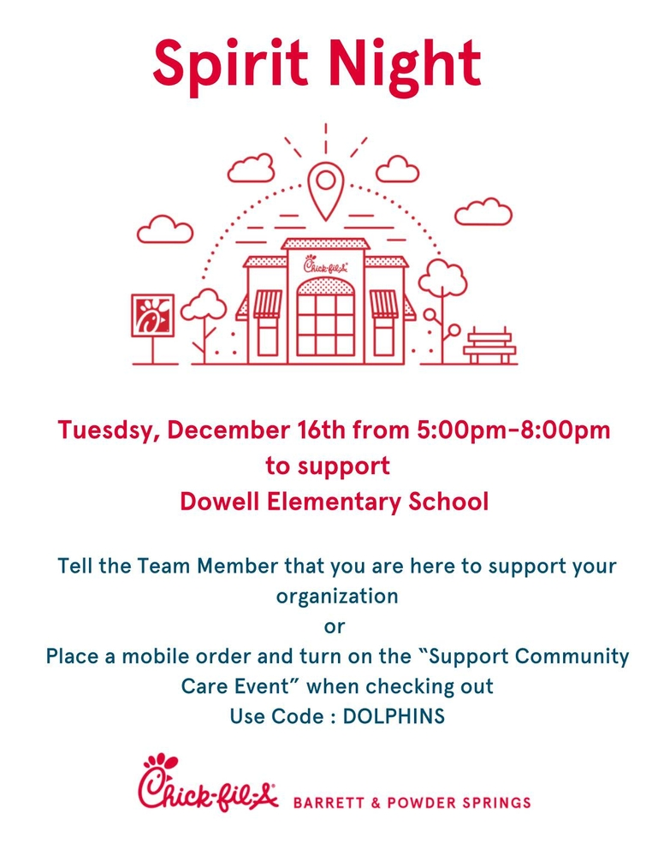



Fun Club Registration is now OPEN!
Spring 2026 Registration Opens Soon! Please Visit https://www.funclubs.com/schools and Choose Dowell Elementary School to Preview Clubs that will be offered this coming semester!

📅 Mark Your Calendars! Sign-Ups are now Open!

Year End
As our first semester comes to an end so does fun clubs. Please see below to find out what date each club.

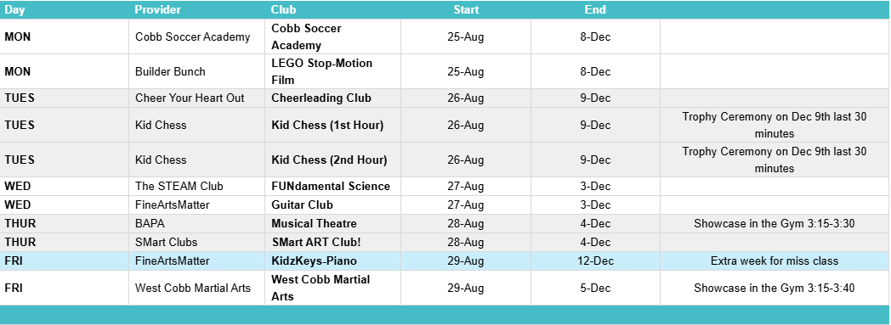

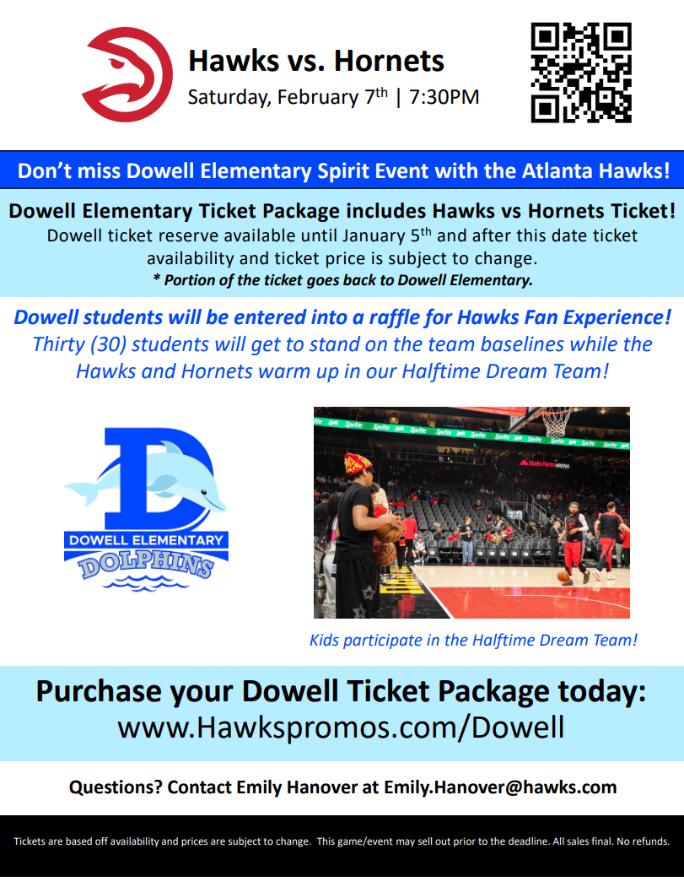

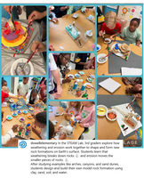
Follow us on social media.
https://www.instagram.com/dowellelementary

