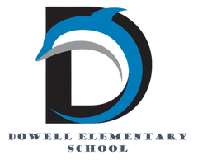
Dolphin Weekly
Sunday, December 7, 2025


Save the Date!

December 11/Thursday
- 6:00, Chorus Concert & PTA Holiday Event: Pictures with Santa & Holiday Shop (extended hours 4:00-7:00pm)
December 12/Friday
- Chorus at Piedmont, 5:30-6:30
December 18 & 19/Thursday & Friday
- Early Release Days (students dismissed 2 hours early)

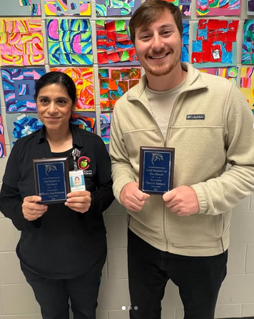

From the Principal's Desk
Dear Dowell Families,

We are excited to celebrate our Dowell Staff Members of the Month—Mr. Ramsey (3rd Grade) and Ms. Vega-Perkerson (Cafeteria Manager)! Thank you both for everything you do for our students and school each and every day. We appreciate you!

🌟 Celebrating Our Girls on the Run!
Dowell’s Girls on the Run team wrapped up their season with a 5K in downtown Atlanta—and they were incredible! Their teamwork, confidence, and determination make us so proud. Congratulations, girls! 💙

📊 BEACON Assessments Continue
Students will continue completing BEACON assessments this week. Thank you for supporting students by helping them arrive on time and ready to do their best!

🎨 Arts Integration Showcase
On Tuesday, we look forward to welcoming guests from our district and the ArtsNOW Organization as our students and teachers highlight Arts Integration work happening here at Dowell. We are excited to share our learning with our visitors!

🎄 Join us Thursday Night! (12/11)
• Chorus Concert
• PTA Holiday Shop
• Pictures with Santa
We look forward to seeing you and celebrating this festive season together!

⏰ Mark Your Calendars
Thursday & Friday, December 18 & 19
• Early Release Days
• Students dismissed two hours early
Thank you for planning ahead!

With appreciation,

Dr. Cain
principal


----------------------------------------------------------------

Reminders:
- ID Requirement: A picture ID is required every time you visit the school. Please show it to the camera at the right front door and press the button (door bell). A staff member will confirm your reason for visiting and verify your child’s information before buzzing you in. Upon entry, always go straight to the front office.
- Visiting for Lunch? You’re welcome to sit with your child in the cafeteria during their lunch time. We kindly ask that you not bring fast food or restaurant meals, as it’s not fair to other students. Please check out at the front office after your visit.
- Do NOT Enter: For student and staff safety, please do not use the DO NOT ENTER/Buses Only entrance during AM or PM carpool.

Holiday Shop
Our holiday shop starts TOMORROW! Our school shop will be open from December 8-12, 2025 during school hours. Gift certificates, cash, and credit/debit cards will be accepted for payment.

We highly encourage the purchase of gift certificates to ensure a smooth check out experience. Gift certificates can be purchased from our website: https://myschool.holidayshop.org/dowellelem/gift-certificates

Your child's teacher should have notified you of when they will be shopping during school hours. If unsure, please contact your child's teacher or dowellpta@gmail.com for confirmation.

REMINDER: We will have extended hours from 4-7p on Thursday, December 11th with a holiday photobooth from 6-7p during our Winter Chorus performance!

Join us for our December Dress Up Days!

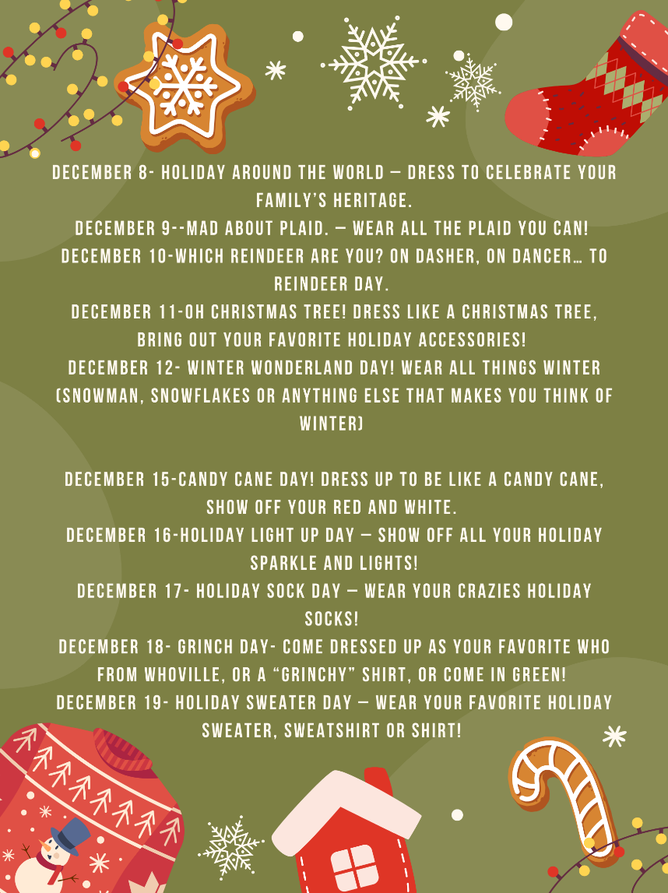

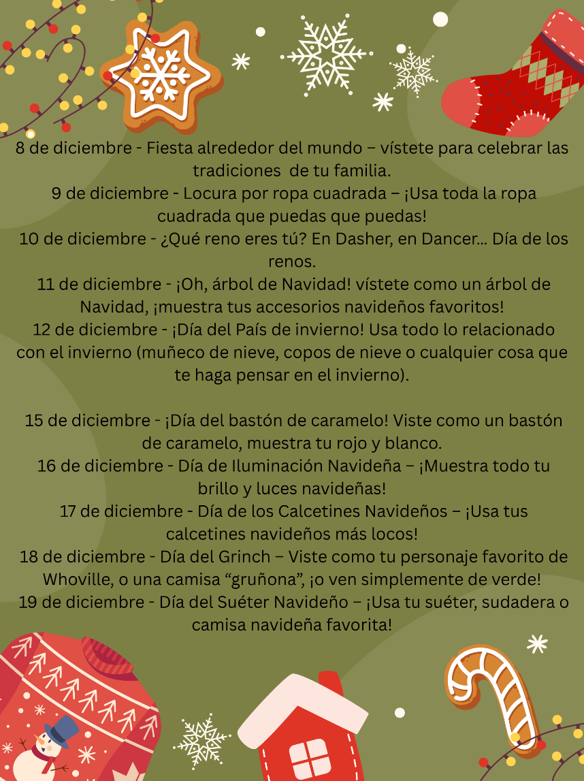

Black History Month
We’re beginning to plan our Black History Month celebration and would love for our families to be part of it! If you’d like to volunteer, share a tradition, or help make this event special, please fill out our short interest form.

Save the Date: Thursday, February 26th

Sign up here

Classroom Celebrations Request Form
Dear Teachers/Parents/Staff,
Do you want to celebrate with your students but don’t have the time for all the planning and details? Return this request form to the Cafeteria Manager and leave the party to us! Upon receipt of the request form, we will provide you with a price quote for your party within 48 hours. On the celebration day, we take care of everything for you!

Please see attached form for pricing items and pricing.

Also if you plan on bringing in a treat for your child's birthday please fill out the attached cupcake form at least 24 hours in advance for the teacher and front office staff to be aware. This helps with planning and any allergies in the classroom.

Community Events



Holiday Shop coming soon!
We are still in need of volunteers for the holiday shop. Especially December 11th and 12th. Please consider signing up below.

https://www.signupgenius.com/go/20F0F4DAFA82B0-60318955-2025#/

Preview items at Dowell Elementary School | Marietta, GA | MySchool Holiday Shop

Volunteers Needed

Its that time of year…the time for giving. Please consider volunteering for the Dowell Holiday Shop.

https://www.signupgenius.com/go/20F0F4DAFA82B0-60318955-2025#/

https://www.signupgenius.com/go/20F0F4DAFA82B0-60375873-santa#/

FREE photos with Santa Dec 11th 6pm-7pm in the Dowell Media Center. You can also visit the Dowell holiday shop with extended hours 8am -7pm.

Congratulations
Congratulations to two of our Dowell students who will be moving on to the Georgia State PTA Reflections Competition.

Olivia Evans ( 2nd Grade) - for Photography
Norah Joof (3rd Grade) - for Dance Choreography



Fun Club Registration is now OPEN!
Spring 2026 Registration Opens Soon! Please Visit https://www.funclubs.com/schools and Choose Dowell Elementary School to Preview Clubs that will be offered this coming semester!

📅 Mark Your Calendars! Sign-Ups are now Open!

Year End
As our first semester comes to an end so does fun clubs. Please see below to find out what date each club.

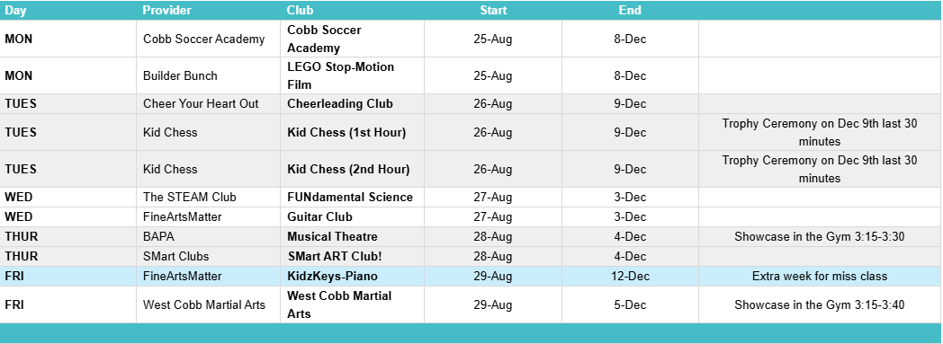

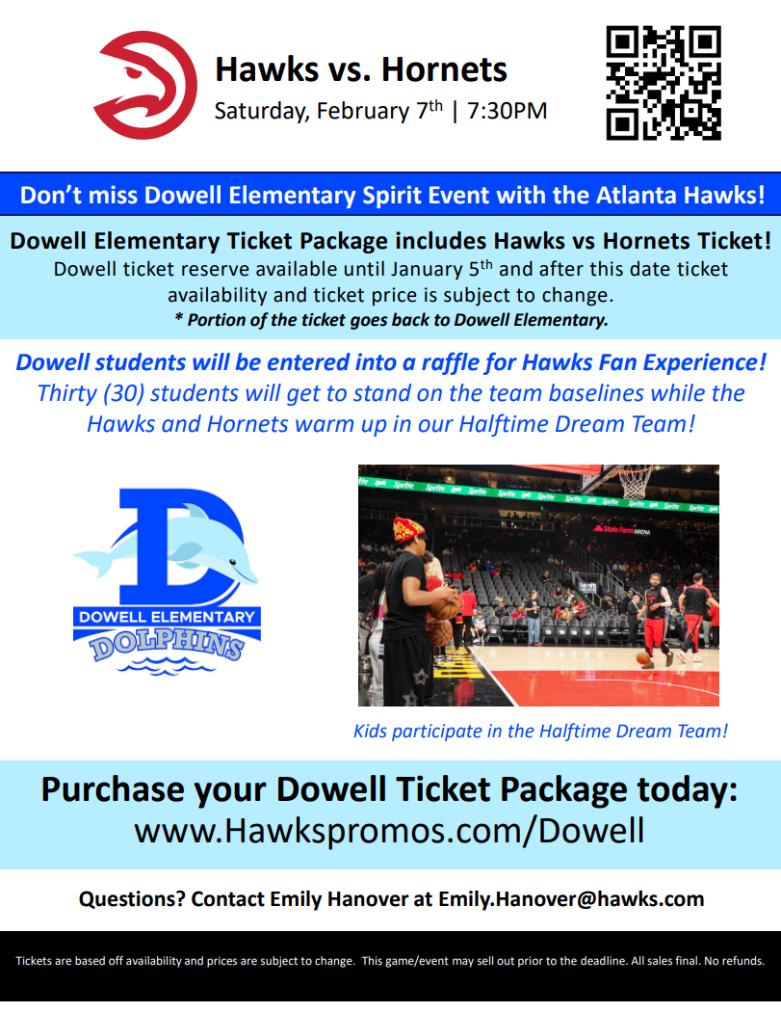

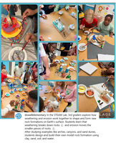
Follow us on social media.
https://www.instagram.com/dowellelementary

