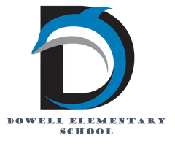
Dolphin Weekly
Sunday, February 1, 2026

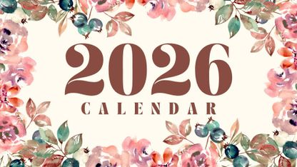
Save the Date!

Tuesday, 2/3
- 5th Grade Georgia Learning Power Visit
Friday, 2/6
- Terrific Kids- Resilience
Saturday, 2/7
- Atlanta Hawks game, 7:30
Tuesday, 2/10
- Reflections Breakfast
- Lovinggood Middle School - STEM Night
Wednesday, 2/11
- 1/2 of 3rd Grade to Tellus Museum
Thursday, 2/12
- Picture Day
Monday-Friday, 2/16-20
- February Break (no school)
Thursday, 2/26
- Black History Performance

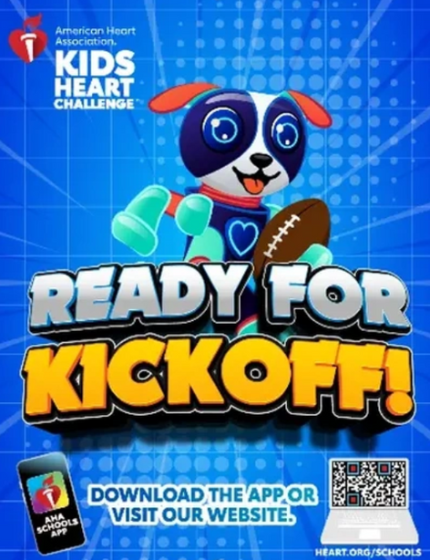

From the Principal's Desk
💙 National School Counseling Week💙 February 2–6, This week, we proudly celebrate National School Counseling Week! Dowell is incredibly grateful for our amazing school counselors, Mrs. McLane and Ms. Wallace. Their care, guidance, and dedication support the academic, social, and emotional growth of our students every single day. We truly love our counselors and thank them for all they do for our Dolphins! 💙🐬

❤️ Kids Heart Challenge – Kickoff Next Week!
The Kids Heart Challenge kicks off next week! Students can complete Finn’s Mission for a chance to win two tickets to Super Bowl LXI in 2027.
- For every 18 participants who complete Finn’s Mission, Dowell will be entered to win a $10,000 fitness equipment makeover.
- The first students to complete Finn’s Mission will earn a special prize!
- Learn more and get started at heart.org/schools.

💌 5th Grade Valentine’s Day Pop-Up Shop
Our 5th grade team will be hosting a Valentine’s Day Pop-Up Shop from February 6–February 13! Students are invited to visit the Maker Space from 7:15–7:50 a.m. to shop for Valentine’s Day gifts, including bears, pencils, erasers, cups, and more. This is a fun way to celebrate while supporting our 5th graders!

You are invited to Lovinggood Middle School's 🔎STEM Night 🔎 on February 10. See the video below from principal, Derrick Bailey.
https://youtu.be/E9BP08O8Iqc

📅 Mark Your Calendars
- 📸 Picture Day: Wednesday, February 12
- 🏖️ February Break: February 16–20

Thank you, as always, for your continued partnership and support. We are grateful for our Dowell families and love sharing these special moments together. 💙🐬

With appreciation,
Dr. Pam Cain
Principal

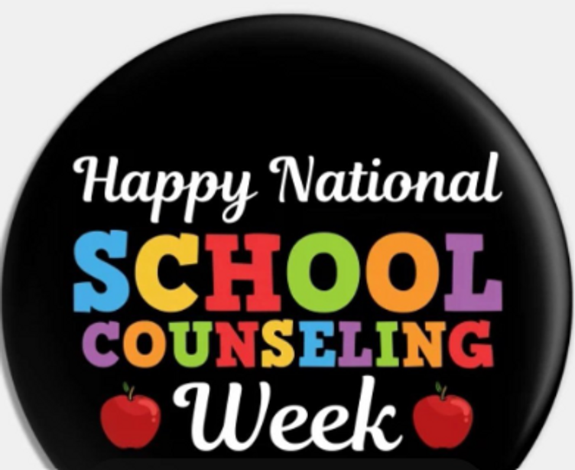

----------------------------------------------------------------

Reminders:
- ID Requirement: A picture ID is required every time you visit the school. Please show it to the camera at the right front door and press the button (door bell). A staff member will confirm your reason for visiting and verify your child’s information before buzzing you in. Upon entry, always go straight to the front office.
- Visiting for Lunch? You’re welcome to sit with your child in the cafeteria during their lunch time. We kindly ask that you not bring fast food or restaurant meals, as it’s not fair to other students. Please check out at the front office after your visit.
- Do NOT Enter: For student and staff safety, please do not use the DO NOT ENTER/Buses Only entrance during AM or PM carpool.

Family Survey Announcement
Dear Parent or Guardian,
Dowell Elementary School will take the new Georgia School Climate Survey this year. Each parent or guardian is invited to take the family version to answer questions about the current school or schools you have a child or children attending. If two or more children attend the same school, please only complete one survey for that school.
The survey measures what you think about how the school engages with families. Answers are not linked to names in any way. When typing answers, please do not give names or information that you don’t want to share with this school. Data will be shared with school leaders to help improve the school and will be published on the GaDOE website.
Please help by sharing your honest opinion on this 22-question survey. T
If you have any questions about the survey, please contact Dr. Clark at Tina.Clark@cobbk12.org.

Take Survey Here

Classroom Celebrations Request Form
Dear Teachers/Parents/Staff,
Do you want to celebrate with your students but don’t have the time for all the planning and details? Return this request form to the Cafeteria Manager and leave the party to us! Upon receipt of the request form, we will provide you with a price quote for your party within 48 hours. On the celebration day, we take care of everything for you!

Please see attached form for pricing items and pricing.

Also if you plan on bringing in a treat for your child's birthday please fill out the attached cupcake form at least 24 hours in advance for the teacher and front office staff to be aware. This helps with planning and any allergies in the classroom.

Girls on the run

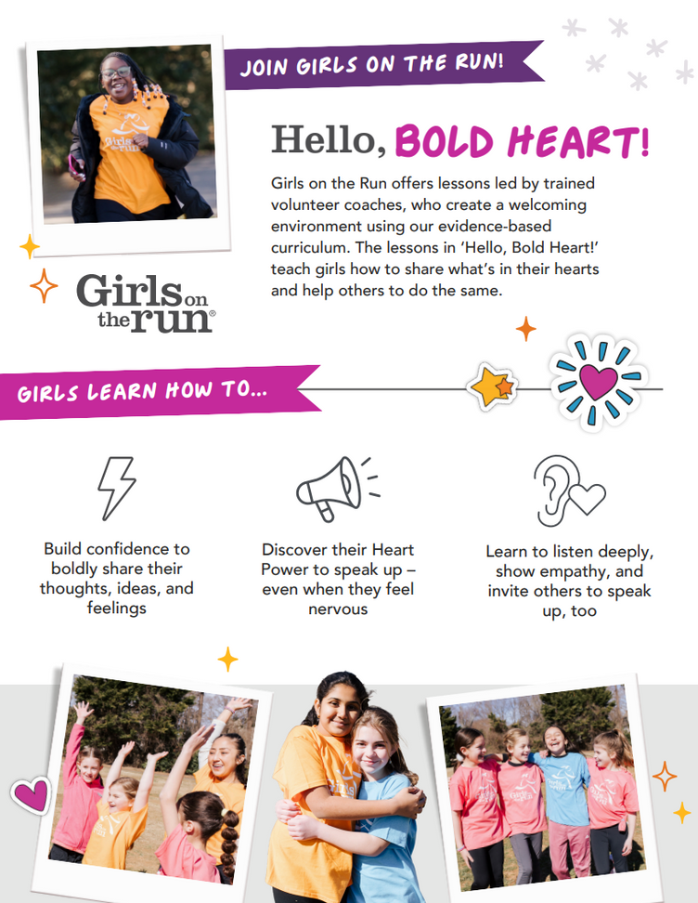
.
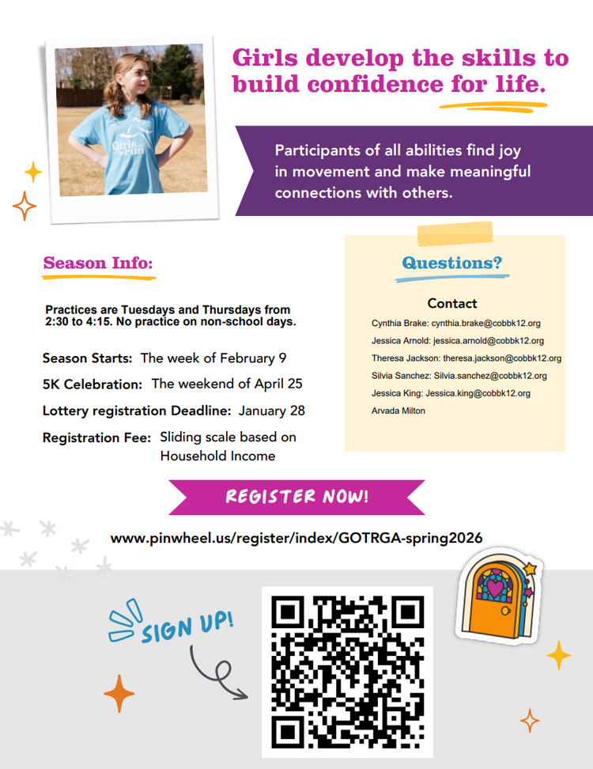
.

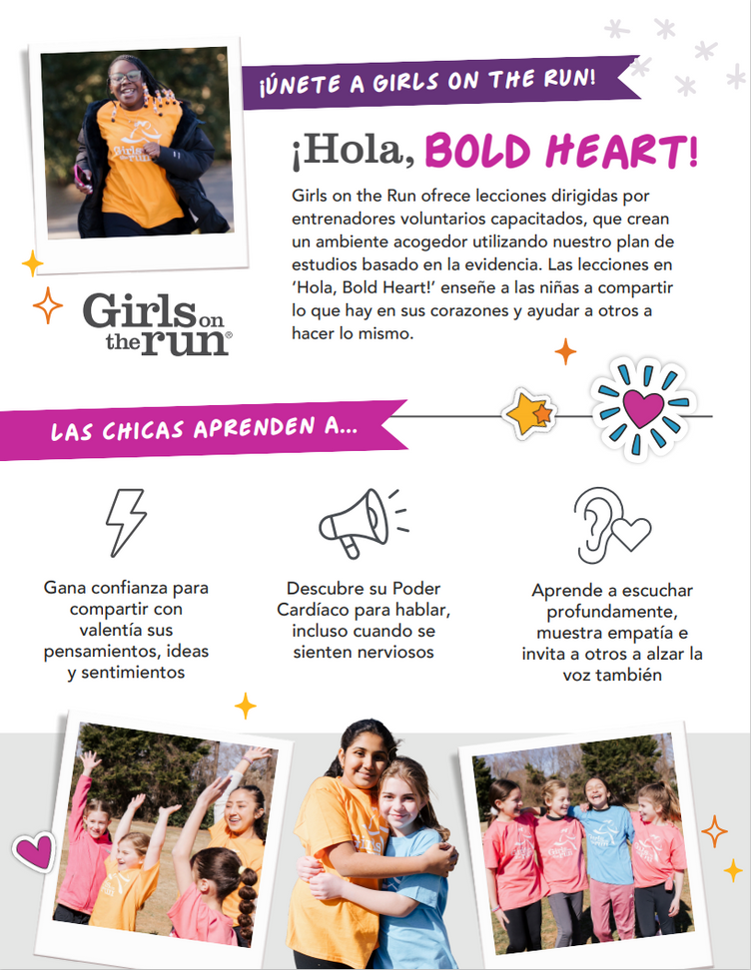
.
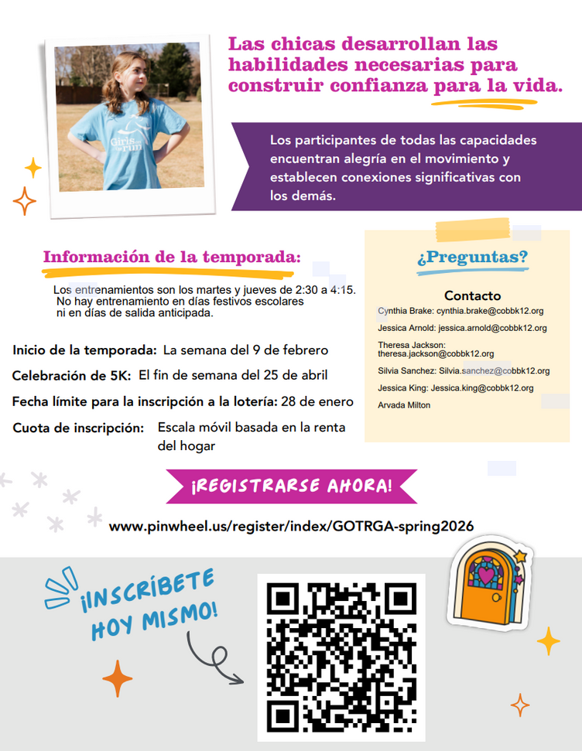
.

Community Events



Fun Clubs Are Up and Running
Please remember to update your child’s dismissal for Fun Clubs starting next week to CLUB in parentvue. If your child is a car rider (after clubs), please pick up no later than 3:50pm. All remaining students will be sent to ASP. Thank you!

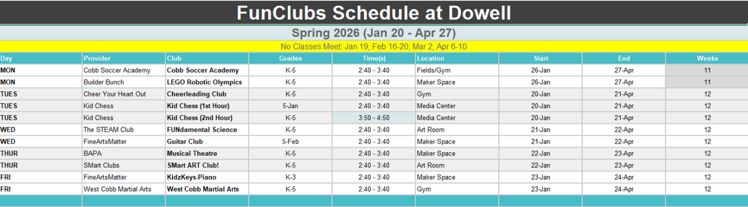

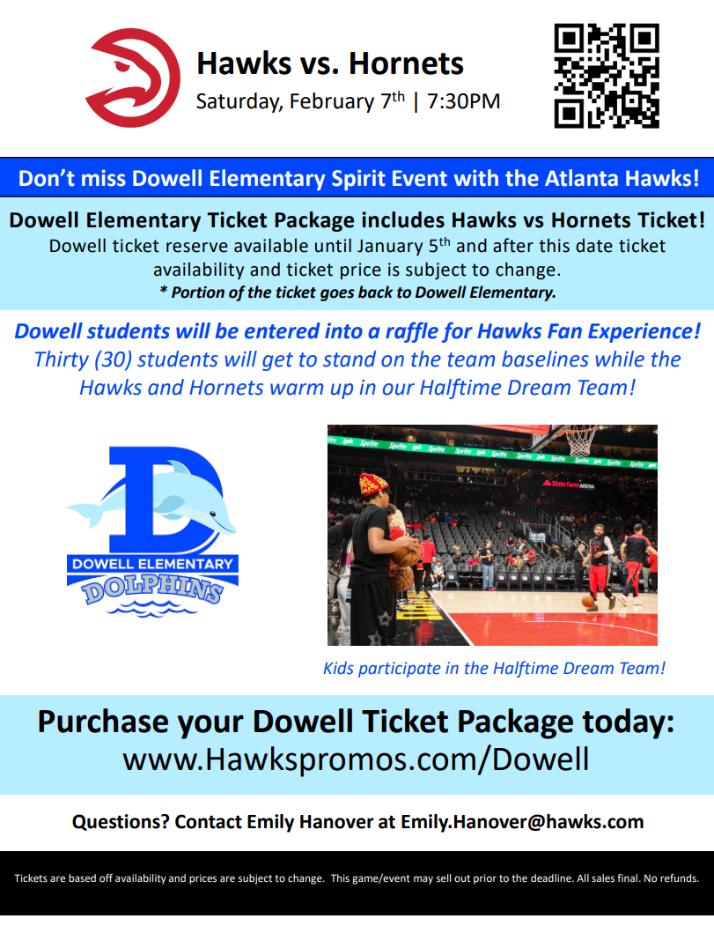

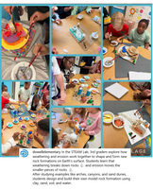
Follow us on social media.
https://www.instagram.com/dowellelementary

