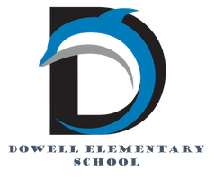
Dolphin Weekly
Sunday, February 22, 2026

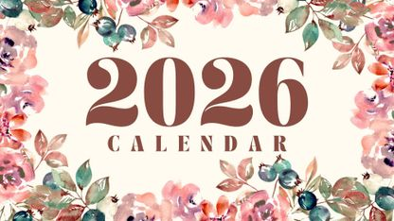
Save the Date!
Monday, 2/23
- Students return to school
Thursday, 2/26
- Black History Performance, 5:00-7:00
Monday, 3/2
- Digital Learning Day
Tuesday, 3/3
- Fun Run Kick-Off
- BEACON Assessment, 5th grade/ELA
- BEACON Assessment, 4th grade/Math
Wednesday, 3/4
- Read Across Cobb
- BEACON Assessment, 3rd grade/Math
- 4th Grade Students - NAEP Test
- 5th Graders to Smitha MS
Thursday, 3/5
- BEACON Assessment, 5th grade/Math
Friday, 3/6
- Terrific Kids-Tolerance
- BEACON Assessment, 3rd grade/ELA
- BEACON Assessment, 4th grade/ELA
- Kona Ice for ALL from PTA
- Kindergarten: High Touch/High Tech Inhouse Field Trip
- Chorus - Elementary Choral Festival
March 5 - 13, Book Fair

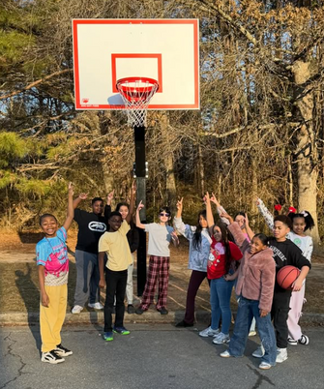

From the Principal's Desk
Dowell Families,

I hope your February break was restful and wonderful! We are excited to welcome our students back and jump right back into learning together.

🎉 Black History Night – Thursday, February 26th

We look forward to seeing our families on Thursday, February 26th for our Black History Night. This will be a meaningful evening of learning, celebration, and community, and we hope you’ll join us as we honor history, culture, and contributions together.

🏀 Thank You, Dowell Foundation!

A huge thank you to the Dowell Foundation for the purchase of our new basketball goals and Gaga Ball pits! These exciting additions were made possible through Dowell’s yearly fundraiser and are wonderful examples of how fundraising directly enhances student experiences.
The kids absolutely LOVE the new additions! 🐬
The Dowell Foundation Fun Run – Shamrock Shuffle is coming soon on March 17th. Funds raised will go toward additional items, materials, and resources—just like the basketball goals—to continue enhancing our school environment and student engagement.

💻 Digital Learning Day – Monday, March 2nd
Please remember that Monday, March 2nd is a Digital Learning Day.
➡️ Students do not report to school and will complete learning activities from home.

📅 Quarter 3 & Assessments
We are quickly approaching the end of Quarter 3 on March 13th. Let’s make every day of learning count between now and the end of the year!

The BEACON Assessment is coming soon. Please encourage your child to do their very best on this and all assessments.
⭐ 5th Grade Families: Please note that middle schools use BEACON Assessment data to help determine 6th grade placement, making this assessment especially important.

Thank you, as always, for your continued partnership and support. We are grateful for our Dowell families and all that we accomplish together!

Warmly,
Dr. Pamela Cain
Principal, Dowell Elementary 🐬

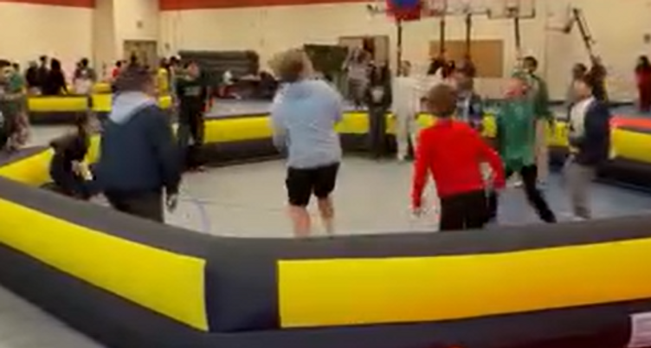

----------------------------------------------------------------

Reminders:
- ID Requirement: A picture ID is required every time you visit the school. Please show it to the camera at the right front door and press the button (door bell). A staff member will confirm your reason for visiting and verify your child’s information before buzzing you in. Upon entry, always go straight to the front office.
- Visiting for Lunch? You’re welcome to sit with your child in the cafeteria during their lunch time. We kindly ask that you not bring fast food or restaurant meals, as it’s not fair to other students. Please check out at the front office after your visit.
- Do NOT Enter: For student and staff safety, please do not use the DO NOT ENTER/Buses Only entrance during AM or PM carpool.

Black History Month



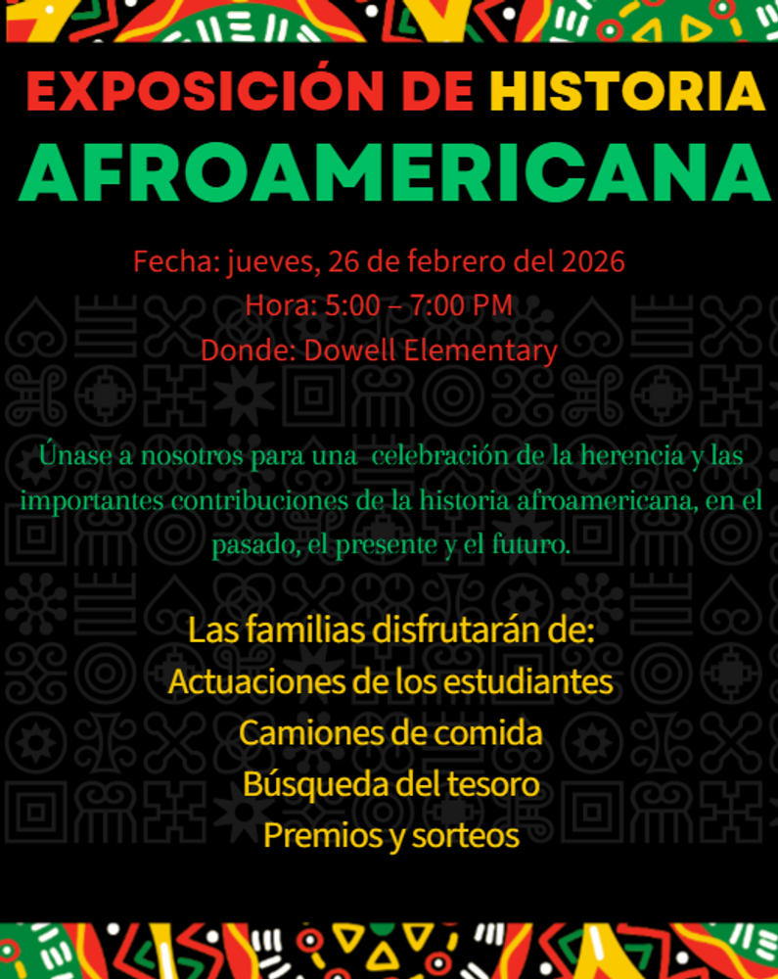

2nd Grade Presents
Please join us on March 19th at 6:00 pm for Three Piggy Opera, performed by our 2nd Graders.

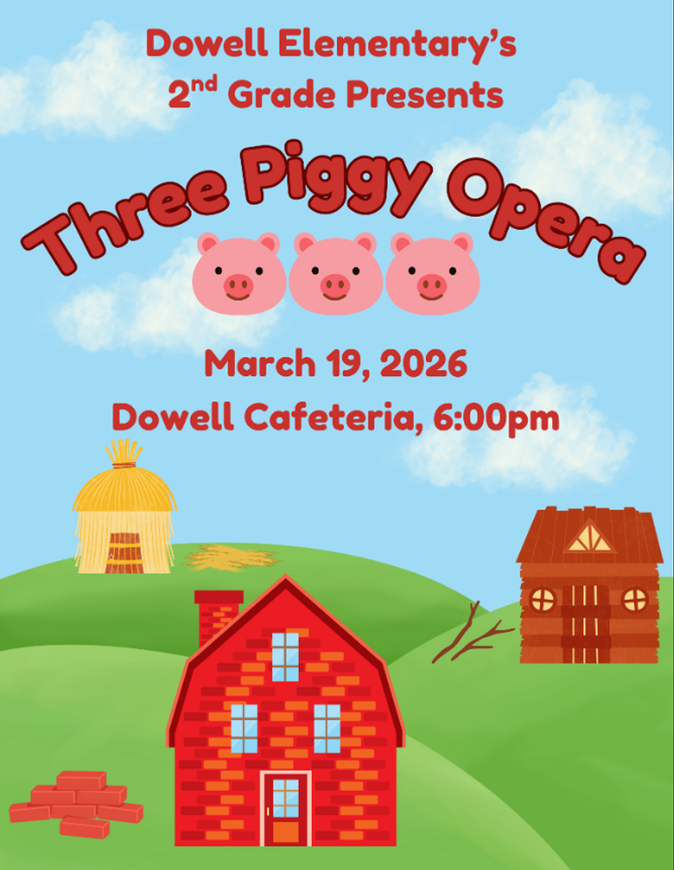

Family Survey Announcement
Dear Parent or Guardian,
Dowell Elementary School will take the new Georgia School Climate Survey this year. Each parent or guardian is invited to take the family version to answer questions about the current school or schools you have a child or children attending. If two or more children attend the same school, please only complete one survey for that school.
The survey measures what you think about how the school engages with families. Answers are not linked to names in any way. When typing answers, please do not give names or information that you don’t want to share with this school. Data will be shared with school leaders to help improve the school and will be published on the GaDOE website.
Please help by sharing your honest opinion on this 22-question survey. T
If you have any questions about the survey, please contact Dr. Clark at Tina.Clark@cobbk12.org.

Take Survey Here

February 23rd-27th

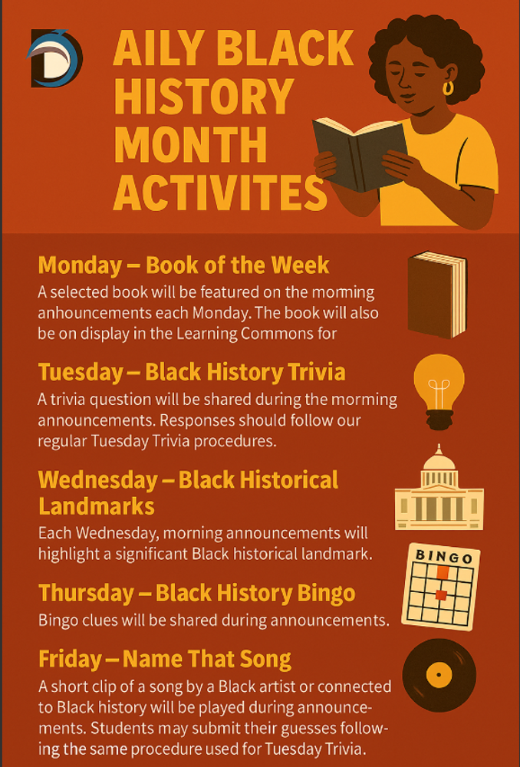

February 2nd-27th



Get Your Yearbook now
Yearbooks are now on sale for $30. The price will increase March 1st so get yours now. If you purchased a yearbook through your membership, you will receive an email from the PTA notifying you that you already purchased one.

You can purchase the yearbook here for $30 until February 28th. Prices will increase on March 1st.

https://dowellpta.givebacks.com/shop?category=18350

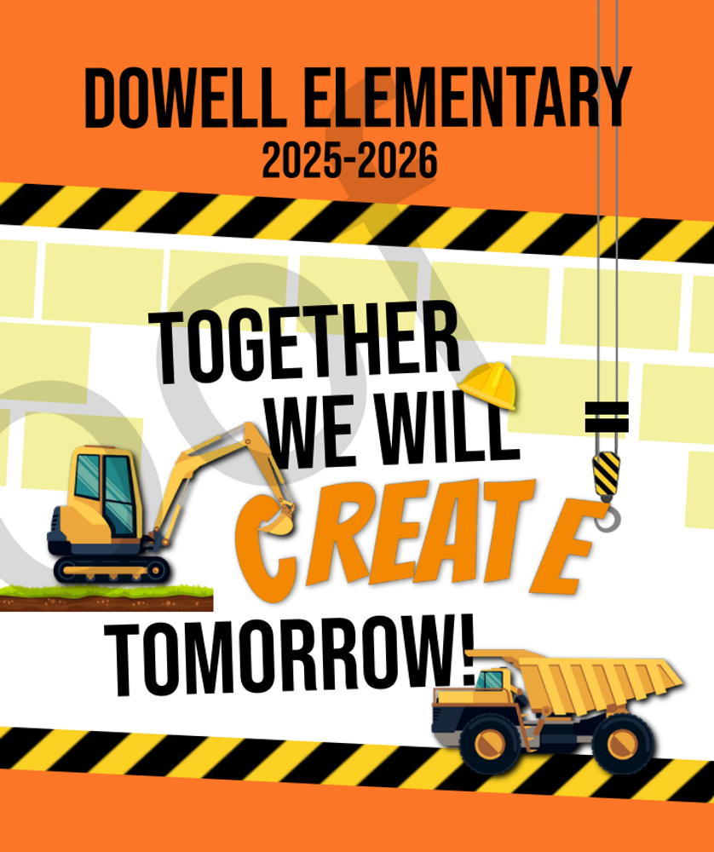

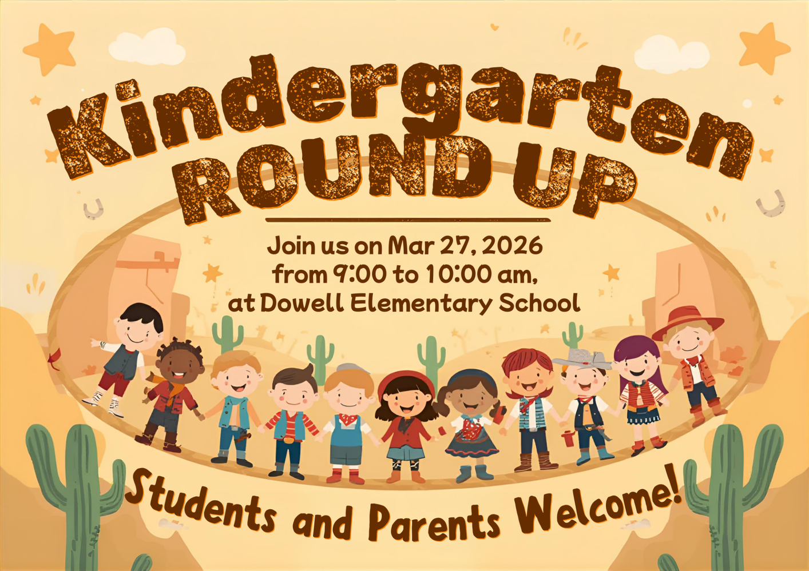

Classroom Celebrations Request Form
Dear Teachers/Parents/Staff,
Do you want to celebrate with your students but don’t have the time for all the planning and details? Return this request form to the Cafeteria Manager and leave the party to us! Upon receipt of the request form, we will provide you with a price quote for your party within 48 hours. On the celebration day, we take care of everything for you!

Please see attached form for pricing items and pricing.

Also if you plan on bringing in a treat for your child's birthday please fill out the attached cupcake form at least 24 hours in advance for the teacher and front office staff to be aware. This helps with planning and any allergies in the classroom.

Community News



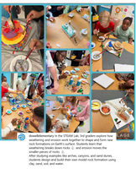
Follow us on social media.
https://www.instagram.com/dowellelementary

