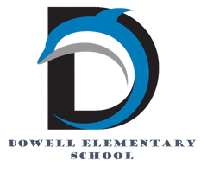
Dolphin Weekly
Sunday, February 8, 2026

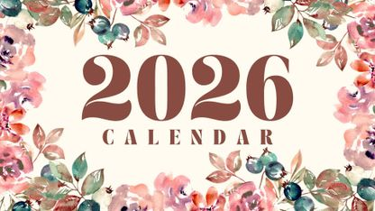
Save the Date!
Tuesday, 2/10
- Reflections Breakfast
- Lovinggood Middle School - STEM Night https://youtu.be/E9BP08O8Iqc
Wednesday, 2/11
- 1/2 of 3rd Grade to Tellus Museum
Thursday, 2/12
- Picture Day
Monday-Friday, 2/16-20
- February Break (no school)
Thursday, 2/26
- Black History Performance
Monday, 3/2
- Digital Learning Day

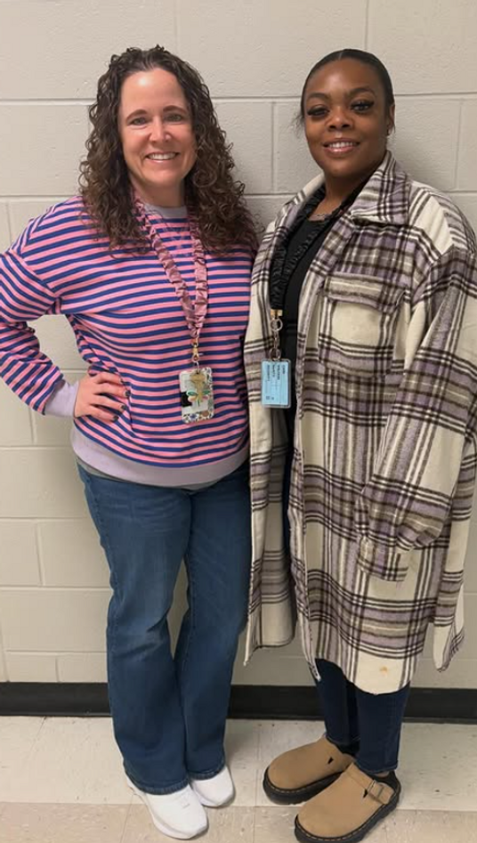

From the Principal's Desk
Dowell Families,

We hope you had a great weekend! As always, thank you for your continued partnership and support. We love celebrating the people and events that make our school community so special. 💙🐬

🌟 Staff Members of the Month
Please join us in congratulating our Staff Members of the Month!
- Jennifer Itnyre, 4th Grade Teacher
- Ms. Kilpatrick, Paraprofessional
We are so grateful for their dedication, hard work, and the positive impact they make on our students each day. Congratulations! 👏

🔬 Lovinggood Middle School STEM Night
If your child will be attending Lovinggood Middle School or if you’re simply looking for a great family-friendly event, consider checking out Lovinggood Middle School’s STEM Night this Tuesday, February 10th. It’s a wonderful opportunity for hands-on learning and exploration for the whole family!

📸 Spring Picture Day
Spring Picture Day is coming up on Thursday, February 12th. Be sure your child is ready for picture day—we can’t wait to see those smiles!

Black History Night
We look forward to seeing our families on Thursday, February 26th for our Black History Night. This will be a meaningful evening of learning, celebration, and community, and we hope you’ll join us.

Thank you for being such an incredible part of our Dowell community. We look forward to seeing you at our upcoming events! 💙🐬

With appreciation,
Dr. Pam Cain
Principal


----------------------------------------------------------------

Reminders:
- ID Requirement: A picture ID is required every time you visit the school. Please show it to the camera at the right front door and press the button (door bell). A staff member will confirm your reason for visiting and verify your child’s information before buzzing you in. Upon entry, always go straight to the front office.
- Visiting for Lunch? You’re welcome to sit with your child in the cafeteria during their lunch time. We kindly ask that you not bring fast food or restaurant meals, as it’s not fair to other students. Please check out at the front office after your visit.
- Do NOT Enter: For student and staff safety, please do not use the DO NOT ENTER/Buses Only entrance during AM or PM carpool.

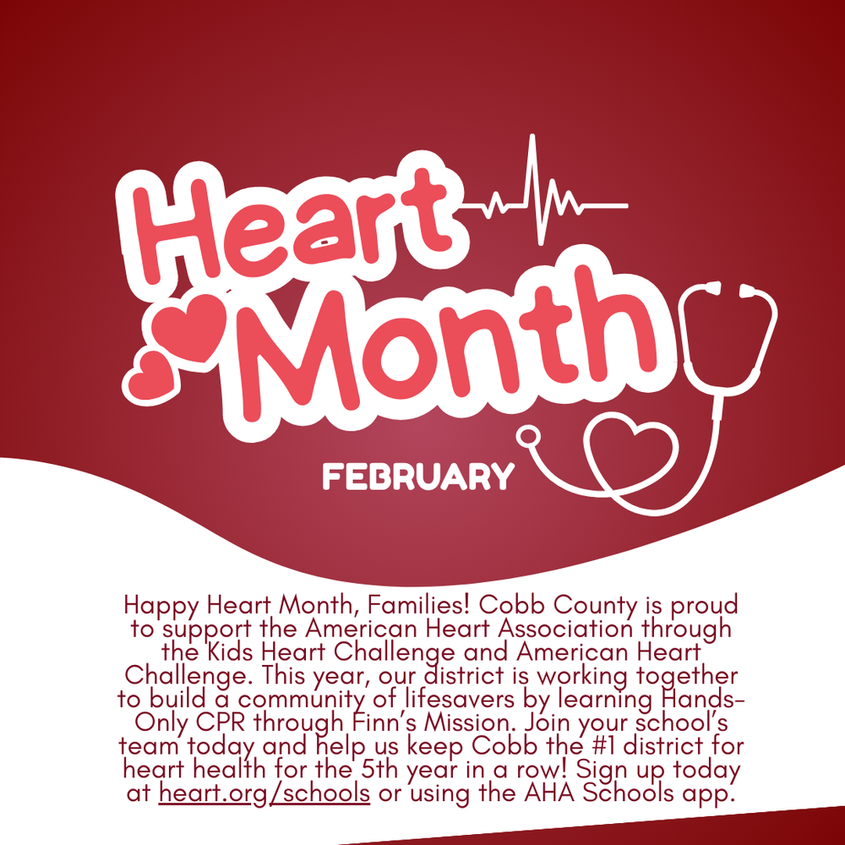

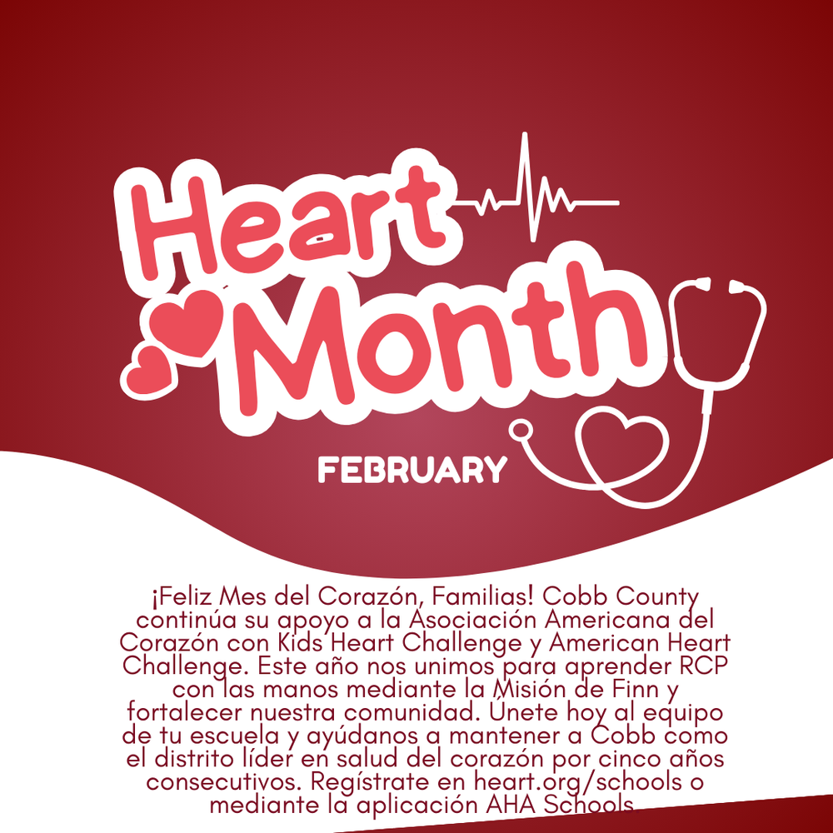

Mark you calendar for Spring Picture Day- February 12th.

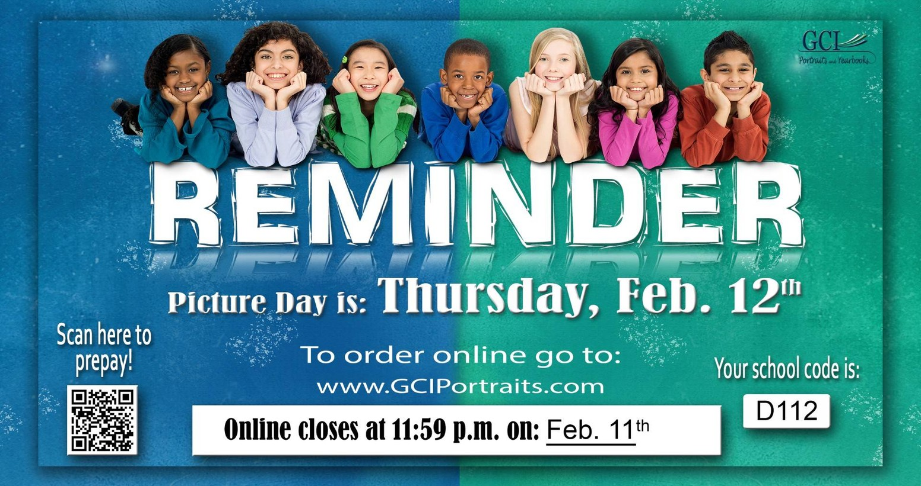

From our English Learner Program

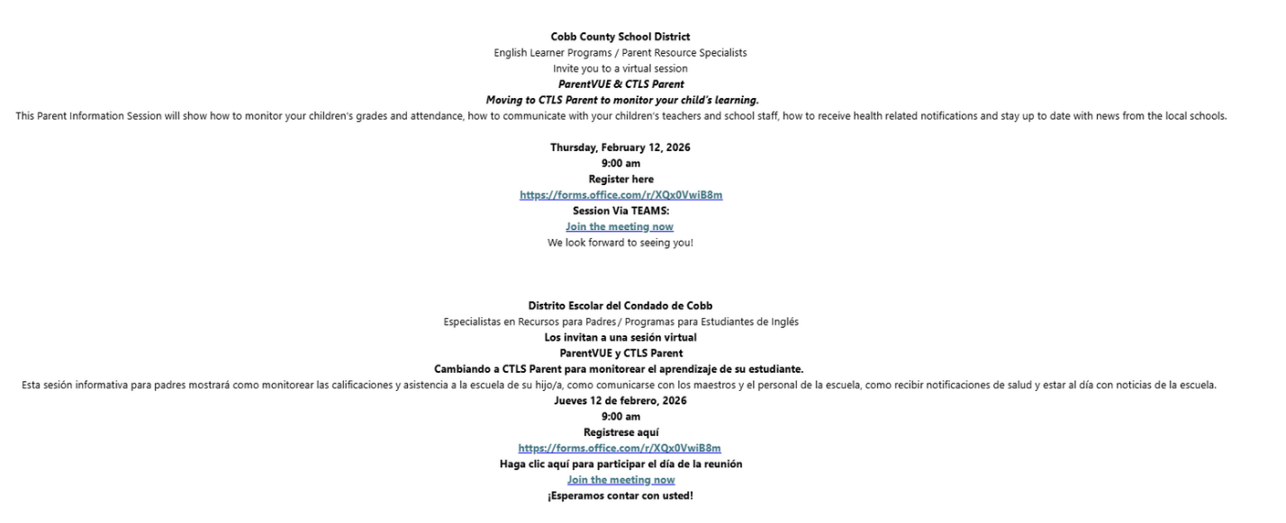

Family Survey Announcement
Dear Parent or Guardian,
Dowell Elementary School will take the new Georgia School Climate Survey this year. Each parent or guardian is invited to take the family version to answer questions about the current school or schools you have a child or children attending. If two or more children attend the same school, please only complete one survey for that school.
The survey measures what you think about how the school engages with families. Answers are not linked to names in any way. When typing answers, please do not give names or information that you don’t want to share with this school. Data will be shared with school leaders to help improve the school and will be published on the GaDOE website.
Please help by sharing your honest opinion on this 22-question survey. T
If you have any questions about the survey, please contact Dr. Clark at Tina.Clark@cobbk12.org.

Take Survey Here

Valentines Pop-Up Shop

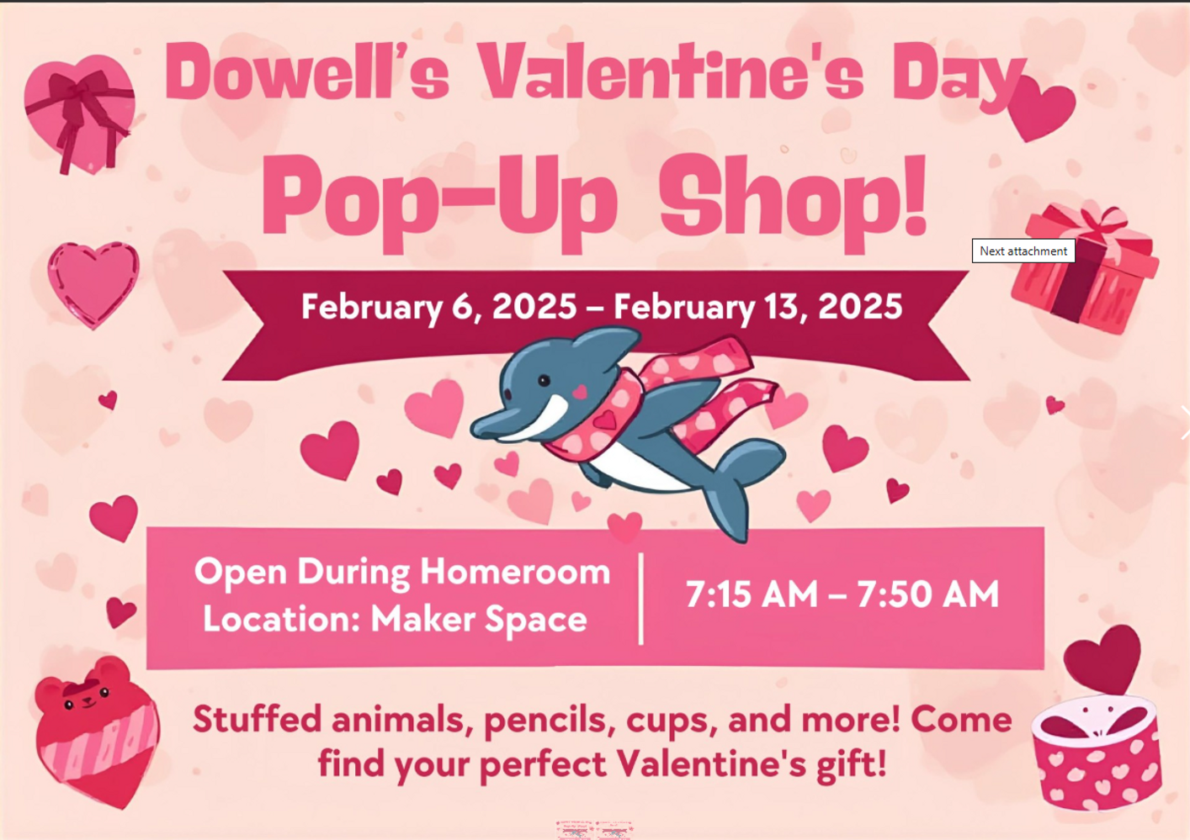

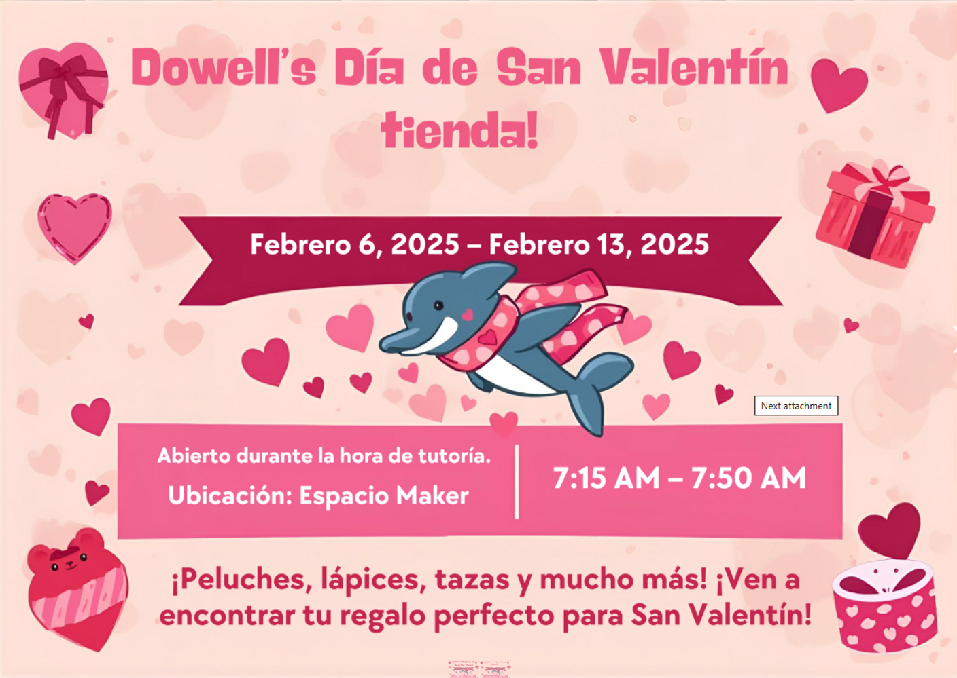

Black History Month

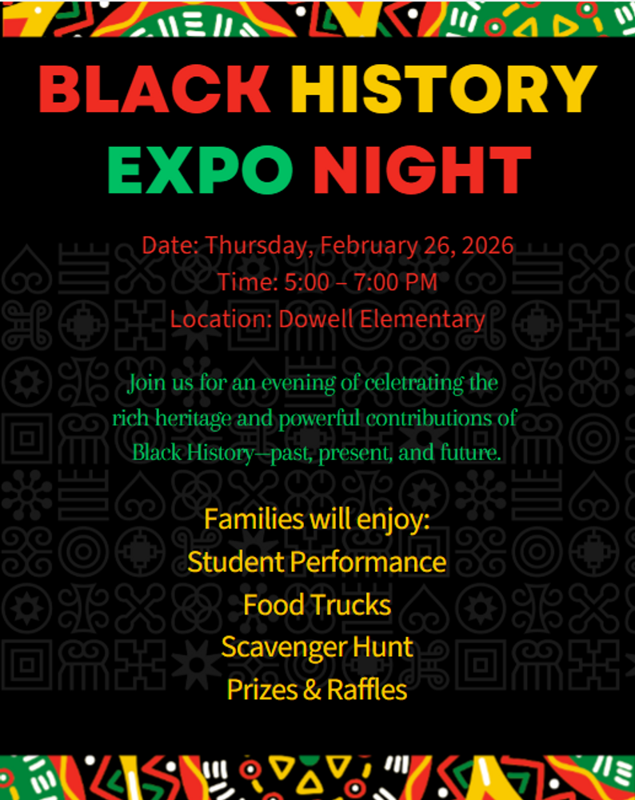

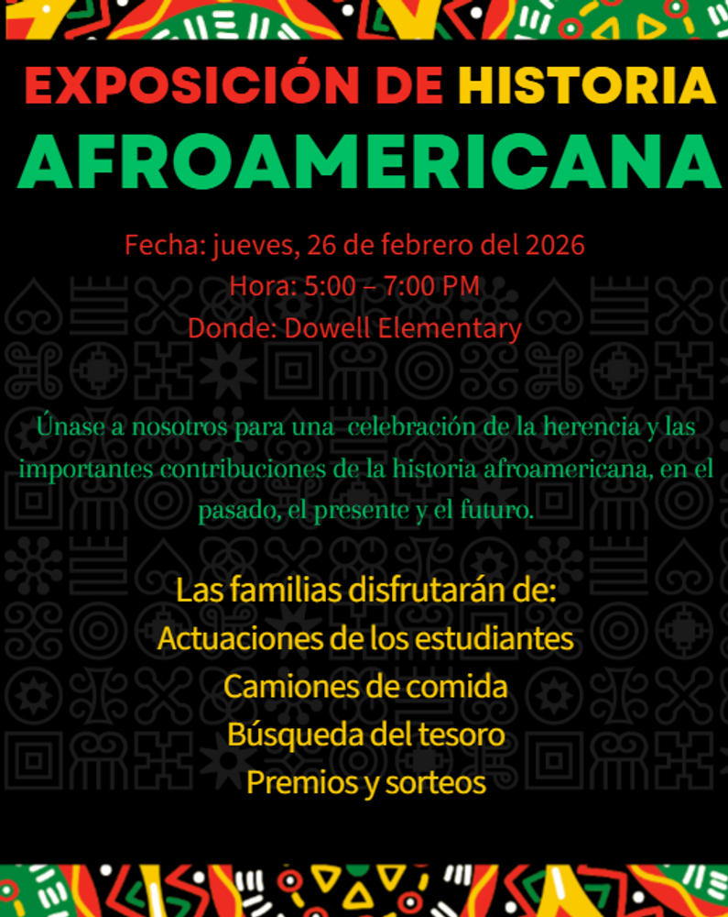

February 23rd-27th

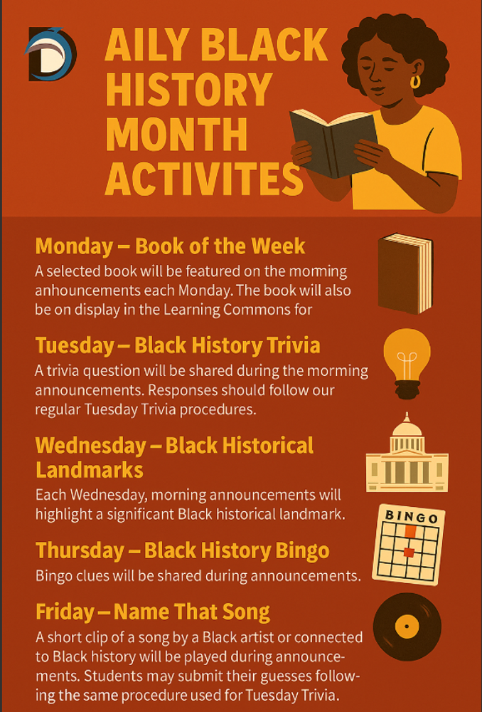

February 2nd-27th



Get Your Yearbook now
Yearbooks are now on sale for $30. The price will increase March 1st so get yours now. If you purchased a yearbook through your membership, you will receive an email from the PTA notifying you that you already purchased one.

You can purchase the yearbook here for $30 until February 28th. Prices will increase on March 1st.

https://dowellpta.givebacks.com/shop?category=18350

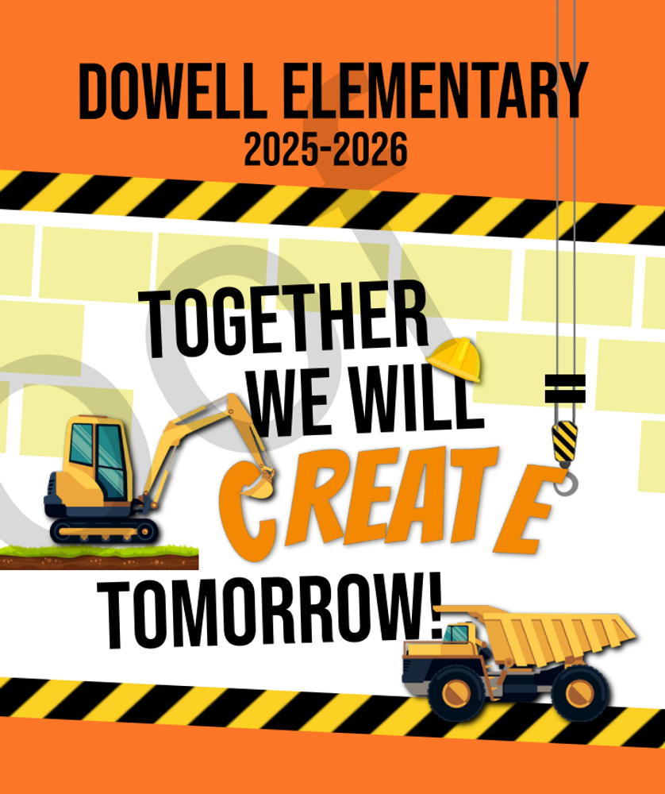

Classroom Celebrations Request Form
Dear Teachers/Parents/Staff,
Do you want to celebrate with your students but don’t have the time for all the planning and details? Return this request form to the Cafeteria Manager and leave the party to us! Upon receipt of the request form, we will provide you with a price quote for your party within 48 hours. On the celebration day, we take care of everything for you!

Please see attached form for pricing items and pricing.

Also if you plan on bringing in a treat for your child's birthday please fill out the attached cupcake form at least 24 hours in advance for the teacher and front office staff to be aware. This helps with planning and any allergies in the classroom.

Community Events

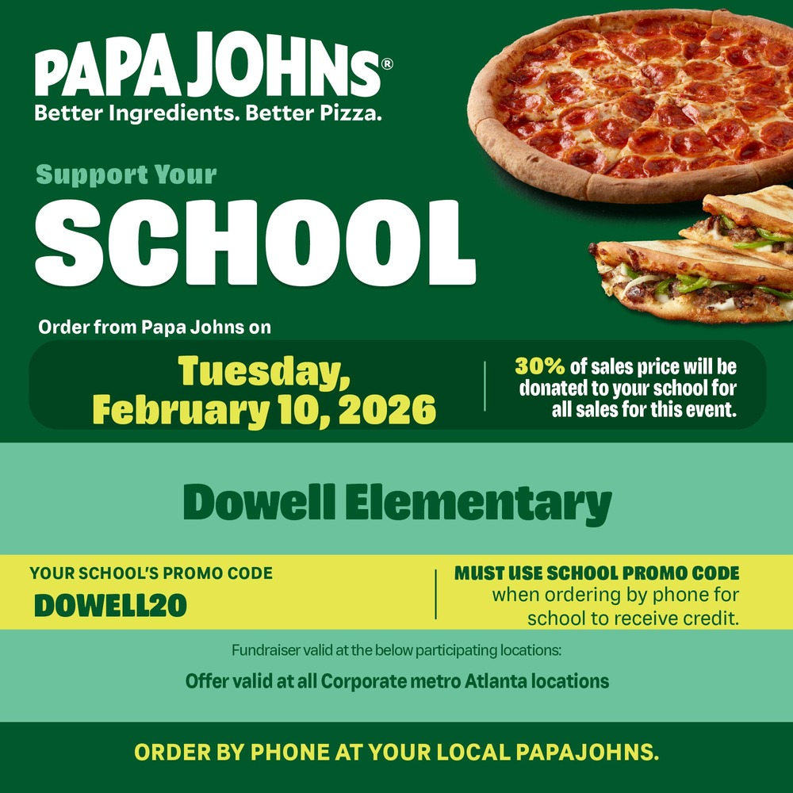






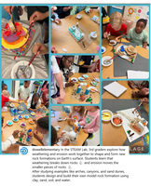
Follow us on social media.
https://www.instagram.com/dowellelementary

