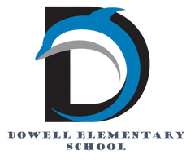
Dolphin Weekly
Sunday, March 15, 2026

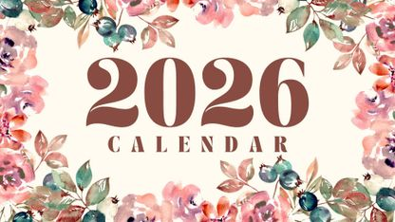
Save the Date!
March 16
- 2nd Grade Trip to Etowah Indian Mounds
March 17 🍀
March 19th
- Shamrock Shuffle - Fun Run *NEW DATE*
- Report Cards
- 5:30-7:30, 2nd Grade Presents 🐷Three Piggy Opera & School Wide Art Show🎨
March 24
- Career Day Pre-K- 2nd Grade
March 25
- Career Day 3rd-5th
March 26
- 2nd Grade to Atlanta Ballet Snow White
March 27
- 1st Grade to Atlanta Aquarium
- Kindergarten Round Up (for rising K families/students), 9-11
- 5th Grade visit to Lovinggood MS
- Spirit Night at Sparkles in Hiram
April 1
- 5th Grade to Tapp MS
April 2
- Spanish Spelling Bee
April 3
- Terrific Kids - Commitment
April 6-10
- Spring Break 🏖️
April 14
- Field Day, Kinder & 1st grades
April 15
- Field Day, 2nd & 3rd grades
April 16
- Young Ladies with High Expectations Ceremony, 5:00 PM
- 5th Grade Performance, 6:00 PM
April 17
- Field Day, 4th & 5th grades
- Carnival, 5:00-8:00 PM

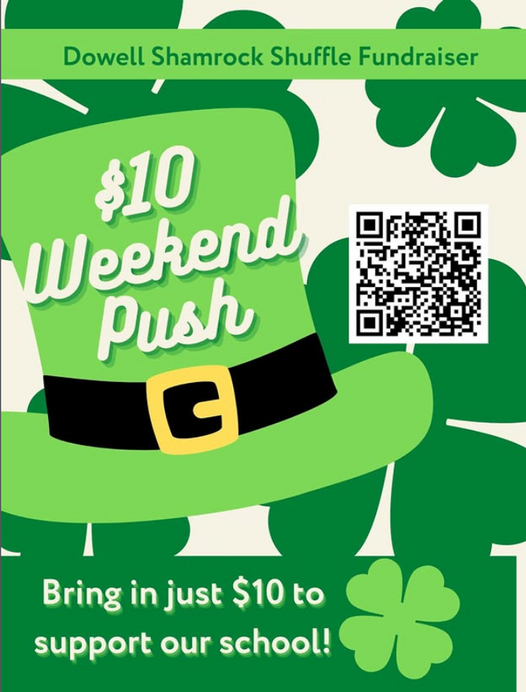

From the Principal's Desk
Dowell Dolphins Families,

The countdown continues and it’s the Weekend Push! ☘️🍀We are so excited about the Dowell Foundation 2026 Campaign as we work together to raise funds that directly support our students and enhance the experiences, we are able to provide here at Dowell.

After a high-energy pep rally with Activate to kick things off, the excitement is building across the school! Your child should have brought home a bright yellow packet with information about the fundraiser, including all of the prizes and incentives available. Be sure to take a look and help your child get involved! Thank you for your continued support, encouragement, and generosity as we work together for our school community. 💚

A Special Community Celebration
Thank you to Chick-fil-A at Macland Crossing for inviting Dowell to participate in the Ribbon Cutting Ceremony for their brand new building today! We were proud to have Olivia Evans represent Dowell as our student representative. A special thank you to owner/operator Mr. Kapoor for inviting surrounding elementary schools to celebrate the opening of the new indoor playground. There were parachuting cows, playground time, and even lunch—what a fun day! It was truly a great day to be a Dowell Dolphin! 🐬

Dowell Art Show & 2nd Grade Performance – Thursday Night

We are also looking forward to a wonderful evening this Thursday at our Dowell Art Show. When you visit, you’ll see student artwork displayed throughout the building, showcasing the creativity and talent of our Dolphins.

Also happening that evening is the 2nd Grade Performance, and I can confidently say it’s sure to be one of the cutest performances you’ve ever seen! We hope many of our families will join us for this special night celebrating the arts at Dowell.

Thank you for being such an important part of the Dowell community. Your partnership makes all the difference for our students.

Warmly,
Dr. Pamela Cain
Principal, Dowell Elementary School 🐬
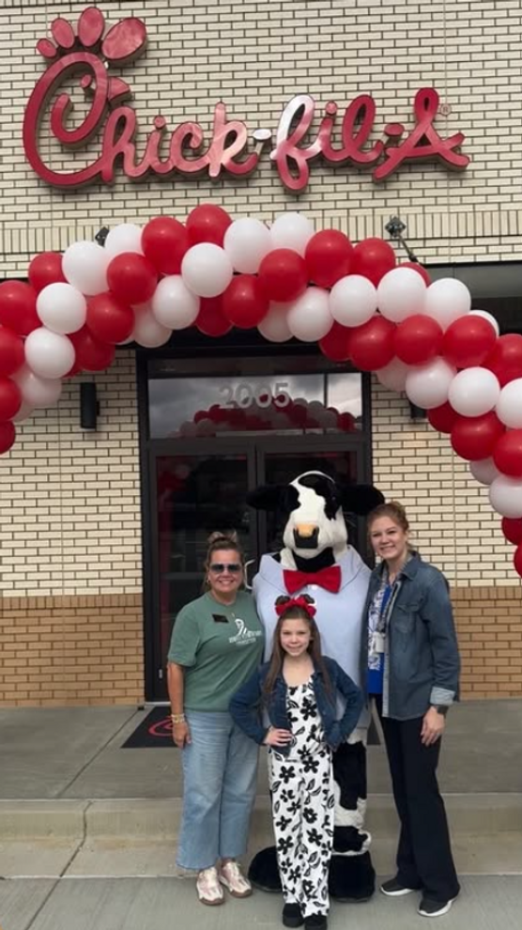

🚗 Morning Carpool Safety Reminder

The safety of our students is always our top priority. During morning carpool, students should only be dropped off at the designated front carpool area, where school staff members are present and ready to assist and supervise students as they enter the building.

For safety reasons, students should not be dropped off anywhere else, including along the curb, in the parking lot, while waiting in line, at the road, or in any other undesignated area. These practices create unsafe conditions for students and drivers and are not permitted.

Thank you for helping us keep our Dolphins safe by following the designated front carpool drop-off procedures each morning. Your cooperation helps ensure a smooth and safe start to the school day for everyone. 🐬

Reminders:
- ID Requirement: A picture ID is required every time you visit the school. Please show it to the camera at the right front door and press the button (door bell). A staff member will confirm your reason for visiting and verify your child’s information before buzzing you in. Upon entry, always go straight to the front office.
- Visiting for Lunch? You’re welcome to sit with your child in the cafeteria during their lunch time. We kindly ask that you not bring fast food or restaurant meals, as it’s not fair to other students. Please check out at the front office after your visit.
- Do NOT Enter: For student and staff safety, please do not use the DO NOT ENTER/Buses Only entrance during AM or PM carpool.

2nd Grade Presents
Please join us on March 19th at 6:00 pm for Three Piggy Opera, performed by our 2nd Graders.

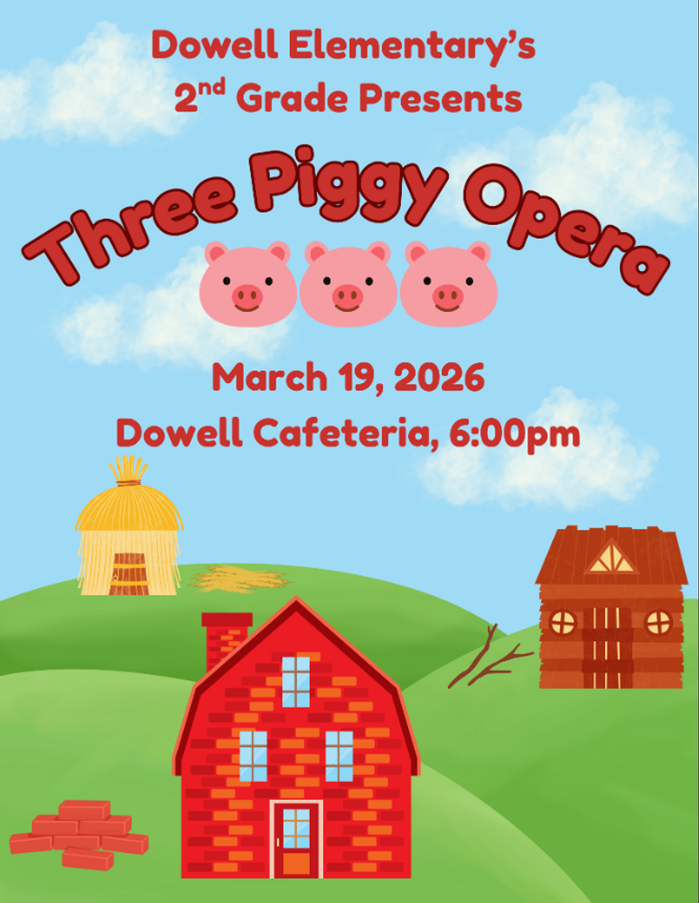

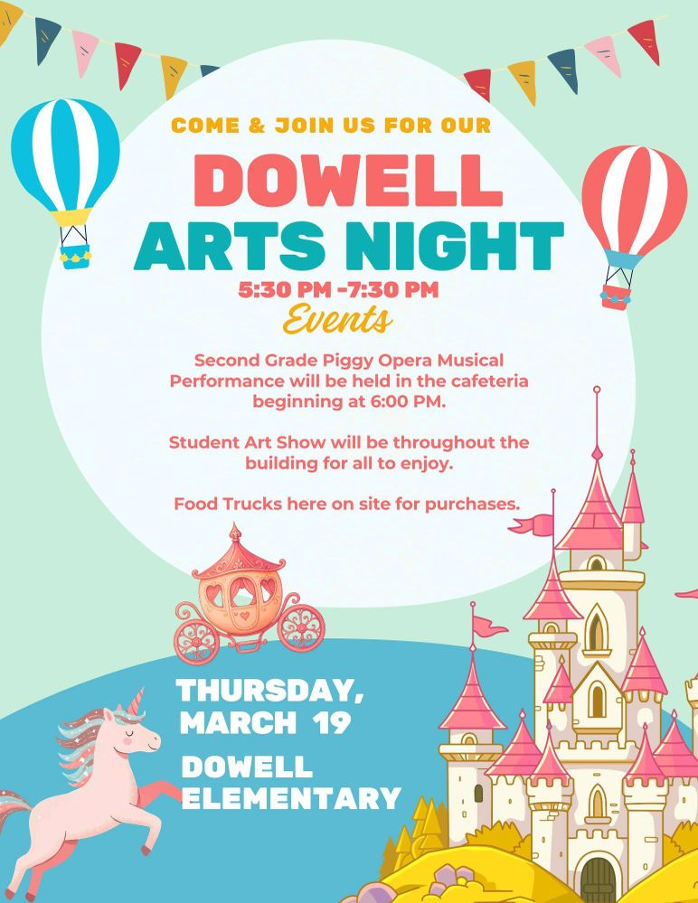

Career Day
Career Day is around the corner, and we would love it if we could get some more volunteers to come speak about their careers to our students. If you are interested, we would love for you to come and support Dowell’s Career Days. If interested, please fill out the forms link below.

SPEAKERS NEEDED FOR CAREER DAY 2026 – Fill out form

Family Survey Announcement
Dear Parent or Guardian,
Dowell Elementary School will take the new Georgia School Climate Survey this year. Each parent or guardian is invited to take the family version to answer questions about the current school or schools you have a child or children attending. If two or more children attend the same school, please only complete one survey for that school.
The survey measures what you think about how the school engages with families. Answers are not linked to names in any way. When typing answers, please do not give names or information that you don’t want to share with this school. Data will be shared with school leaders to help improve the school and will be published on the GaDOE website.
Please help by sharing your honest opinion on this 22-question survey. T
If you have any questions about the survey, please contact Dr. Clark at Tina.Clark@cobbk12.org.

Take Survey Here

Get Your Yearbook now!
Yearbooks are now on sale for $35, while supplies last.

https://dowellpta.givebacks.com/shop?category=18350

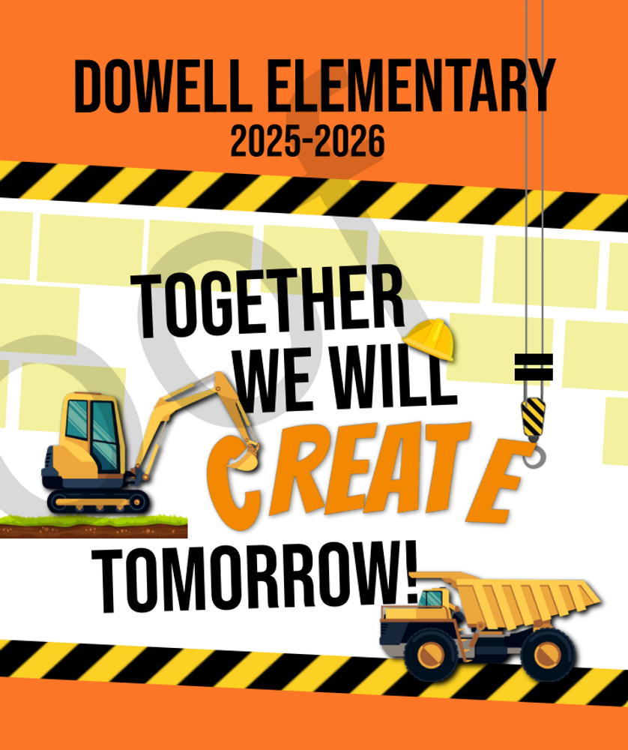

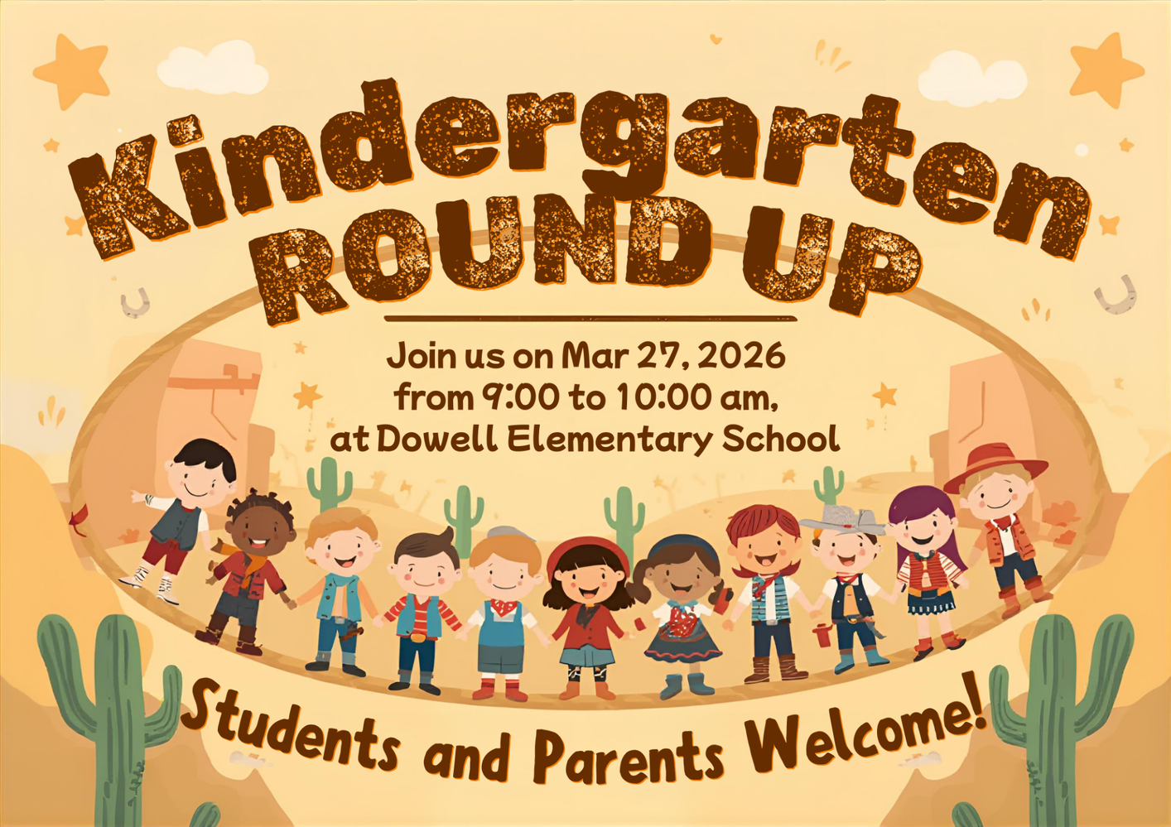

PTA Carnival
Please join us for the Annual PTA Carnival On April 17th from 5:00-8:00pm.

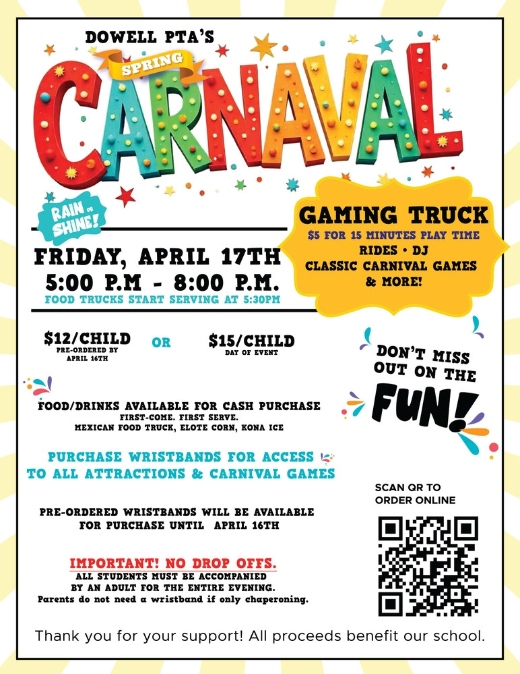

Classroom Celebrations Request Form
Dear Teachers/Parents/Staff,
Do you want to celebrate with your students but don’t have the time for all the planning and details? Return this request form to the Cafeteria Manager and leave the party to us! Upon receipt of the request form, we will provide you with a price quote for your party within 48 hours. On the celebration day, we take care of everything for you!

Please see attached form for pricing items and pricing.

Also if you plan on bringing in a treat for your child's birthday please fill out the attached cupcake form at least 24 hours in advance for the teacher and front office staff to be aware. This helps with planning and any allergies in the classroom.

Community News

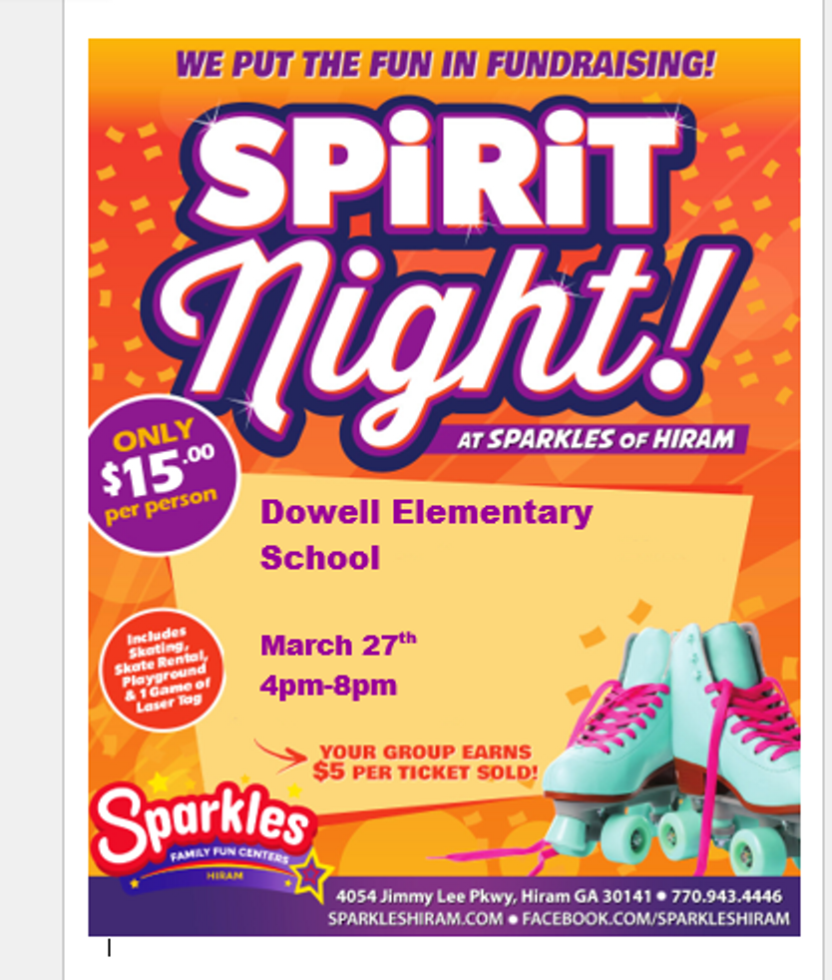

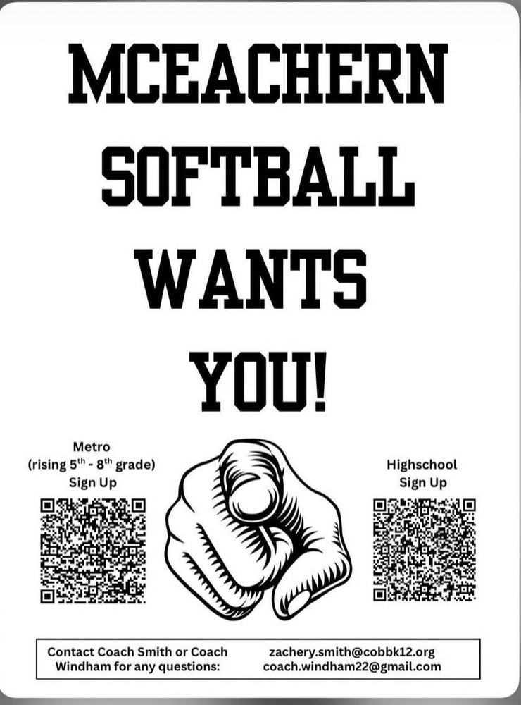

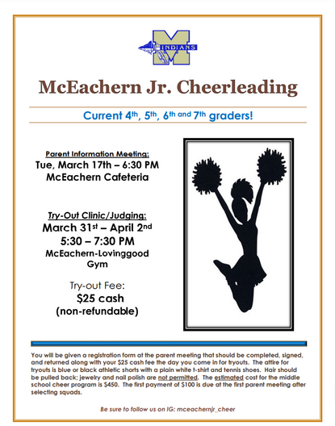
McEachern Jr. Cheerleading
McEachern Cheerleaders what to know….DO YOU HAVE SCHOOL SPIRIT and would like to show it on the Football Sidelines or on the Competition mat? All current 4th, 5th, 6th, and 7th-grade girls interested in trying out for the McEachern Jr. Cheerleading program should pay attention! We will have a Parent Information meeting on Tuesday, March 17th at 6:30 PM in the cafeteria at McEachern. The tryouts will be March 31st - April 2nd. Follow us on Instagram at mceachernjr_cheer.

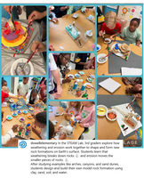
Follow us on social media.
https://www.instagram.com/dowellelementary

