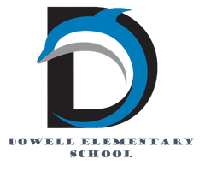
Dolphin Weekly
Sunday, March 29, 2026


Save the Date!

April 1
- 5th Grade to Tapp MS
April 2
- DLI/Spanish Spelling Bee
April 3
- Terrific Kids - Commitment
April 6-10
- Spring Break 🏖️
April 13
- 2nd grade: High-Touch-High-Tech Inhouse Field Trip
April 14
- Field Day, Kinder & 1st grades
April 15
- Field Day, 2nd & 3rd grades
- 5th Grade Field Trip to Birmingham
April 16
- Young Ladies with High Expectations Ceremony, 5:00 PM
- 5th Grade Performance, 6:00 PM
April 17
- Field Day, 4th & 5th grades
- Carnival, 5:00-8:00 PM
April 21
- Milestones Assessment for 3rd & 5th grades
April 22
- Milestone Assessment for 3rd & 5th grades
April 23
- Milestones Assessment for 3rd & 5th grades
April 24th
- Kindergarten Cap & Gown pictures
April 27th
- Milestones Assessment for 5th grade
April 28th
- Milestones Assessment for 3rd & 5th grades
April 29th
- Milestones Assessment for 3rd & 5th grades
April 30
- Milestones Assessment for 4th grade
May 1st
- Milestones Assessment for 4th grade

Looking Ahead...
- May 14th: 5th Grade Award Ceremony at Smith MS, 6:00 PM
- May 15th: Senior Walk at Dowell, 8:30 am
- May 18, 19, & 20: Early Release Days
- May 20th: Last Day of School

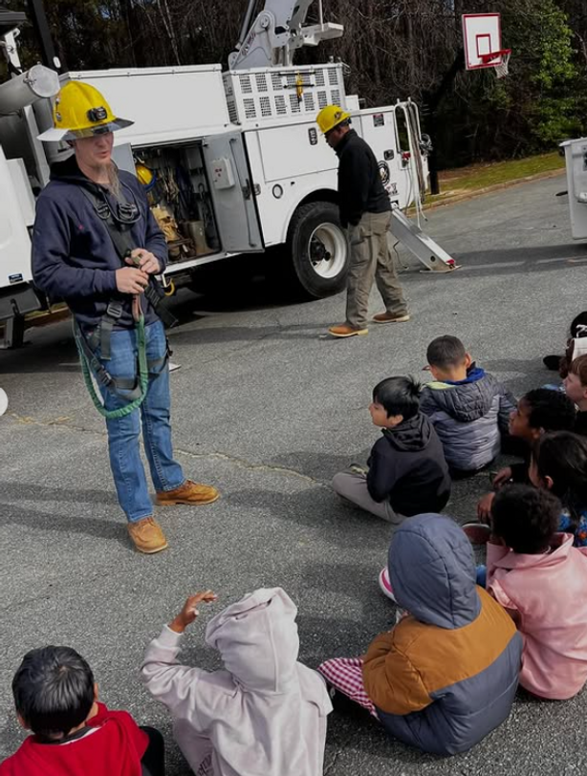

From the Principal's Desk
Dear Dowell Families,

It has been another wonderful week of learning and engagement at Dowell!

We are excited to share that both our K–2 and 3–5 Career Days were a huge success! Our students had the opportunity to learn about a wide variety of careers from our incredible community partners. These experiences help our students begin thinking about their futures and the many possibilities ahead. A very special thank you to our outstanding school counselors, Mrs. McLane and Ms. Wallace, for organizing such meaningful and engaging events for our students!

In classrooms, learning continues to come alive in the best ways. Be sure to check out highlights of our 4th graders preparing for an upcoming math assessment. At Dowell, our teachers work hard to create engaging, hands-on learning experiences—using manipulatives, encouraging collaboration, and making learning both meaningful and fun. It’s always inspiring to see our students actively involved and excited about their learning!

As a reminder, the Georgia Milestones Assessment is quickly approaching for our 3rd, 4th, and 5th grade students.

Georgia Milestones Assessment Information (Grades 3–5)

As we approach the Georgia Milestones Assessment, we want to partner with you to ensure our students feel confident, prepared, and supported.

The Georgia Milestones Assessment System is a statewide test that measures how well students have learned the knowledge and skills outlined in Georgia’s academic standards. For our students:
- Grades 3–5 take assessments in English Language Arts and Mathematics
- 5th grade students also take Science
These assessments provide important information about your child’s academic progress and readiness for the next grade level. They also help our school and district continue to improve teaching and learning for all students.

🔗 Parent Resource:

You can learn more and access helpful study guides here:
Georgia Milestones Assessment System – Georgia Department of Education

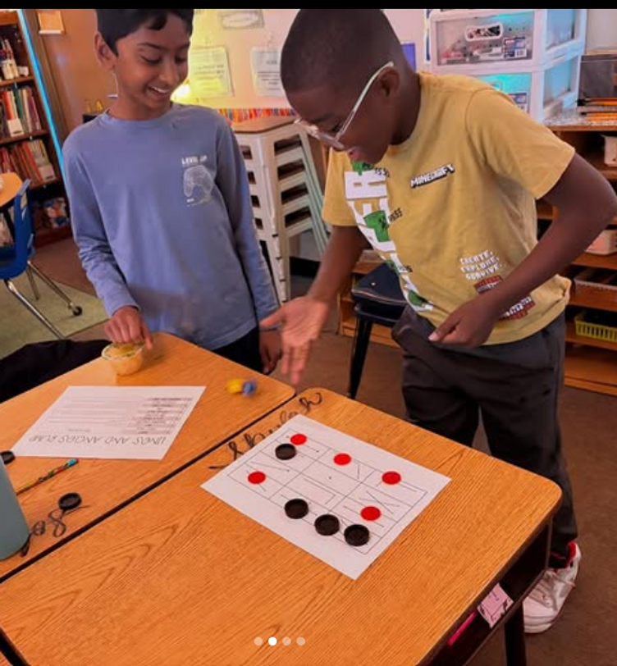
How Families Can Help at Home

Your support makes a big difference! Please help your child by:
- Ensuring a good night’s sleep each evening
- Having them arrive at school on time each day (testing begins promptly)
- Encouraging a positive mindset and doing their very best
A Note for 5th Grade Families
If a student scores a Level 1 in Math, they will receive targeted remediation and participate in a retest opportunity. Our goal is to provide the support needed for every student to grow and succeed.
Encouragement Matters
We encourage you to talk with your child about the importance of the assessment while also helping them feel calm and confident. This is an opportunity for them to show what they know—not something to fear.

🚗🚘🚙🛻🚕🚘🚗🚙🚓🛻🚕🛻🚔🚙🚘

Morning Carpool Safety Reminder

The safety of our students is always our top priority. During morning carpool, students should only be dropped off at the designated front carpool area, where school staff members are present and ready to assist and supervise students as they enter the building.

For safety reasons, students should not be dropped off anywhere else, including along the curb, in the parking lot, while waiting in line, at the road, or in any other undesignated area. These practices create unsafe conditions for students and drivers and are not permitted.

Thank you for helping us keep our Dolphins safe by following the designated front carpool drop-off procedures each morning. Your cooperation helps ensure a smooth and safe start to the school day for everyone. 🐬

Reminders:
- ID Requirement: A picture ID is required every time you visit the school. Please show it to the camera at the right front door and press the button (door bell). A staff member will confirm your reason for visiting and verify your child’s information before buzzing you in. Upon entry, always go straight to the front office.
- Visiting for Lunch? You’re welcome to sit with your child in the cafeteria during their lunch time. We kindly ask that you not bring fast food or restaurant m

Family Survey- Last Day March 31st!
Please take a few moments to answer a few questions about your experience at our school! We need more participation by March 31st!

Take Survey Here

Get Your Yearbook now!
Yearbooks are now on sale for $35, while supplies last.

https://dowellpta.givebacks.com/shop?category=18350

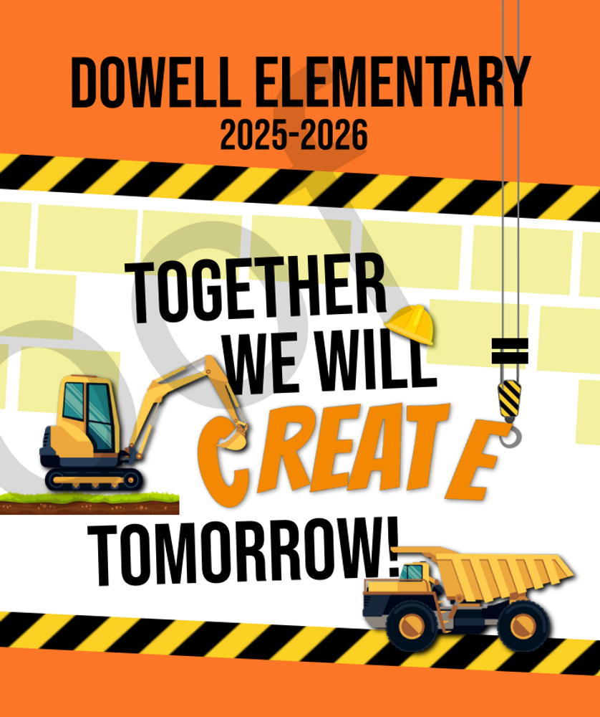

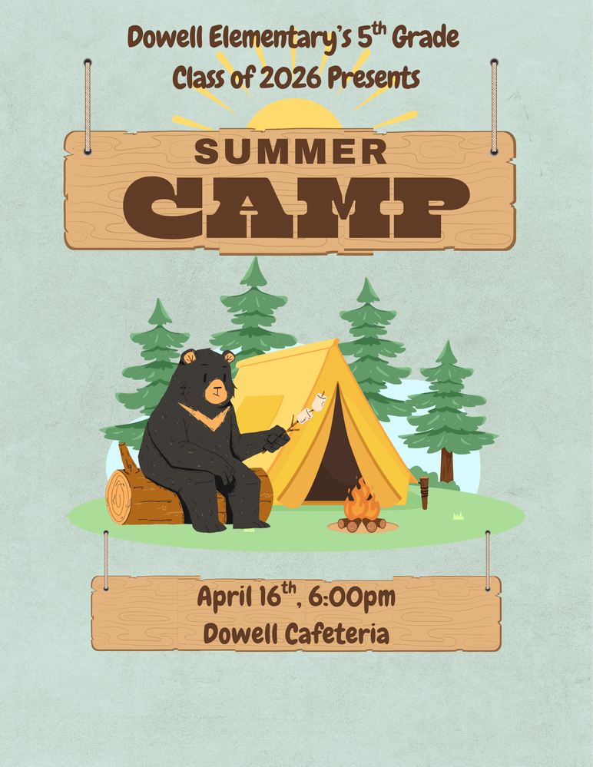

PTA Carnival
Please join us for the Annual PTA Carnival On April 17th from 5:00-8:00pm.

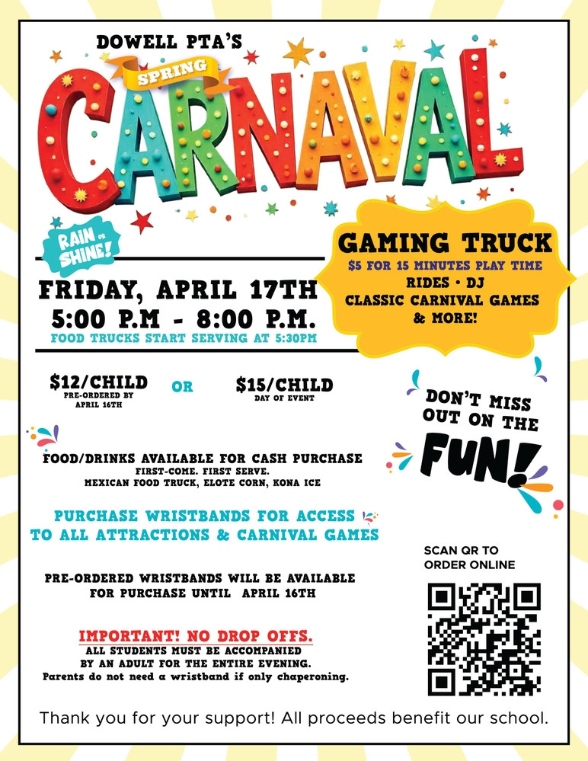

Carnival- April 17th
Purchase your Tickets for Spring Carnival here
https://dowellpta.givebacks.com/shop
Sign up for the game truck here
https://www.signupgenius.com/go/20F0F4DAFA82B0-63024285-game#/

Volunteers for Spring Carnival – sign up below.
https://www.signupgenius.com/go/20F0F4DAFA82B0-62622071-copy#/

Classroom Celebrations Request Form
Dear Teachers/Parents/Staff,
Do you want to celebrate with your students but don’t have the time for all the planning and details? Return this request form to the Cafeteria Manager and leave the party to us! Upon receipt of the request form, we will provide you with a price quote for your party within 48 hours. On the celebration day, we take care of everything for you!

Please see attached form for pricing items and pricing.

Also if you plan on bringing in a treat for your child's birthday please fill out the attached cupcake form at least 24 hours in advance for the teacher and front office staff to be aware. This helps with planning and any allergies in the classroom.

Community News

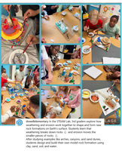
Follow us on social media.
https://www.instagram.com/dowellelementary

