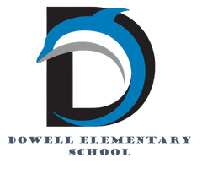
Dolphin Weekly
Sunday, March 8, 2026

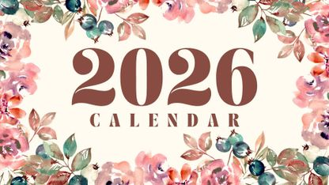
Save the Date!
March 9- 13, Book Fair

March 9
- K/Math BEACON Assessment
- 1st/ELA BEACON Assessment
March 10
- 2nd/Math BEACON Assessment
- 4th/Math BEACON Assessment
March 11
- 1st/Math BEACON Assessment
March 12
- PTA Board Meeting, 7:30
- 2nd/ELA BEACON Assessment
- Spring Chorus Concert, 6:00
March 13 👧🏻
- Terrific Kids- Tolerance 7:45am
- Title 1 Parent Meeting 8:30am
March 16
- 2nd Grade Trip to Etowah Indian Mounds
March 17 🍀
- Shamrock Shuffle - Fun Run
March 19th
- Report Cards
- 5:30-7:30, 2nd Grade Presents 🐷Three Piggy Opera & School Wide Art Show🎨
March 24
- Career Day Pre-K- 2nd Grade
March 25
- Career Day 3rd-5th
March 26
- 2nd Grade Atlanta Ballet Snow White
March 27
- 1st Grade to Atlanta Aquarium
- Kindergarten Round Up
- 5th Grade visit to Lovinggood MS

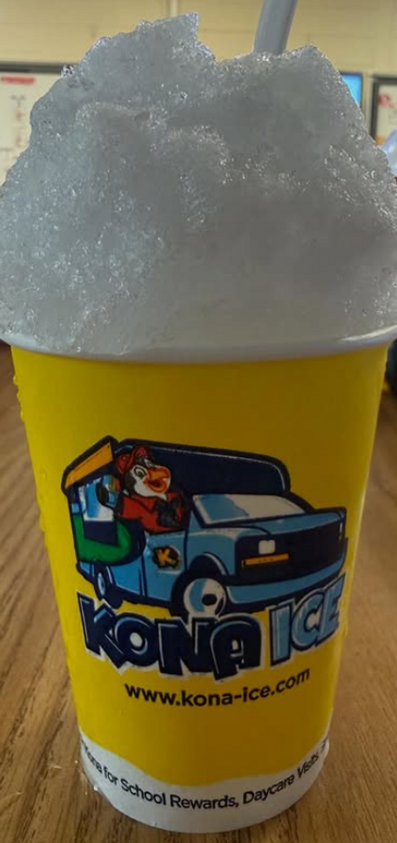

From the Principal's Desk
Dear Dowell Families,

It has been another wonderful week at Dowell! Thank you to our amazing Dowell PTA for providing Kona Ice for all of our students, teachers, and staff. It was a refreshing treat and a great way to celebrate together. We are so grateful for the support our PTA continually provides for our school community!

Our Dowell Foundation FUNdraiser is underway, and we are so excited about the enthusiasm we’ve already seen from our students and families! If you have not already done so, please take a moment to participate:
1️⃣ Step One:
Register your child online:
https://www.gofundschools.com/schools/dowell-elementary
2️⃣ Step Two:
Share your child’s donation link with friends, family, neighbors, and on social media. Be sure to let everyone know which teacher to select so your child’s class receives credit for the donation.
3️⃣ Step Three:
Check back regularly to watch the progress and see the classroom and school rewards that are being earned!

All classes will celebrate together during the Shamrock Shuffle on March 17th, which will wrap up this year’s FUNdraiser with lots of fun and school spirit.

📚 Read Across America Week was a wonderful celebration of reading at Dowell! Our school was transformed into a literary wonderland, and the hallways were filled with the excitement and spirit of books. Students enjoyed book walks, author spotlights, and reading challenges, and it was so much fun seeing our Dolphins engaged in stories and discovering new favorites. It was a great week reminding us all of the magic and joy that reading brings!

🎶 Upcoming Events

We have several exciting events coming soon and hope many of our families will join us:

• Spring Chorus Concert – March 12
We look forward to seeing our chorus families and friends for a wonderful evening of music.
• Dowell School-Wide Art Show – March 19
Our halls will be filled with the incredible artwork created by our talented students.
• 2nd Grade Performance – March 19
Our second graders will also take the stage that evening to showcase their hard work and talent.

Thank you for your continued partnership and support. It is always a joy to see our school community come together to celebrate learning and creativity.

Have a wonderful week, Dolphins!
Warmly,
Dr. Pamela Cain
Principal, Dowell Elementary School 🐬
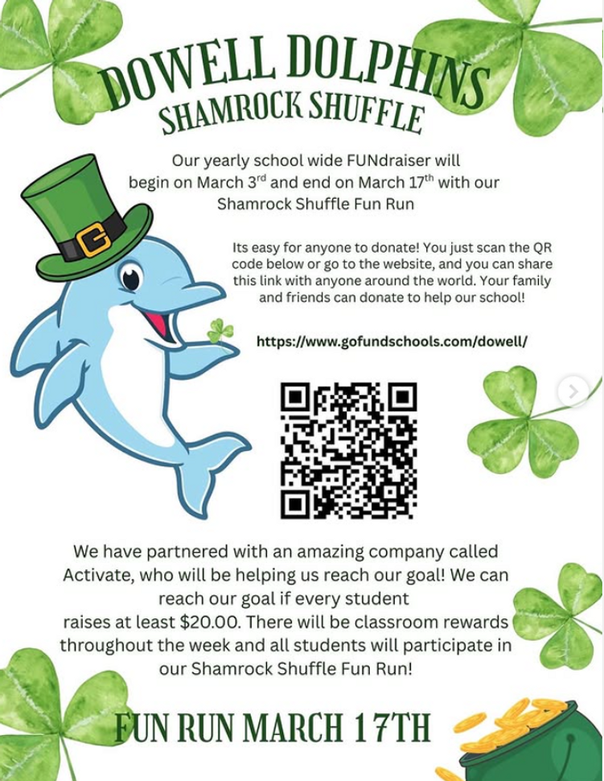

🚗 Morning Carpool Safety Reminder

The safety of our students is always our top priority. During morning carpool, students should only be dropped off at the designated front carpool area, where school staff members are present and ready to assist and supervise students as they enter the building.

For safety reasons, students should not be dropped off anywhere else, including along the curb, in the parking lot, while waiting in line, at the road, or in any other undesignated area. These practices create unsafe conditions for students and drivers and are not permitted.

Thank you for helping us keep our Dolphins safe by following the designated front carpool drop-off procedures each morning. Your cooperation helps ensure a smooth and safe start to the school day for everyone. 🐬

Reminders:
- ID Requirement: A picture ID is required every time you visit the school. Please show it to the camera at the right front door and press the button (door bell). A staff member will confirm your reason for visiting and verify your child’s information before buzzing you in. Upon entry, always go straight to the front office.
- Visiting for Lunch? You’re welcome to sit with your child in the cafeteria during their lunch time. We kindly ask that you not bring fast food or restaurant meals, as it’s not fair to other students. Please check out at the front office after your visit.
- Do NOT Enter: For student and staff safety, please do not use the DO NOT ENTER/Buses Only entrance during AM or PM carpool.

2nd Grade Presents
Please join us on March 19th at 6:00 pm for Three Piggy Opera, performed by our 2nd Graders.

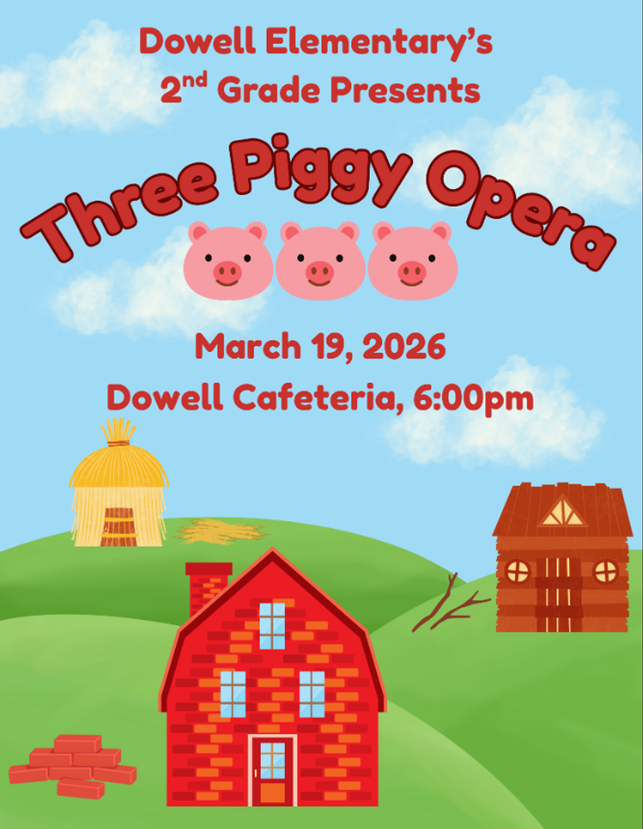

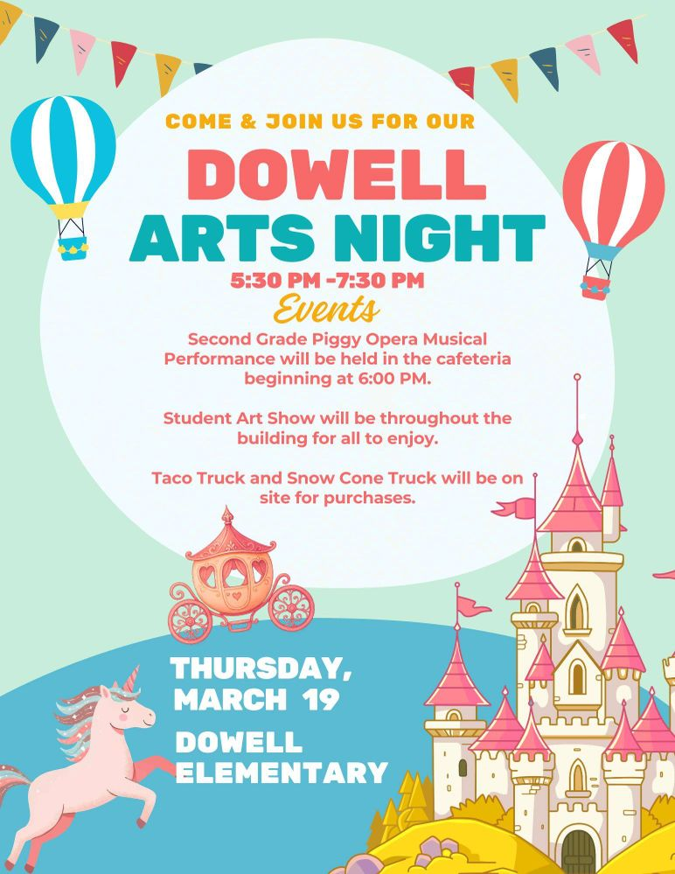

Career Day
Career Day is around the corner, and we would love it if we could get some more volunteers to come speak about their careers to our students. If you are interested, we would love for you to come and support Dowell’s Career Days. If interested, please fill out the forms link below.

SPEAKERS NEEDED FOR CAREER DAY 2026 – Fill out form

Family Survey Announcement
Dear Parent or Guardian,
Dowell Elementary School will take the new Georgia School Climate Survey this year. Each parent or guardian is invited to take the family version to answer questions about the current school or schools you have a child or children attending. If two or more children attend the same school, please only complete one survey for that school.
The survey measures what you think about how the school engages with families. Answers are not linked to names in any way. When typing answers, please do not give names or information that you don’t want to share with this school. Data will be shared with school leaders to help improve the school and will be published on the GaDOE website.
Please help by sharing your honest opinion on this 22-question survey. T
If you have any questions about the survey, please contact Dr. Clark at Tina.Clark@cobbk12.org.

Take Survey Here

Get Your Yearbook now!
Yearbooks are now on sale for $30. The price will increase March 1st so get yours now. If you purchased a yearbook through your membership, you will receive an email from the PTA notifying you that you already purchased one.

https://dowellpta.givebacks.com/shop?category=18350

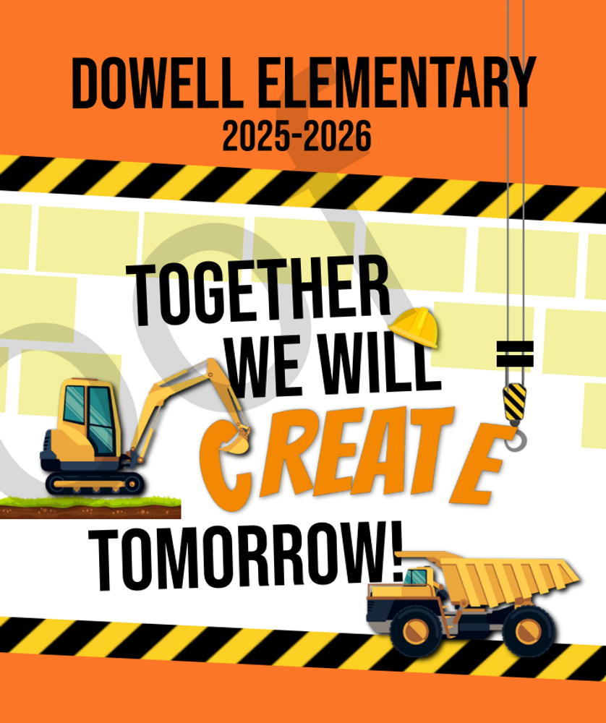

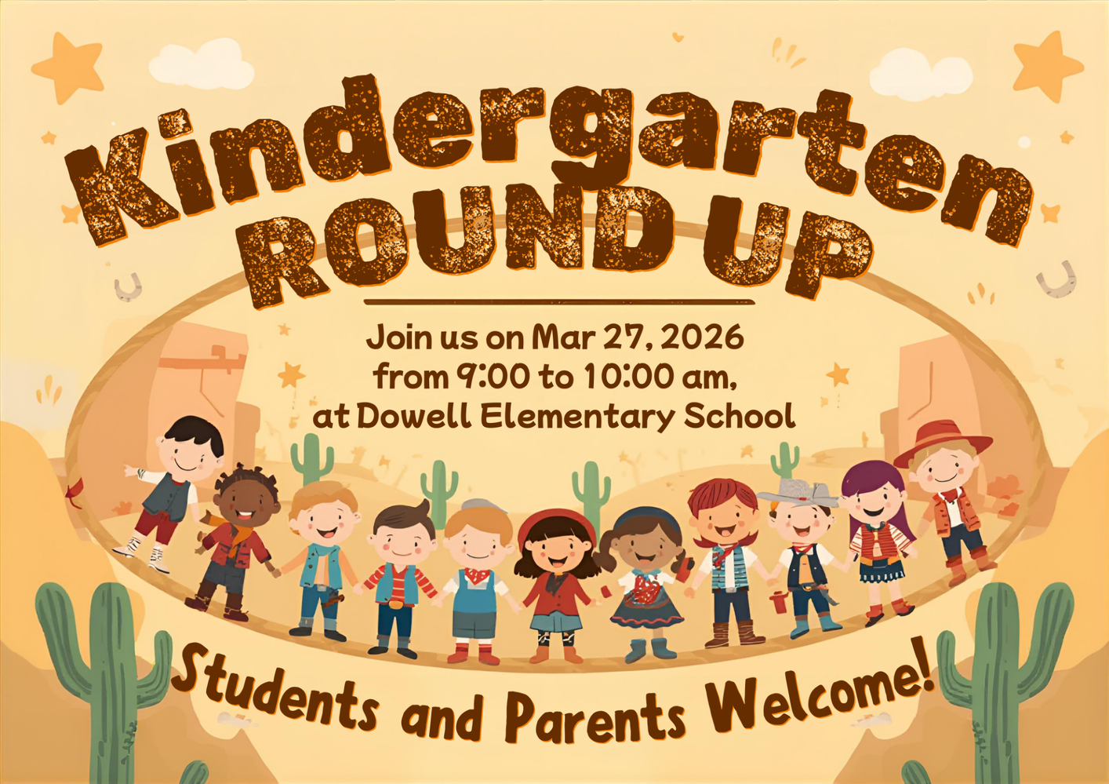

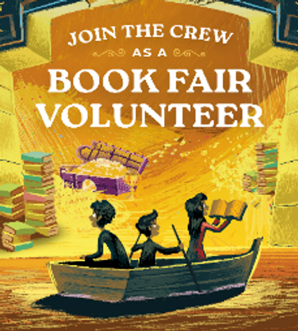
Volunteers Needed
The Spring Book Fair is just around the corner.

We need Volunteers! Help us bring the joy of reading to Dowell students! All Volunteers receive 20% off purchases during their shift! You can sign up below.

Dowell PTA: Parent Volunteers - Dowell PTA Book Fair Spring 2026

Classroom Celebrations Request Form
Dear Teachers/Parents/Staff,
Do you want to celebrate with your students but don’t have the time for all the planning and details? Return this request form to the Cafeteria Manager and leave the party to us! Upon receipt of the request form, we will provide you with a price quote for your party within 48 hours. On the celebration day, we take care of everything for you!

Please see attached form for pricing items and pricing.

Also if you plan on bringing in a treat for your child's birthday please fill out the attached cupcake form at least 24 hours in advance for the teacher and front office staff to be aware. This helps with planning and any allergies in the classroom.

Community News

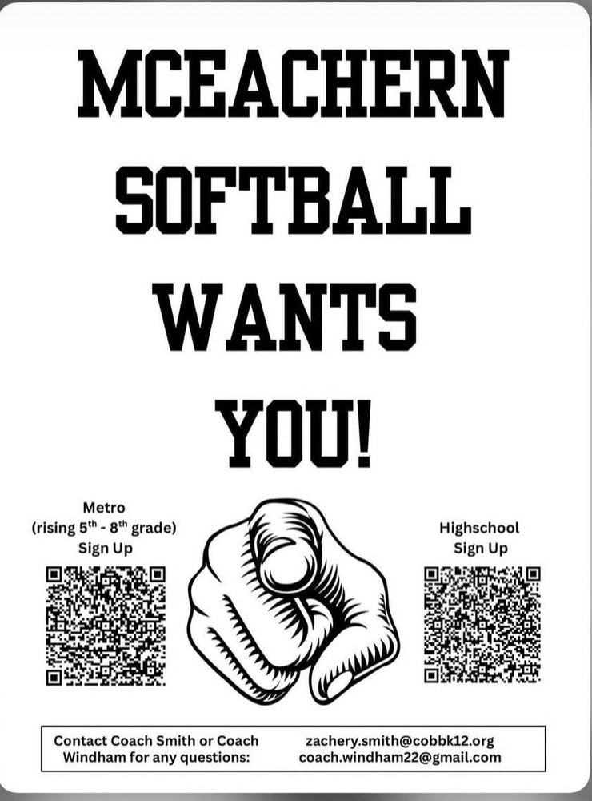

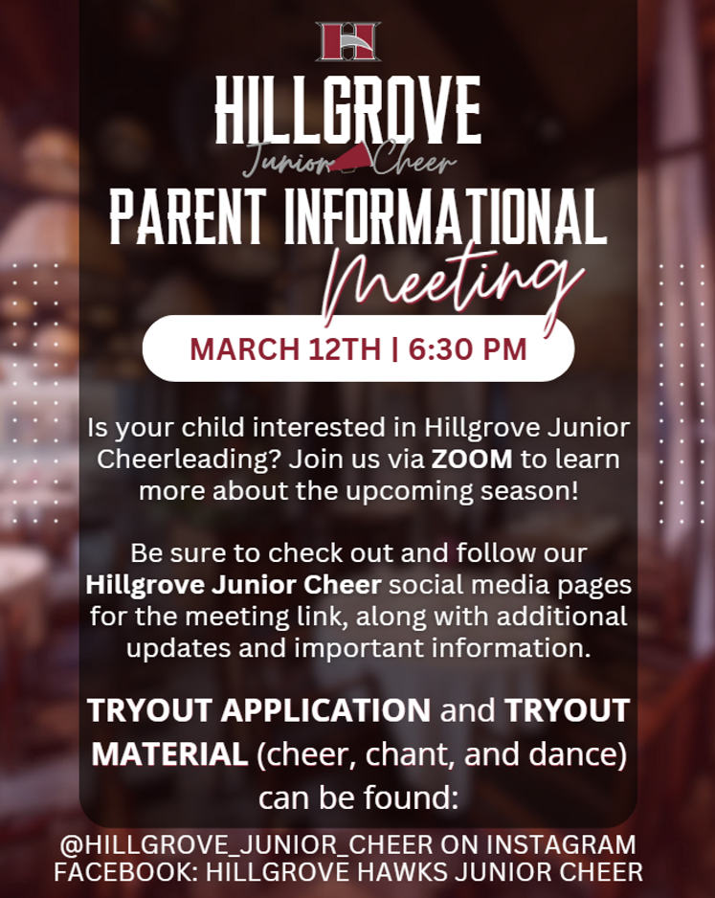
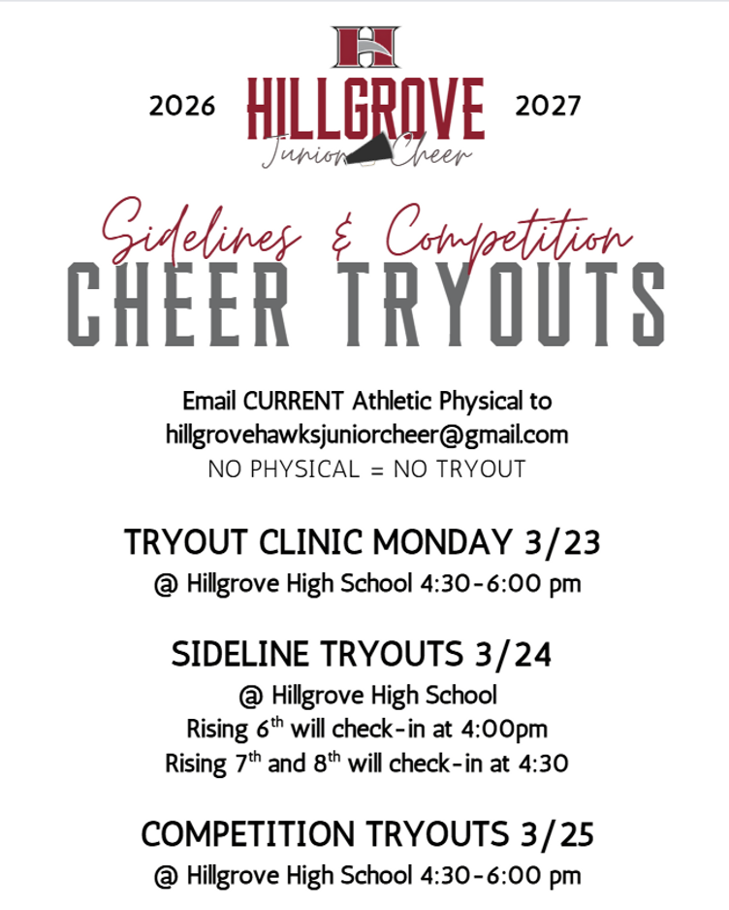

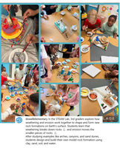
Follow us on social media.
https://www.instagram.com/dowellelementary

