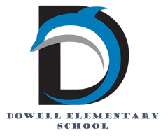

Dolphin Weekly

Sunday, April 12, 2026

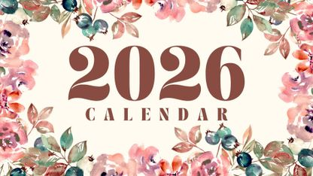

Save the Date!
April 13
- 2nd grade: High-Touch-High-Tech Inhouse Field Trip
April 14
- Field Day, Kindergarten, 8:15-10:45
- Field Day, 1st Grade, 11:30-2:00
April 15
- Field Day, 2nd Grade, 8:15-10:45
- Field Day, 3rd Grade, 11:30-2:00
- 5th Grade Field Trip to Birmingham
April 16
- Young Ladies with High Expectations Ceremony, 5:00 PM, in the Library
- 5th Grade Performance, 6:00 PM, in the Cafe
April 17
- Field Day, 4th Grade, 8:15-10:45
- Field Day, 5th Grade, 11:30-2:00
- PTA General Meeting 8am
- Carnival, 5:00-8:00 PM
April 21
- Milestones Assessment for 3rd (ELA) & 5th (Math) grades
April 22
- Milestone Assessment for 3rd (ELA) & 5th (Math) grades
April 23
- Milestones Assessment for 3rd (ELA) & 5th (Science) grades
April 24th
- Kindergarten Cap & Gown pictures
- Last Day for Library check-outs
April 27th
- Milestones Assessment for 5th grade (ELA)
April 28th
- Milestones Assessment for 3rd (Math) & 5th (ELA) grades
April 29th
- Milestones Assessment for 3rd (Math) & 5th (ELA) grades
April 30
- Milestones Assessment for 4th grade (Math)
May 1st
- Milestones Assessment for 4th grade (Math)
- All Library Books are DUE
May 4
- Milestone Assessment for 4th grade (ELA)
May 5th
- Milestone Assessment for 4th grade (ELA)
May 6
- Milestone Assessment for 4th grade (ELA)
May 12th
- DLI Picnic
- 5th Grade Milestone MATH Re-test
May 13th
- Kindergarten Ceremony
- 5th Grade Milestone MATH Re-test
May 14th
- 5th Grade Award Ceremony at Smith MS, 6:00 PM
May 15th:
- Senior Walk at Dowell, 8:30 am
- 5th Grade Picnic, 9 - 1pm
May 19th
- 5th Grade Walk 8:30 am
May 18, 19, & 20:
- Early Release Days
May 20th:
- No Student Back-Packs
- Last Day of School

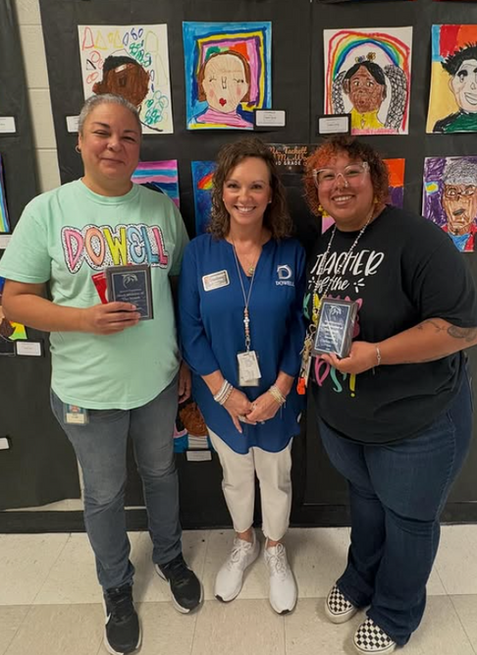

From the Principal's Desk
Dear Dowell Families,

We hope everyone had a wonderful and restful Spring Break! We are looking forward to welcoming our students back and jumping into a fun and exciting week ahead. We are especially excited for Field Days this week—always a favorite for our students—and our 5th Grade Performance on Thursday evening. We can’t wait to see our students shine!

Please join us in celebrating some of our amazing staff:
- 🎉 Congratulations to Ms. Doby, our Teacher of the Month
- 🎉 Congratulations to Mrs. Clare, our Staff Member of the Month
These ladies are so deserving, and we truly appreciate everything they do for Dowell. You both are SO amazing!

We also had a fantastic Spanish Spelling Bee today! We are so proud of our DLI students in grades for their hard work and courage in participating. Our winners from 3rd, 4th, and 5th grades are:
- 🥇 1st Place – Kourtney Okoh
- 🥈 2nd Place – Andrea Medrano Villalta
- 🥉 3rd Place – Elijah Holness & Gerardo Rodriguez
Congratulations to all of our participants and winners—we are proud of each and every one of you!

We are looking forward to a strong finish to the school year and a great week back together!

As a reminder, the Georgia Milestones Assessment is quickly approaching for our 3rd, 4th, and 5th grade students.

Georgia Milestones Assessment Information (Grades 3–5)

As we approach the Georgia Milestones Assessment, we want to partner with you to ensure our students feel confident, prepared, and supported.

The Georgia Milestones Assessment System is a statewide test that measures how well students have learned the knowledge and skills outlined in Georgia’s academic standards. For our students:
- Grades 3–5 take assessments in English Language Arts and Mathematics
- 5th grade students also take Science
These assessments provide important information about your child’s academic progress and readiness for the next grade level. They also help our school and district continue to improve teaching and learning for all students.

🔗 Parent Resource:

You can learn more and access helpful study guides here:
Georgia Milestones Assessment System – Georgia Department of Education
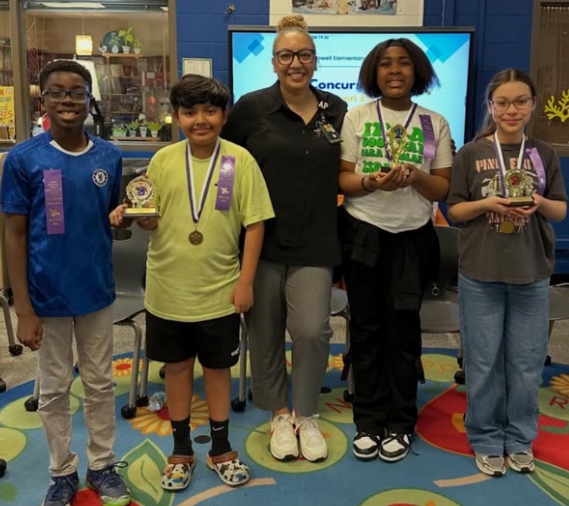
How Families Can Help at Home

Your support makes a big difference! Please help your child by:
- Ensuring a good night’s sleep each evening
- Having them arrive at school on time each day (testing begins promptly)
- Encouraging a positive mindset and doing their very best
A Note for 5th Grade Families
If a student scores a Level 1 in Math, they will receive targeted remediation and participate in a retest opportunity. Our goal is to provide the support needed for every student to grow and succeed.
Encouragement Matters
We encourage you to talk with your child about the importance of the assessment while also helping them feel calm and confident. This is an opportunity for them to show what they know—not something to fear.

🚗🚘🚙🛻🚕🚘🚗🚙🚓🛻🚕🛻🚔🚙🚘

Morning Carpool Safety Reminder

The safety of our students is always our top priority. During morning carpool, students should only be dropped off at the designated front carpool area, where school staff members are present and ready to assist and supervise students as they enter the building.

For safety reasons, students should not be dropped off anywhere else, including along the curb, in the parking lot, while waiting in line, at the road, or in any other undesignated area. These practices create unsafe conditions for students and drivers and are not permitted.

Thank you for helping us keep our Dolphins safe by following the designated front carpool drop-off procedures each morning. Your cooperation helps ensure a smooth and safe start to the school day for everyone. 🐬

Reminders:
- ID Requirement: A picture ID is required every time you visit the school. Please show it to the camera at the right front door and press the button (door bell). A staff member will confirm your reason for visiting and verify your child’s information before buzzing you in. Upon entry, always go straight to the front office.
- Visiting for Lunch? You’re welcome to sit with your child in the cafeteria during their lunch time. We kindly ask that you not bring fast food or restaurant m

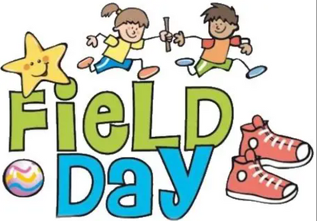

📢 Important Field Day Information

April 14 – Kindergarten & 1st Grade
• Kindergarten: 8:15–10:45 (Tug of War: 10:15–10:45)
• 1st Grade: 11:30–2:00 (Tug of War: 1:30–2:00)
April 15 – 2nd Grade & 3rd Grade
• 2nd Grade: 8:15–10:45 (Tug of War: 10:15–10:45)
• 3rd Grade: 11:30–2:00 (Tug of War: 1:30–2:00)
April 17 – 4th Grade & 5th Grade
• 4th Grade: 8:15–10:45 (Tug of War: 10:15–10:45)
• 5th Grade: 11:30–2:00 (Tug of War: 1:30–2:00)
Parents and family members are welcome to join the fun!
Please remember:
• You much sign in at the front before attending
• Bring a valid ID for check-in
• Revised Lunch Schedules

Get Your Yearbook now!
Yearbooks are now on sale for $35, while supplies last.

https://dowellpta.givebacks.com/shop?category=18350

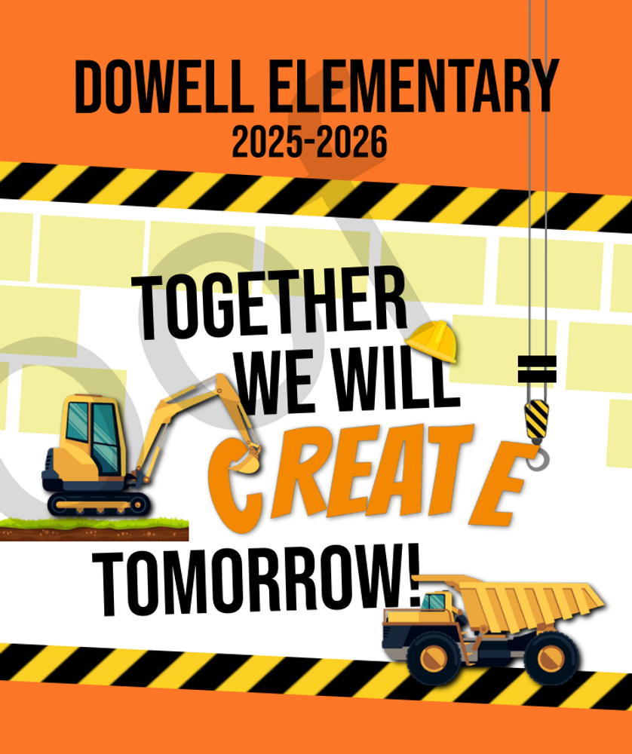

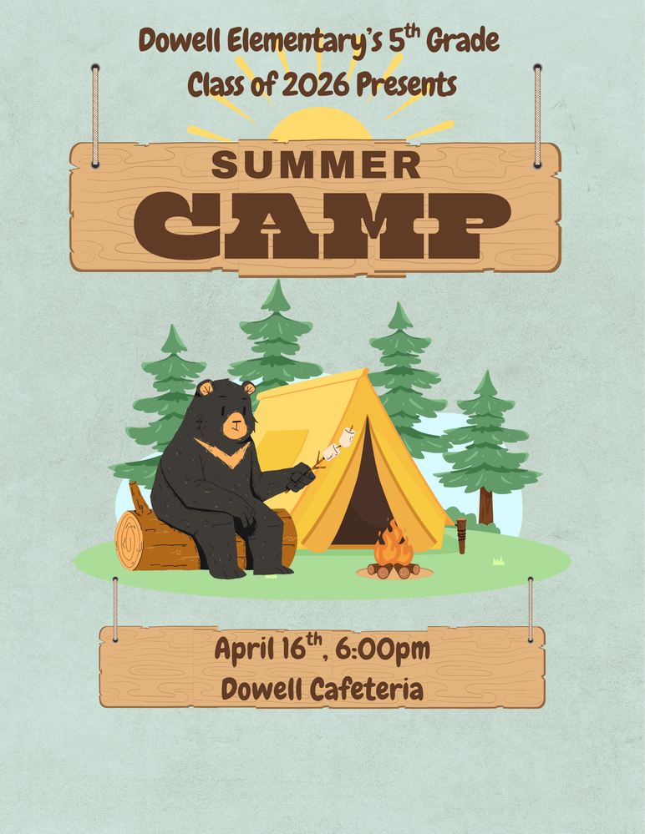

PTA Carnival
Please join us for the Annual PTA Carnival On April 17th from 5:00-8:00pm.

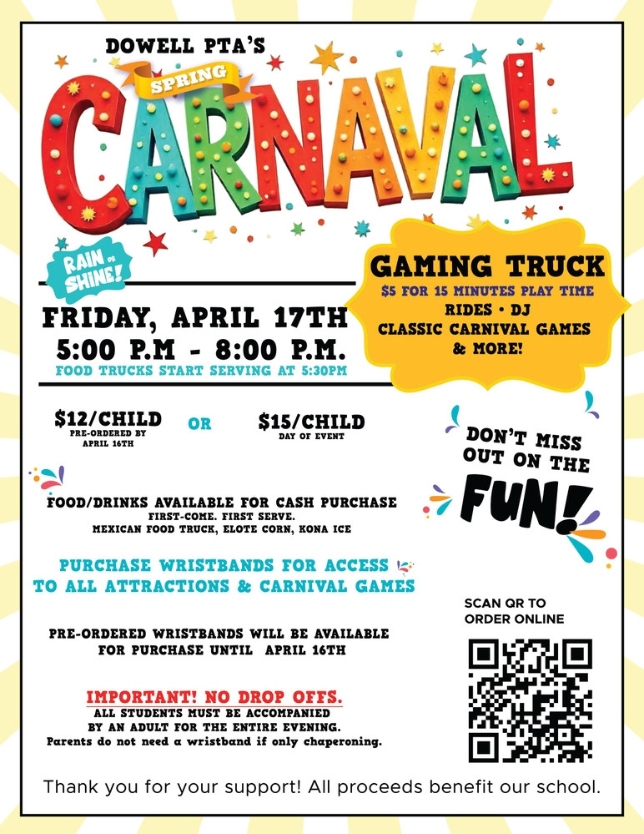

Carnival- April 17th
Purchase your Tickets for Spring Carnival here
https://dowellpta.givebacks.com/shop
Sign up for the game truck here
https://www.signupgenius.com/go/20F0F4DAFA82B0-63024285-game#/

Volunteers for Spring Carnival – sign up below.
https://www.signupgenius.com/go/20F0F4DAFA82B0-62622071-copy#/

Reflections Update
We are excited to announce that Dowell is heading to the National PTA Reflections Competition!
Our very own 2nd grader, Olivia Evans, has won 1st place for photography at the PTA State Level and is 1 of 2 elementary students in the state of Georgia to advance to the National level in photography.

Classroom Celebrations Request Form
Dear Teachers/Parents/Staff,
Do you want to celebrate with your students but don’t have the time for all the planning and details? Return this request form to the Cafeteria Manager and leave the party to us! Upon receipt of the request form, we will provide you with a price quote for your party within 48 hours. On the celebration day, we take care of everything for you!

Please see attached form for pricing items and pricing.

Also if you plan on bringing in a treat for your child's birthday please fill out the attached cupcake form at least 24 hours in advance for the teacher and front office staff to be aware. This helps with planning and any allergies in the classroom.

Community News

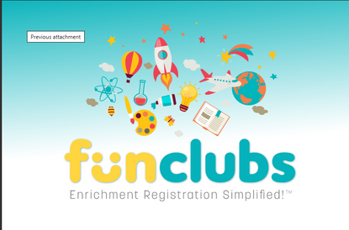

Fun Clubs Summer Camps
FunClubs are offering Summer Camps, sign up here: https://www.funclubs.com/camps

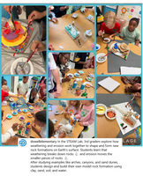

Follow us on social media.

https://www.instagram.com/dowellelementary

