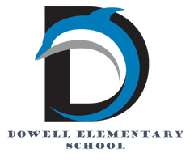
Dolphin Weekly
Sunday, April 27, 2026


Save the Date!
April 27th
- Milestones Assessment for 5th grade (ELA)
- Progress Reports
- PTA Spirit night at Bruster's 2-8pm
April 28th
- Milestones Assessment for 3rd (Math) & 5th (ELA) grades
April 29th
- Milestones Assessment for 3rd (Math) & 5th (ELA) grades
April 30
- Milestones Assessment for 4th grade (Math)
May 1st
- Milestones Assessment for 4th grade (Math)
- All Library Books are DUE

❤️May 4-May 8, Teacher/Staff Appreciation Week❤️

May 4
- Milestone Assessment for 4th grade (ELA)
May 5th
- Milestone Assessment for 4th grade (ELA)
- Deadline for Optional Parent Input form: Dowell Elementary 26-27 OPTIONAL Student Placement Form – Fill out form
May 6
- Milestone Assessment for 4th grade (ELA)
May 8
- Terrific Kids
- 5th Grade: Human Growth & Development
May 11th
- 1st - 4th Grade Classroom Awards
May 12th
- DLI Picnic *Parents must bring ID and Sign-In*
- 5th Grade Milestone MATH Re-test
May 13th
- Kindergarten End of the Year Ceremony & Classroom Awards, 8:30 *Parents must bring ID and sign-in*
- 5th Grade Milestone MATH Re-test
May 14th
- 5th Grade Award Ceremony at Smith MS, 6:00 PM
May 15th:
- Senior Walk at Dowell, 8:30 am
- 5th Grade Picnic, 9 - 1pm *Parents must bring ID and sign-in*
May 18, 19, & 20:
- Early Release Days
May 19th
- 5th Grade Walk 8:30 am
- No Student Backpacks
May 20th:
- No Student Backpacks
- Last Day of School ✌🏻

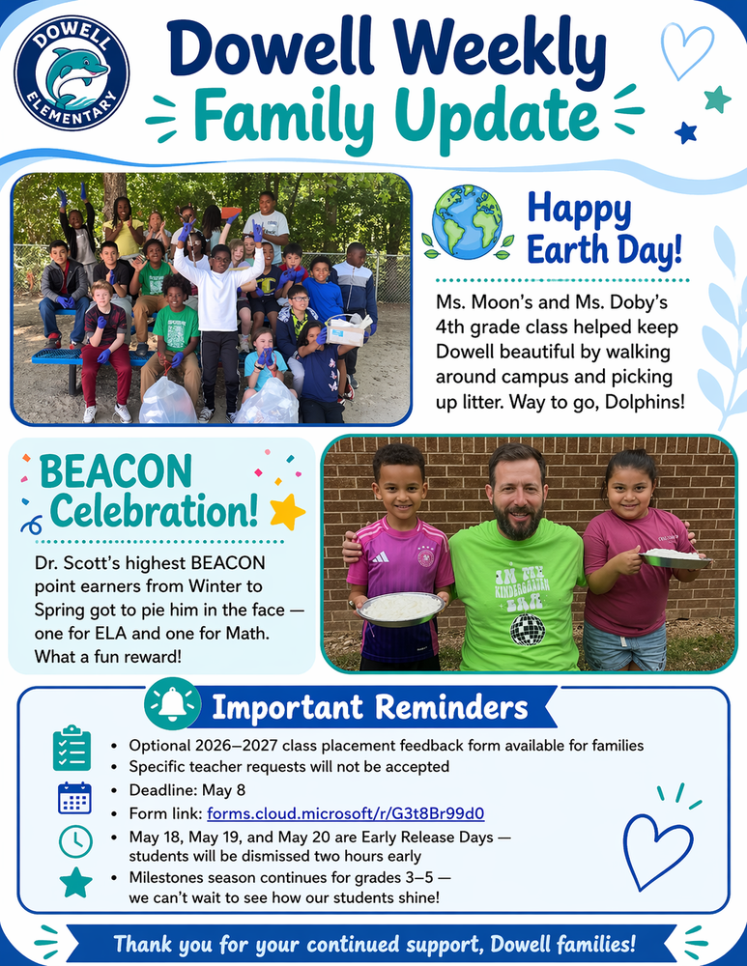

Classroom Celebrations Request Form
Dear Teachers/Parents/Staff,
Do you want to celebrate with your students but don’t have the time for all the planning and details? Return this request form to the Cafeteria Manager and leave the party to us! Upon receipt of the request form, we will provide you with a price quote for your party within 48 hours. On the celebration day, we take care of everything for you!

Please see attached form for pricing items and pricing.

Also if you plan on bringing in a treat for your child's birthday please fill out the attached cupcake form at least 24 hours in advance for the teacher and front office staff to be aware. This helps with planning and any allergies in the classroom.

Community News

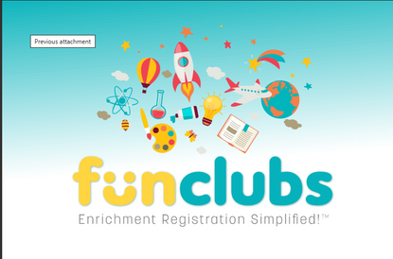
Fun Clubs Summer Camps
FunClubs are offering Summer Camps, sign up here: https://www.funclubs.com/camps

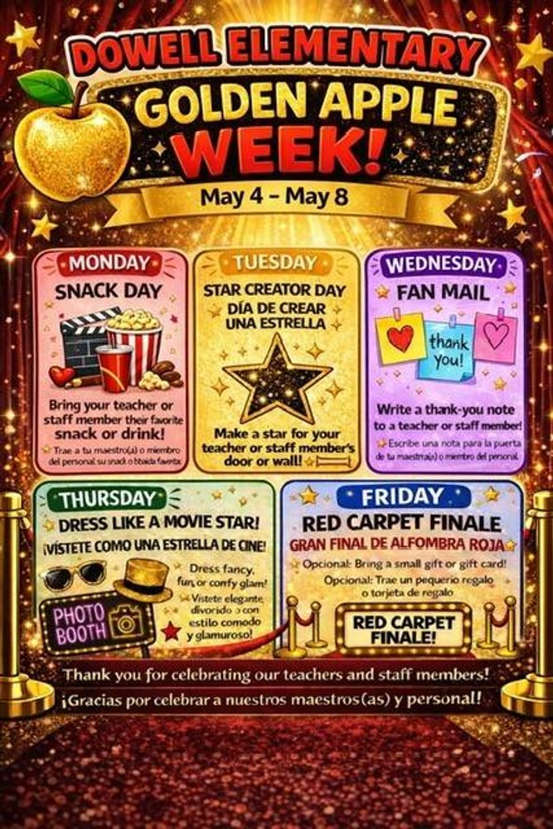

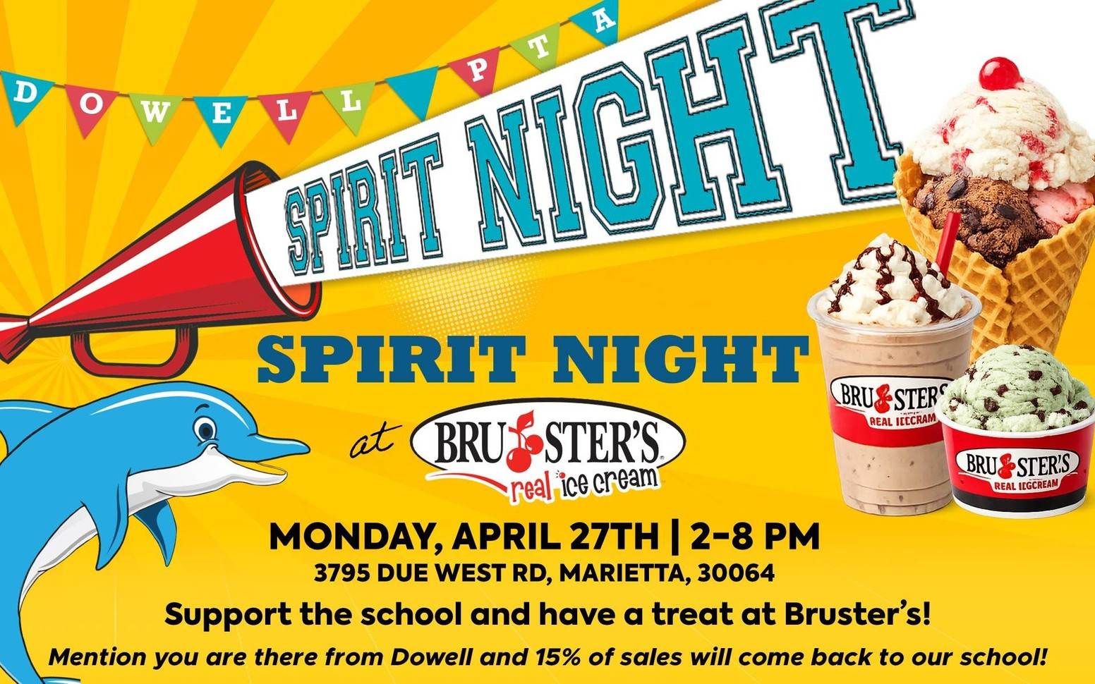

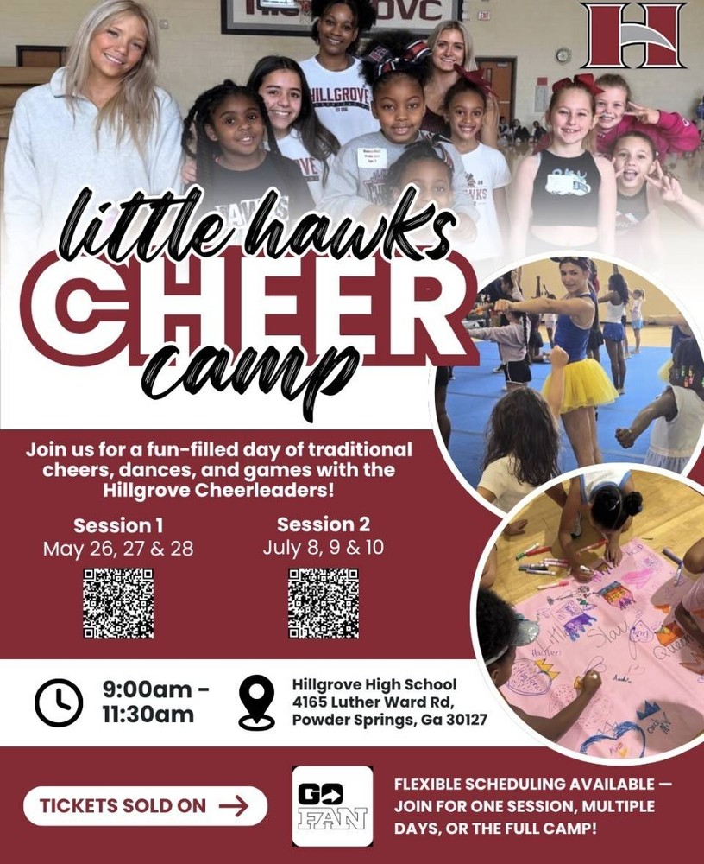



Register for Hillgrove SB Here

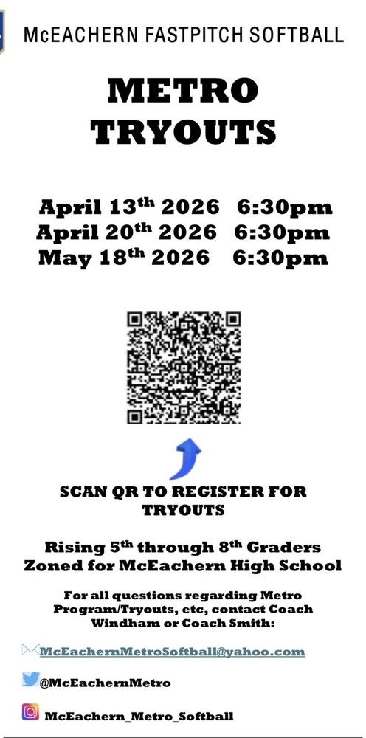

Register for McEachern SB Here



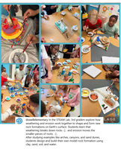
Follow us on social media.
https://www.instagram.com/dowellelementary

