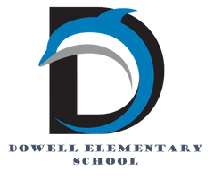
Dolphin Weekly
Sunday, May 10, 2026


Save the Date!
May 11th
- 1st - 4th Grade Classroom Awards
May 12th
- DLI Picnic *Parents must bring ID and Sign-In*
- SNPK Mother's Day Tea and End of Year *Parents must bring ID and Sign-In*Ceremony
- 5th Grade Milestone MATH Re-test
May 13th
- Kindergarten End of the Year Ceremony & Classroom Awards, 8:30 *Parents must bring ID and sign-in*
- 5th Grade Milestone MATH Re-test
May 14th
- 5th Grade Award Ceremony at Smith MS, 6:00 PM
May 15th:
- Senior Walk at Dowell, 8:30 am
- 5th Grade Picnic, 9 - 1pm *Parents must bring ID and sign-in*
May 18, 19, & 20:
- Early Release Days (students dismissed 2 hours early)
May 19th
- 5th Grade Walk 8:30 am *Parents must bring ID and sign-in*
- No Student Backpacks
May 20th:
- No Student Backpacks
- Last Day of School ✌🏻

July 30th: Meet & Greet your 2026-27 Teacher

12:00-1:00, PreK & Kindergarten
1:00-2:00, Last Names A - L
2:00-3:00, Last Names M - Z

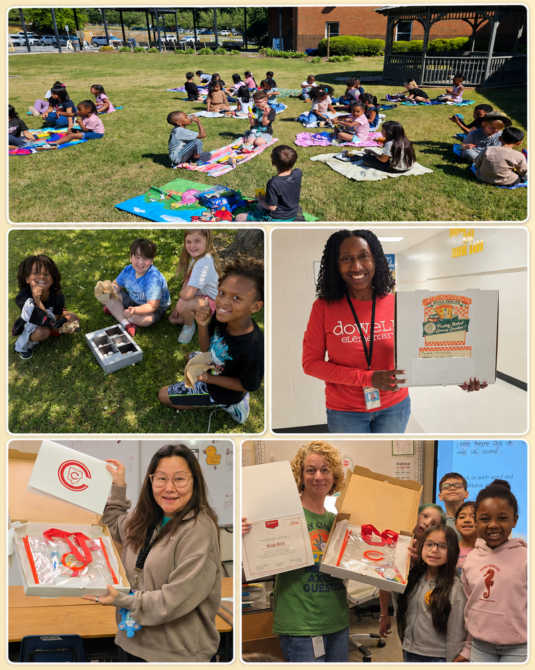

Message from the Principal
Dowell Families,

We had another wonderful week at Dowell as we continue making special memories during these final days of school! Mrs. Wint’s class celebrated “O” for Outside Day by enjoying lunch on the front lawn, and it was the perfect beautiful day to learn, laugh, and spend time together outdoors. Ms. Pipe’s 3rd grade class also took learning outside with solar oven s’mores, using the power of the sun to create a sweet science treat! ☀️🍫

This week we also celebrated our amazing teachers during Teacher Appreciation Week! Our Dowell teachers truly shine brighter than the stars and make learning sparkle each and every day. A huge thank you to our PTA for making our hallways glow and for helping our staff feel so loved and appreciated! ✨

Congratulations to Mrs. Mitchell, Mrs. Boswell, and Dr. Birch for completing and graduating from the LETRS Professional Learning program. This is a tremendous accomplishment and a wonderful reflection of their commitment to growing as educators and supporting student literacy. Way to go!

As an important summer FYI, our building will be closed for construction this summer as we receive new flooring in the hallways, every office, and every classroom, along with new windows. Because of this work, the school building will be closed to visitors until late July. We are excited for these improvements and look forward to welcoming everyone back into a refreshed building!

It is hard to believe, but we only have 8 more school days left! Let’s continue to finish strong, stay focused, and enjoy these last few days together as Dowell Dolphins.

Dr. Cain


New Bus App
Greetings Parents,
All buses have been transferred over to the new Parent Portal App and will no longer be trackable on Here Comes the Bus. If you would like to track your students' buses for the remainder of the school year, please download the Parent Portal Application. See the link or QR code below.

For the next school year, you will need to complete your student(s) registration in the Parent Portal App. Please look for more information to come on that soon.

If you have any questions, please reach out to Transportation @ 770-429-5816.

Thank you for your patience and understanding as we transition!

https://www.cobbk12.org/track-my-bus

Classroom Celebrations Request Form
Dear Teachers/Parents/Staff,
Do you want to celebrate with your students but don’t have the time for all the planning and details? Return this request form to the Cafeteria Manager and leave the party to us! Upon receipt of the request form, we will provide you with a price quote for your party within 48 hours. On the celebration day, we take care of everything for you!

Please see attached form for pricing items and pricing.

Also if you plan on bringing in a treat for your child's birthday please fill out the attached cupcake form at least 24 hours in advance for the teacher and front office staff to be aware. This helps with planning and any allergies in the classroom.

Community News

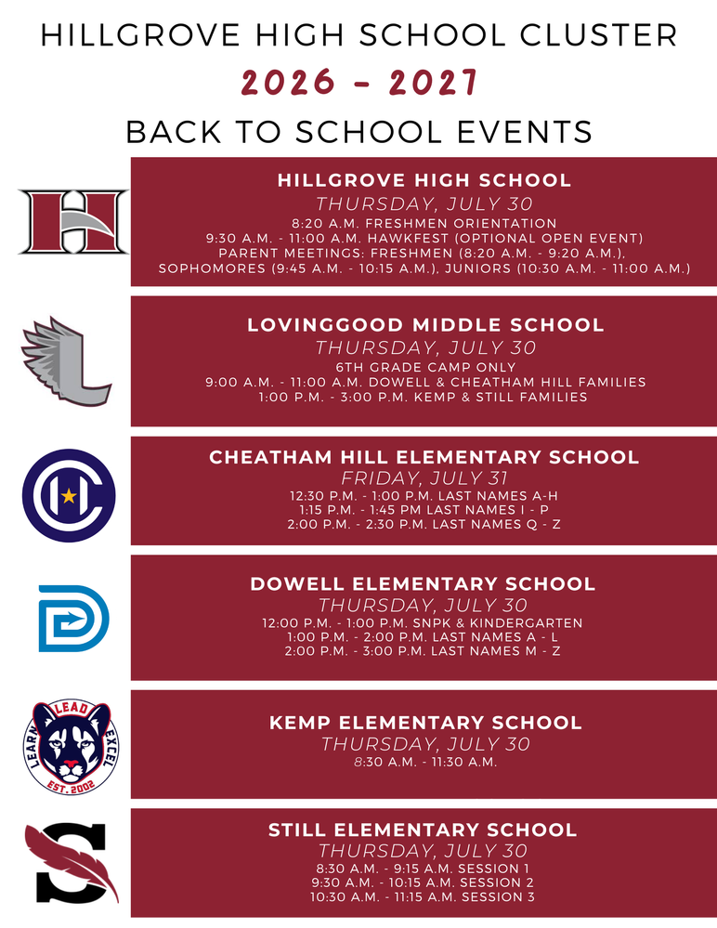

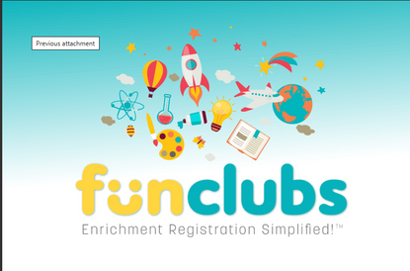
Fun Clubs Summer Camps
FunClubs are offering Summer Camps, sign up here: https://www.funclubs.com/camps

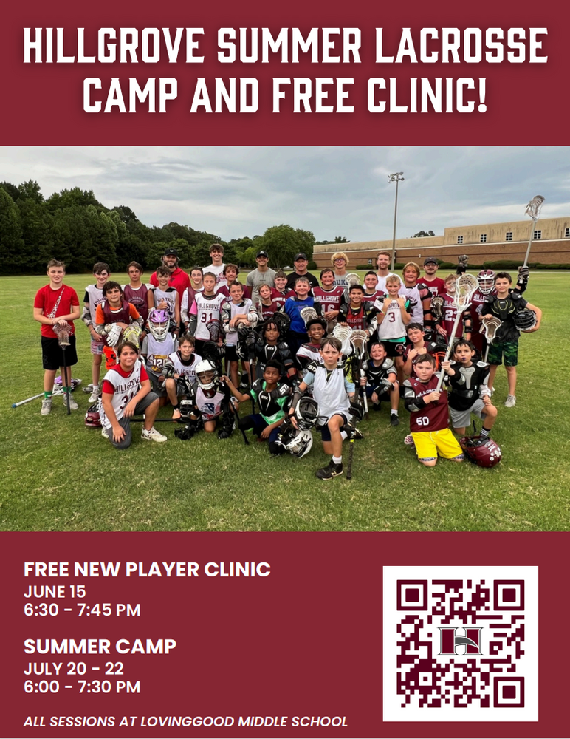

Lacrosse Registration Here



Evan Engram Registration

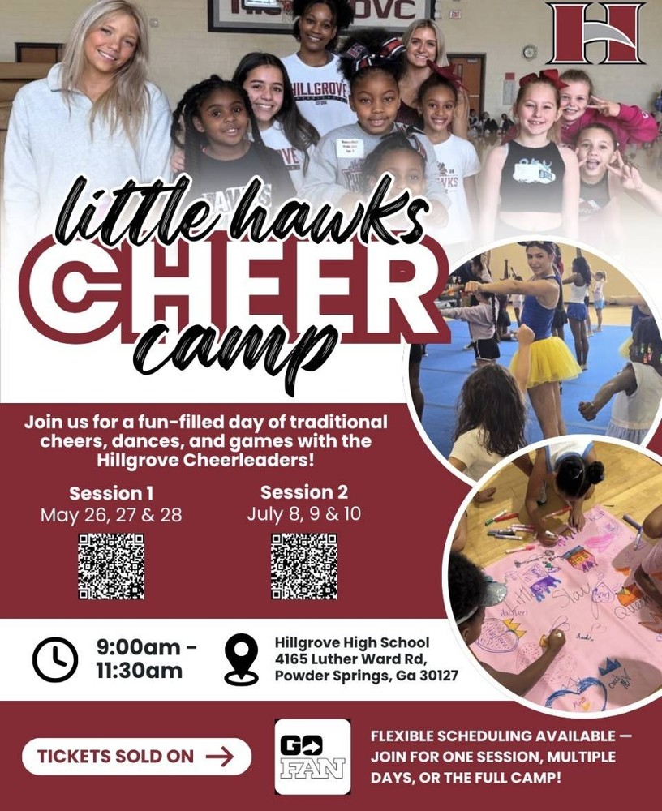



Register for Hillgrove SB Here

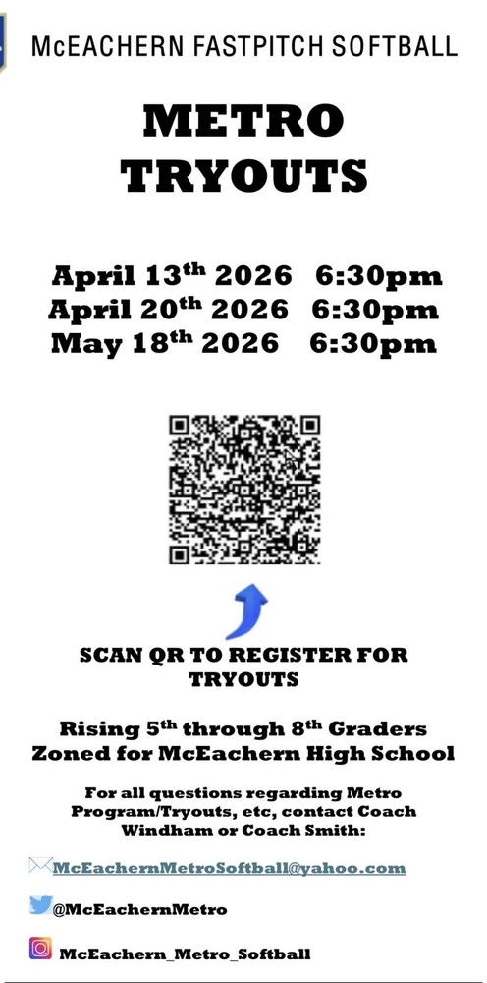

Register for McEachern SB Here

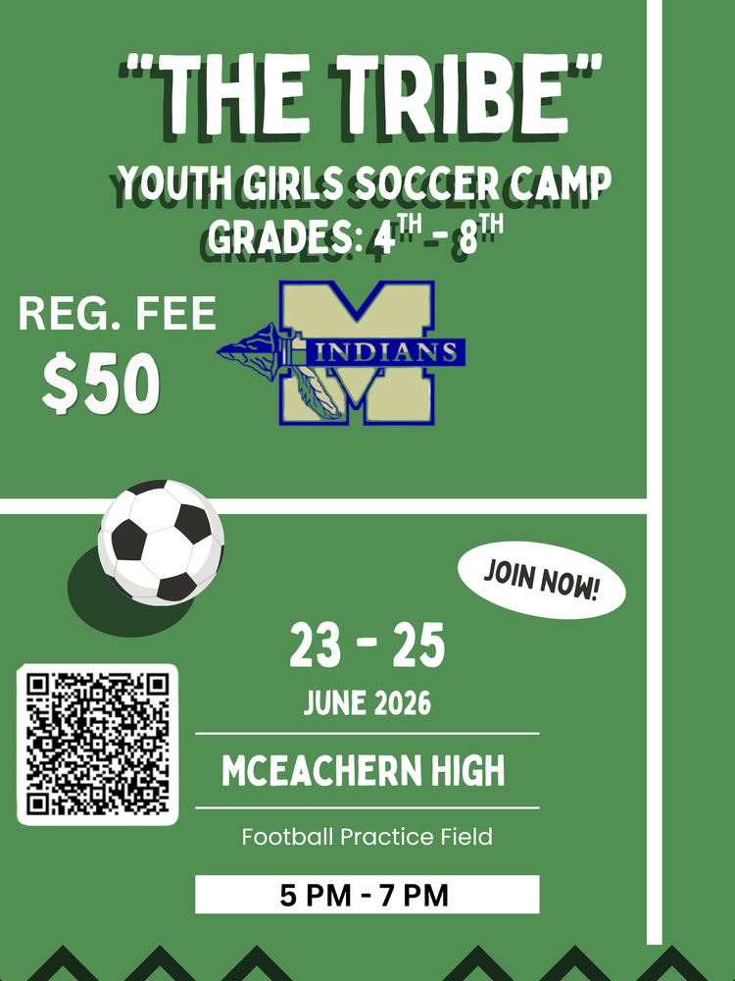

Register Here for The Tribe

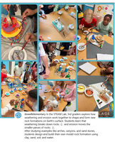
Follow us on social media.
https://www.instagram.com/dowellelementary

